Nicholas DeNardo
ENGN 2340 Final Project

Link to my Github Fork of EN234FEA:
https://github.com/ndenardo/EN234_FEA

The goal of this project was to implement a finite-strain version of a B-Bar element as an Abaqus UEL, using the Neo-Hookean material model, where B refers to the Left Cauchy Green Strech Tensor, J the determinant of the deformation gradient, and mu and K are material constants with K >> mu:

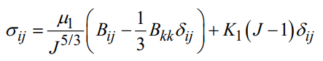 | (1)

The UEL was first implemented in EN234_FEA, using stiffness checks to validate the element and internal consistency. As a first check, a deformation test of 1 element was used, wherein all degrees of freedom were specified, and volume was not conserved, given by:
$$\left[F\right]= \left[\begin{matrix}1.25 & 0 & 0 \\ 0 & 1 & 0 \\ 0 & 0 & 1\end{matrix}\right]$$ | (2)

Where F is the deformation gradient. The element was successfully coded to where stiffness checks before and after deformation were both passed:
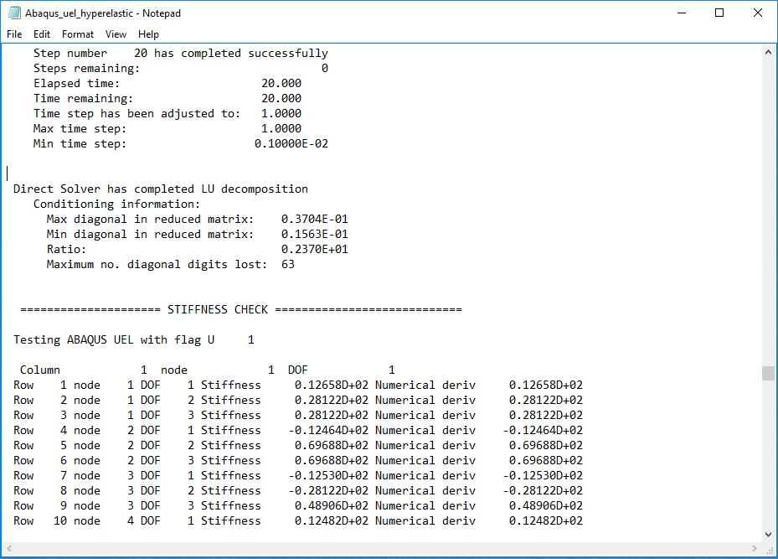

As further validation, the stress computed by the subroutine was compared against an analytical solution using (1) and (2) and values of 1 and 200 for mu and K, respectively, which are the same as those given to the subroutine. This gives the following analytical values for Kirchoff stress τ_{ij} = J*σ_{ij} within the element:
τ11 = 62.9351
τ22 = 62.2824
τ33 = 62.2824

The subroutine computed similar stress values at the specified deformation gradient, with slight deviation from the analytical solution:

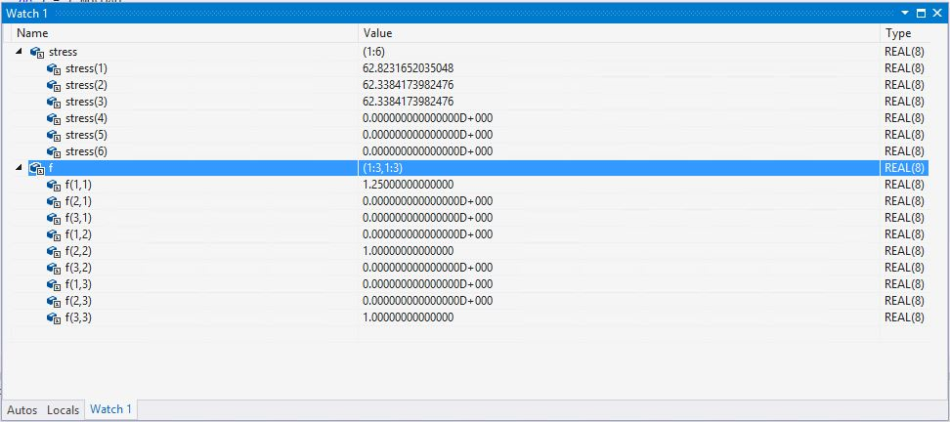

As a final test, two elements were stretched and then rotated 90 degrees. Newton-Raphson iterations also converged for this, with stiffness checks before and after deformation passing again. A contour plot of results at various steps is shown below:

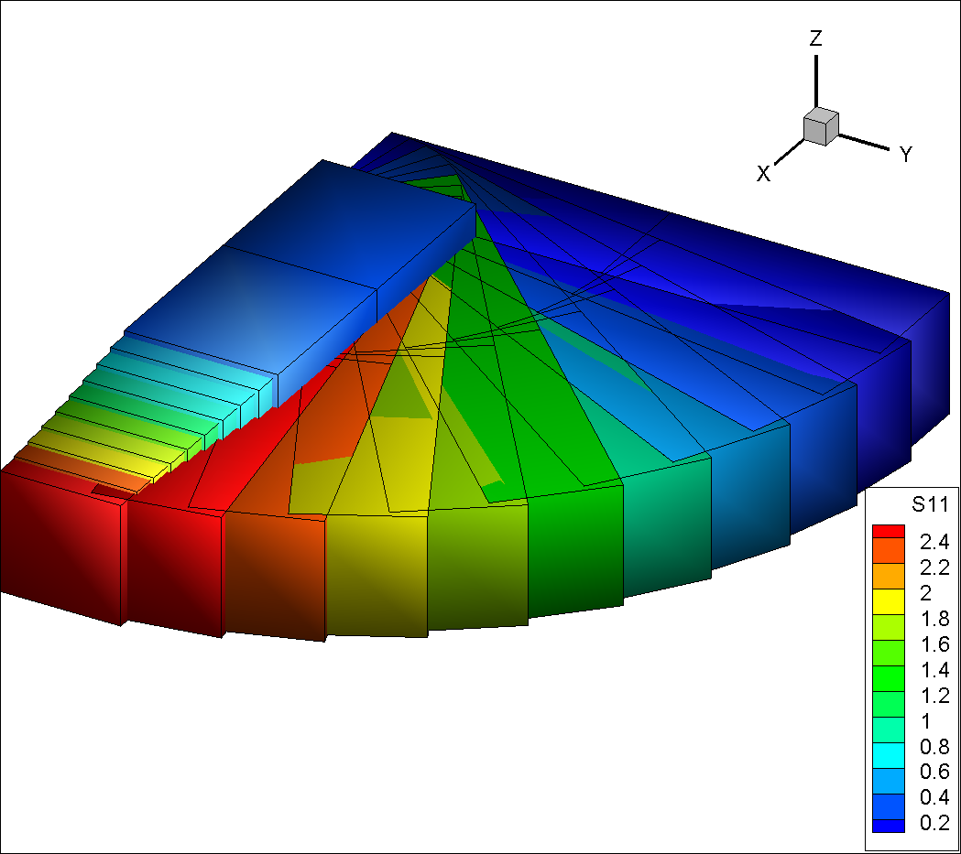

Where S11 decreases as the material rotates away from the x-axis, as expected. This demonstrates the ability of the element to handle large rotations as well as stretches.

Future work may include revising the material model to slightly more accurately predict stress, as well as using the element in ABAQUS.

