Teacher Resources - Sediment Sample Analysis

Objective:
- Students first learn about the formation of the Miller Woods ponds system of northwest Indiana. This information is then used to help students construct an understanding of the purpose of coring for macrofossils and how the method of relative dating is important in this practice.
- Next, students use an interactive online sediment core example to collect data on species identifications of macrofossils found in an actual core taken from a Miller Woods pond and the depths in the core at which each was found.
- Finally, in a hands on activity, students disassemble models of core sample segments to identify the depth from which they were taken and the relative age of the macrofossils found in their samples in relation to macrofossils found in the remainder of the core.

Materials

- Paper Plates (one for each of the seven sediment samples)
- Paper shred
- Noodle shapes
- Plastic sandwich baggies for storing sediment samples
- Student Data tables
- Internet Access

Prep Simulated Sediment Baggies:

Materials:

Core Sample Data table
Paper shred
Noodle shapes
Sandwich baggies
Core Sample Data Table
Red and Blue Glitter
Sharpie marker
7 – 3x5 index cards

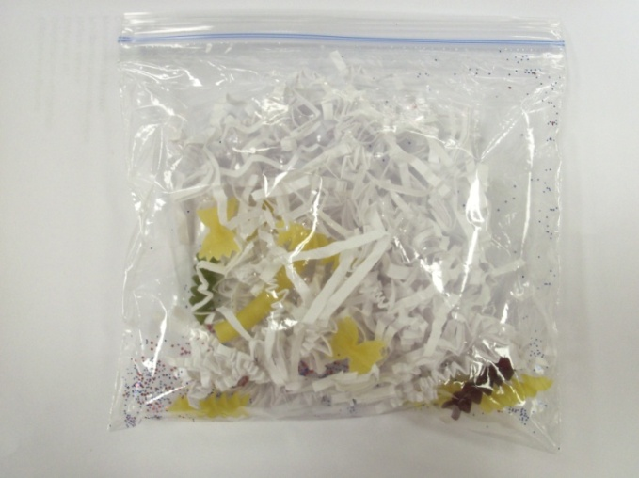
Procedure:
Add to each baggie
- A small handful of paper shred

- Red and Blue glitter as needed

- Label each baggie numbers 1-7

- Appropriate number of noodle shapes
  - Use the Core Sample Data Table find appropriate numbers of each noodle type per baggie

- Glue extra noodle shapes to 3x5 index cards and label each to make identification key cards for each group.

Set-up:
Part 1: A short pre-lab reading portion catches students up on background information important to the rest of the lesson. Following the reading is a series of pre-lab questions to assess student readiness for concepts addressed in the interactive online portion.
Time requirement: 15-20min

Part 2: Data collection is carried out online using an interactive website. This site allows students to zoom in on macrofossils found in an actual core during the summer of 2011 by researchers from Brown University. Accompanying questions assess understanding of vital concepts.
Web Address: http://coolhub.imsa.edu/web/core-project/core2
Time requirement: 30-40min

Part 3: Data collected in part 2 is put to use as students compare the dissected contents of simulated sediment baggies to their data tables to determine the depth of the core that their sample represents. Once the represented depth is determined, students must then determine the relative age of the sample keeping in mind that variable such as compression have made it nearly impossible to determine actual age.
Time requirement: approx. 30-45min

Using fossil pollen to study climate ch

Part 1 review - Pre lab questions

Name:______________________________________Date:_______________Class:________________
- How did the Miller Woods ponds form?

The ponds formed in rows as Lake Michigan retreated to the North as glaciers repeatedly melted and stalled.
- Why are there fewer ponds today than when Henry Cowles began to research the plant communities of the Miller Woods?

Today only a few remain with the rest having been taken over by industry and housing.
- Pick one and write a hypothesis:
  - How have the plant communities of the Miller woods changed over the course of the past 300 years?

Answers will vary- generally lending to the idea that there is less variation of original native species and more invasive species

  - What has caused the plant communities of the Miller Woods ponds to change over the course of the past 30 years?

Answers will vary- generally lending to the idea that human development has lead to habitat destruction and introduction of new species that decreased population sizes.

- Define macrofossil?

A macrofossil is a preserved leaf, stem or other plant segment useful in identifying the plants growing in the area during that time period.

- Which sediment layer contains the older macrofossil: one found 17 cm deep or one found 12 cm deep? Explain.

A macrofossil found in a sediment layer 17cm deep is older than one found in a layer 12cm deep because the deeper layer was deposited first and the younger layer deposited later.

- If a sediment core is 4 centimeters long, how many years of sediment does it
contain?

If 1 cm of core length = 22 years of sedimentation then 4cm of sedimentation x 22 years = 88 years.

Part 2- Sediment Sample Analysis Data Collection

Name:______________________________________Name:__________________________________
Name:_____________________________________ Date:_______________Class:________________
Objective: In this activity, we will collect data from the most recent cores taken from the Miller Woods ponds. We will use an interactive web site that allows you to zoom in on the actual macrofossils found by researchers from Brown University. Later we will use this data to analyze a segment of a model sediment core.

Go to the Online Core Sample 2: http://coolhub.imsa.edu/web/core-project/core2
- Complete the data table by indicating how many of each plant species was present at that depth.
- Put a check mark in the appropriate box if Ambrosia pollen or Industrial Particles were found

Sediment Sample Data Table #1
Macrofossils | Core Depth (cm)
 | 2-4 | 4-6 | 6-8 | 8-10 | 10-12 | 12-14 | 14-16 | 16-18 | 18-20 | 20-22
Brasenia
schreberi
Cyperaceae-trigonous |  |  |  |  |  |  |  |  | 2 | 1
Cephalanthus occidentalis | 2 | 1 |  |  |  |  |  | 1
Eleocharis  sp. | 3 |  |  |  |  |  |  | 2 | 10 | 16
Nuphar  advena |  |  |  |  |  |  |  | 1 |  | 2
Polygonum hydropoperoides | 9 | 3 | 1 | 1
Proserpinaca  Palustris | 11 | 12 | 26 | 4 | 2 |  | 1 | 1
Quercus  leaf |  |  | 8 |  | 6 | 4
Scirpus  sp. | 7 | 4 | 11 | 14 | 5 | 15 | 200 | 41 | 5
Typha  sp. |  | 1 | 1
Industrial  particles | √ | √ | √ | √ | √ | √ | √ | √ | √ | √
Ambrosia  pollen | √ | √ | √ | √ | √ | √ | √ | √ | √ | √

Sediment Sample Data Table #2
Macrofossils | Core Depth (cm)
 | 22-24 | 24-26 | 26-28 | 28-30 | 30-32 | 32-34 | 34-36 | 36-38 | 38-40 | 40-42
Brasenia  schreberi | 1 | 1 |  |  |  |  | 1 | 2 | 1 | 2
Cyperaceae-trigonous | 4 | 2 | 7 | 1 | 1 |  |  | 3 | 2 | 4
Cephalanthus occidentalis
Eleocharis  sp. | 5 | 8 | 6 | 2 | 3 | 4 | 1 | 14 | 8 | 15
Nuphar  advena |  |  |  | 4 |  |  |  | 5 | 7 | 1
Polygonum hydropoperoides |  |  |  | 2 |  | 1 |  |  | 2
Proserpinaca  Palustris |  |  |  |  | 1
Quercus  leaf | 1 | 1 | 1
Scirpus  sp. |  |  |  |  |  |  |  |  | 2
Typha
sp.
Industrial
particles
Ambrosia
pollen

Data Analysis Questions:

- How long ago did industrial particles begin to appear in the sediment? Show your work. (Hint: Remember that 1cm = 22 years).

22cm x 22 years = 484 years

- Why is it considered only a very rough estimate to say that 1cm of sediment formation equals 22 years?

Compression is a variable that is different in various ponds and for different cores.

- Why do you think Ambrosia pollen increased during the same time that industrial particles began appearing in the sediment?

Environmental conditions changed to favor ambrosia growth when humans began to settle the area more aggressively by segmenting the land with railroads and highways, etc.

- Describe the changes in the Scirpus sp. population over time.

Very little evidence of Scirpus sp. was seen until around 18cm depth. Then the Scirpus sp. began to increase rapidly until it leveled off between 14-16cm. Since then it has been slowly declining.

- Describe the changes in the Proserpinaca palustris population over time.

A similar rapid increase then decline was seen with Proserpinaca palustris however the climax was a smaller community and the entire event was both shorter in duration more recent.

- Based on this sediment core what two plants seem to have disappeared from the pond community? What could have caused these losses?

Brasenia schreberi and Cyperaceae trigonous dwindled to nothing in the sediment core. Both loses occurred at about the same time that industrial particles became evident. There may be a correlation between these two pieces of evidence.

- Why do you think some macrofossils seem to disappear then reappear in the sediment core?

Conditions may not have been optimal to form fossils from the plant fragments during those missing years.

Post Lab Questions:
- According to your results, from what depth was your sample taken?

Answers will vary

- How were you able to determine the depth identity of your sample?

Students are able to determine the depth that the sample represents by correlating the contents to the data of the actual sediment core.

- Compare the depth of your sample to the depth of the other samples of the class. Put the lab groups in order according the age of their samples from oldest to youngest.

- Youngest Lab Group___________________________________________________________________

2. Lab Group _______________________________________________________________________________

3. Lab Group _______________________________________________________________________________

4. Lab Group _______________________________________________________________________________

5. Lab Group ______________________________________________________________________________

6. Lab Group ______________________________________________________________________________

7.Oldest- Lab Group ______________________________________________________________________

- How do you think that this is similar to the way scientists collect sediment cores from ocean and lake floors? How is it different?

The data used is real data from an actual core. It is used to relate the ages and time spans of real plant species over actual periods of time to environmental conditions that effect them. It is different because more than one core sample is taken and compared.

- Predict what plants would be growing in the pond today in the sediment.

Plants that are growing in the pond today are those found at the top layers of the core.

- Why are some plants present today but not found in the sediment?

Environmental conditions must be ideal for plants to form fossils. Under most conditions plant tissues decay to form indistinguishable sediment. Those plant species may have been present but may not have fossilized. Other plant species may have been introduced since the formation of deeper layers of the core.

