Make a Sample Sediment Core Model:

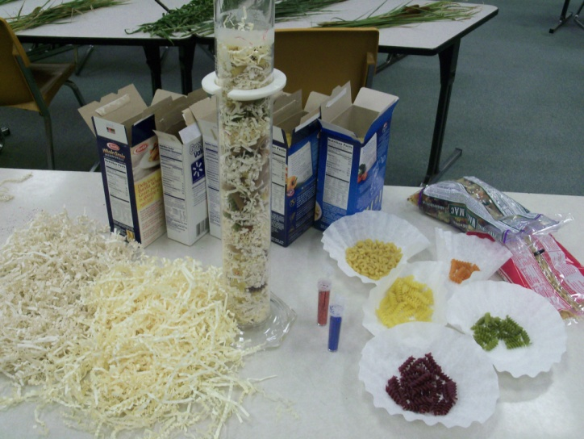
Materials:

- Paper Shred 2 colors
- Assortment of pasta shapes
- Glitter 2 colors
- 1000mL Graduated cylinder
- Core Data

Procedure:

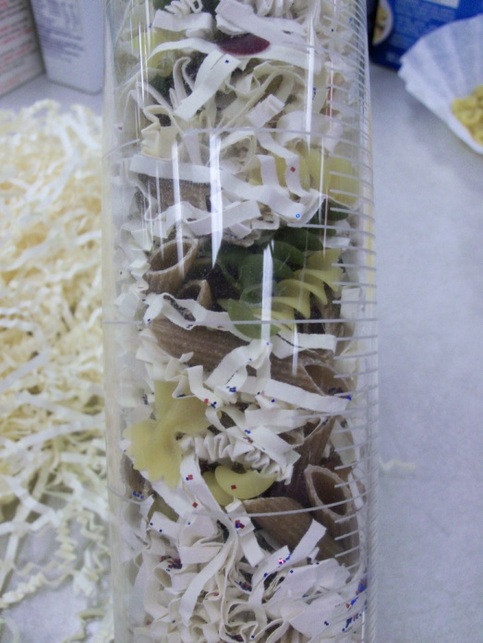
- Gather just enough paper shred for each layer of the core to fill no more than 50mL in the beaker.
- Add pasta shapes to each layer according to the Core Model Key on the sediment data table or modify to it fit your needs.
- As you build the model core, use blue and red glitter to represent Industrial particles and ambrosia pollen where noted in the data.
- Press layers down along the way to compress your core model.
- Use extra pasta pieces and glitter to make a key to go along with your core model.

Data included was recorded from a core taken from Miller Woods summer 2011, Brown University.

