Part 1: The Temperate Deciduous Forest Biome

Name:___________________________________Date:___________Class:_____________

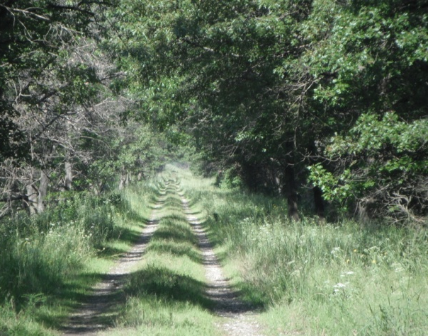
The trees and grasses in the forest to the left are examples of species that can be found in the Great Lakes region. A large portion of the Great Lakes region is part of the temperate deciduous forest biome. The temperate deciduous forest biome can be distinguished from other biomes with key characteristics including seasonal temperature changes, year round precipitation, and deciduous trees which go dormant and shed their leaves in the fall to help them survive through the cold winter.
Forest ecosystem in the temperate deciduous forest biome showing forest edge habitat
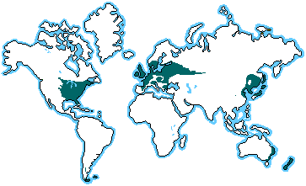

The name “temperate deciduous forest biome” can be misleading since the entire biome isn’t made up of forests. Biomes are made up of several ecosystems. For example, in the Great Lakes region of the temperate deciduous forest biome, ecosystems include forests, prairies, lakes, wetlands, dunes and more.
Location of the temperate deciduous forest biome
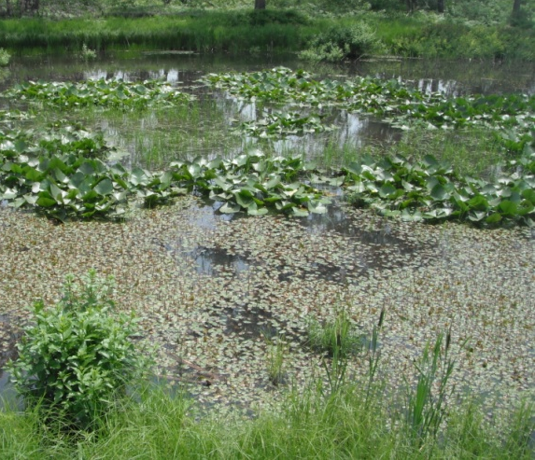
Within each ecosystem, multiple habitats are found which are areas inhabited by a particular species of organism. For example, the canopy is the habitat for birds found at the tops of the trees in the forest ecosystem of the tropical rainforest biome. In the photo to the left, the lilypads are growing in the water habitat of the pond ecosystem of the temperate deciduous forest biome

Pond ecosystem in the temperate deciduous forest biome showing water and shoreline habitats

1. Both examples of ecosystems pictured above are found in the temperate deciduous forest biome. List 3 more examples of Great Lakes ecosystems and one of their habitats. Don’t use the examples that were mentioned above! Include 2 organisms that live in each. Answers will vary
  - Ecosystem:______________________Habitat: ______________________________
    - Organism #1: _____________________________
    - Organism #2: _____________________________
  - Ecosystem:______________________Habitat: ______________________________
    - Organism #1: _____________________________
    - Organism #2: _____________________________
  - Ecosystem:______________________Habitat: ______________________________
    - Organism #1: _____________________________
    - Organism #2: _____________________________
Both biotic factors and abiotic factors can affect the ability of organisms to survive in an ecosystem. Living things in the environment such as plants, animals, and bacteria are biotic factors. Biotic factors also include once-living parts such as dead leaves on the forest floor. Abiotic factors are nonliving aspects of the environment such as sunlight, temperature and water.
One important abiotic factor is soil. The soil found in the forest ecosystem of the temperate deciduous forest biome is rich in nutrients because of decaying material such as fallen leaves that is broken down into rich organic material called humus. This humus rich soil is also great at holding water, making it available for plant use. Nutrients and water are then available to support the producers of the food web, which in turn support primary consumers, which support secondary consumers and so on providing some areas of the temperate deciduous forest biome with a wealth of biodiversity. Conversely, in the dune ecosystem the sand does not hold water or nutrients well leaving the soil very poor for plant growth. Very little decaying material is produced and there is almost no humus. In wetland ecosystems, the soil is so wet that there is very little oxygen available for the bacteria that break down dead plants. Dead plant material does not decay, leading to mucky sediment with lots of nutrients trapped in the old plant material.

2. Use complete sentences to define the terms in your own words:
- Biotic factors: _ Living things in the environment such as plants and animals________________
______________________________________________________________________________
- Abiotic factors: ____ things that were never living such water or light_________________
______________________________________________________________________________

3. Is the example Biotic (B) or Abiotic(A)

a. ____B_____ Grass
b. ____A_____ Water
c. ____A_____ Temperature
d. ____B_____ Bee
e. ____A_____ Cloud
f. _____A____ Oxygen
g. _____B____ Seed
h. _____B____ Log

4. Give additional examples of each Answers Will Vary
Abiotic factors:

a.________________________

b.________________________

c. ________________________

Biotic Factors

a. ________________________

b. ________________________

c. ________________________

5. A student tested soils from 3 ecosystems: dune grassland, dune forest, and forest.

- Which should have the most humus in the soil? Why?
The Forest soil will have the most humus because the abundance of plants supplies nutrients to the soil.

- Which should have the least nutrients in the soil? Why?
The dune grassland would have the least because nutrients are trapped in plant debris and the sand does not allow for decay. Also there are fewer plants to decay.

Survival:

Each organism each has a limited range of tolerance for abiotic factors in their environment. Since each ecosystem contains a new range of abiotic factors the creatures there must be adapted to survive those conditions or their species will go extinct.
For example, a cattail often found in the wetlands of the Great Lakes region could never survive in the arctic because of temperature extremes beyond its range of tolerance. However, the creatures that live in in the arctic tundra are adapted to the cold and dry conditions and could not survive in the wetlands of the Great Lakes. If a group of cattail were taken to the tropical rainforest where the soil is nutrient poor, they may thrive for perhaps a few seasons but more likely the group wouldn’t survive much longer. Since the group died locally but more of the species exists on the earth, this is called local extinction.

- What is your range of tolerance:
  - Name 3 factors required for your survival? ______Answers will vary __________

  - Do other organisms require the same factors for survival or different? Explain.

Most, but not all require the same factors including food and water. However, humans also require shelter

  - How do other organisms survive outdoors, get food or escape predators?

____All organisms rely on adaptations best suited for the environmental in which they live

- List 5 examples of adaptations that species in your ecosystem need to survive.

Species |  | Adaptation
a. | Answers will vary
b.
c.
d.
e.

- Name 2 species that have gone extinct in one area but are not extinct worldwide. Why did they go locally extinct?

Species |  | Reason
a. | Answers will vary
b.

