tapStat version 0.90
Compiled on February 1, 2003
by: David Phillips dphilli4@msn.com

Introduction

tapStat is a collection of simple statistical tools for the Pocket PC platform. Data can be entered directly into the program, and it can read and save CSV (comma separated values) files that can be transferred to and from a desktop PC running most common spreadsheet software. Data sets can be summarized, control charted, compared with ANOVA methods, and checked for capability (among other things). A set of QuickTools (which do not require a data set) includes statistical tables (z, t, chi-square) and a capability calculator for attribute data.

Requirements and Installation

tapStat is designed for Pocket PC 2000 and Pocket PC 2002 devices. It has been tested on a Toshiba e330 (running Pocket PC 2002) and on the PC-based Pocket PC Emulator (running Pocket PC 2000). I have not tested any other Pocket PC models or OS – however, versions are included for ARM, MIPS, and SH. The install should use about 1.2 MB on the device.
Download the “TSPPC090.ZIP” file and unzip it to any convenient place. There will be a “CD1 0.90” directory – run the “Setup.exe” file found inside. The install will proceed along the lines of most other Pocket PC programs. If you have other Embedded Visual Basic (eVB) programs on your device you may be asked for permission to overwrite files – be sure to check the PPC’s screen after the install. Give permission to overwrite (by tapping “Yes”) only if the file is newer than the currently existing one (the dates will be given).
tapStat is written in eVB. There are reports that if one eVB program is uninstalled from a device, all other eVB programs will stop working. I recommend using VBRegFix 2.2, a freeware program designed to avoid this problem.

Version History

0.90 (2/1/03): First public release. The program is reliable on the PPC 2000 emulator and on my personal Toshiba e330 and the results seem accurate when compared to published examples.

Copyright Notice and Disclaimer – the Short Version

tapStat version 0.90
Copyright 2003 David Phillips

tapStat version 0.90 is freeware. Please copy it to as many devices as you wish or to distribute it by other free means. You may not charge anyone else for the program (for instance, by burning a compilation CD of freeware programs then charging for the CD). I have tested the results generated by tapStat against various textbooks and commercially available statistical software packages – however, I cannot guarantee that tapStat will be accurate and reliable under all possible circumstances. The software is provided “AS-IS”
with no warranty of any kind with regard to results, data integrity, or anything else. For more details, see the “Copyright Notice and Disclaimer – the Long Version” at the end of this document.

General Comments on Running tapStat

Let me get the bad news out of the way – tapStat is s-l-o-w. My Toshiba e330 has a 300 MHz X-Scale processor (no snickering out there, please) and there are noticeable pauses especially as screens change (once a particular screen loads once the subsequent transitions are faster). I have never had the program crash, so it is just a matter of waiting. During many of the longer pauses, the word “Working…” will appear on the screen to let you know what is going on. The main culprits are tapping the Analyze Data button on the Main Menu and any graphical output. Create / Edit Data Set can also involve a delay.
tapStat does not always seem to play nicely with others. Sometimes I have noticed that no other programs are left running after tapStat closes on my Toshiba e330. It is stable enough not to crash, but it must be a memory hog.
Do not use the “ok” (PPC 2000) or “X” (PPC 2002) button to close tapStat. Those buttons will only close the current screen and will not close the program. Closing just the current screen may lead to unpredictable results.

Data Formats

Data in tapStat comes from “data sets”, which may be created from within the program or imported from CSV (comma separated value) files. Each data set may hold up to 10 “variables” which are represented as columns in the data set. The top row of each variable is the variable name, and all succeeding rows are the data values. Each variable may have up to 1000 data values. Data values must be numeric to be analyzed, but it is OK to enter any type of value (like a date or an identifier). Blank cells and non-numeric data are always treated as missing values in any analysis.
The safe way to enter data is to use the built-in create/edit function, since it will not let you violate the above rules. These data sets are already in CSV format and can be read by many common spreadsheet programs for the PC. You can use externally generated CSV files as data sets as long as:
- each column is a variable
- there are 10 or fewer columns
- the first row in each column contains the variable name
- there are 1000 or fewer data values in each column

Starting tapStat

Note that all screenshots are from the PPC 2000 emulator, so things may look a bit different on your Pocket PC.
By default, the tapStat icon will be in Start Menu > Programs. Tap the icon to start and the main menu will appear.
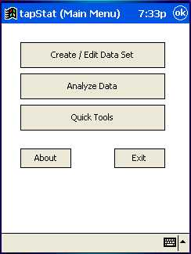
Create/Edit Data Set will let you make a new data set from scratch or modify an existing set. Analyze Data is the gateway to all of the analysis tools that work on data sets. Quick Tools leads to tools that do not require data sets (so far, this only includes some tables and an attribute capability calculator).

Create / Edit Data Set

When this form opens it will always be empty:
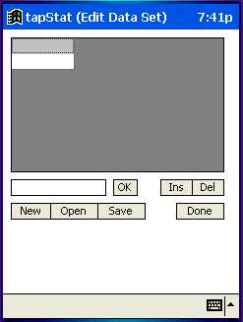
The New button will clear any data in the grid and return you to the blank screen. Open lets you open a previously saved file or an externally generated CSV file. Note that tapStat will allow you to open any type of file – if it is not a tapStat file or in CSV format the results will be (shall we say) very unpredictable. Save will allow you to store the data in the grid in standard tapStat (CSV) format for use with the Analysis tools or for export back to a desktop spreadsheet. Done closes this screen and returns you to the Main Menu.
To enter data, tap on a cell in the grid. It will turn green to indicate it is selected. Then, enter a value in the text box and tap OK to accept.
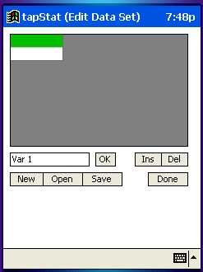
After tapping OK:
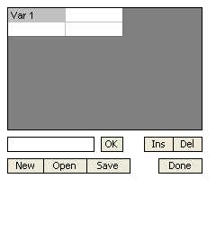
Note that this value has a gray background – this is because it is in the top row of the grid and so is treated as a variable name. Also notice that after OK was tapped, a new (empty) column was added to the right. By tapping on the top row we can add another variable name (and another column will be added to the right).
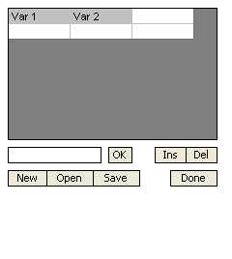
Tapping the cell below “Var 1” will let us add a data value. Remember that all values in a column are treated as one variable. Note that once the value is added, a new row appears on the bottom of the grid so we can continue to add more values (up to 1000 per variable).
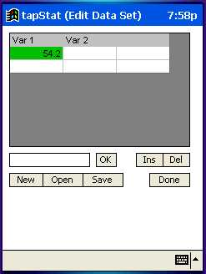
So in short: tap on an empty cell, enter the value in the text box, and tap OK. If you enter a value into the first row of the grid, it will become a variable name (and have a gray background). You can enter anything you want into a data cell (like dates or identifiers), but it can only be analyzed if it is numeric. Non-numeric or blank entries are saved as part of the data set but are treated as missing values for analysis purposes.
To replace the value in a cell just tap the cell, put the new value in the text box, and tap OK. To delete a cell (and pull all of the cells in the same column up to fill in) tap the cell and select Del. To delete a variable, tap the variable name in the top row of the grid and tap Del. To insert a blank cell (and push all of the cells in the same column down to make room) tap the cell and tap Ins. There is currently no method to insert a column – however, column order is not important for any of the tapStat tools.

Analyze Data

After a pause, you will be prompted to select a data set using the standard Open dialog box – then the Select Analysis screen will appear. There is only a cursory check to verify that the selected file is really a data set, so be careful. If you accidentally pick the wrong file, just tap Back on the next (Select Analysis) screen.
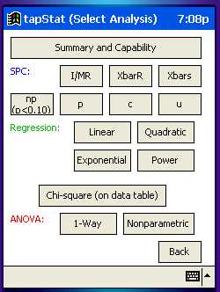
There are 5 “groups” of tests on this screen: summary, SPC, regression, chi-square, and ANOVA. All buttons in each group work in a similar manner and will be discussed together below. Once the test is selected (by tapping on a button) the Select Variables screen will appear no matter which test was picked.
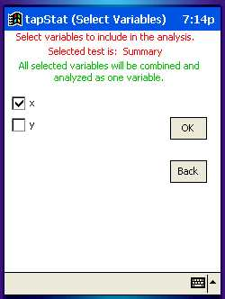
Each data set may have multiple variables (columns), but you may not want to analyze all of them – use the checkboxes by the variable names to select the variables to analyze. In the above screenshot there is an “x” and “y” variable in the set, but we will only analyze the “x”. The selection of variables will be slightly different depending on the test selected (a reminder of these rules will appear on the screen in green):
Summary, I/MR chart, np chart, c chart – all selected variables are combined and analyzed as if they were in one variable (column). Each succeeding variable is tacked on to the bottom of the one preceding.
Xbar-R chart, Xbar-s chart – each row is a subgroup and each variable (column) holds one observation in that subgroup. For example if there are five measurements taken every 2 hours, then there would be five variables in the data set and each row would be the group measured for that 2 hours.
p chart, u chart – only two variables may be selected. The leftmost column is a count of defect(ive)s and the rightmost column is the area of opportunity.
All regressions – only two variables may be selected. The leftmost is assumed to be the x and the other the y (you are given the option to switch them).
Chi-square – select variables that define a data table. The table may not have more than 30 total cells, but it can be any dimension within that constraint.
1-Way ANOVA, Nonparametric – select 2 to 5 variables to compare to each other.

Once you select your variables and tap OK, you will be taken to a results screen according to the test selected.

Summary and Capability
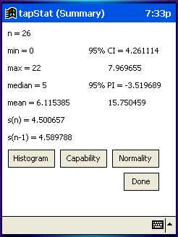
This screen provides summary statistics for the selected variables, considering all of the variables as one large group. Tapping Normality will run a simple chi-square based normality test (it is somewhat “desensitized” to work better with larger data sets, so it is a good idea to check the histogram also). Histogram does exactly what it says:
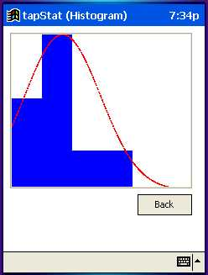
The number of bars is automatically determined and increases as the samples size increases. The red normal curve will be drawn no matter how non-normal the data is. Capability will show this form:
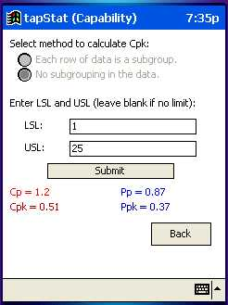
Cp and Cpk are calculated using an estimate of process standard deviation (“sigma hat”) that is based on the average range within each subgroup (Rbar). The radio button (grayed out in this example) let you choose the method of calculating sigma hat. If each row of data represents a subgroup, select the top button and Rbar will be found directly from each subgroup. The default is that there is no subgrouping (the bottom button). If there is no subgrouping or only one variable is being analyzed, Rbar comes from the moving range from data point to data point. Pp and Ppk use the calculated standard deviation instead of sigma hat. Enter the Lower Spec Limit (LSL) and the Upper Spec Limit (USL) in the text boxes. If either one is undefined, just leave the box blank. Tap Submit to see the results.

SPC Charts

Each type of SPC chart expects data to be in a certain format. I/MR, np, and c charts do not involve data subgroups, so all selected variables are “strung together” to create the chart. Xbar-R and Xbar-s charts will assume that each row is a subgroup and each variable (column) is an observation. For example, this data set:
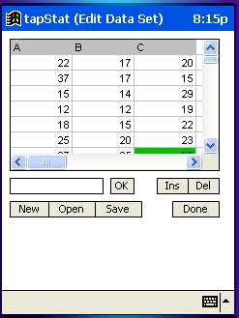
is set up to have 3 observations (A, B, and C) per subgroup. The first subgroup is 22, 17, and 20; the second is 37, 17 and 15; etc. p charts and u charts require that 2 variables be selected – one is the defect(ive) count and the other is the area of opportunity.
The output for all types of SPC charts is basically the same. Here is an example of an I/MR chart:
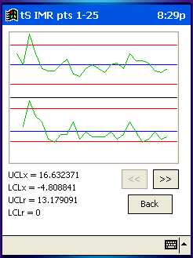
The top half of the graph is the I values (will be Xbar for other types of charts). The bottom half shows the moving range (again, this will vary by chart type). Red lines are control limits (also given numerically as UCLx, LCLx, UCLr, and LCLr) and the blue lines are the means. Each screen can only show 25 points at a time. If there are more, use the >> and << buttons to scroll left and right (the range of points you are currently viewing is given in the title bar):
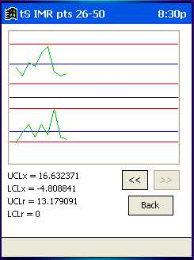
p, np, c, and u charts only plot data values, so there will only be one graph. p and u charts have control limits drawn individually for each data point to reflect the effect of changing sample size:
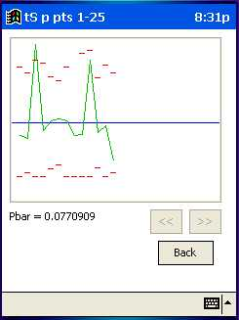

Regression

All four types of regression require that two variables be selected. tapStat will assume the leftmost variable on the grid is the x (independent) variable and the rightmost is the y. However, you will be given the option to override this default and switch the x and y variables by tapping No in this dialog box that will appear before the results are displayed:
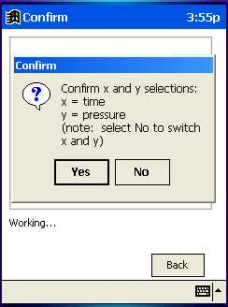
The output screen for all four regressions will look the same. The regression equation and R² will be shown, along with the graph of data points and the regression line. This example shows a quadratic regression:
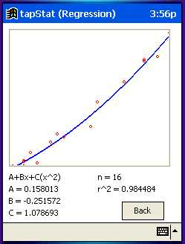

Chi-Square Table

The chi-square test requires that the variables selected make up a table that contains no more than 30 cells. For example, this table compares 3 delivery companies (A, B, and C) for number of on-time (top row) and late (bottom row) deliveries for a total of 6 cells (2 rows x 3 columns):
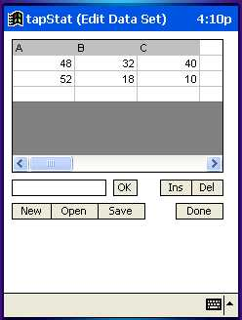
The results screen for this data would be:
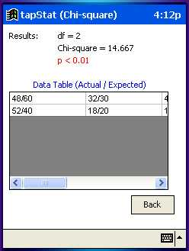
The degrees of freedom and calculated chi-square statistic are displayed, as well as the resulting p-value (which, in this case, indicates a significant difference between the delivery companies at a 99% confidence level). The data table is also shown – each cell shows the observed frequency (direct from your data) and the expected frequency.

ANOVA: One Way and Nonparametric

Both of the ANOVA tests allow you to compare between 2 and 5 variables. The one-way test assumes the variables are all normally distributed and have equal variances – the nonparametric test does not make these assumptions. The one-way analysis is a t-test, while the nonparametric analysis is a Mann-Whitney (if 2 variables are selected) or a Kruskal-Wallis (if 3-5 variables are selected).
Results for nonparametric tests are reported as follows (this example compares running temperatures of four machines):
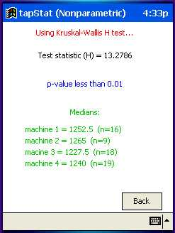
The test statistic (U or H) is reported, as well as a p-value. The medians and size of each variable are also shown.
Results for a one-way ANOVA give more information:
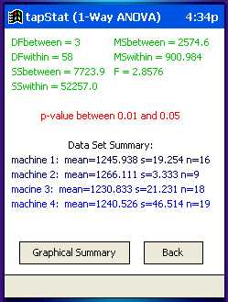
All of the “guts” of the t-test are displayed, as well as a p-value. A summary of mean, standard deviation, and number of data points is given for each variable. A Graphical Summary can also be displayed:
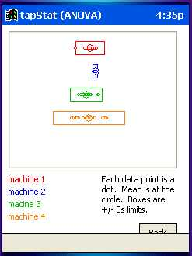
This summary shows each variable in a different color (keyed to the legend in the bottom left). A large circle represents the mean and a box is drawn around the +/- 3 sigma limits. Each small dot represents a data point.

Quick Tools

The Quick Tools include a few extra features that do not require a data set. The menu look like this:
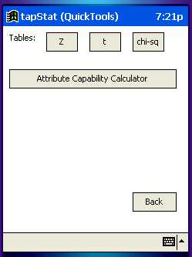

Tables

Lookup tables are included for the cumulative normal distribution, the (2 tailed) t distribution, and the chi-square distribution. Values returned for the normal distribution are calculated; the t and chi-square tables are derived from published tables and will use linear interpolation between points specified by the published tables.
The normal table lookup screen requires you to enter a Z value, from which the cumulative distribution will be found. The t and chi-square screens are very similar – the t table screen is shown below:
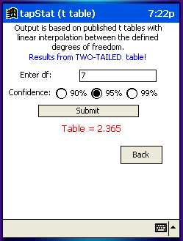
Enter the degrees of freedom and select the level of significance from the radio buttons. Tap Submit to generate a result from the table. Note that the only included t table is the two-tailed variety.

Attribute Capability Calculator

This tools allows you to generate an approximate Z value and capability scores for attribute data. The approximation is based on the proportion of defects and the (cumulative) standard normal distribution. The proportion of defects is converted to a Z score via a “reverse lookup” on the standard normal table.
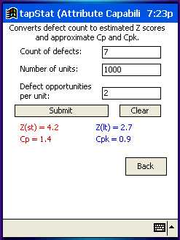
Enter the number of defects, number of units, and defect opportunities per unit. The example above might be for a situation where each part has 2 screws that can be properly tightened or not – we checked 1000 parts and found 7 screws not fully tightened.

Possible Upgrades

Right now, tapStat reflects the tools and techniques that I seem to use most often. Here are some other items that may (or may not) be addressed in future version of tapStat. Please contact me if you want to add to the list.
- Speed improvements
- Add more tables (F, one-tailed t)
- Add multiple linear regression
- Add (binary) logistic regression
- Improve normality determination
- Add QuickTools for probability distributions (hypergeometric, binomial, Poisson)
- Add method to determine equality of variances between variables
- Did I mention speed improvements?

References

This list of references cannot be complete, but here are the sources I found most useful while writing tapStat:

Books:

Freund, John E. and Williams, Frank J. (1966). Dictionary/Outline of Basic Statistics. Dover: Mineola, NY.

Juran, Joseph M. (1974). Quality Control Handbook Third Edition. McGraw Hill: New York, NY.
Juran, Joseph M. and Godfrey, A. Blanton (1999). Juran’s Quality Handbook Fifth Edition. McGraw Hill: New York, NY.
Statistical Process Control (1995). Chrysler Corporation, Ford Motor Company, and General Motors Corporation.
Tacke, Christopher and Bassett, Tim (2002). embedded Visual Basic: Windows CE and Pocket PC Mobile Applications. Sams: Indianapolis, IN.
Weiss, Neil A. and Hassett, Matthew J. (1987). Introductory Statistics Second Edition. Addison Wesley: Reading, MA.
Witte, Robert S. (1980). Statistics. Holt, Rinehart, and Winston: New York, NY.
Wortman, Bill (2000). The Quality Engineer Primer. Quality Council of Indiana: West Terre Haute, IN.

Web Sites:

StatLib at http://lib.stat.cmu.edu/apstat
iSixSigma at http://www.isixsigma.com

Copyright Notice and Disclaimer – the Long Version

tapStat version 0.90
by David Phillips

Freeware
Copyright 2003 David Phillips

License Agreement:

You should carefully read the following terms and conditions before using this software. Unless you have a different license agreement signed by David Phillips, your use of this
software indicates your acceptance of this license agreement and warranty.

Registration:

tapStat version 0.90 is freeware and may be used for free by any user for personal use.

Disclaimer of Warranty:

THIS SOFTWARE AND THE ACCOMPANYING FILES ARE DISTRIBUTED "AS IS" AND WITHOUT WARRANTIES AS TO PERFORMANCE OR MERCHANTABILITY OR ANY OTHER WARRANTIES WHETHER EXPRESSED OR IMPLIED. Because of the various hardware and software environments into which tapStat may be utilized, NO WARRANTY OF FITNESS FOR A PARTICULAR PURPOSE IS OFFERED.

Good data processing procedure dictates that any program be thoroughly tested with non-critical data before relying on it. The user must assume the entire risk of using the program. ANY LIABILITY OF THE SELLER WILL BE LIMITED EXCLUSIVELY TO PRODUCT REPLACEMENT OR REFUND OF PURCHASE PRICE.

Distribution:

You are hereby licensed to make as many copies of the tapStat version 0.90 freeware applications and documentation as you wish; give exact copies of the original versions to anyone. You may distribute tapStat version 0.90 along with this license in its unmodified form via electronic means. There is no charge for any of the above.

You are specifically prohibited from charging, or requesting donations, for any such copies, however made; and from distributing the software and/or documentation with other products (commercial or otherwise) without prior written permission from
David Phillips.

