Jasmin Gonzalez
EN100: Sp/Su 2006
Lesson Plans for Robotic Rovers

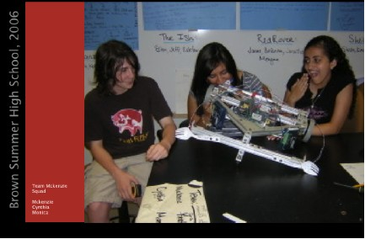

A little taste of Engineering
Engineering can be thought of as open-ended design in teams utilizing theory over trial-and-error to meet specifications and compete with other teams.

For this project each team was required to construct a rover that can be navigated autonomously by an on-board circuit linked to a power box and a motor. The rover has two wheels that are driven by independent stepping motors. The students learned basic shop skills that allowed them to layout on a chassis the motors and their drivers, pillow blocks, 24v battery pack, and mechanical support for the power box and electrical board. On the front of the rover the students installed a bumper, and lever switches that had the function of sensing barriers in order to avoid it. The size and shape of the chassis, and arrangement of components on it were the students'-design.
The stepper motor drivers each have 3 controls: Clock, Direction and Enable. Clock determines speed (RPM), and Enable is an ON-OFF switch. The stepper motor was connected to the motor in order to give the wheels direction. This was all connected to the power box to generate enough power to be able to move the rover around the track.
To begin the course, the students were provided with an overview of the project, safety rules and equipment functionality. The students had access to a generic rover model, which they had the opportunity of studying before figuring out their own design. The students worked in teams of four. Two were electrical experts in charge of the power box and two were mechanical experts in charge of the chassis.

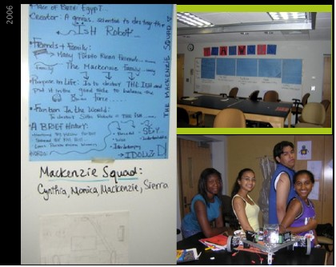

Team Effort - it all pays off!! :-)

A group sits around and talks about stuff. A team must do something, achieve results, and usually has a division of labor. The coaches on the sideline are a group, the football players on field are a team.

At the beginning of the project the students seemed a little concerned and questioned a lot their ability to accomplish this project. The students came into the classroom with no previous workshop experience or building experience. Most students did not know the function of the different machinery, tools and materials used for the rover construction. I was forced to almost individualize their instruction to meet the needs of each team. As the students began to build upon their own knowledge base and feel more comfortable using the tools, I was able to “take a step back” and merely facilitate the growth of the teams.
The students were giving specific instructions and enough information in order to be in good shape to start working on their rovers. The first step of this long term project was “design”. Coming up with a good design plays a big role in the development of a long term project in an efficient and effective manner. The students worked on their design posters and specifications following given guidelines. I revised all their designs to make sure their designs were achievable in the time we had for Brown Summer High school. I made necessary revisions and went over them with the students. The students were assessed based on their ability to follow instructions and meet the given guidelines.

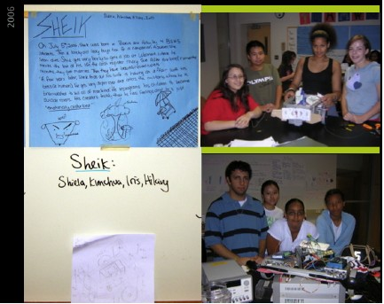

During the entire process of the development of the rover I tried to assess the students knowledge and progress by giving them exit tickets. In the exit tickets students were prompted with questions such as “What questions came up after working in the construction of your rover? What challenges are you facing? What can we provide you with to make the construction process easier? What did you get done today? What would you like to get done tomorrow?”

Their answers during the first exit tickets showed their concerns about not having a clear sense of what they were doing and their concerns about being able to finish the project. I would always read the exit tickets and pick out all their answers and concerns to go over it at the beginning of the next class. As time went on they seemed a lot more confident about using the tools and about the development of this project.

Early on, I realized that we might have “bit off more than we could chew” in respect to the completion of rovers. Instead of giving up and settling for incomplete rovers, I recommitted myself to designing a plan that would allow all teams to complete construction in a timely fashion. All the students demonstrated to be exceptionally smart. They picked up all the concepts quick allowing everyone to have a finished rover at the end of Brown Summer High School. We offered the student with a lot of individual instruction and also helped them on the side to be able to trouble shoot quicker and find their rover limitations in an efficient manner. Doing this also allowed us to make better use of the class time and also plan the lesson s according to the students’ needs.

The rovers are themselves an assessment of the students’ accomplishment over the duration of the course. All the teams in the class were able to successfully complete the electrical and mechanical components of the rover. Unfortunately, we did not have enough time to trouble shoot each single rover to make sure all the students had a working rover to play and drive around the track we had built in the classroom. I would have liked to have more time to spend troubleshooting the rovers.

Regardless of our time limitations, all the students left the classroom with a sense of accomplishment. Despite all the difficulties and unexpected complications they encountered throughout the development of this project, they all remained diligent and persistent becoming authentic experts in their area, be it mechanical or electrical.

