Jonathan Migliori

Professor Harmanşah

Ancient West Asian Studies 0800

4 December 2009

A Strong Foundation: The Brief Life of Çatalhöyük Figurine 12401.X7

Çatalhöyük, a Neolithic village inhabited from around 7400–6000 BC, was brought into the public consciousness by James Mellaart’s excavations in the 1960s (Hodder 2006: 7). When excavations were resumed in 1993 under Ian Hodder, many of Mallaart’s conclusions were questioned, namely his interpretation of the figurines found throughout the site. Mellaart connected the more spectacular figurines with special ritual areas and thus interpreted them as cult statues (Meskell et al. 2008: 146). Recent excavations have found no conclusive evidence of what Mellaart called “shrines,” and instead have noted that figurines are consistently found in secondary deposits, namely fills in abandoned houses and middens (ibid.). In this paper I will examine one such clay figurine, labeled 12401.X7, and its use-life as well as its symbolic meaning through the lens of its depositional context and relationship to other finds at Çatalhöyük. Instead of being a religious idol, this figurine was as much a process as a practical object used to represent and ensure both prosperity and abundance.

First, it is important to understand the object and where it was found. The figurine is anthropomorphic, most likely a female. The front is in the form of a corpulent body, with a pronounced belly and breasts. The legs are broken but seem to originally have been crossed. There are traces of red paint in concentric arcs between the breasts. The head is missing, and was made to be detachable. The back is skeletal, with clearly outlined vertebrae, hips, scapulae, and ribs. It was found in an ashy area next to a wall, which also featured burnt mud brick, carbonized seeds, and bits of pottery and bone (Unit 12401 report).

As with all archaeological materials, understanding the context in which this figurine was found is critical to understanding its use. This figurine was found in what was either a midden or abandonment fill. Houses in Çatalhöyük had roughly 45 to 90 year life spans, and would be routinely filled in (sometimes with midden soil) and built over (Meskell et al. 2008: 144). Given that this figurine was found in a context next to an internal wall, it seems more likely that this was an abandonment fill.

The nature of the other objects in the fill indicates the day-to-day use of the figurine. Bits of bone and pottery were, as they are now, garbage, and are unlikely to be found with a revered cult statue. This indicates that figurine had fulfilled its purpose and was thrown away, unless the act of being discarded was its purpose. Meskell discusses the possible significance of these figurines to the daily lives of their makers:

Perhaps ease of manufacture and ubiquity meant that they were commonplace and easily reproducible, thus not ‘special’. Conversely, an argument could be marshalled to their very frequency and quotidian characteristics suggest that they were central to the Çatalhöyük lifeworld: they may not have operated in some separate sphere of ‘religion’ or ‘ancestor worship’, but, rather, in the practice and negotiation of everyday life.

Meskell et al. 2008: 144

Meskell is correct to assert that the ubiquity of these figurines is not contrary to their nature as important aspects of life in Çatalhöyük. An analogy can be made to pens and pencils in our society: they are produced cheaply and in bulk, widely used, and disposable while still being absolutely necessary to daily life. As a category of objects they are crucial for society, but each individual example has only a temporary lifespan. Much as people today are not buried with their favorite pencils, the inhabitants of Çatalhöyük were not buried with figurines (Meskell 1998: 59).

The production of figurines argues towards their disposable nature. Figurines were “quickly made,” and were likely produced close to the house (Meskell et al. 2008: 151, 157). Most importantly, there is no evidence for kilns in the town (Meskell et al. 2008: 157). If these figurines were baked at all, it would have been outside by the sun or fires in the household, such as that from the hearth or in the burning of refuse that accompanied abandonment (note the ash layer in which figurine 12401.X7 was found) (ibid.). There is evidence that the clay in some figurines was still wet at the time of deposition (Meskell et al. 2008: 151). There are also figurines made from stone attested in the record. While stone is harder to work and more durable than clay, they were buried in the same kinds of fills and deposits as the clay figurines, indicating that the modern archaeologists’ “privileging,” or attaching more contemporary value and importance, of stone over clay was not shared by the inhabitants of Çatalhöyük (Meskell et al. 2008: 143). Objects meant for permanent use and significance would not be produced so quickly and cheaply.

The simple production and deposition of these figurines indicates their brief, though not meaningless, life. As rapidly disposed of objects, it stands to reason that their significance lay in the aforementioned production and deposition, not in a final product. Thus, we should view them less as objects, but more as material remains of a process, an important and quotidian feature of life in Çatalhöyük. The nature of this process gets its meaning from two components: the practice of deposition itself, and the character of the figurines.

One noteworthy feature of Çatalhöyük is that its inhabitants were buried under their floors. While this practice may seem strange and unsanitary, it is not unheard of in other societies, such as the Tikopia of Polynesia (Meskell 1998: 57–9). Burying one’s ancestors in the floor is a highly symbolic act: it stresses generational and ancestral ties. The more elaborate houses tended to be those that also featured more burials and seemed more concerned with “memory storage” (Meskell and Nakamura 2009: 215). Such burials not only preserve the past, but also allow it to be reclaimed in the future (Meskell and Nakamura 2009: 217). There is evidence that bodies were dug up and heads were plastered and reburied (Meskell and Nakamura 2009: 225). One of the more striking examples of was found in Building 1 on the site, in which a woman was buried holding the plastered skull of another individual (Hodder 2006: 148). This skull was likely that of an ancestor (one would imagine that the skulls of strangers were rather hard to come by). The skull was coated in three layers of plaster and red paint, indicating it was used for a while and in a fashion that required regular maintenance (ibid.). Being buried with the skull of an ancestor indicates a strong connection with the power of that ancestor. This connection would be even more evident if the skull was used as a symbol of generational ties while the person buried with it was alive. It is apparent that heads had a symbolic value to the inhabitants of Çatalhöyük. This is connected to the practice of removing the heads of figurines. If possessing the head of ancestor gave one its (the ancestor’s) power, the same would hold for the head of a figurine. The headless figurines deposited in the fill under one’s new house would then represent the headless ancestors buried under the houses of others.

Objects deposited in walls can also be interpreted as memory objects, much as the bodies of ancestors and figurines were. Many buildings feature animal skulls and bones embedded in the wall and plastered over (Hodder 2006: 11). These bones could belong to either wild (aurochs, vulture) or domesticated (sheep, goats) animals. These plastered bones could serve to commemorate important events in the life of the family. The bones could be from farm animals slaughtered for special events, such as wedding or funeral feasts, or to mark other important events, such as Junior’s first kill as man of the community. These animal and ancestral bones, as well as figurines, were literal deposits in a family’s memory bank.

With the importance of burial having been established, it is also important to understand the nature of what the figurine symbolizes. While it is true that the power of this and other figurines primarily lay in the process of manufacture and (dis)use as opposed to the final product, that does not mean that the physical form of the figurine was unimportant or there was no care and attention to detail involved in making it. I picked this figurine because of its singular nature of being both human and skeletal in form. This duality fits in with what Hodder describes as a “tension surrounding pairing” (2006: 92). He cites how leopards, usually solitary in the wild, are often depicted in pairs, a white marble figurine with two heads, the placement of pairs of “shrines” around work/storage areas, and pairs of those pairs (ibid.). The tension, he argues, lies in between “unity and difference […] social balance and community, and individual difference” (ibid.). Objects and representations are given meaning by incorporating disparate elements.

The tension in Figurine 12401.X7 lies in its combination of human and skeletal forms. The interpretation of these forms and their dialogue is crucial to interpreting the figurine. The skeletal side of the figurine is straightforward. An articulated skeleton most likely represents death. The inhabitants of Çatalhöyük would have been quite familiar with bones through their butchering of animals and exhumation of their ancestors. It is no great leap to assume that a connection between bones and death thus formed.

The “living” side of the figurine is more complicated. Mellaart believed the obese women depicted in the corpus of figurines were “Mother Goddesses” (Meskell 1998: 46). The large breasts and hips were taken as signs of extreme fertility. This mode of thought was furthered by the work of Marija Gimbutas and her vision of a matriarchal and matrifocal Neolithic that lasted until Indo-Europeans swept in with their chariots and sky gods, and taught everyone how to hate women (Meskell 1998: 52–3). The figurines were even linked to later religious traditions in the Aegean (ibid.). Associating the fat on these figurines with fecundity imposes our society’s sense of iconography and symbolism on a foreign culture, and is thus not reliable.

Though these figurines were not cult statues, that does not imply that they did not have what we would consider a religious function. Meskell et al. note, “a strict division between the ‘everyday’ and the ‘magical’ or ‘ritual’ might not have been operative in the past” (2008: 158). Our contemporary positivist worldview separates the superstitious and the secular, even making them mutually exclusive. As this was not necessarily the case in Çatalhöyük, the fact that the figurines were found in contexts we would consider “everyday,” does not preclude their being believed to have a material agency that we would today consider “ritual.”

Recent work by Lynn Meskell and Carolyn Nakamura has shown that these figurines did not depict “Mother Goddesses,” but served as representations of age, prosperity, and abundance (Meskell and Nakamura 2009: 208). The discussion above about expedient production and disposal refutes the idea of their role as cult statues, as one would expect of “Mother Goddesses.” The concept of such a deity as a Mother Goddess requires a clearly gendered society. Of all the figurines found at Çatalhöyük there are only two with pubic triangles and eight phallomorphs (Meskell and Nakamura 2009: 212). In addition, Meskell and Nakamura note:

Furthermore, while breasts and stomachs are secondary reproductive traits (genitalia being primary), buttocks are not. The most common paring of traits was bellies with buttocks (21), breasts with buttocks (20), and breasts with bellies (19), while all three occurred together a total of 17 times.

2009: 212

Elsewhere in the representational sphere there is a lack of gender-related motifs, especially depictions of children, adolescents, mothers with babies, and childbirth (ibid.). These motifs would be more common in a society based around a gynocentric fertility cult. The portrayal of gender-specific traits was not a major concern of the figurine makers. The best evidence, however, of the role of gender in played in Çatalhöyük comes from the inhabitants themselves. Analysis of the burials, diets, and bone wear of the people who lived in Çatalhöyük indicates that men and women “participated in similar kinds of labor, sustained similar injuries, shared a similar diet, died at comparable ages, and were ultimately buried with similar treatments and objects” (Meskell and Nakamura 2009: 208). Different grave goods and injuries for the different sexes would reveal more concrete gender roles for the people living in the society: e.g. if men were buried with weapons and symbols of power while women were buried with pots and baskets, it could mean that men fought and ruled while women tended the domestic sphere. A heavily gendered society usually mirrors these divisions in its mythology, cf. Zeus the angry sky god and his consort Hera, the goddess of weddings, childbirth, and the home from the Greek pantheon.

Instead of fertility, these exaggerated forms of figurines represent prosperity and age, stressing the relationship between a family and its forebears discussed above. It is common knowledge that body fat accumulates in one’s torso and buttocks. Meskell and Nakamura also describe these features as:

flattened, drooping, and angular , rather than robust and rounded in shape. Many breasts are not portrayed symmetrically and appear to be somewhat flattened and pendulous. Similarly, stomachs, while exaggerated, are not evocative of pregnancy, but rather of advanced maturity or even obesity.

2009: 219

These features do not depict an ideal of enticing fertility but an ideal of abundance. I use the term “ideal” because there is no evidence of obesity attested in Çatalhöyük (Meskell and Nakamura 2009: 221).

Thus it seems that these figurines can be considered symbols of prosperity, as opposed to real-life depictions. As symbols they may have meant more than purely physical abundance, but could have also “materialized a cultural desire and respect for accumulated knowledge, skill, and power through the bodily idiom of accumulated flesh” (Meskell and Nakamura 2009: 222). This “accumulation” would be the product of age and experience. The importance of ancestral ties in Çatalhöyük reinforces this notion. The figurines, especially 12401.X7, are also marked with a physical representation of this connection: their navels. A navel is a scar—a memory made corporeal—that marks where the unborn child was attached to its mother (Meskell and Nakamura 2009: 217). It is a physical link between the generations. The pronounced navel on 12401.X7 and the other figurines show the importance of the relationship between people and their ancestors, the living and the dead.

The “tension surrounding pairing” in figurine 12401.X7 mentioned above is now clear. The synthesis of the death (the skeletal side) and abundance and accumulation (the living side) represents the idealized ancestor. Though dead, they lived a life of prosperity and abundance that can be felt by those still living. The deposition of these figurines in secondary contexts, especially abandonment fill, mirrors the burial of ancestors beneath floors. Building a house over such a figurine as this would be much like building a house over, and thus being connected to, a prosperous ancestor. A figurine such as 12401.X7 could have worked in lieu of or in addition to a family’s forbears.

A successful person today could describe his or herself as having “stood on the shoulders of giants” or “had a life built on a strong foundation of family and good values.” These metaphors would be quite literal if spoken by an inhabitant of Çatalhöyük. The connection between the living and their predecessors was not merely genetic, but physical. One manifestation of this link is these figurines. Their quick production and disposal was a regular occurrence yet full of meaning. This figurine reveals that the importance of memory and family is a human trait that goes back thousands of years.

Images from Çatalhöyük Research Project: On-Line Database Facility <http://www.catalhoyuk.com/database/catal/specialist.asp?subject=fig&num=12401.X7>

:::::Desktop:DSCN1379.jpg:::::Desktop:DSCN1382.jpg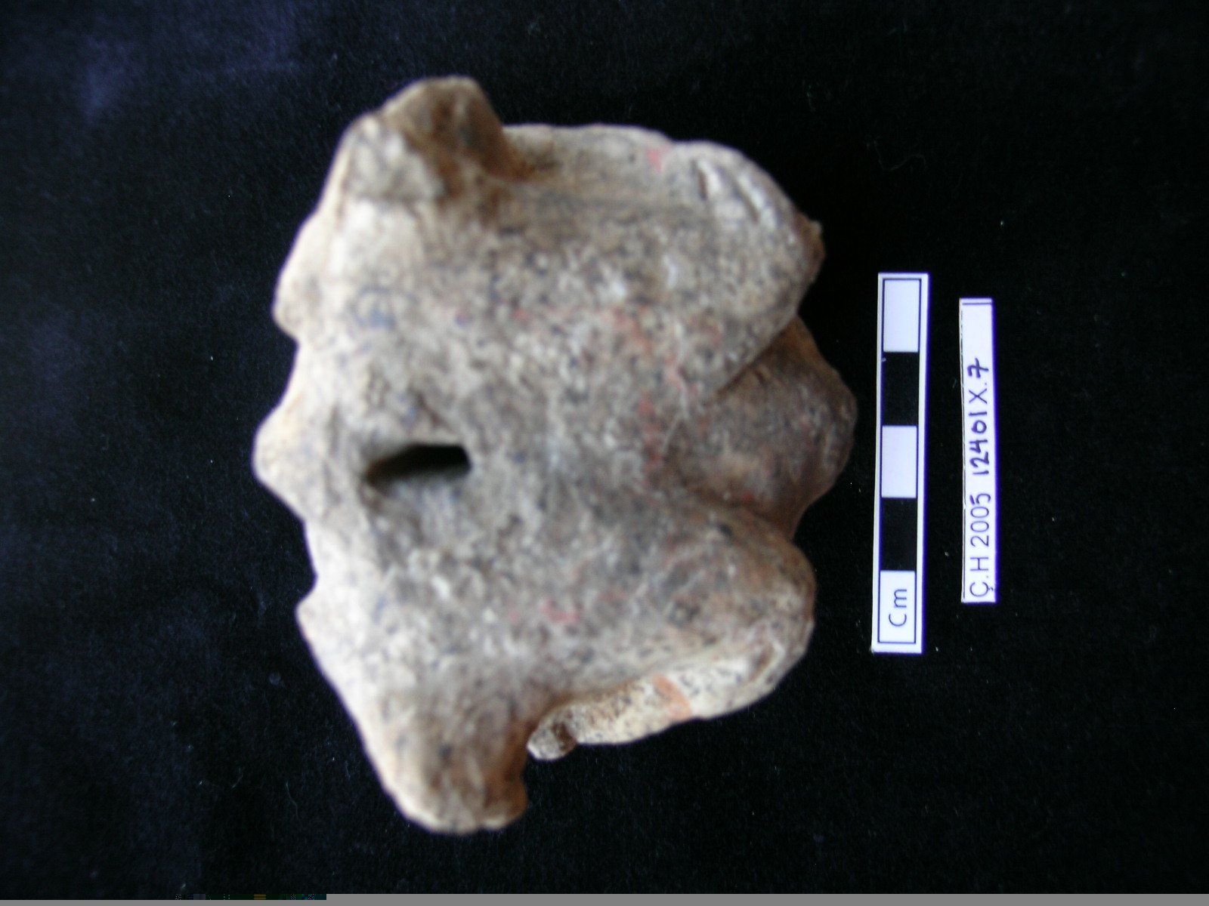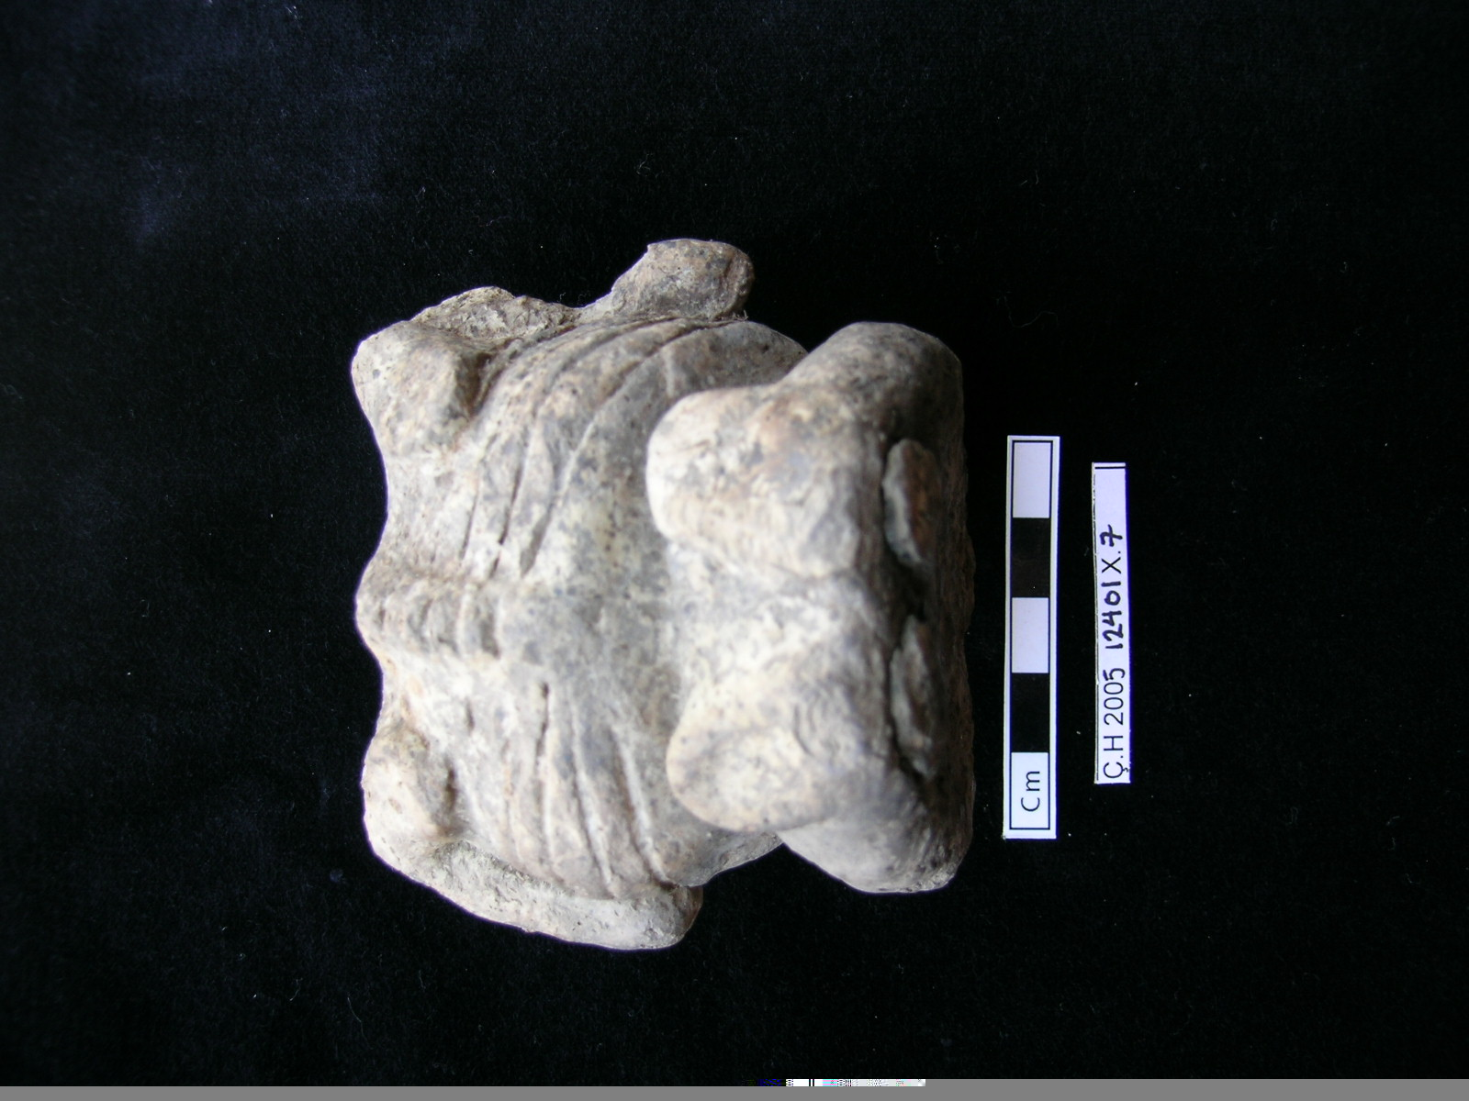Works Cited

Hodder, Ian; 2006. *The leopard’s tale: revealing the mysteries of Çatalhöyük*. London: Thames & Hudson.

Meskell, Lynn; 1998. “Twin peaks: the archaeologies of Çatalhöyük,” in *Ancient goddesses: the myths and the evidence*. Edited by Lucy Goodison and Christine Morris. London: British Museum Press, 46–62.

Meskell, Lynn and Carolyn Nakamura; 2009. “Articulate bodies: forms and figures at Çatalhöyük,” *Journal of Archaeological Method and Theory* 16: 205–30.

Meskell, Lynn, Carolyn Nakamura, Rachel King, and Shahina Farid; 2008. “Figured lifeworlds and depositional practices at Çatalhöyük” in *Cambridge Archaeological Journal* 18:2 139–61.