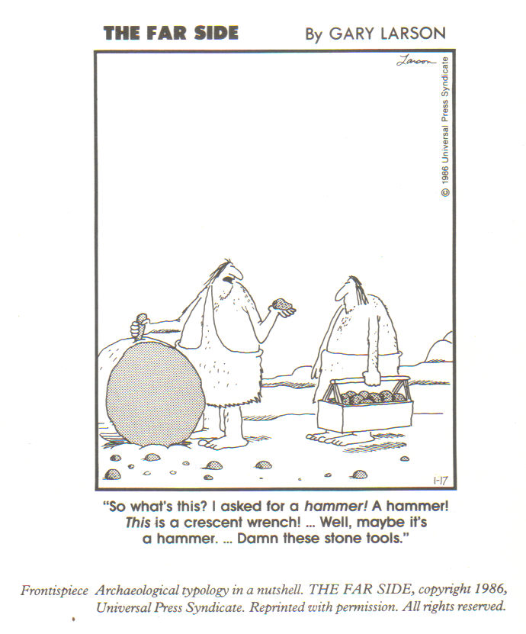
Classifying Classification

Who, what, where, why, when, how. Since grade school we have been taught that these are the key questions to ask in problem solving. Today, as adult scholars, we are still asking those same simple questions, yet the answers are evermore complex. In the world of archaeology we have structured the study of objects and cultures around a systematic methodology and body of theoretical knowledge, but in the midst of all this method and theory, we forget to ask the basic questions about fundamental aspects of archaeological practice. One of those fundamental aspects that is used on a regular basis in archaeology is the classification system, which is in reality quite an ambiguous concept. There really is no one true classification system, or at least one upon which all scholars agree. With so many differing ideas and opinions about classification, we must go back to our grade school roots of problem solving, and ask ourselves, “What exactly is classification? How do we use it and why?” Once we look into these questions, we can gain greater understanding for why we practice archaeology the way we do in the museum, the field, and the lab.
Archaeologists and museum curators, among other scholars, have long grappled with the issue of classification and the arrangement of objects into some comprehensive system. Even the father of American anthropology, Franz Boas, and his contemporaries were faced with such a predicament. Boas believed that materials in a museum could reveal more about their parent cultures if they were arranged according to the society from which they arrived. He was of the opinion that the main object of an ethnological collection should be the “dissemination of the fact that civilization is not something absolute, but that it is relative, and that our ideas and conceptions are true only so far as our civilization goes” (1887: 589). Therefore, a tribal arrangement of cultures would be the best bet in accomplishing such an objective. However, some scholars, such as J.W. Powell, disagreed with Boas’ method of classification. He saw Boas’ suggested tribal museum to be too impractical because of its magnitude and that since “there is and can be no classification of the tribes of America, so there can be no classification of their arts on that basis” (1887: 613). The problem Powell had difficulty dealing with was that he believed that a science of ethnology could not exist for every attempt at classifying people into groups is doomed to fail. Because of this reasoning, Powell saw an anthropological museum as an impossibility in its nature, whereas a museum of arts would be more effective.
The question that Boas and others were confronted with in erecting exhibits was: “What it the purpose of a classification?” For example, in the June 1887 issue of Science J.W. Powell questions on what principles should selections for a museum exhibit be made and in what order they should be arranged. In his view, classification should be used as a teaching tool designed by the museum administrator to “determine what is the most useful lesson to the general public which his materials can be made to teach” (1887: 229). Thus, no classification system should be complete and final, for by definition of being a teaching device it must be flexible, depending on what is desired to be taught by such an arrangement. Wm. H. Dall was of a similar opinion. He believed that the decision to choose one type of classification over another “must depend on the amount of material to be handled, the space available for its exhibition, and the purpose most at heart in the organization of the museum considered as an agency for effecting a purpose” (1887: 587, emphasis added).
Even though Boas, Powell, and Dall all have differing opinions as to how classification of objects in a museum should progress, there seems to be a common theme in each of their ideas: classification is meant to be functional. For Powell, classification aided in teaching while for Dall it was a practical means to organizing a museum. Ultimately, classification is a means to an end, a systematic means of getting one’s point across, and that point in terms of archaeology is to discover what objects can reveal about the cultures that created them. This was Boas’ goal in his ethnological museum and it is the goal of archaeologists today working in the field and the lab. Not only is classification a tool used in organizing museum exhibits, but it is also a tool used in archaeological interpretation. Classification in this sense is most commonly known as typology.
So, what is a typology? According to James A. Brown (1982: 177) an artifact typology is “a systematic representation of one or more classes of objects that are called types.” Such a definition is a little bit ambiguous for what a ‘type’ in itself needs to be defined. We can gain a better understanding of typology by going back to referring to it in terms of classification. For this, Dwight W. Read (1974: 216) offers the best explanation:
Classification is of necessity the foundation of data analysis in archaeology. It is largely on the basis of classification of the raw data—the artifacts excavated—that inferences are made. The accuracy of the classification, in a very real sense, determines the extent to which meaningful and significant inferences will be possible. Inferences in archaeology are, to a large part, based on patterning in data through space and time.
Thus, in combining the definitions of Brown and Read, we can consider classification to be a systematic approach to organizing data so that patterns can be recognized and interpretations made. A major theme in discussing the issue of classification has been that of purpose. As seen with the organization of museum exhibits, classification had teaching and practical purposes. The purpose of artifact classification/typology can be said to be data analysis: “The proximate purpose of classification is usually to permit the enumerative, comparative, or statistical treatment of type data; to discover I one way or another what is the quantitative relationship between objects of different types” (Adams and Adams 1991: 157-8). Adams and Adams (1991) further elaborate classification to have basic purposes that teach us something about the material being classified and instrumental purposes where the classified material tells us about something else, such as the date of site. Basic purposes can be descriptive, comparative, or analytical whereas instrumental purposes are divided into ancillary and incidental categories. For them, all typologies serve a purpose, for “[i]f a typology serves no purpose, it probably means only that the typologist neglected to specify what his purpose was” (1991: 157). The backbone of understanding what a classification is truly lies in its defined purpose.
As has been demonstrated by others, typologies can be very useful instruments. They create a common vocabulary pertaining to particular assemblages (e.g. lithics, ceramics) that facilitate communication among archaeologists. They can also provide a guide to identifying and outlining chronological changes/advancements/evolutions in technology and styles. However, there are some dangers present in relying too heavily in typological sequences, whose rigidity may result in erroneous interpretation. A case in point is Shott and Ballenger’s (2007) study of Dalton points in Oklahoma. In reanalyzing an assemblage of Dalton points, Shott and Ballenger realized that previous researches in following a specific typological sequence based on size and shape had incorrectly categorized the points into distinct types when in reality what was observed to be differences in point types was actually a result of one type of point undergoing stages of reduction and curation (see Figure 1). In light of such new information, Shott and Ballenger criticize the traditional premise of categorizing tools based on size and shape, and more specifically assuming that the size and shape in which archaeologists find tools are the size and shape in which they were used. For them, this premise is “equivalent to supposing that we find short pencil stubs in trash cans because that is the size at which people used pencils” (2007: 153). The significance of Shott and Ballenger’s study is that it demonstrates how typologies based solely on physical characteristics do not take into account observed differences in tool types resultant from human activity. This is not to say that we should completely disregard typology. The point is to be aware that as with any other analytical advice, if we pigeonhole ourselves in using that advice we will miss out in other factors of interpretation. Once again, the results of a certain classification scheme or typology is very much dependent on the stated purpose of that classification. Purpose is the key.
Perhaps there will never be a consensus as to how to proceed with classification. As of now, when we ask ourselves, “What is a classification or typology?” the best answer we can give is that it is a mechanism that aids us in our interpretation of culture. Beneath all the jargon and differing opinions regarding classification, at its most fundamental level, it is really only one thing—a tool. Just as people use screwdrivers to accomplish varying tasks, so too do archaeologists use classification. It all depends on what the person using that tool wishes to accomplish with it that will determine how that tool is used. That is why we have such differing views and applications of classifications. In the long run, it is up to us as scholars to assess how and why we are going to make use of a device such as classification to obtain the best interpretation pf archeological material as possible. We must remember, as Dunnell (2001: xiv) points out, that “classification is an act of the archaeologist, not a discovery in nature.” Because the definition and purpose of classification can be very much in the eye of the beholder, it is imperative that the archaeologist, or any scholar for that matter, explicitly define and explain his/her classificatory procedure. In this manner, classification systems will still remain to be a very useful and fundamental tool in archaeological method and interpretation.

References Cited

Adams, William Y. and Ernest W. Adams
- Archaeological typology and practical reality: A dialectical approach to artifact classification and sorting. Cambridge: Cambridge University Press.
Brown, James A.
- On the Structure of Artifact Typologies. In Essays on Archaeological Typology. Edited by Robert Whallon and James A. Brown. Evanston: Center for American Archaeology Press, pp. 176-187.
Dall, Wm. H. and Franz Boas
- Museums of Ethnology and Their Classification. Science 9(228): 587-589.
Powell, J.W. and Franz Boas
- Museums of Ethnology and Their Classification. Science 9(229): 612-614.
Read, Dwight W.
- Some Comments on Typologies in Archaeology and an Outline of Methodology. American Antiquity 39(2): 216-242.
Shott, Michael J. and Jesse A.M. Ballenger
- Biface Reduction and the Measurement of Dalton Curation: A Southeastern United States Case Study. American Antiquity 72(1): 153-175.

