Anjana Joshi
Arch1600

Barbed Wire: Open Space to Forbidden Place

Barbed wire significantly alters landscapes by creating a distinct divide between open and prohibited spaces, be them public vs. private, military vs. civilian, state vs. state or hazardous vs. safe, to name a few common distinctions. Its function lies mainly in selective inclusion on the one hand and exclusion of the majority on the other. The practical uses of barbed wire are numerous and the social implications it has on the populations it divides are diverse. Barbed wire was originally invented as a means for farmers to tame the uncontrollable wilderness in the nineteenth century American West. Over time, however, its function has expanded from simple yet effective agricultural border to include the creation of more complex and aesthetically pleasing boundaries during both wartime and peacetime, and its social significance is continually reinvented. In many of the cases mentioned in this paper, barbed wire grants its users a sense of power, security and control over the vast and untamed exterior world.
The patenting of barbed wire fencing began in 1868 with Michael Kelly’s double-stranded “thorny fence,” which met the farmer’s need for clearer agricultural boundaries in the American West in order to propagate the domestication of cattle and keep intruders out. Kelly’s design would later be expanded upon by a number of others, most notably in 1874 by Joseph Glidden, whose improved design was stronger and more efficient and whose invention of a mass-producing machine made barbed wire the cheapest and most efficient and foolproof resource available, especially in comparison to stone, wood, shrubbery and hedging. It is Glidden’s design that provided the model for the most commonly used barbed wire today. As the use of barbed wire was adopted in the West and settlement increased, wide, open spaces became increasingly difficult to find. The power and influence of the farmer grew at the expense of those with roaming and migratory patterns, including the open-range cattleman and cowboy and the religious and Native American, who began calling barbed wire “the Devil’s rope,” in protest of the pain it caused animals upon their encounter with it among other reasons (The National Archives).
Although a few strands of barbed wire were sufficient to detain cattle, a different method was developed during wartime in the twentieth century to regulate or inhibit the movement of humans. Attached to the top of fences, barbed wire was employed in trench warfare, the security of prisons, military installations, detention and concentration camps, and to demarcate minefields (The National Archives). Not surprisingly, barbed wire often takes on a negative connotation, as its prolonged use on the battlefield (and perhaps more popularly, its depiction with entangled corpses in photographs of “crimes against humanity” such as the Holocaust) have led it to be associated with conflict and often to become a symbol of oppression and the denial of freedom. Perhaps it is the sterile and unsightly appearance of barbed wire, together with its frequent use in combination with equally sterile materials such as concrete and sand, which have created a popular psychological association of barbed wire with permanent barrenness, political oppression, decay and even death. An especially telling example of the increasingly negative connotations of barbed wire took place in Kashmir in April 2006. Many residents were outraged at the efforts of state police to beautify bunkers surrounded by barbed wire in Kashmir in an effort to make them presentable to tourists who passed them on their way to the airport. According to many separatists fighting against Indian rule, the “beautification” of the bunkers was an effort to “camouflage the prevailing situation in restive Kashmir” (Shah). Part of the effort to beautify the bunkers included rebuilding the old structures with a wooden exterior, a far more natural material to use than concrete, which was suggestive of India’s permanent presence in Kashmir. Thus, the social and political implications derived from barbed wire are not always desirable. Unlike the farmers in the American West, whose delineation of private property showed their status and success on the wild frontier, the state police in Kashmir were eager to cover up the “ugliness” of the barbed wire and its association with their abuse of power in public opinion.
According to Kevin Broussard and Roger Gates, associate and assistant professor at the Louisiana State Agricultural Center, barbed wire is no longer the cheapest and most enduring material for constructing fences and boundaries (224). New methods and technologies have rendered barbed wire in its original function as the cheapest and best fence-building resource available theoretically useless, yet it continues to be a popular means of constructing boundaries. Barbed wire is used frequently today to mark off construction sites and private property, including homes and businesses, where trespassers are prohibited for safety, privacy and other reasons (The National Archives). For those who live in areas with barbed wire, there is often a need for or impulse toward its beautification. For example, many people who live in Jerusalem are willing to overlook the negative atmosphere created by the installation of barbed wire for its utility and the safety it provides from an uncertain exterior world. Accepting that it is a necessity but that its presence does not have to overpower their lives, many people try to incorporate the barbed wire into the décor of their homes, planting flowers in between the wires and choosing wire with elaborately designed barbs in an effort to lesson its immediate harshness. This may be indicative of the idea that boundaries have become a necessity in some parts of the modern world, though they are not always desired.
Barbed wire is also useful today as a tool for protecting domesticated animals as well as warding off and tracking wild animals. Although there are many instances where smaller animals, such as bats, get caught in the fencing, larger wild animals can pass through these boundaries with little problem. Sometimes these animals leave traces of their presence behind which aid researchers in their quest for information. By using the fur of brown and black bears trapped in barbed wire fences in British Colombia, Canada, for example, wildlife researchers were able to track and identify individual bears through DNA testing (Woods, 617). Although it often interrupts the natural migration patterns of wildlife and is fatal to some animals, barbed wire provided these researchers with a superior way to study their wild subjects with minimal harm to and invasion of the subjects themselves.
Barbed wire and its association with settlement, permanence and power have been controversial since its widespread adoption in the nineteenth century. Its evolution from an agricultural tool into an everyday object is a result of its utility and adaptable social function. The idea of barbed wire and its effects on and division of space have even recently become integrated into popular culture. The effects of barbed wire on the popular psyche can be seen in its recurrence in political cartoons, film and modern art. More superficially, and especially in the West, fascination with private, material culture and the idea of the beautification of barbed wire have inspired popular tattoos as well as fashion trends in hats, jewelry and cufflinks.
Works Cited
1. Broussard, Kevin R. and Roger N. Gates. “Comparative Costs for Fence Construction.” Rangelands Vol. 10 (5). October, 1998: 224-226.
2. Shah, Gowhar Nazir. “Beautifying the Bunkers.” Kashmir Newz. 16 April 2006.
3. “Teaching With Documents: Glidden’s Patent Application for Barbed Wire.” The National Archives. 18 February 2008. <http://www.archives.gov/education/lessons/barbed-wire/>.
4. Woods, John G., David Paetkau, David Lewis, Bruce N. McLellan, Michael Proctor and Curtis Strobeck. “Genetic Tagging of Free-Range Black and Brown Bears.” Wildlife Society Bulletin Vol. 27 (3). 1999: 616-618.

Images taken from: Devil’s Rope Museum
The “beautification” of barbed wire – available designs.
<http://www.barbwiremuseum.com/barbedwireimages.htm>

Collector's Guide  to Barbed Wire | 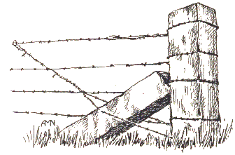

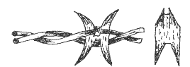  691B. C-543, G-127, B-77, A-559, J46, ( )  Scutt Single Clip "H" Plate  Two twisted strand wire with four point "H" barb. Barb is fastened to one strand with a metal clip. Patent #205,000, June 18, 1878 by Hiram B Scutt of Joliet, Ill. | 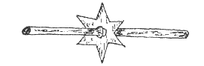  204B. C-235, G-340, B141, A-180, ( )  Dodge Six Point Star Barb  Single strand wire with six point sheet metal star barb. Strand is enlarged on each side of barb to prevent movement. Barbs may or may not rotate. Patent #250,219, Nov. 29, 1881 by Thomas H. Dodge of Worcester, Mass.

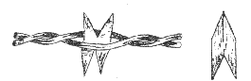  693B. C-573, G-129, A-562, ( )  Scutt Arrow Plate  Two twisted strand wire with four point sheet metal arrow plate barb. Barb is split and shaped like an arrowhead. Variation of Patent #205,000 as per wire #691B | 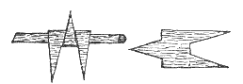  194B. C-213, G-140, B-49,A-442, J-50, ( )  Knickerbocker Applied Three Point Barb  Single strand wire with a three point hand applied barb. Barbs could be bought by the pound and hand applied. Patent #185,333, Dec. 12 1876 by Millis Knickerbocker of New Lenox, Ill.

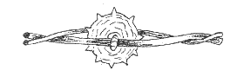  730B. G-818, A-414, ( )  Hodge Spur Rowel on Large & Small Strands  Twisted large and small strands with ten point sheet metal spur rowel barb. Variation of Patent #367,398, Aug 2,. 1887 by Chester A. Hodge of Beloit, Wisc. | 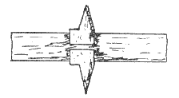  920B. C-811, G-236, B-123, A-78, J-126, ( )  Brinkerhoff Face Clamp Barb  Flat sheet metal ribbon with two point sheet metal clamp-on barb. Barb plate is cut so that barb can be bent around ribbon. Patent #241,601, May 17, 1881 by Jacob & Warren M. Brinkerhoff of Auburn, N.Y.

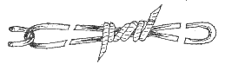  860B. C-704*, ( )  Cady Barbed Link, Double Wrap  Folded single strand link with ends joined in center of link by double wrap to form two point barb. Variation of Machine Patent #292,408, Jan. 22, 1884 by Frank P. Cady of Chicago, Ill. | 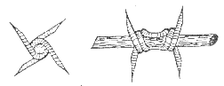  155B. C-148, G-110, B-50, A-464, J-51, ( )  Merrill Four Point Twirl  Single strand wire with four point barb. Patent #185,688, Dec. 26, 1876 by John C. Merrill of Turkey River Station, Iowa

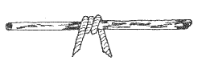  34B. C-72, A-355, ( )  Glidden Hanging Barb  Single strand wire with two point hanging barb. Variation of Patent #RE 6913, Feb. 18, 1876 by Joseph F. Glidden of De KaIb, Ill. | 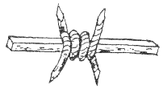  138B. C-144, G-7, A-367, ( )  Glidden Square Strand  Single square strand wire with four point coil barb. Patent # RE 6914, Feb. 18, 1876 by Joseph F. Glidden of De Kalb, Ill.

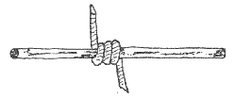  35B. G-596, B-8, A-351, ( )  Glidden Round Single Strand  Round single strand wire with coiled two point barb. Patent #RE 6913, Feb. 18, 1876 by Joseph F. Glidden of De KaIb, Ill. | 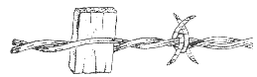  570B. G-216, A-424, ( )  Jayne & Hill Locked Staples& Wood Block  Two twisted strand wire with wooden block warning device and four point barb around both strands. Patent #176,120, April 11, 1876 by William H. Jayne & James H. Hill of Boone, Iowa

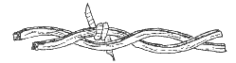  408B. G-1032, ( )  Glidden Large Square Strands  Two large square twisted strands with two point barb on one strand. Patent #157,125, Nov. 24, 1874 by Joseph F. Glidden of De Kalb, Ill. | 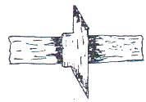  914B. G-93, A-75, ( )  Brinkerhoff Opposed Lugs Lance Point  Flat ribbon wire with two point lance point applied barb. Patent #214,095, April 8, 1879 by Jacob Brinkerhoff ofAuburn, N.Y.

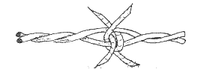  567B. C-481,G-349, A- 422, ( )  Jayne & Hill Locked Staples Around One  Two twisted strand wire with four point barb on one strand. One leg of barb straddles other strand. Variation of Patent #176,120, April 11, 1876 by William H. Jayne & James H. Hill of Boone, Iowa | 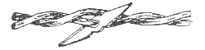  638B. C-506, C-98, A-428, ( )  Kelly Thorny Common  Two twisted wire strands with two point sheet metal thorny barb. Patent #74,379, Feb 11, 1868 by MichaeI Kelly of New York, N.Y.

