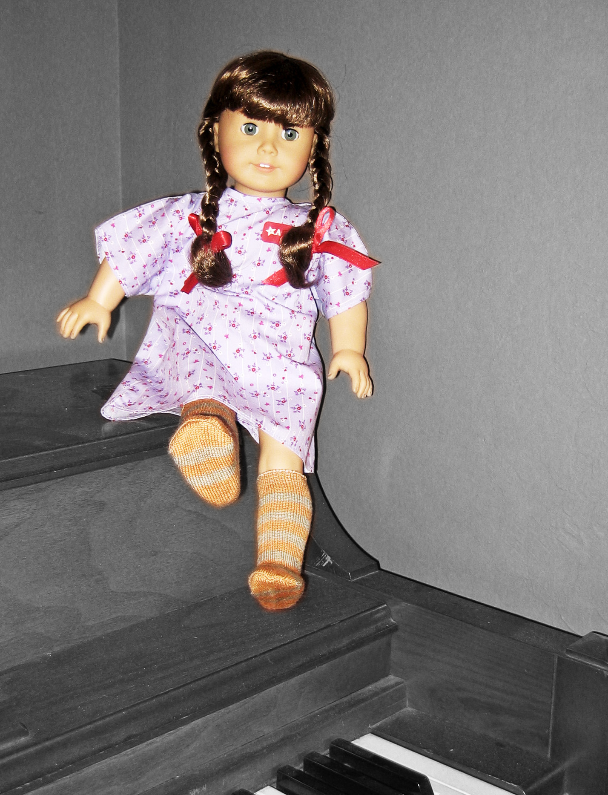
Kelly Sanford
Omur Harmansah- Archaeologies of the Near East
Assignment 2: Cultural Biography of Objects
February 20th 2008

Meet Molly, My Molly
Molly McIntire arrived with her shiny chestnut braids tied with red ribbons and silver rimmed glasses poised on her nose. She was wearing white socks with black Mary Janes, a blue skirt, and an argyle sweater. She came wrapped in tissue paper in a white box with a golden seal. Molly is a doll, but to my 6-year old self she was much more than that. She was a treasured friend, a powerful role model, and a social enabler to my young shy self. To this day, at 18” tall, she holds a place in my heart. How has such a simple object sustained such a grip on me? What made her different from other childhood toys?
Molly was invented along with two other dolls, Samantha and Kirsten in 1986 by Pleasant Rowland. The dolls were the physical representations of characters in historical fiction books, and each character came from a different place and time period in American history. The books were themed around the exciting lives of girls aged nine to ten. They gave modern girls a window into the past that they could relate to, while also providing exposure to a range of serious issues including independence, immigration, slavery, class, gender roles, and ethnicity. (Acosta-Alzuru and Kreshel 2002) Molly grew up in the mid 1940s during World War II. Her father was away at war, and she had to make sacrifices for the war. While reading about Molly, girls learned about victory gardens, scrap drives, and the things people lost during the war. At the same time, they realized that the girls of the forties weren’t so different from the girls in the present. They had feuds with boys, got picked on by their older brothers, and had to eat foods that they didn’t like. As the girls identified with the characters in the novels, they identified more closely with the dolls. Every several years a new historical doll and set of stories was introduced, broadening the scope of American Girl dolls to a variety of backgrounds. In 1995 it was possible to order a custom doll by specifying eye color, hair color, and face shape. By 2003 Pleasant Company had sold 8 million dolls. (Kinzer 2003)
My doll was a tangible version of the Molly I knew from the stories, and yet she also was uniquely mine to play with and love. She was immediately my favorite doll and never lost the position. Over the years I collected her accessories: the school set, her Christmas dress, and her birthday party games to name few. I saved up for a year to buy her a bunk bed, and then tucked her in with a kiss every night. There was a I time when I would set a place for Molly at the dinner table, bringing food to her lips and then swooping it into my own mouth at the last second. Unlike a baby doll or a Barbie, Molly was a girl like me and deserved respect. She was a strong character and role model for me in the books: smart, stubborn and adventurous. Thousands of other girls also were also inspired by American Girl dolls and accompanying books. These experiences influence their ideas of it meant to be an American girl, and when several doll owners were interviewed in a study by Catherine Acosta Alzuru and Peggy J. Kreshel, they connected the idea of being an American girl with traits such as independence, intelligence, and problem solving, as well as activities like sports and slumber parties.
Owners of American Girl dolls were welcomed to become a part of a larger community. Every month a new catalog came, showcasing clothing and accessories for each doll organized by scenes from the books. In 1998 the first storefront, called American Girl Place, was established in Chicago. “To stroll through American Girl Place is to enter a subculture in which huge numbers of girls and their mothers — a male face is rare — have been immersed for years.” (Kinzer 2003) Pleasant Company had been actively cultivating this community in a variety of ways over the years and The American Girl Place finally provided a national gathering place for enthusiasts across the country to gather. Visitors could dine with their dolls in a restaurant, give their dolls a makeover at the salon, and see a plays based on their dolls.
In 1992 American Girl Magazine was published, providing supplemental stories and activities for girls including embarrassing moments and advice columns. By 1997, circulation of the magazine reached 800,000 (Vargas 1997). A website was launched in 1999 with games, tips, party ideas, and a place where girls could ask and answer questions. Girls were encouraged to form their own American Girl Clubs at home but also felt a bond with a larger national community. Proper clubs would do community service, learn about history, do historical arts and crafts, and raise money for the club all while celebrating great American Girldom. As a third grade student, Molly and I were a part of a small club made up of five girls that met in the classroom at lunchtime to sit, talk, and play with our dolls. It was clear that each of us was attached to her own doll in the way that we gingerly played with her and gave her a unique personality.
I was very possessive over Molly and ten years ago I was horrified to come home to find another girl (a family guest) playing with her. She was several years younger than I was and had layered on outfit after outfit until Molly was covered in a bulging mess of clothes. Soon Molly was tossed aside on the floor. I wanted rescue her, redress her, and comfort her. With any other doll I would not have minded and outsider’s touch, but Molly was special: she was a friend and she was mine.
As I continued to grow up I played less and less frequently with Molly and over the years her home transitioned from her bunk bed, to the shelf, to the plastic storage container. Still, while I gave away the rest of my dolls and childhood toys, Molly stayed. I wouldn’t give her away; I just couldn’t. Even in high school I would go through her clothes and change her outfits from time to time.
I was surprised however, when I opened up a Christmas present this year to find a shiny white box with a golden seal from American Girl. It was Molly, and she finally had her new hair. In fact, she had an entirely new head. Part of me was excited to have realized a childhood wish, but at the same time, I really felt like I had lost something. I had lost the evidence of hours of playtime and the authenticity of my doll. Was it the same Molly that stared back at me from her place on the shelf all those years? I couldn’t decide, but I propped her up on my piano anyway with mixed feelings.
American girl dolls have touched the lives of millions of girls across the United States. In a Facebook group with over 1500 members– “The American Girl Collection Significantly Influenced My Formative Years”— women in their twenties still discuss the activities they once shared with their dolls: bringing them along on family vacations, celebrating cultural holidays, and most commonly, changing their outfits and doing their hair. Several of the members proudly state that they still play with their dolls from time to time and are saving them to pass on to their own children. In a society where traditions have been diluted and commercialized and consumer items are no longer built to last, American Girl dolls stand out from the rest. These dolls have helped girls forge a connection with the past as they shaped their own futures and grew into women. Women, who can’t wait to pass on their own dolls to the next generation.
References

“The American Girl Collection Significantly Influenced My Formative Years” Facebook Group. Administrator: Molly Dickerson. Accessed on 19 February 2008. <http://brown.facebook.com/group.php?gid=2205063905>

Kinzer, Stephens. “Dolls as Role Models, Neither Barbie Nor Britney” New York Times (November 6, 2003)

Vargas, Alexia. “A Pretty Population Explosion Sets Stage for Doll Wars.” Wall Street Journal (December 16, 1997)

Villhauer, Meghan and Noble, Johanna “History of American Girl” Accessed 20 February 2008 Available online: <www.agplaythings.com/historyofag/historyofag.html>

Acosta-Alzuru, Carolina, and Kreshel, Peggy J. “ ‘I’m an American Girl…Whatever That Means’: Girls Consuming Pleasant Company’s American Girl Identity” Journal of Communication 2002

