Land Ownership of the John Brown House Property

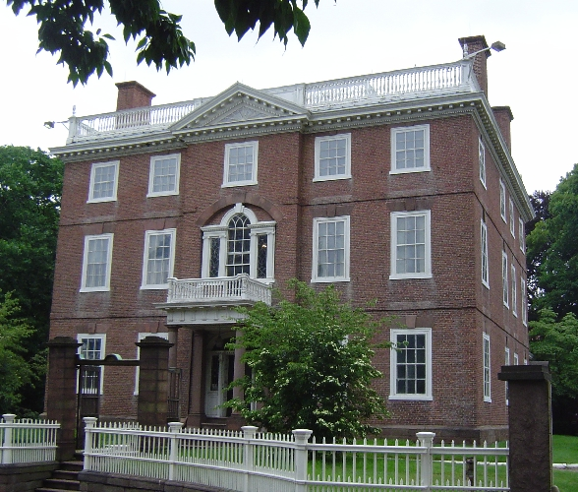

Steffi Yellin and Megan Algeo

“Fortunate, indeed, is in the owner of this, perhaps the finest colonial mansion in New England. May it long endure a noble monument to the memory and achievement of the two brothers, Joseph and John Brown.”
(The Providence Sunday Journal, October 13, 1901)

- INTRODUCTION
A complete timeline for ownership of the John Brown House and the surrounding property does not currently exist. Secondary sources outlining the history of the property, some of them unaccredited and unsourced, are in the collections of the John Brown House and the Rhode Island Historical Society Library. However, comparison of these documents shows that they are each incomplete and inconsistent to varying degrees. A review of the available information at the John Brown House, the Joukowsky Institute Library, and the Rhode Island Historical Society Library provides foundational knowledge to assist in an examination of the deeds contained in the archives at City Hall. The resulting ownership history helps to resolve questions pertaining to who may have inhabited the property, at what time they were there, how they obtained it, and any documented landscape changes.

We began our research by meeting with Dan Santos, Educational Programs and Services Manager to review the available materials and ascertain the John Brown House Museum’s knowledge of the ownership history and any other resources in the area. Surprisingly, materials at the John Brown House were, to the best of Dan’s knowledge, largely independent from those found at the Rhode Island Historical Society Library. This meeting confirmed that we would be able to make new contributions to the body of knowledge available to the Museum. A search of three binders relevant to the history of the property turned up multiple documents with potential relevance to the site history. The two most important were an unaccredited history of the property, and a one page figure that contained rough sketches of the property at different years, with divisions to indicate which party owned it at the time. The parties were identified only by initials, which we matched to their most likely names over the course of our research.

The following week, we made two trips to the Rhode Island Historical Society Library. Dan had kindly informed the staff of our interest in the library’s holdings, so access was relatively easy. At the library, we found genealogies, a biography on John Brown that noted a garden planted by his middle daughter on the property at some point, and a document from 1969 entitled “John Brown House Research Project,” by Clarkson Collins, which contained references to fire records with information on the composition of the property, a schedule of real estate, and insurance policies. At this point, we felt we had enough names and dates on hand to turn to the Recorder of Deeds and Land Evidences Office at Providence City Hall.

The main deeds office has computerized records going back to the 1980s, so we were directed to the City Hall archives for our research. The head archivist and his assistant demonstrated how to look up deeds in the registers and locate them in the stacks. Over two research sessions, we were free to browse the stacks and look over any documents of interest. Any deeds between two parties relevant to our chronology were investigated, though many turned out to reference different parcels of land throughout the state. In total, about sixty deeds were analyzed. We found evidence for most of the parties mentioned in secondary sources. Though photocopying the old deeds is prohibited, photography is acceptable. Digital photographs of representative deeds and one sketch of the property are included. For relevant deeds, the body of the document detailing the land survey was noted, and the date of transfer, price of transfer, and parties involved were recorded. When combined, the information from the sources above confirms at extends the body of knowledge on the land history that existed prior to our research. It can also inform new directions for archaeological exploration and historical understanding of the property.

- BACKGROUND:
Chad Brown was the patriarch of the Brown family in the American colonies; he arrived in 1638 as a surveyor and marked out for himself an ample lot which extended from Towne Street at the foot of the hill (South Maine and Market Square) up to the hill and beyond the highway (Hope Street). In 1672, his son John freely gave the land to his son James Brown. On December 31, 1672, James Brown sold the plot of land to Daniel Abbott, who would later, in 1723, build the first house of worship in Providence on the corner of College and Benefit Streets. Not until 1770, did the land return to Brown hands, when Nicholas Brown sold the land to his brother, John Brown.
At this point, it would be helpful to give some background of the Brown family living in Providence during the 18th century. Although James and his wife Hope reportedly had six children, there were four sons, in particular, who all contributed greatly to society: Nicholas, Joseph, Moses, and John, the future constructer of the red brick mansion house. They all contributed to their family business, Nicholas Brown & Co., and continued the mercantile business of their father and uncle, which included the production and trade of candles, molasses, and iron. In addition to these pursuits, Nicholas was one of the founders of Rhode Island College (now Brown University), Joseph was an architect and philosopher, and Moses was a fervent abolitionist, scientist, and mechanic.
John Brown was perhaps the most risky and independent of the brothers: he was adamant in the conservation of slavery and directed several voyages across the Atlantic in that pursuit; he was involved in merchant trade directly with China; he also served as the treasurer of Brown University for over 20 years. In 1787, John Brown built his red, brick mansion house which was designed by his brother, Joseph. John married Sarah Smith and their descendants include the Herreshoffs and Francises, while Nicholas Brown’s descendants include the Ives and Gammells.

- ANALYSIS:
In presenting the ownership history of the John Brown property, we have elected to create a timeline which compiles all our sources, deferring to those we deem most trustworthy in cases of disagreement, and including quotations and appropriate references wherever possible. This should provide the reader with an overview of the changes taking place. To synthesize the most important points, we have created a series of figures mapping the transition of the properties through time and owners, in the style of the figure we found among the documents at the John Brown House. Finally, we include an analysis of the landscape changes we deem to be most relevant to an understanding of the house and the archaeological excavations taking place on the property.

The Barn
When James Brown sold the property to Robert Hale Ives in 1831, the property was marked off using a barn as a point of reference. It is not clear when the barn was built. This barn no longer stands on the property, and was unknown to us at the beginning of our research. The area where the barn stood can be located precisely, as this particular deed incorporates a meticulous survey of the property line, and includes the barn’s dimensions: 20 feet by 20 feet (Book 61 Deed 225). The figure was drawn directly on the reverse of the deed by S.B. Cushing, a person that may warrant further investigation.
A rough survey of the modern day property suggests that the barn may have existed on the areas where an outbuilding and a modern yellow garage currently sit. We know that an addition to the original mansion followed a few years after the date of this deed, making it possible that the barn was demolished to allow for construction to take place. If the land can be accurately surveyed, it may be possible that a portion of the former barn site is on exposed turf, as grass runs between and to the west of the outbuilding and the garage. Perhaps some of the Brown family’s extensive correspondence can help place the date of construction of the barn, or explain its use.

The Robert Hale Ives Homestead
When Robert Hale Ives bequeathed his property north of the site of the mansion to his daughter Elizabeth Amory Ives Gammell, the land included his homestead. This means that the home was built sometime between 1832, when the land came into his possession, and 1875, when Robert Hale Ives died. The house existed on the property through three generations of Ives relatives, but we were not able to find any information about who exactly inhabited the site. When the property passed to Marsden J. Perry, the building was demolished at an unknown date in order to complete the large front lawn on the property. This information comes from the invaluable—but somewhat problematic—unsourced history found at the John Brown House. To the best of our knowledge, the information contained in this document agrees well with the information we obtained from other resources and the deeds.
To find out more about the history of the house, it will be necessary to investigate the genealogy and history of the Ives family in greater detail, a task too large for the limitations of this project. We hypothesize that the magnetic anomaly detected during the geophysical survey of the property is part of the foundation of the building, or another structure related to it, such as a fence or path. Further excavation may uncover finds to support this conjecture.

Garden and Outbuildings
In addition to the actual mansion house, it is interesting to note other aspects of the land plot which were recorded, including a garden and outbuildings. Carole Blanck’s 1975 biography indicates that Sally Brown, John and Sarah Brown’s middle daughter was said to have planted a garden somewhere near the house. Since she moved from the premises in 1801, we are led to assume that she planted the garden sometime before then. Further excavation on the site and in the historical record may yield more clues as to the location and contents of the garden. This could perhaps be connected to the same garden that John Brown describes in his will to his son, James in 1802: “viz the garden east of the house… Messrs Brown and Ives corner on the southeast corner of my garden: then running northerly until it reaches the northeast part of my garden: then running westerly and running to the street adjoining.”
Much later, in 1852, a garden was again made mention of in the land deeded from Nicholas Brown, to his nephew Moses B. Ives: “The garden part of the mansion lot as east of the 30 foot line was deeded unto Moses Brown Ives—now part of the so called Bishop’s house lands.” As well, certain outbuildings were noted in the 1814 tax papers: “These include 1.5 acres, the mansion, as well as “a coach house of wood” and a “stable of wood both connected by a shed.” The author notes that “this record would seem to indicate that some of the original outbuildings were no longer standing some twenty years after the house was built.” Both the garden and outbuildings are important for future research done on the site. If traces are ever found of anything similar to their makeup, we will have some sort of foundational information.

Monetary Exchange
The monetary exchange during the multiple sales of the John Brown property is very interesting. While some sell the land for its proper monetary value, others give the land away for free, for a token dollar, or as a favor. For the most part, the land exchanges between direct family members are given away for free or for the symbolic sale of $1. The only exception happened when Nicholas Brown originally sold the land to John Brown in 1769, “for and in consideration of the sum of two hundred and two pounds two shillings and a half penny.” James Brown also sold land to Robert Hale Ives for $2000. In the case of James and Robert, the price may have been steeper because they were extended family members, as opposed to close relatives. In reference to the sales between non-family members, those involved were very cordial. The Gammells sold their land to Marsden Perry for $100, which for a man of his wealth was merely symbolic pocket change. In 1936, Perry returned the favor by selling the land back to the Brown family for a symbolic $1.

- CONCLUSION:
One can see the sale and purchase of what is now known as the John Brown House property as having a somewhat symmetrical chronological history. [Since 1768, the ownership history of the John Brown House has come full circle, ending with John Nicholas Brown as the last individual to own the property before gifting it to the Rhode Island Historical Society in 1942.] In other words, what was a originally a large parcel of land sold to Nicholas Brown in 1768, terminated as a large parcel of land which was sold to the Rhode Island Historical Society in 1942. However, the centuries in between provide ample instances of land exchanges, divisions, and transformations between members of the extended Brown family and their contemporaries. Primary and secondary documents including land deeds, wills, insurance policies, narratives, and illustrations, were all beneficial in helping to trace back these property changes and exchanges. Although we were able to trace back the property’s owners relatively easily, it often proved difficult to try and determine the exact location, size, and occupants of each specific parcel of land within the larger land plot, as it was often divided among many people.
If given the chance to research further, perhaps we could begin to fill in some of these gaps. During our initial research, we were unaware of the Nicholas Cooke lot within the plot of land which Nicholas sold to John Brown. Besides the information given in the initial deed document, we know nothing more about the transaction of his 3 acre plot of land; what happened to it? Did somebody buy it? If given the chance for future research, we would try to trace back the exchange of this land through deed documents. In addition, in 1769, there are three lots within the property owned by John Brown, two of which we were able to trace forward to some degree. Upon further research, we would like to investigate what happened to the 2.5 acre plot referenced in item two of his 1802 will.

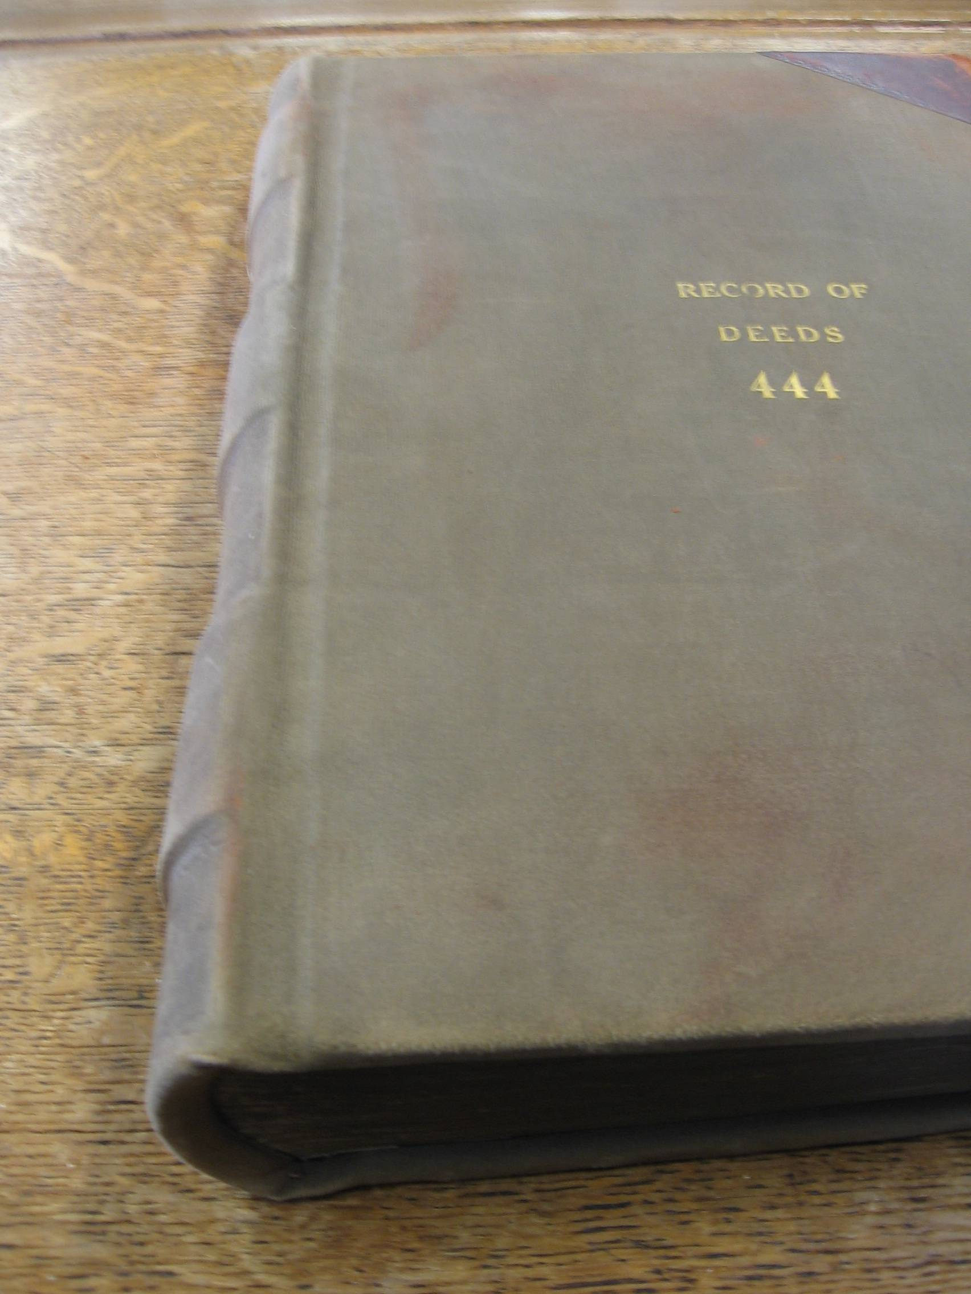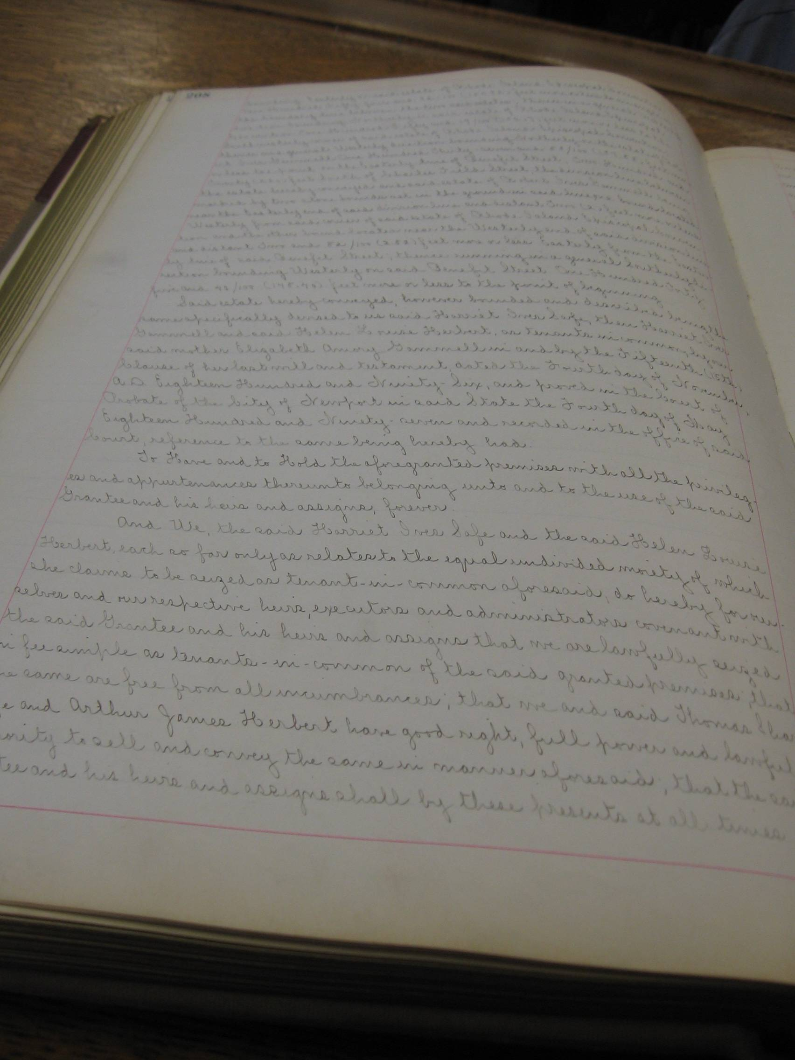

- TIMELINE

Joseph Whipple to Nicholas Brown
May 10, 1768
According to an unsourced history found in the documents at the John Brown House, Nicholas purchased the 14 acre lot east of Benefit Street, minus a 60 foot by 80 foot lot at the northeast corner of Power Street and Brown Street, which was owned by Nicholas Cooke.

Nicholas Brown to John Brown
DEED: February 13, 1769
“for and in consideration of the sum of two hundred and two pounds two shillings and a half penny”
To all people to whom these presents shall come, I Nicholas Brown of Providence in the county of Providence in the colony of Rhode Island merchant…send greeting. Know ye, that I the said Nicholas Brown…for and in consideration of the sum of two hundred and two pounds two shillings and a half penny lawful money to me…in hand before the ensealing hereof, well and truly paid by John Brown of said Providence merchant and son of James Brown Esq deceased the receipt whereof, I do hereby acknowledge and myself to(?) therewith fully satisfied, contented and paid; and thereof, and of every part and parcel thereof, do exonerate, acquit, and discharge him, the said John Brown his heirs, executors, and administrators, forever by these presents: have given, granted, bargained, sold, aliened, enfeoffed, conveyed, and confirmed; and by these presents, do freely, fully, and absolutely give, grant, bargain, sell, alien, enfeoffe, convey, and confirm, unto him the said John Brown and to his heirs and assigns forever, three certain tracts or pieces of land all lying in Providence aforesaid and containing in all by estimation about seven acres and fourteen rods be the same more or less on of said tracts or pieces is bounded westerly on a back street called Benefit street, beginning at the middle of the front of the lot I bought of Joseph Whipple and running (sic) to the sow west corner of said lot, then running easterly adjoining Powers lane (so called) till it reaches Nicholas Cook Esq(?) lot he bought of said Whipple and whereon his the said Cooks barn now standeth then running northerly partly on said Cooks line and partly on my own to a stake being half across the said land I bought of said Whipple and then westerly to the first bound. Containing about one acre and a half more or less. One other tract or piece is on the easterly side of the hill or highest part of the lot I bought of said Whipple and is bounded southerly on said Powers lane westerly and easterly on land of my own being part of said land bought of said Whipple and northerly on land belonging to the heirs of charles field deceased containing about two acres and a half more or less, one other tract or pieces being the easterly part of said lot I bought of said Whipple and is bounded southerly on Powers lane aforesaid westerly on me the said Nicholas northerly on land of the said heirs of charles field deceased and easterly on a highway running between said lot and the Young Orchard (so called) belonging to Nicholas Cook Esqr. aforesaid containing about three acres more or less together with all the fencing and improvements thereon. All the which premises hereby granted is part of the lot I lately bought of Joseph Whipple aforesaid being one half part of the same as I the said Nicholas Brown and by brother John Brown have agreed on the division thereof, all being as the stone walls built in company between me and my said brother John now standeth.
-Rhoda Brown, wife of Nicholas, also gives up rights to property below this section.

witnessed by Sam Chace, Justice of the Peace
recorded May 1 1769 by J. Angell, Clerk

deed 321 in the book “record of deeds 18”

- Nature of John Brown’s purchase, construction of mansion
According to the unsourced history, which incorrectly lists the date of purchase as February 10, 1769, John purchased half of the 14 acre lot. One and a half acres were situated on the area from Benefit Street (then known as Ye Back Street) to the east side of Brown Street, and the southern half of the property when divided north to south halfway through the tract. The mansion was built in 1787 and first inhabited in 1788.

People living in the mansion house:
1800
John Brown, Sarah Brown, James Brown, Sally Brown, Abby Francis, John Francis Brown

Sally Brown plants a garden
exact date unknown
Sarah “Sally” Brown, John and Sarah Brown’s middle daughter, planted a garden at some point. Since she moved to New York around 1801, we can assume it occurred while she was living with her parents. This comes from Carole Blanck’s short history of the Browns.

John Brown Will
September 13, 1802
To his wife Sarah: (life interest in)
1. His three story-deep cellar-54 X 50 mansion house on Power Street where at they lived at the time of his decease: with 1 ½ acres of adjacent lands.
2. A 2 ½ acre lot 40 rods distant—with a “Water Well.”
3. A 3 acre lot at eastmost end of Power Lane.
*Items two and three are the second and third of the six lots Nicholas Brown divided his property into when he sold half of it to John Brown. The division information comes from the unsourced history.
To his son James: (Direct)
4. The three story Mansion house with its 1 ½ acre of land where at Jon Brown lived at the time of his decease-52 Power Street
5. The 2 ½ acre “Water Well” lot.
6. The 3 acre lot at the eastmost end of Power Lane
- “with the provision that upon her decease the mansion house and its adjacent land were to go to his son James Brown.”
-“viz the garden east of the house and the greene yard west of the house adjoining the street: said lot on the south side adjoining Power Lane so called until it reaches Messrs Brown and Ives corner on the southeast corner of my garden: then running northerly until it reaches the northeast part of my garden: then running westerly and running to the street adjoining: the whole way on the east and north on lands of Messrs Brown and Ives; including also the yard and gangway around the house
-“the homestead in which I now live being 54 feet by 50 feet square…with a deep cellar under the whole, and all brick from the cellar stone walls as well as the partitions as the walls of the house together with the out floufs: viz the coach house; kitchen; stable; and wood house with the bathing house and about 1 ½ acres of land on which the house stands and nearly in the center. Said land is bounded by the street on the west and on the south, and on the east and north by lands of Messrs Brown and Ives, including all fences, garden, paved yard, fruit tress, etc. etc.”
(unsourced document)

A Schedule of John Brown’s Estate
June 8, 1802
This document list out the value of everything John Brown owns. Items 1, 2, and 3 describe the lots listed as items 1, 2, and 3 in his Will, valued at 18,000 dollars, 2,000 dollars, and 2,000 dollars, respectively.

Sarah Brown accedes to power of thirds
DEED: November 8, 1803
deed 27- 675
(gets property upon her husband’s death)

Documentation of relative locations of outhouses and a spring
At some point between 1807-1857
According to the John Brown House Research Project, “Fire Record, No. 86 in Volume I insures John Brown House. It describes the house as of brick, three stories high, fifty by fifty feet in dimensions, and states that the outhouses, the same as listed by John Brown, were of wood with the exception of the wood house. The house and outhouses were remote from any other buildings and were contiguous to a spring.”

People living in the mansion house:
1803
Sarah Brown, James Brown, Abbey Francis, John Brown Francis, Sally Herreshoff, Carl Frederick Herreshoff, Anne Francis Herreshoff, Sarah Herreshoff, John Brown Herreshoff, Agnes Herreshoff, Charles Frederick Herreshoff, James Brown Herreshoff

Providence Direct Tax Papers, referenced in John Brown House Research Project
1814
The papers outline a “List of Lands and lots with their Improvements owned by Mrs. Sarah Brown on the 1st of Feb. 1814, being in the town of Providence.” These include 1.5 acres, the mansion, as well as “a coach house of wood” and a “stable of wood both connected by a shed.” The author notes that “this record would seem to indicate that some of the original outbuildings were no longer standing some twenty years after the house was built.”

People living in the mansion house:
1821
Sarah Brown, James Brown, Sally Herreshoff, Anne Francis Herreshoff, Sarah Herreshoff, John Brown Herreshoff, Agnes Herreshoff, Charles Frederick Herreshoff

People living in the mansion house:
1825
James Brown, Sally Herreshoff, Anne Francis Herreshoff, Sarah Herreshoff, John Brown Herreshoff, Agnes Herreshoff, Charles Frederick Herreshoff (Sarah dies)

James Brown to Robert Hale Ives
DEED: December 7, 1831
“for two thousand dollars”
A certain lot of land lying and situate in the southerly part of the town of Providence and which is bounded and described as follows, viz beginning at a point twenty feet distant from the north west corner of the foundation of the barn on the grantors premises, whence? south 6 ¾ degrees west, twenty three feet eight inches to a point twenty feet distant from the south west corner of said barn thence south 23 ½ degrees east forty five feet to a point forty one feet eight inches distant from the north west corner of the foundation of the grantor’s mansion thence south 10 degrees west ninety four feet eight inches to Power street, thence along said Power street north 83 degrees west sixty one feet to benefit street, thence along said Benefit street north 30 ½ degrees west one hundred ninety seven feet seven inches, thence south 83 degrees east one hundred sixty three feet seven inches to first bound. The same being part of the mansion house estate of my late Honored father. A plot of said lot was made by S.B. Cushing December 6 1831 and is copied on the back of this deed.
-Recorded December 15 1831
-book 61 deed 225
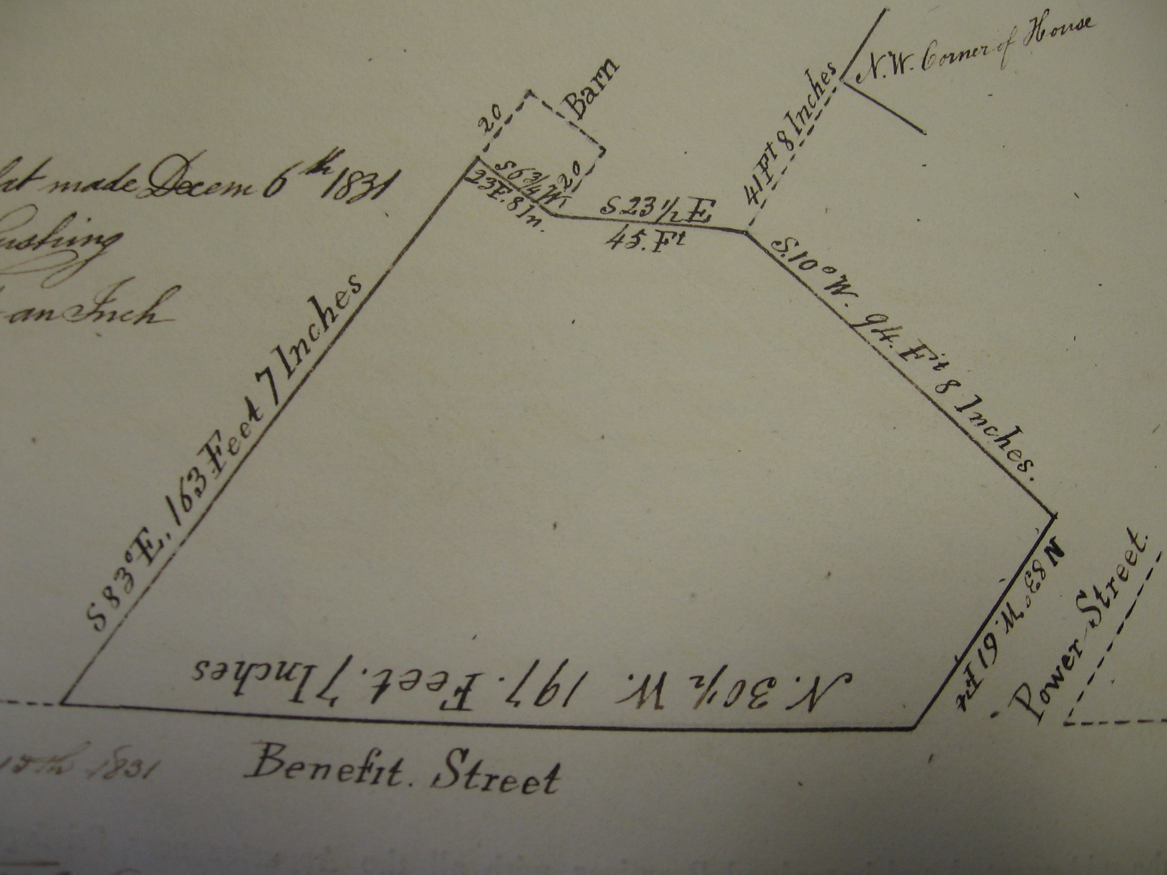

“part of the green yard west of the John Brown mansion house, the part sold being apparently westward from the foot of the present slope on the west side of the mansion house unto Benefit Street—about 1/3 of the original 1 ½ acre lot” (source without citation)

Nicholas Brown sells to W Moses Brown Ives and Robert Hale Ives
DEED: July 30, 1832
“good wishes I feel towards my two nephews”
A certain piece of land, being the western part of the lot, which belongs to the estate of my Honored father, deceased, situated in the town of Providence a little northward of the residence of the subscriber, founded as follows, viz, beginning at the northwest corner, which is at the junction of Benefit and Charlesfield streets, thence running alongside Charles Field street in an easterly direction about two hundred and sixteen feet, thence in a southerly direction to the north east corner of a lot of land conveyed by James Brown Esq to Robert Hale Ives by deed, dated December 7th 1831, thence in a westerly course along said lot to Benefit street, thence northerly along said Benefit street to the first mentioned point at the junction of Benefit and Charles Field streets…
- This was the part of lot which was different and apart from the mansion house. Nicholas Brown gave the land to Nicholas Jr., and Nicholas Jr. gave the land to his two nephews (everything apart from the section of land where the house was, which was given to Sarah Brown)

recorded July 30 1832
provided to Providence June 8 1832
book 62 deed 84

People living in the mansion house:
1834
Sally “Sarah” Herreshoff, Anne Francis Herreshoff, John Brown Herreshoff, Agnes, Herreshoff, Charles Fredrick Herreshoff (James dies)

The James Brown Estate
1834
The “3 acre lot at the eastmost end of Power Lane” passed from the estate of James Brown to his nephew John Brown Francis. This lot is first mentioned in the John Brown Will, 1802. Sarah Herreshoff received the mansion and its contents from the same estate. (Taken from the unsourced document beginning John Brown Plate and Household Furniture.)

Mutual Fire Policy 9866 taken by Sarah Herreshoff
August 9, 1842
The policy was for 4,500 dollars on the house and its addition, as well as 275 dollars on an outbuilding on the rear of the same lot, built of wood, 40 feet by 22 feet. This building is used for “D.H.” and stables. A second outbuilding, insured for 225 dollars, is made of wood and measures 40 feet by 22 feet, with an adjoining shed measuring 50 feet by 10 feet. The shed is mostly brick, and connects the two outbuildings.

John Brown Francis sells to Hope Ives
DEED: March 14, 1845
“for one dollar”
A certain tract or parcel of land lying and situate in the easterly part of the city of Providence aforesaid, bounded on the north by Charles Field street, on the east by Hope street on the south by Power street, and on the west by lands belonging to the heirs of Nicholas Brown, and of Thomas P Ives deceased being all the land owned by me between the said Power and Charles Field streets and west of Hope Street, and which formerly belonged to my uncle the late James Brown deceased reference regarding the same may be also had to a quit claim deed to me from my aunt Mrs. Sarah Herreshoff dated 21 April 1835.
14th March 1845, recorded June 23 1845
deed 95-156

From the Unsourced document beginning John Brown Plate and Household Furniture: “In the division of the James Brown (deceased 1834) estate the 3 acre lot at the eastmost end of Power Lane went to his nephew John Brown Francis. As of March 14th, 1845 John Brown Francis sold the above “3 acre eastwardmost tract of land” to Hope Ives, widow of Thomas P. Ives; all well covered by residences as now is.
- “As elsewhere set forth herein the division of the James Brown estate old mansion house with all of its contents went to Sarah Herreshoff”
Unsourced Document
- James Brown left unto his nephew John Brown Francis: “…a 1/6 part of all of estate of whatever kind of nature or where located--.”
- James Brown left unto his sister Sarah Herreshoff: “…all the residue and reminder of my estate where ever found.”

Sarah “Sally” Herreshoff to her daughters”
August 1846
Sarah “Sally” Herreshoff-deceased in August 1846-bequeathed unto her daughters Ann; Sarah; and Agnes all the property and estate of every kind that may be remaining at the time of here decease…the residue of her estate-real as well as personal she left undivided unto her grandson James Brown Herreshoff (son of her son John Herreshoff) until he became of age. It was through such a clause in his grandmother’s will that James Brown Herreshoff was to have become possessed of the old Brick Mansion of his Great Grandfather on Power Street (unsourced document).
- Her son John and his sisters may have the privilege of residing there without paying any rent. John and his sisters may also reside at the Providence mansion house until her grandson reaches the age of 21 (Sarah “Sally” Brown Herreshoff’s will)

People living in the mansion house:
1846-1852
Sally dies, children remain in the Brown house; only Charles Frederick marries; house sold to Ives in 1852

James Brown Herreshoff to Hope Ives
1852
As elsewhere set forth herein the famous old mansion was sold by the then living children of Sarah Herreshoff to Hope Ives
-Hope Ives gets the parcel of land containing the mansion house. James Brown who was of the age of 18 (and not 21) at the time of the transfer of the title… Now she is in ownership of the eastward tract of land in addition to the part of the lot with the mansion house.
- The property is thus passed out of the John Brown line until 1936

Hope Ives sells to Robert H. Ives
DEED: February 21, 1854
“one dollar and other considerations to me”
A certain lot or parcel of land, situated in the city of Providence aforesaid, being all that part of the “John Brown Estate,” so called, conveyed to me by Ann F. Herreshoff and others per deed dated the twenty sixth day (day crossed out) of October one thousand eight hundred fifty two, which lies west of a line drawn northerly from Power street, parallel with the John Brown mansion house and thirty feet distant from the underpinning on east side of said house is bounded as follows, viz, easterly by aforesaid line on which it measures about one hundred fifty six feet southerly by Power street on which it measures about one hundred and thirty feet, westerly by land belonging to the grantee upon which it measures about one hundred and sixty three feet, northerly by land belonging to Moses B. Ives, on which it measures about one hundred and fifty feet.
-21 February 1854, recorded February 21 1854
-book 136 deed 21
- “all that part of John Brown Mansion house and its lands as west of a line draw parallel to and 30 feet east of the mansion house, northerly unto then northern bounded of the mansion house lot, unto the lot which James Brown sold unto Robert Hale Ives in 1831.” (not cited)
- “The garden part of the mansion lot as east of the 30 foot line was deeded unto Moses Brown Ives—now part of the so called Bishop’s house lands.” (not cited)

Robert Hale Ives to William Gammell:
1875
BEQUEATHED from Robert Hale Ives to his daughter, Elizabeth Amory Ives who married William Gammell on Sept 22nd, 1851.
- The bequeath not only included the old mansion house and its grounds but also Robert Hale Ives own homestead at the corner of Benefit and Charlesfield Street—thus giving Elizabeth Amory Gammell a much larger estate on the east side of Benefit Street that possessed of by John Brown.

Mutual Fire Policy taken by Robert Hale Ives
November 8, 1859
This does not mention the outhouses, but redefines the policy as 10,000 dollars on the mansion and its addition.

William and Elizabeth Gammell to Robert Ives Gammell
DEED: Sept 27, 1878
“their free and voluntary act”
William and Elizabeth Amory Gammell…constitute and appoint our son Robert Ives Gammell our house (?) and lawful attorney for us and each of us and in our and each of our names and stead to take the charge care and management of all the property and estate real as well as personal now of or belonging or which shall hereafter belong to us or either of us with power (?) in said Robert Ives Gammell to sell and dispose of any part or parts of said real or personal estate by public auction or private contract…also to release the power of said Elizabeth Amory Gammell in and to any part or parts of the said real estate.
- Received the house of his grandfather, not the John Brown Mansion. This was estate lands with a homestead at the corner of Benefit and Charlesfield Streets.
- Eventually Marsden Perry would knock this house down: “[he] demolished the old homestead of Robert Ives Gammell and made the lawns of the two adjoining estates into a beautiful lawn such as is now a part of the John Brown Mansion estate lands. The same tract of land as bequeathed by Robert Hale Ives unto his daughter Elizabeth Amory Gammell-wife of Prof. William Gammell” (not sourced).

Elizabeth Gammell to her daughters
1897
Deceased on April 7th, 1897 Elizabeth Amory Gammell-widow- BEQUEATHED land unto her two daughters Miss Harriett Ives Gammell and Helen Louise Gammell.
- This deed refers to the mansion property

Helen and Harriett Gammell to Marsden J. Perry
DEED: Oct 9th, 1901
“for and in the consideration of the sum of $100”
Thomas Shaw Safe and Harriet Ives Safe his wife…and we, Arthur James Herbert and Helen Louise Herbert, his wife…being the daughters of Elizabeth Amory Gammell, late of Newport in the state of Rhode Island…and truly paid by Marsden J. Perry of Providence,…do hereby give, grant, bargain, sell, assign, and convey onto the said grantee, his heir and assigns forever the following described estate, namely:
That parcel of land with all the buildings and improvements thereon, situated at the southeast corner of Power Street and Benefit Street in the city of providence in the said state of Rhode Island and known as the John Brown estate, and founded and described as follows, namely: beginning at the said corner of Power Street and Benefit Street and thence running in a general easterly direction bounding southerly on said Power Street. 121 and 27/100 feet, more or less, to the estate of Rhode Island Episcopal convention (congregation ?) and formerly of Mrs. Hope B. Russell, thence brotherly direction bounding easterly on church 154 and 92/100 feet on angle in boundary line between the two estates. Westerly direction bounding brotherly on said Episcopal 150 and 17/100 feet to the southwestern corner of the estate of the convention; westerly direction bounding brotherly on the estate of Robert Ives Gammell 137 and 33/100 feet to a point on the easterly line of Benefit Street 200 feet south of Charlesfield Street. The division line between the estate hereby and said estate of Robert Ives Gammell being marked by two stone bounds set in the ground. Found located near the easterly end of said decision line and distant two feet, more or less, westerly from the corner of said estate of Rhode Island Episcopal convention.
-by the 15th clause of her last will and the testament dated the 4th day of November AD 1896

Eliza Anthony Hoppin Gammell to Marsden J. Perry
DEED: July 6, 1923
“for and in consideration of the sum of $100”
I, Eliza Gammell….by virtue and in exercise of the power and authority vested in me in and by the last will and testament of my husband, Robert Ives Gammell, late of the said city of Newport, deceased, and for and in consideration of the sum of $100 and other valuable consideration to me paid by Marsden J. Perry…herein after called the grantee.
Beginning on the southeasterly corner of Benefit Street and Charlesfield Street; thence easterly, bounding northerly on Charlesfield Street 265 and 29/100 feet, more or less, to land now or lately of Rhode Island Episcopal Convention (congregation?); thence southerly bounding easterly on said last mentioned land 132 and 28/100 feet, more or less, to the land of Marsden J. Perry; thence southwesterly, bounding southeasterly on said Perry land 137 and 52/100 feet, more or less, to Benefit Street; thence northwesterly, bounding southwesterly on Benefit Street 220 feet, more or less, to the point of the beginning.
- She is also known as Elizabeth Anthony Hoppin Gammell, and was the widow of Robert Ives Gammell. The property transferred was her deceased husband’s “homestead estate at the corner of Benefit and Charles Field Streets.” Marsden Perry would eventually demolish the building on this property, creating a landscape similar to the modern one (unsourced history).

Perry family to John Nicholas Brown
DEED: March 13, 1936
“for and in consideration of the sum of $1”
Marian Lincoln Perry and Marsden J. Perry Jr. of the city, county, and state of New York and Luke Vincent Lockwood of Greenwich, in the state of Connecticut, in their capacities as Executrix and Executors, respectively under the last will and testament of Marsden J. Perry, late, of the said Providence, herein after called the grantors…in consideration of the sum of $1 and other good and valuable consideration paid to them in hand by John Nicholas Brown
-being the same premises conveyed by deed of Thomas Shaw Safe
-also being the same land conveyed by Eliza Gammell to Marsden Perry on July 6, 1923
-also some land along Well and Power Street

John Nicholas Brown to the Rhode Island Historical Society
February 1942

2008
-current total value of the land = $4,906,800
-the house is now a museum open to the public

