Evelyn Ansel
Arch1900
12.18.08
Krysta Ryzewski

John Brown House Archaeological Excavations:
Managing and Preserving the Archaeological Record

Archaeology is both a scientific and a humanities based discipline. The knowledge generated in the production of archaeological knowledge is unquestionably cross-disciplinary. However, the scientific side of archaeology is quite an unconventional science. In the archaeological arena, data is gathered, hypotheses are tested, and theories and papers are written and published; all of these steps in the production of scientific knowledge would be familiar to any biologist or chemist. However, archaeology diverges from traditional scientific method when the idea of repeated experimentation is applied to prove or disprove a hypothesis; unlike many disciplines within the scientific realm, archaeologists cannot repeat the “experiment” that results in data collection. As soon as the first shovelful of dirt has been removed from a trench, the site has been changed irretrievably. Archaeology is an inherently destructive practice, but some destruction (or, more literally, deconstruction) is necessary in order to collect data. With this idea in mind, the ethical motives behind the pursuit of archaeological knowledge should be based on the idea of stewardship to the public and the addition of knowledge to the pool of cultural history that humanity lays claim to. This is something that we have kept in mind as we have excavated at what is both the historic home of John Brown and the home of the Rhode Island Historical Society in Providence, Rhode Island, for the fall season of 2008. But now that it is December, and we have traded trowels for keyboards as we analyze our artifacts and begin to piece together a site report, we must not leave the idea of stewardship behind. Our discussions throughout the semester have placed the ideas of education, accessibility, and preservation at the forefront of our responsibilities to the public in our archaeological studies. And our responsibilities certainly don’t end on the date of publication; because we have removed these artifacts from the ground, we must address the question of what happens to them after the site has closed for the season and we have finished our final papers. It is our responsibility to develop a plan for the care, storage and maintenance of these artifacts so that they may continue to add to the body of archaeological knowledge through study and preservation.
In archaeology, it is common for the people who performed the physical excavation of the site to not be involved with the writing and publication of the site report. Archaeologist A. Jones points to the danger of “exploding” a site, wherein the traditionally linear path of excavation, post-excavation and then publication creates “an interpretive distance between those who have a primary engagement with the site, and those who report on the encounter” (Jones 2003, 39). We have been striving to overcome this inconsistency in interpretation by following through the process of producing knowledge about a site and being intimately involved with the material every step of that process. Designing a plan for the care and display of the artifacts post-“publication” for us is another attempt to continue to be involved, and to minimize the linear nature of our findings. G. Lucas characterizes archaeology as a group practice where human interaction is a key component of interpretation, yet this step is often erased from the site report, and “there is a violence which accompanies this when people are silenced in the name of representation, the production of knowledge” (Lucas 1997, 13). Therefore, it is important that not only are we, the excavators, involved in the interpretation and in the publication of our work, but that we are also reflexive about our self-involvement within the site report. Discussing the treatment of the artifacts post-excavation and interpretation is a key component in including ourselves in an interpretative process that is both non-linear and open to further interpretation by other people who have an interest in this topic, from published scholars to casual museum visitors. Instead of presenting a unilateral interpretation that removes the people from the process, we are working together to create a site report that reflects current cross-disciplinary methods and thought processes in the production of knowledge within the archaeological field.
So, theoretical motives aside, what exactly happened to the artifacts once they left the relatively public sphere of the site during excavation? The artifacts were taken to the archaeological lab for further study and interpretation. First, the jumble of artifact bags were set out in numerical order by context. This seems to be a strange “explosion” of a site as contexts are assigned randomly based on chronology- whoever reaches the next soil change or arbitrary context simply takes the next number. The very act of assigning a context number is a form of decontextualization. However, sorting the artifacts by context number sorts them more or less into the order in which we found the artifacts generally over the site. By looking at the ordered contexts, we can see how our first basic interpretations in the field developed over the whole site. As a class, we took each context one at a time to clean the artifacts, and walked through the excavation as we experienced it in the field again in the lab. And because we were doing this all together around a small table, and people were washing artifacts from all contexts regardless of which unit they worked in, we discovered that despite feeling like we had a good impression of what was going on around us on the site, we were largely buried in our own trenches with blinders on. Personally, it made me realize how limited my initial interpretations were, and how little I really knew about what was being found in other trenches, despite what I had believed at the time. Working in the lab with these artifacts granted the excavators a greater level of interaction and a deeper understanding of what was being excavated, and writing about the experience in a report allows the public access to a closed lab and various steps in the process from trench to display that are not usually visible to those outside of the interpretive process.
After the artifacts had been cleaned, either dry-brushed or rinsed, we were able to examine them more closely in the labeling process, and more analytically in the cataloging process. Cataloging and identifying the artifacts is a very time consuming and labor-intensive process, but it is also imperative to the goals of stewardship to the public, accessibility, preservation, and education. Without first organizing and recording the numbers of artifacts along with key identifying features, many things like research and preservation would be nearly impossible. But when the information is entered into a database, the curators of a museum can search the collection and be aware of what is there without physically going through every single object, which can increase wear and tear and reduce the life of the artifact; with a database, a conservator can search the collection for potential trouble spots for future care; with a database, a visiting scholar can peruse the collection that might be in storage so that they know what to ask for, and what they may be looking at; and with a database, we can calculate trends that would be extraordinarily difficult to determine if we were only working with a jumbled box of artifacts. One instance where cataloging would have been exceedingly helpful to our investigations is with the case of the artifacts mysteriously exhumed sometime in the 1970s or 1980s at the John Brown House; they are currently sitting in a box somewhere in the Rhode Island Historical Society attic. However, if these objects had been cataloged and this information was available to us before we began to dig, it would have provided us with an extraordinary amount of insight about everything from what types of artifacts we could expect to find to where we should excavate. If this excavation had been recorded properly, instead of starting fresh, we could have built upon the previous work of these students. It also demonstrates the value of keeping meticulous notes on excavations; you never know when that information could be called upon in the future, or who it might be useful to.
The catalog and database used for the John Brown house excavations was designed by Dana Munro of the Rhode Island Historical Society so that it can be collated with the RIHS’ existing database and object catalog. A catalog entry includes identifying information about an artifact, from information about where and when it was excavated (context number, unit, depth, soil color, excavators, and date excavated) to details about the specific make-up of that particular object (material, type, class, variety, fragment type). The catalog entry also tells the number of that type of artifact found in a particular context, whether the artifact is diagnostic or not, and any other notes that the cataloger feels should be included. The Rhode Island Historical Society object catalog is completely accessible online; therefore, once the cataloged information from our excavations is incorporated into the RIHS database, anyone with internet access will be able to search the collection and see the catalog information about what was excavated from John Brown’s front yard. This is an excellent form of community accessibility (though, of course, it does require access to a computer and the internet), and will provide an excellent resource for any scholar wishing to search the collection.
The database is an exceedingly useful tool; with it, we can shuffle and arrange and rearrange our information by any number of variables to find certain trends across a site. In this way, the catalog can serve the interests of many different users. For example, a scholar who is researching the occurrence of a variety of pottery designs throughout a site would use the database in a very different manner than the curator who must devise a storage and collections care plan for the artifacts. A scholar studying the different pottery designs would be more interested in the number of catalog entries for pottery across the site, because this would give an idea of how many different types of pottery were found in each context. One context could contain nine sherds of one type of pottery, and three of another type. This information would go into the database as two separate catalog entries; one for each type of pottery found in that particular context. However, the curator would more likely be interested in the raw count of pottery sherds found overall on the site, because the curator has to think about how many pieces overall he or she must accommodate in the storage area. Alternately, knowing that there are 32 catalog entries for “brick” or that there are 241 individual pieces of brick is not very helpful when trying to decide on storage box dimensions. However, if you know that these sherds together weight 2,148g, and a brick weights maybe 2.5kg, the curator knows that he or she will need to make room for about two bricks worth of sherds. Using the various searching and sorting methods within the catalog can assist people with different aims in their research, and be a very versatile tool.
Fig. 2 demonstrates one aspect of the catalog that can be very helpful in devising an artifact care and management plan for the future. A chart like this informs the viewer
of the raw numbers of artifacts in the collection. A curator could use this chart to determine what percentage of the collection is stable, and what percentage of the collection will require more attentive care and storage to prolong the life of the artifacts. According to the chart, 24% of the material in the collection is either historic ceramic or glass. These materials can be delicate and will require careful storage (as with all artifacts in a collection) but aside from that, they are relatively inert and will require a fairly low-key treatment plan. Additionally, 26% of the collection is labeled as “other historic” according to this chart. When we search in the database, it is clear that “other historic” is mostly architectural materials, including slag, brick, mortar, clinker, concrete, and cement. Therefore, nearly half of the collection thus far is made up of relatively stable and inert artifacts that with proper preparation and careful storage, should last indefinitely. The organic materials in the collection may require slightly more care than the ceramic, glass, and architectural materials. But as these items make up less than 3% of the total artifacts in the collection, this should be quite manageable.

Figure 1. Graph of catalog entry frequency for most common materials encountered in excavations

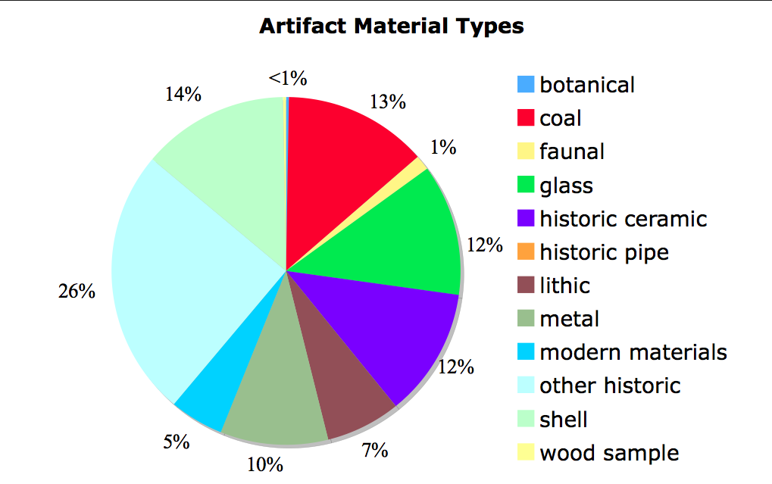

Figure 2. Artifact material type percentages

A careful storage plan, which includes both the initial set-up and periodic reviews of storage areas, is the most effective way to promote the longevity of a collection of artifacts. Ideally, artifacts should be stored in acid-free boxes or trays in a way that they are easily accessible without having to move many boxes of artifacts. Artifacts should never be stored in a manner that requires as little shifting of the collection overall to reach any given artifact. Metal cabinets with large, relatively shallow pull out drawers serve very well for a collection like ours, for they would allow for easy perusal of the collection without having to move too many objects. The more artifacts get handled, the higher chance that they will be damaged; therefore, objects should be packed and carefully labeled for accessibility. Fragile small pieces such as ceramics and glass should be wrapped in acid-free tissue or placed in small archival plastic bags. Non-archival bags will off-gas as they break down, possibly staining artifacts or speeding rates of deterioration. Likewise, wooden cabinets can release acidic gases as they age, providing a poor storage environment for objects.
Artifacts should be stored in an area where temperature does not fluctuate too greatly, and for our collection, humidity would be ideal at or below 55%. About 13% of our collection is metal, according to the catalog. Because the metal in this collection may have been in the ground for more than two centuries, much of it is already quite corroded due to exposure to water. Therefore, the humidity should be monitored in the storage facility to discourage further corrosion. For this reason, a damp basement, for example, is a poor location to store metals. Likewise, an attic is a poor choice for a storage facility for a collection, because temperatures tend to fluctuate greatly throughout the year. Different materials react differently to extreme temperature changes; materials such as wood and other organic materials expand and contract with temperature and humidity change, which can cause wear and deterioration in a collection.
Storage space is often in high demand in museums, considering the vast majority of a collection is generally not on display. It can be a challenge to find ideal storage space, especially in an historic house that has been converted to a museum or historical society. But wherever objects are stored, temperature and humidity should be monitored and checked regularly, and the space should be examined for evidence of pests often. Pests are one of the most feared visitors in a museum. Because some of the material that we will be introducing to the RIHS is organic, and all of it came out of the ground, steps should be taken to ensure that we will not be introducing any unwanted critters to the Rhode Island Historical Society collection. The wood samples are the prime suspect for unwanted visitor introduction; this can especially be a problem in this time of year, when the artifacts were in a cool outdoor shed for a time before they came to the lab. It is fairly common that things that have lain dormant in wood in cold weather will begin to wake up once they have been stored in a nice warm museum for a time. Several steps can be taken to ensure that the Rhode Island Historical Society won’t be receiving any unwanted guests from our collection. Because the possible problem area is a small portion of our artifacts, and the pieces themselves are relatively small, the easiest method of pest eradication is to place the wood samples in sealed plastic bags with iron filings and leave them there for a few weeks. The iron filings will oxidize, thereby removing the oxygen from the air in the bag, and any critters in there will be taken care of. Alternatively, objects can be left outside in sealed plastic bags if it is very cold for a few weeks, or the objects can be fumigated.
Artifacts should be displayed with as much care as they are stored. Display stands should be stable and secure. The objects should be displayed out of direct sunlight if at all possible, as UV exposure will damage many types of artifacts over time. If the artifacts are in a particularly bright room where the lightning cannot be changed, the display should be designed so that artifacts can be traded out after a few months time. If the display is interactive, steps should be taken to insure the safety of the artifacts. If docents will be handling the objects, they should be instructed on proper handling techniques. Gloves should always be worn when handling metals, as fingerprints may become permanently etched into the surface of the metal due to corrosion where oils have been deposited on the surface of the piece. However, gloves should not be worn when handling glass or pottery, as cotton may be slippery against a glazed surface and this may make the artifacts harder to handle safely. With proper storage and display procedures, the artifacts should remain a part of the collection indefinitely.
Efforts have been made throughout the excavation and investigation of this site to keep the participants in the production of knowledge about this site engaged at every step of the process. In designing a display and adding our information to the Rhode Island Historical Society, we are ensuring that this site is adding to a body of knowledge that is deeply tied to both Providence and the University. We have disrupted the site with our tarps and our backfill, but we know more now than we did before, and have left room for other scholars, students, and visitors to continue to interpret and reinterpret the data we have made available to them.

Works Cited:

Jones, Andrew. 2002 Archaeology observed, pgs. 39-62, In Archaeological theory and
scientific practice. CUP: Cambridge.

Lucas, Gavin. 2001 Introduction, pgs. 1-17, In Critical Approaches to Fieldwork.
Routledge: London.

Lucas, Gavin. 2001 Chapter 3, "Splitting Objects", In Critical Approaches to Fieldwork.
Routledge: London, pgs. 64-106.

Silberman, Neil A. 2008 Virtual Viewpoints: Multivocality in the Marketed Past? In J.
Habu, C. Fawcett, and J. Matsunaga, eds, Evaluating Multiple Narratives: Beyond
Nationalist, Colonialist, Imperialist Archaeologies. New York: Springer, pgs. 138-143.

The Rhode Island Historical Society website: http://www.rihs.org/ December 3, 2008.

The interpretations I make here are based on the information we currently have entered into our database. However, we have not cataloged all of the artifacts we collected. We are about 75% of the way through contexts (We’re missing 11 of 42) Therefore, these interpretations are not completely accurate and are intended to give the reader an idea of what can be accomplished with a catalog like ours. However, these interpretations are by no means complete or “correct.”

