Alexander Ruby
Object Biography: Bullet Casing
ARCH 1900
Prof. Krysta Ryzewski
December 15, 2008

Object Biography of a Bullet Casing

The Archaeology of College Hill class uncovered a number of interesting artifacts during the course of the John Brown House excavation. From ceramic sherds and corroded wire nails to modern materials such as coffee cups and rubber erasers, the diversity of findings was both surprising and impressive. One artifact that particularly drew some excitement from the excavation teams was a tarnished copper bullet casing from Unit 1, JBH 31. While the history of this particular bullet casing is still shrouded in mystery, its presence is a helpful guide to learning more about the John Brown House site.
It was a chilly afternoon (Ruby, 11/10/08) on the last day of digging the John Brown House site, November 10, 2008, when from the soil protruded what first appeared to be another greenish plastic tube. But the chilliness subsided to enthusiasm when Professor Ryzewski informed us that what we had found was in fact a bullet casing. Not only was the dig team happy that this object was not necessarily another example of modern refuse, but also that this casing came from what appeared to be a significantly more historic context layer of Unit 1 than had previously been encountered. Much of Unit 1 was characterized by a modern midden in fill soil, but JBH 31, the deepest layer that Unit 1 had time to dig, revealed a change in soil (Munsell value of 10YR ¾) and much older artifacts. The bullet casing only served to heighten our interest in this context layer.
The details of the bullet casing are diagnostic to both its identity and its possible date of production. The bullet casing as unearthed is a dark green color, which suggests that it is either tarnished copper or an exceptionally tarnished piece of brass, both of which are common to bullet casings. The artifact’s dimensions are 15.4mm in length with a barrel diameter of 6.2mm and a rim diameter of 7.8mm. The fact that the casing has a rim is significant because it shows that this bullet was a rimfire cartridge, an idea first patented in 1831 in which the rim at the base essentially serves as an internalized percussion cap (Wikipedia: “Rimfire ammunition”). There are no visible maker’s marks on the casing, but the dimensions suggest that it is either a .22 caliber Long or a .22 caliber Long Rifle bullet casing. (While there are slight differences between this casing’s dimensions and the standard dimensions of a .22 Long or Long Rifle casing, these are minimal and probably due to either degradation in the ground or from inconsistencies during the manufacturing process.) The .22 Long was an evolution of the .22 Short and was first produced in 1871 (Wikipedia: “.22 Long”). It was soon superseded by the .22 Long Rifle (first developed in 1887 by the J. Stevens Arms and Tool Company) which used a longer, heavier bullet with better range (Wikipedia: “.22 Long Rifle”). The casings for both the .22 Long and .22 Long Rifle are identical, rendering it difficult to determine for sure to which category this particular casing belongs. However, one can predict that the bullet casing from JBH 31 is a .22 Long Rifle casing simply based on the fact that this cartridge is much more popular. The .22 Long is considered obsolete, whereas the .22 Long Rifle is the most common cartridge ever produced (Wikipedia: “.22 Long Rifle”). While it is certainly possible that a .22 Long was used back in the late 19th century and found its way into this context layer, statistically it is more probable that this example is a .22 Long Rifle casing.
Considered as part of the JBH 31 context layer, this bullet casing provides a terminus post quem (TPQ) of 1871 (retaining the possibility that the casing is of a .22 Long cartridge). Many of the other diagnostic artifacts in JBH 31 are ceramic sherds with TPQ dates forty or more years earlier than that of the bullet casing. However, this observation can serve as an example of the time lag that can occur between an object’s production and its date of discard (Adams 41). A bullet casing may not be subject to the same level of time lag because it has the possibility of being used and discarded soon after its production, whereas a ceramic would generally only see this fate if it were broken or considered exceptionally hideous. Therefore, it is not especially surprising that the bullet casing shows a later date of production than other artifacts in the context layer.
This bullet casing also proves valuable to understanding more of the overall history of the John Brown House site. In her presentation on historical research of the excavation area, Steffi Yellin explained that the area of the excavation site in which Unit 1 was placed was most likely near a wall separating outbuildings on the site or was the site of a woodshed located behind the Robert Hale Ives house (Yellin, 12/8/08). Both of these scenarios correspond well to the potential of having a modern midden such as was found at Unit 1, but in the more historical context of JBH 31, these scenarios continue to be relevant. If one were to use a gun for the killing of livestock or for whatever other purpose, it is not unlikely that it would be used in the back of the house or in a shed. Furthermore, a woodshed might also be a likely place for keeping one’s gun supplies. Indeed, if one can claim that there are parts of the John Brown House property that are more likely to contain a bullet casing than others, then this site behind the Ives house site is certainly one of them.
The bullet casing from the John Brown House site was one of those artifacts one hopes is significant when it was first discovered. While it is not possible at this time to say with any certainty how this bullet was used or why, the information gleaned from its presence has helped shed light on this part of the John Brown House property and has provided a fuller history of the JBH 31 context than one can make with ceramic sherds alone.
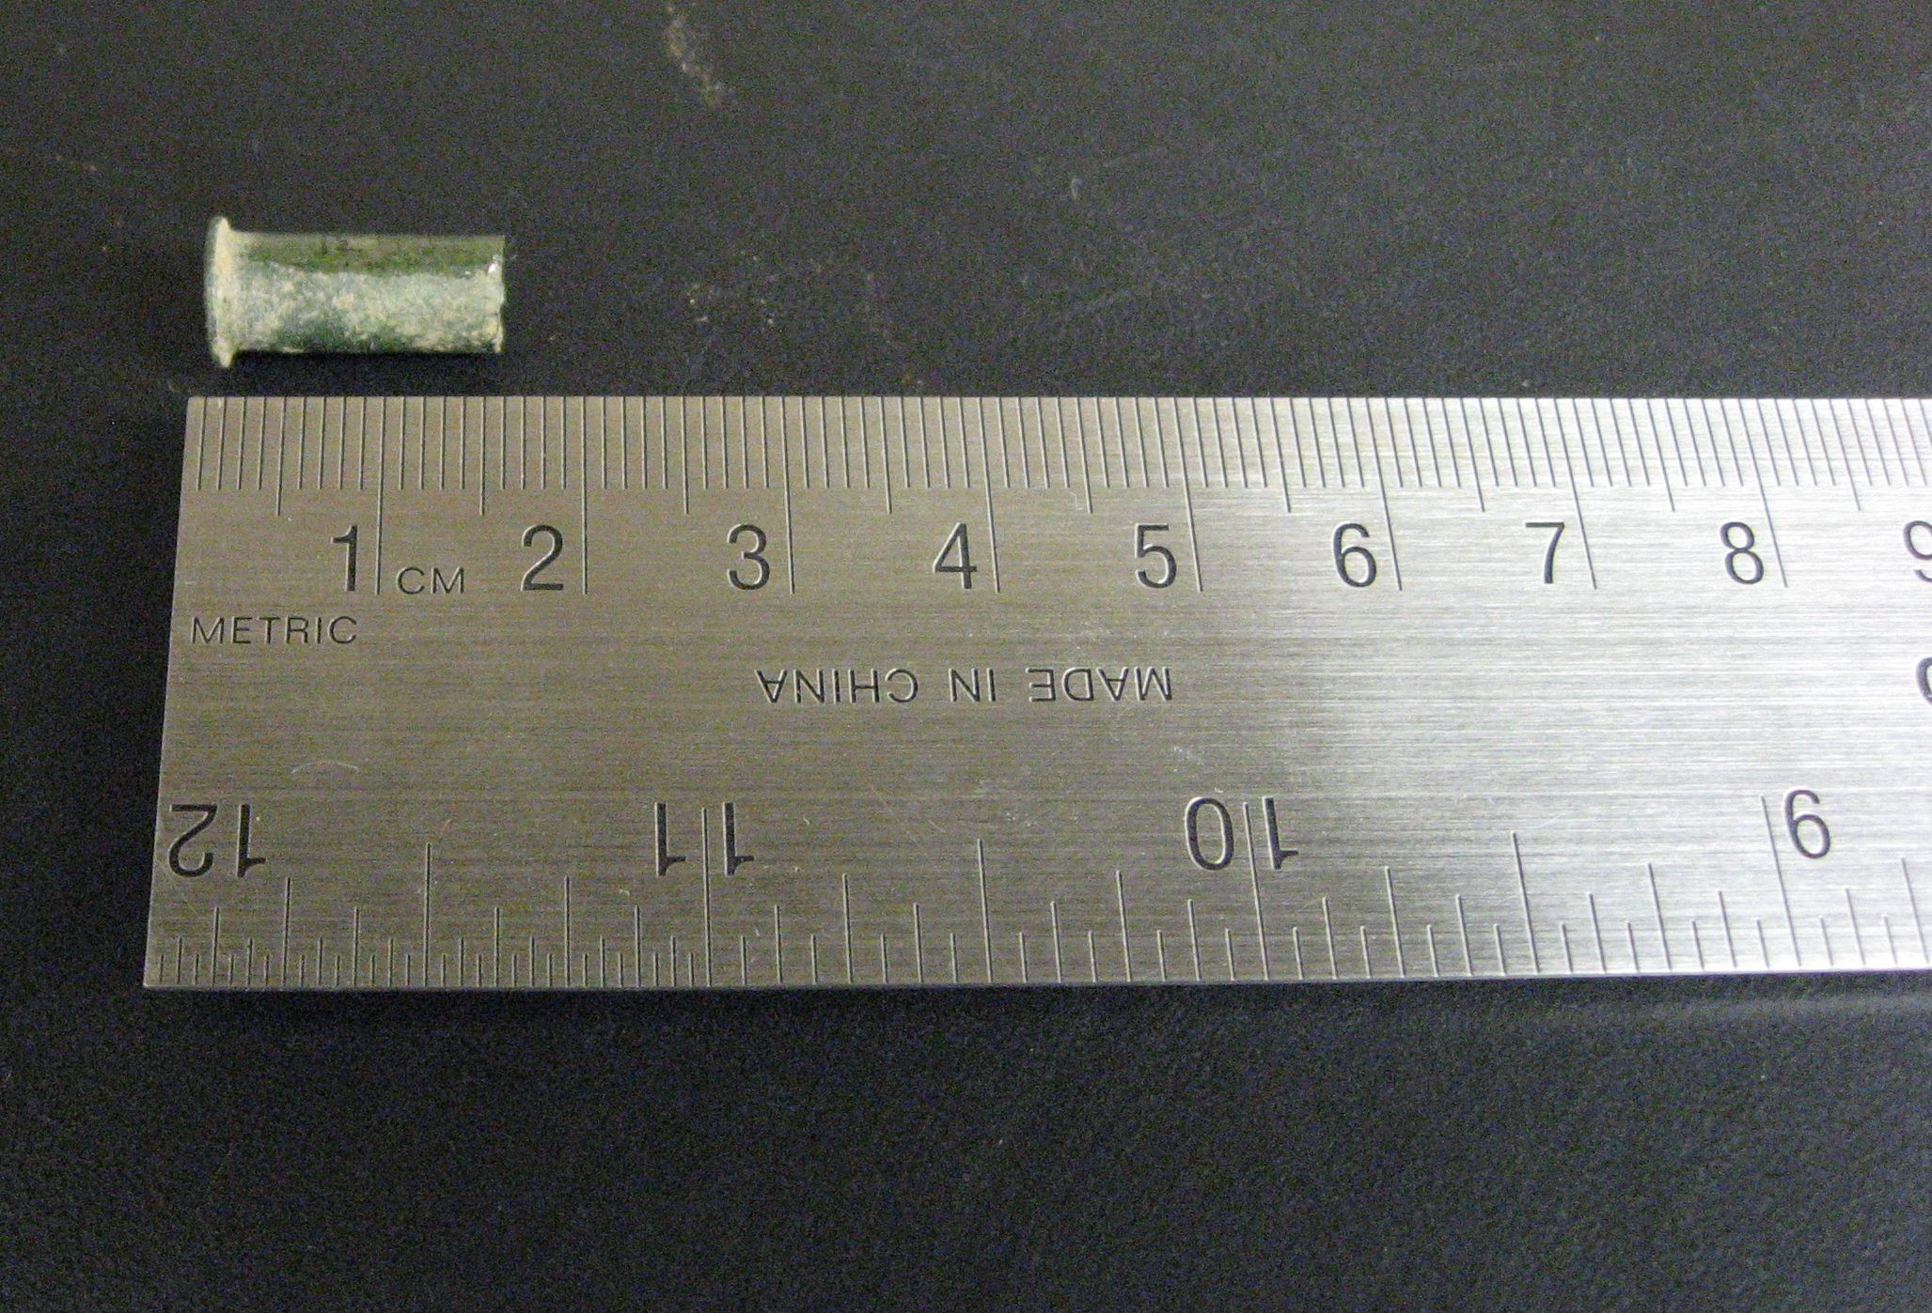
Photo of the bullet casing found in Unit 1, JBH 31

Works Cited

“.22 Long”. Wikipedia. 1 December 2008. Wikimedia Foundation, Inc. 13 December 2008 <http://en.wikipedia.org/wiki/.22_Long>.

“.22 Long Rifle”. Wikipedia. 13 December 2008. Wikimedia Foundation, Inc. 13 December 2008 <http://en.wikipedia.org/wiki/.22_Long_Rifle>.

Adams, William Hampton. “Dating Historical Sites: The Importance of Understanding Time Lag in the Acquisition, Curation, Use, and Disposal of Artifacts.” Historical Archaeology 37 (2; 2003): 38-61.

“Rimfire ammunition”. Wikipedia. 5 December 2008. Wikimedia Foundation, Inc. 13 December 2008 <http://en.wikipedia.org/wiki/Rimfire>.

Ruby, Alexander. “Alex’s Field Blog: November 10, 2008.” ARCH 1900: The Archaeology of College Hill: 2008 Season-John Brown House. 13 December 2008 <http://proteus.brown.edu/archaeologyofcollegehill/6520>.

Yellin, Steffi. “Historical Research on the Excavation Area.” ARCH1900 Final Presentations. Room 305, Metcalf Chemistry Lab, Brown University, Providence, RI. 8 December 2008.

