Alexander Ruby
Object Biography: Redware Fragment
ARCH 1900
Prof. Krysta Ryzewski
December 15, 2008

Object Biography of a Redware Fragment

Ceramic sherds were one of the more common finds at the John Brown House site, and some very interesting examples were unearthed. A simple redware fragment found in Unit 1’s JBH 24 may not, at first glance, seem like one of those examples, but its placement in this context layer and the family of pottery it represents make it an interesting item for further investigation and a worthy subject of an object biography.
The redware fragment in question is a small, triangular piece of unglazed, coarse earthenware. It is about 40mm across its longest side and is orange in color. This fragment was found on October 27, 2008, near the bottom of JBH 24 (approximately 40cm below the unit datum point). At this level of JBH 24, the soil had dramatically changed from a Munsell value of 10YR 2/2 to one of 7.5YR 3/4. What had been a large, modern midden of debris and refuse amid fill soil suddenly transformed into what appeared to be the site of a fire, perhaps a trash fire or perhaps something else. Large amounts of charcoal were found at these lower levels, as was evidence of charring on other artifacts. It is certainly possible that the fire caused the change in the soil composition, although another explanation could attribute the change to the imminent transition into JBH 31, a much more historic layer. It was among these variables that the redware fragment appeared. And it is for these reasons that its story is interesting.
Redware is one of the most common types of pottery in history. Historically, it has been used most often as a kitchenware, as it is cheap and easy to produce, and it is not a huge loss if it breaks or becomes dirty. Redware is fired at a low temperature (900-1200°C), and it is quite porous (Mount Vernon Ladies’ Association, 2008). While redware is usually not considered diagnostic when unglazed, it does have some characteristic production dates. The only problem is that types of redware have been produced for centuries, and coarse earthenware of this type is so common throughout history that it is rarely useful for dating context layers. Indeed, unglazed coarse earthenware has a range of greatest production of 1490 to 1900 (Florida Museum of Natural History, 2004) and has been present in American pottery production since 1725 (Stelle, 2001). And while it may be rarer to see redware as a commonly produced utilitarian ceramic in America today, it is still produced at not insubstantial levels. Thus, one cannot tell for certain from the unmarked fragment found in JBH 24 whether it is two-hundred years old, or only two.
Yet the possibilities of how this redware fragment made its way into JBH 24 can certainly guide our interpretations of the history of Unit 1. One option is that when the modern midden was created, a piece of redware happened to be part of it. Perhaps it was a new acquisition, possibly a planter, which lost favor or broke and was thrown away in the recent past along with the many pieces of plastic and Styrofoam found in the Unit 1 midden. Alternatively, it is possible that this redware fragment was much older and had been discarded long in the past, only to be unearthed during some form of landscaping and discarded once more along with other debris from the site. Finally, it is entirely possible that this fragment was part of an historic redware ceramic, produced long ago, that only recently cracked and was discarded. This final case may seem unlikely because unglazed redware is rarely an heirloom, but it would still be a prime example of the time lag objects can undergo between the time they are produced and the time they are finally discarded (Adams 41).
While simple, this redware fragment is representative of a huge family of ceramics that are often overlooked but rarely negligible. Redware pottery has been an old standby that families both rich and poor rely on for all sorts of household tasks. Such ceramics may not be as glamorous as the hand-painted or heavily glazed sherds also found at such sites, but their role in history has been just as great, if not greater. There is no telling for sure what life this fragment led, but its mystery helps us as researchers trying to piece together the history of the John Brown House site by forcing us to juggle all manner of potential histories. It is through this obligatory thinking-outside-the-box that true historical archaeology finds the real answers to the difficult question of “what happened here way back then?”

Works Cited
Adams, William Hampton. “Dating Historical Sites: The Importance of Understanding Time Lag in the Acquisition, Curation, Use, and Disposal of Artifacts.” Historical Archaeology 37 (2; 2003): 38-61.

“Coarse Earthenwares.” George Washington’s Mount Vernon Estate & Gardens. 2008. Mount Vernon Ladies’ Association. 13 December 2008 <http://www.mountvernon.org/visit/plan/index.cfm/pid/867/>.

“Historical Archaeology: Digital Type Collection: Unglazed Coarse Earthenware (generic).” Florida Museum of Natural History. 2004. Kathleen Deagan, Curator. 13 December 2008 <http://www.flmnh.ufl.edu/histarch/gallery_types/type_index_display.asp?type_ ame=UNGLAZED%20COARSE%20EARTHENWARE%20(GENERIC)>.

Stelle, Lenville J. “An Archaeological Guide to Historic Artifacts of the Upper Sangamon Basin.” An Archaeological Guide to Historic Artifacts of Central Illinois. Parkland College: Center for Social Research, 2001.
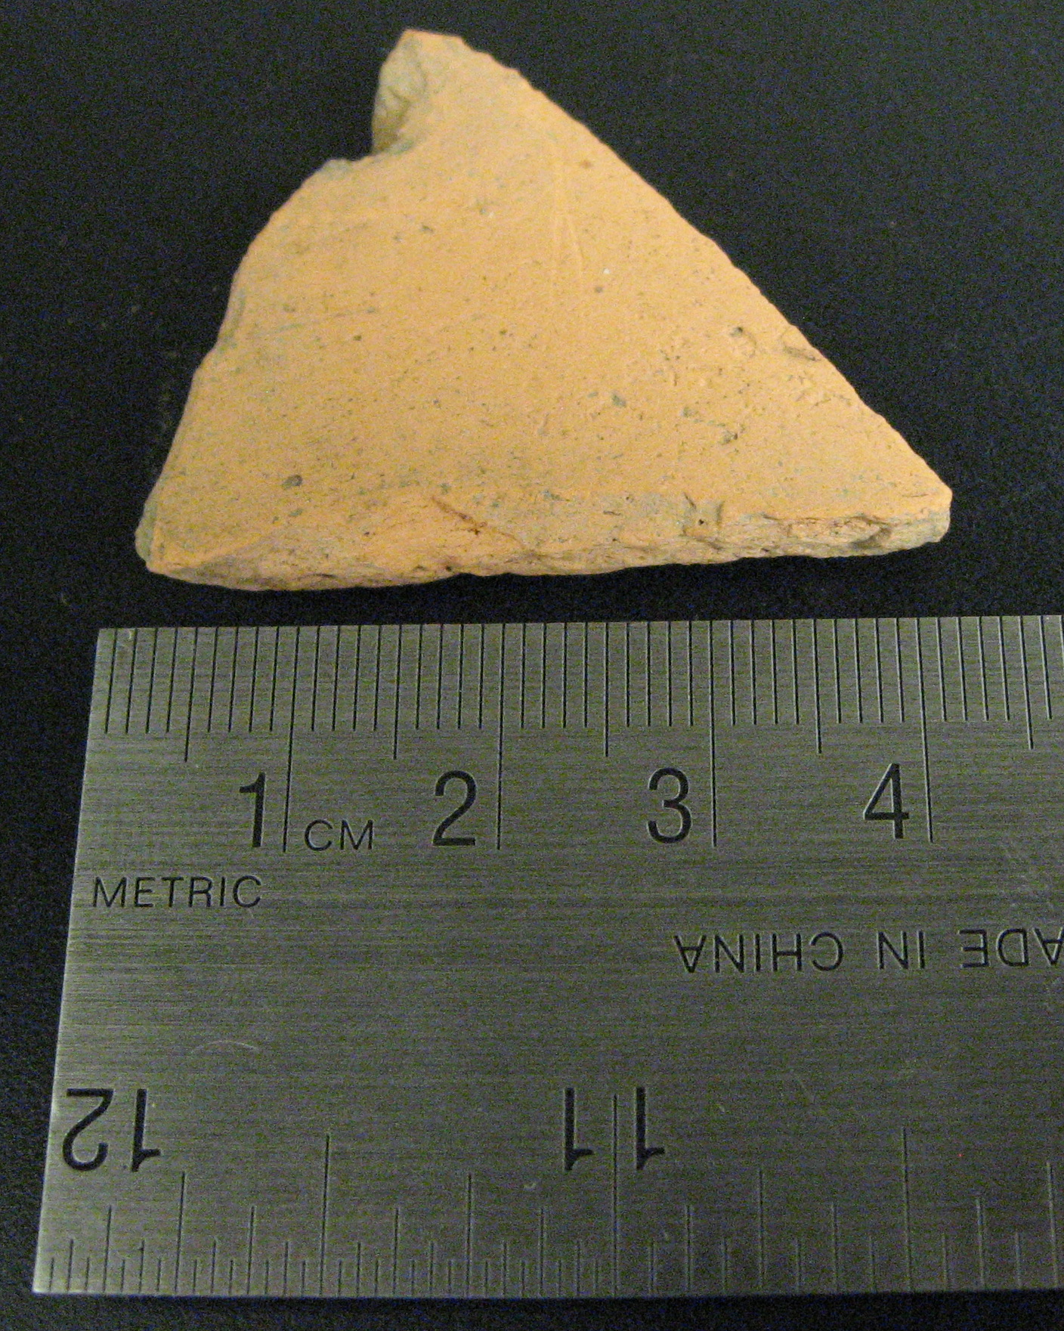
Photo of redware fragment from Unit 1, JBH 24

