Jacob Combs

Object Biographies

Milk Carton

Few things are as beloved by Rhode Islanders as coffee milk. In a way, it is, as some would put it, the state drink. It is only fitting, then, that we would encounter a coffee milk carton during our excavation of the John Brown House. The carton was found in Unit 1 within context JBH18, which was part of Stratum 1, the modern fill soil. Other modern refuse found in this trash pile included a McDonald’s coffee stirrer, a plastic bag, pieces of plastic and string, and a Mr. Donut cup (Field Notes JBH18).
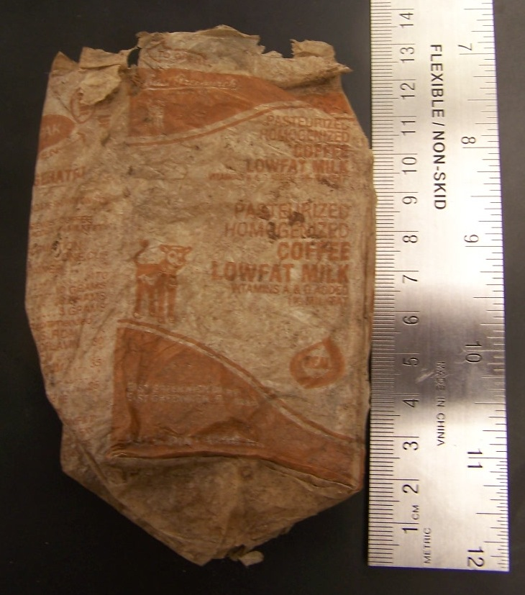
When laid flat, the carton measures 12.5 cm long and 7.6 cm across. Taking into account what the carton would have looked like with its original three-dimensional shape, it measures 11 cm tall, 6 cm across the larger face and 5 cm across the thinner face. Thankfully, the carton is still remarkably legible, so there is a lot of interesting information that can be gleaned from it. As the pictures show, the milk is a product of East Greenwich Dairy Co., of East Greenwich, Rhode Island. This half pint (236 ml) carton contained pasteurized, homogenized, lowfat (1% milkfat) coffee milk, with both Vitamins A & D added in. One of the smaller faces has tabs to be pushed up for opening the carton, and the words ‘For best quality sell by date shown on top,’ a date that, frustratingly, is missing. The other face says Champion International Corporation DairyPak Division, and has the Champion Corporation’s logo. Also on this side is some text that says “Blanks made under license from Ex-Cell-O Corporation.” To the touch, the carton feels almost nothing like the way one would expect it to—it is nearly tissue paper thin, clearly due to the fact that it has been buried in the ground for some time.
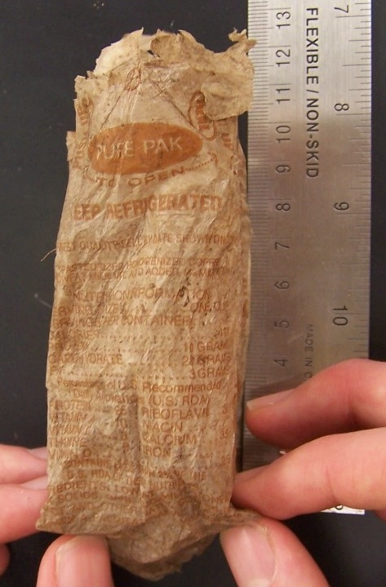
Although this milk carton is highly diagnostic, giving it an exact date of production or use is nonetheless quite difficult. The issue of time lag, discussed in depth by William Hampton Adams (2003: 38) regarding ceramics, is not much of an issue in this case—the time from the production to the consumption of the carton’s contents was probably relatively short, given the perishable nature of the milk itself. It is a bit frustrating that the sell-by date, which was clearly included on the carton at some point, is now missing, since that date would be quite definitive. Without that, other diagnostic elements of the carton must be used to provide a range in which the milk carton could have been produced or used.
The most obvious diagnostic element of the carton is its very material and shape. Folded paper milk cartons were first patented in 1915 by John Van Wormer, who called his system “Pure-Pak.” Ex-Cell-O Corporation, a Detroit car manufacturer, bought the system in 1934. Before 1960, milk cartons had no spout, and instead a hole had to be cut into the carton before pouring. Another diagnostic feature of the carton is the “REAL” sign visible on its face. The REAL sign was created in California during 1976 to identify foods that used real dairy products rather than substitutes. It is now administered by Dairy Management Inc. Ex-Cell-O corporation was bought out in 1986 by Textron, providing a possible end date, unless Textron continued to operate Ex-Cell-O under the same name. In a similar vein, Mister Donut (the maker of a coffee cup we also found in the unit) was bought out by Dunkin’ Donuts in 1990. According to Marianne Migliori, a longtime resident of Providence, the area’s Mister Donut stores adopted the new Dunkin’ Donuts name at that time. Information about the East Greenwich Dairy is a bit scarcer, but that company was bought out by West Lynn Creamery of Lynn, Massachusetts in 1990.
Together, these data provide a good amount of support for a date range for the milk carton between 1976 and 1990. The REAL sign provides a definite post-1976 dating, while the presence of the Mister Donut cup in the same stratum (although a fill soil) makes 1990 a good end date. It could also be argued that a good end date would be 1986, when Textron bought out Ex-Cell-O.
It is not difficult to imagine how a coffee milk container would end up buried in the front lawn of the John Brown House. Clearly, the milk was produced in East Greenwich, Rhode Island, and was probably packaged somewhere nearby. My hypothesis for the refuse found in Units 1 and 2 is maintenance work, probably on the piping system that was found in Unit 2. I remember when my home was being remodeled, and every day we would come home to find fast food trash, essentially, all over the site. I believe that a construction worker had some coffee milk one day and then threw the carton into either what was a trash pile or just on the ground, and it ended up being buried. I also believe that the other trash we’ve found, such as the Mister Donut cup and the McDonald’s coffee stirrer, ended up buried in the soil in the same way. There is something fitting about finding a coffee milk carton when excavating a site in Rhode Island. Excavating Unit 1 gave me great insight into the assumptions that non-archaeologists make about the archaeological process. There is something equally fascinating about a coffee milk carton from 20 years ago as there is with a piece of creamware from a few centuries ago, even if the mystery of another time period isn’t there. During Maggie’s presentation about setting up an installation at the John Brown House, she talked about using the coffee milk container as a way to show kids that history is actually everything that came before, not just objects from another century. Our own material culture is entering the archaeological record in ways that we probably never really think of. The coffee milk carton we found in Unit 1 is a valuable reminder that even modern items have stories of their own.

Button
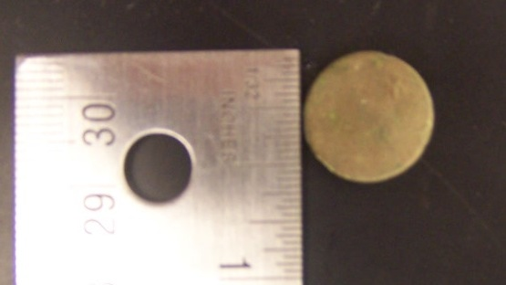
Even the smallest and least assuming of artifacts can be illuminating. A small button measuring 1.5 cm in diameter with a broken shank that is 3 cm long was found in JBH39, a context within Stratum 16 from Unit 4. Other finds in this context included various pieces of ceramic, brick, glass and nails (Field Notes JBH39). Although the button is extremely corroded, especially on its face, an analysis of it is valuable, especially considering the importance of buttons as elements of fashion throughout the last few centuries.
As Carolyn White puts it, “buttons were more than functional fasteners; they were a primary way of embellishing a garment of clothing, particularly for men” (White 2005: 50). The button making industry thrived in England during the 1700s, particularly in Birmingham, and most of the buttons used in America during that century were made in England, although some came from France or the Netherlands (ibid.). An American version of this button making enterprise did not develop until the 19th century.
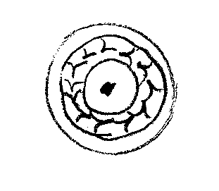
In terms of the button itself, there are only a few definitive conclusions to come to. The shape itself resembles button type 9 from Ivor Hume’s A Guide to Artifacts of Colonial America, a flat, brass disc with a well-soldered eye that has no foot (Hume 1969: 91). Although the shank is broken, it is similar in shape to a brazed omega shape (White 2005: 52). This typology, borrowed by Hume from Stanley South, places this variety of button in the time period 1726-1776. It is interesting, though, that Hume mentions a “hand stamped face design” in his description of this button type (Hume 1969: 91). The face of the button found in Unit 4 is far too corroded to discern any design, but there is a decoration visible on the button’s rear face that I have reproduced here which resembles a laurel wreath.
Why would this decoration would appear on the back of the button and not the front? Clearly, if the button were serving some sort of decorative purpose, one would expect the side with the decoration to be the more prominent one. In this case, there is clearly decoration on the back of the button, since the shank is obviously present to fasten the button to clothing. According to White, however, “many coats had false buttonholes with corresponding decorative buttons” (White 2005: 58). This could be a possible explanation for the decoration being on the ‘wrong side.’ If the button were merely some embellishment on a coat, it could have decoration on the back simply as a nice stylistic touch.
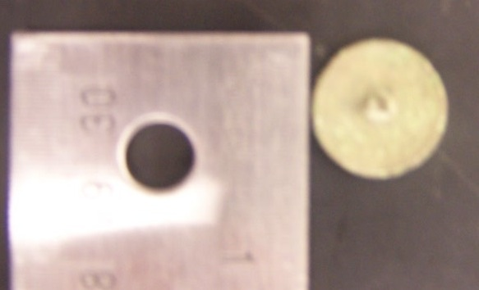
Buttons are generally divided into three sizes based on diameter: small, less than 12 mm, medium, 12 to 18 mm, and large, more than 18 mm. The button from JBH 39 is 15 mm, placing it firmly in the medium category. According to white, this size would be consistent with either a waistcoat button, which are usually between 14.5 and 19.5 mm, or a sleeve button, which are usually between 13 and 17 mm (White 2005: 55-57). Waistcoats usually had only a few functional buttons, while most were included for decoration and had no real buttonholes. The double-breasted waistcoat became popular in the 1750s, and a second row of buttons was added to the front of the garment. These buttons usually coordinated with coat buttons (White 2005: 59). Sleeve buttons, on the other hand, were used mostly to fasten shirtsleeves. These buttons usually had two smaller buttons connected with a link and were inserted into slits on either side of the cuff (White 2005: 61). Because of this, is in unlikely that the button from Unit 4 is a sleeve button, which means that it is most likely a waistcoat button.
The terminus post quem (TPQ) date for Unit 4 so far is 1855 because of a piece of cellulose plastic that was found in the unit during excavation. Without this plastic, the TPQ is still in the 1830s. Because of this, there is some issue of the “time lag” that Adams discusses regarding ceramics when considering the dating of the button (Adams 2003: 38). Although the deposition date for Stratum 16 is much later than the probable manufacture date of the button, this does not necessarily have to be a contradiction, per se. A date range from 1726-1776 would put the button’s manufacturing in a reasonable time frame considering the early history of the John Brown House. It is easy to imagine the button being ripped off of a garment somehow and falling to the ground, especially considering the fact that the shank is broken. But even if this were not the correct scenario, a deposition date in the early to middle 19th century is still very plausible. Clothing is often handed down family lines, so it is easy to imagine some situation in which a waistcoat is handed down from parent to child. Another possible scenario could involve a piece of clothing kept by a family member for sentimental reasons. In any of these scenarios, the manufacturing date of the button does not necessarily have to be the same as its use date (and in fact, almost certainly is not), and of course also does not have to be the same as the deposition date.
It is interesting how different it was to analyze the button compared to more recent artifacts like the milk carton and fence post. With both of the modern trash items, information was (for the most part) readily available, whether on the Internet or from oral sources. In terms of the button, however, I was only able to use written information. A major part of my argument depends on both White and Hume’s analysis, and to some extent I have to accept their information secondhand. In turn, Hume’s classifications are of course themselves taken secondhand from South. In a way, this is all just a part of the archaeological process, but nevertheless a lot of my analysis of the button depended on the research of others, whereas my analysis of the modern trash finds depended mostly on my own analysis.

Fence post

As Robert Emlen, Brown University Curator, puts it, the fence surrounding the property of the John Brown House “has a pretty short shelf life.” A combination of wind and salt air causes the fence to deteriorate quickly, so it often requires maintenance to keep it presentable. It is not surprising, then, that a large chunk of a fence post would be found in JBH24, part of the modern fill that was uncovered in Unit 1. If the fence commonly requires maintenance, it is quite feasible that, at some point, an old, deteriorated piece of fence ended up on the ground and was incorporated into the fill at some point when the ground was disturbed.
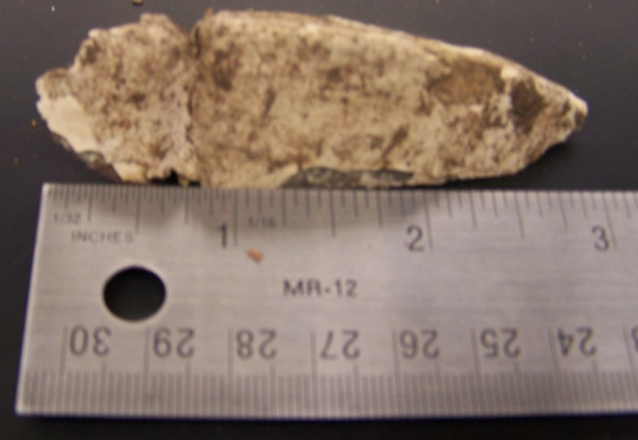
Nevertheless, this fence post fragment must be considered in light of the other finds in Unit 1. The Unit contained a large quantity of painted wood that we didn’t really consider as we were excavating. There was clearly some connection between the different wood chips we were unearthing, but we didn’t consider any possible function for the wood. In terms of the fence post, however, this painted wood takes on a different significance. Clearly, the pieces of wood that we found were of the same type as the post—painted white and rather beat up. Did the splintering of the wood happen after the post was placed intact in the unit, or did it occur sometime before? Both explanations are plausible, since either human action or the simple effects of time and damp soil could affect the wood’s composition. It seems more likely, though, due to the pattern of splintering, that the wood was broken before it made its way into the ground.
The fence post is diagnostic, although not precisely so. Nineteenth-century representations of the John Brown House do not have a fence around the property (instead, there is another house towards the west of the lawn—the house that Steffi has been investigating). When Marsden Perry bought the John Brown House in 1901, he razed the house on the west of the lawn and enclosed the now larger property with a version of the fence that is seen today. A matching fence was constructed at the brick carriage house property across the street around 1904.
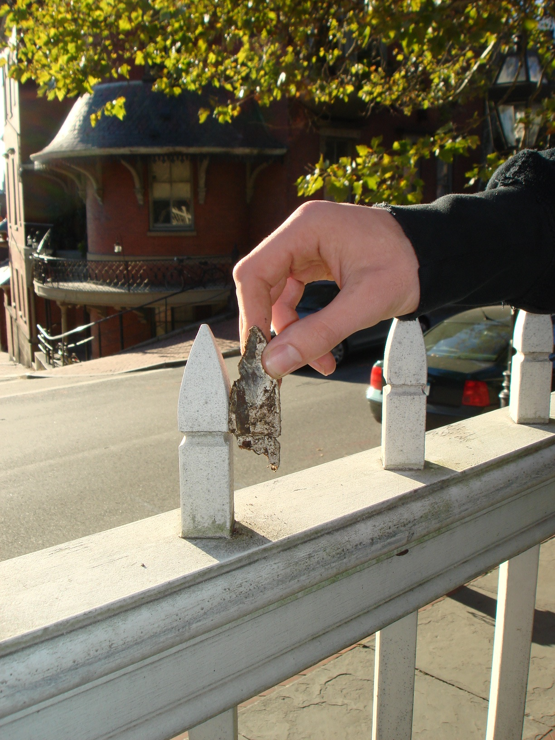
In terms of the actual fence post that we found during excavation, a closer dating is possible. As the accompanying photo demonstrates, the fragment (which measures 7.8 cm tall and 2.7 cm across its longest face) is clearly part of the decorative embellishment atop the fence posts, so it is safe to assume that it came from this fence. The John Brown House celebrated its bicentennial in 1986, at which time the Providence company August Mende Inc. was contracted to repair the fence. I spoke with Robert Mende, who oversaw the repairs, about any information he could provide regarding the fragment we had found. Mende made the gates now visible at the John Brown House, and replaced between 21 and 31 sections of the fence. The original wood used was Cyprus, which he replaced with Spanish cedar. Around two or three years ago, he also replaced the wood fence at the carriage house with an iron one. He estimated that the work occurred in the late 1980s and continued for a few years into the early 1990s.
These dates match the other materials found in the site, such as the coffee milk carton that I profiled above. The dates for the milk carton seem to point towards an early 1990s cutoff, just as Robert Mende’s dates do. I believe that sometime during maintenance work on the fence, parts of the old fence were removed and dropped on the ground, eventually becoming part of the fill layer found in Unit 1. It is possible, actually, that the maintenance work that I described before, which I attributed to possible work on the piping found in Unit 2, could have been this restoration of the fence. Given the fact that work went on for several years, it is not too difficult to imagine such a scenario.
This fence post, and the means I have used to look into its history, demonstrates the importance of the oral record to the archaeology of the recent past. As Laurie Wilkie puts it, “Oral traditions are [a] powerful source for documentary archaeology” (Wilkie 2006: 19). Although neither conversation would really constitute an element of an ‘oral tradition,’ both are a component of the oral record. In her case study, Wilkie uses oral history as a complement to material history. In a similar way, my correspondence with Robert Emlen and Robert Mende filled a gap in the written record regarding the history of the John Brown House. In cases of the recent past, oral recollection can often be more helpful than the written record, although, as Robert Mende put it, thinking back 20 years can sometimes be inaccurate.
In the end, the history of the fence post fragment is much harder to discern than that of milk carton, since the latter is much more diagnostic. The large amount of writing present on the milk carton provided several opportunities to compare dates, while the lack of any visible writing on the fence fragment requires other means of dating. It is encouraging, though, that the oral history obtained from both Robert Emlen and Robert Mende regarding the fence fragment matches the dates from my investigation of the milk carton. It is my hope that next year’s class may be able to explore the history of the John Brown House in more detail, which might reveal further insight into the fill soil that we uncovered in Unit 1. Perhaps some record of maintenance work exists in the museum’s records that could be used to determine how the modern trash actually ended up in the fill soil. Even if this isn’t the case, though, it is still interesting to consider the fence post in a hypothetical situation until more evidence is unearthed.

http://www.associatedcontent.com/article/409477/milk_cartons_history_and_interesting.html
ibid.
ibid.
http://web1.msue.msu.edu/dairy/nobones7.html
http://proquest.umi.com/pqdweb?did=961657971&sid=1&Fmt=3&clientId=7344&RQT=309&VName=PQD
Personal correspondence, Dec. 15, 2008
http://findarticles.com/p/articles/mi_m3301/is_n4_v91/ai_9081597
personal communication, Dec. 8, 2008
Providence Journal, Oct. 8, 1901
personal communication with Robert Emlen, Dec. 8 & 9, 2008

