An object biography of a clay tobacco pipe- Unit 3, JBH 12

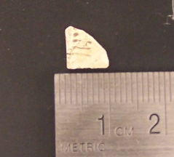
This artefact was uncovered on the 29th September 2008 in context JBH12, the first context assigned in Unit 3. Its measurements are 8 x 8 x 2mm, and it was identified as a shard of a tobacco pipe bowl by the clay material, and by the incised design that runs vertically down from the bowl edge.
Clay tobacco pipes were common household items from the late sixteenth to early twentieth century. The unfired kaolin clay was rolled and placed in moulds, where the pipes were shaped using a gin-press to create the bowl, and hand tools for piercing the bore hole and trimming the edges. They were then stacked, several thousand at a time, in an up-draught kiln and fired. The nature of the pipe as “an item that was manufactured, imported, smoked, and thrown away, all within a matter of a year or two” mean they are richly found in the archaeological record, and dating methods based on the change in bowl shape, and bore diameter have been established through the work of Jean Harrington and Adrian Oswald that can help date the JBH12 sherd.
The incisions around the rim of the bowl are a decorative process known as rouleting, and on the artefact from JBH 12 the irregular marks are an indication of a hand-made rather than machine-made process. Incisions of this sort appeared on pipe bowls as early as 1610, although the marks tended not to extend as far down the bowl as they do on the JBH12 sherd. Rouleting also appeared on the stem,
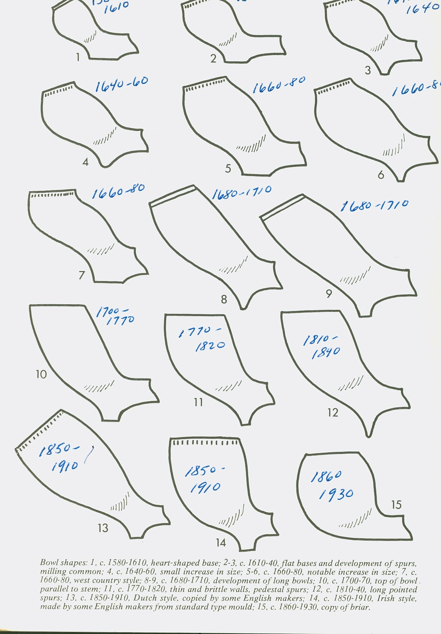
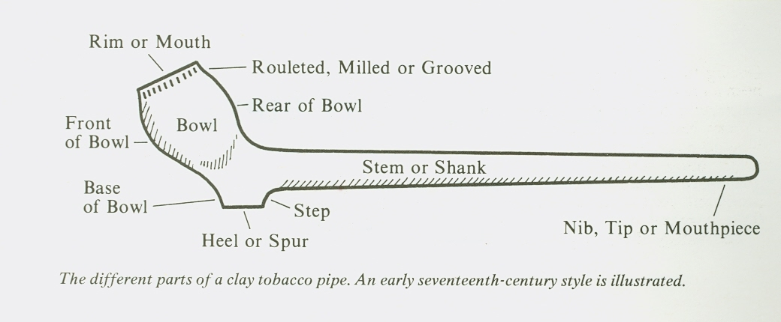
Diagrams from, Clay Tobacco Pipes, by Eric G. Ayto Shire Album 37, Shire Publications Ltd., 1979
as can be seen in a stem from Greene Farm (GF1258, artefact ID 7119, Level 5, see right)) with the oblique hachure motif. There is no curvature from the bowl to the rim on the sherd, which is helpful for dating. The diagram on the previous page that illustrates the change of the bowl shape over time suggests that the JBH12 artefact dates from 1850-1910 as it has the
rouleting, but does not have curvature in the top of the bowl.
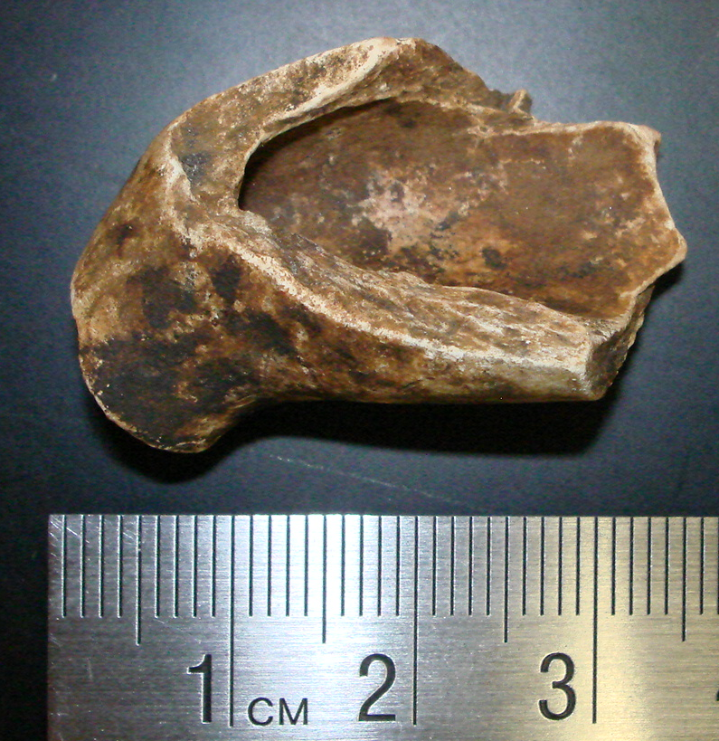
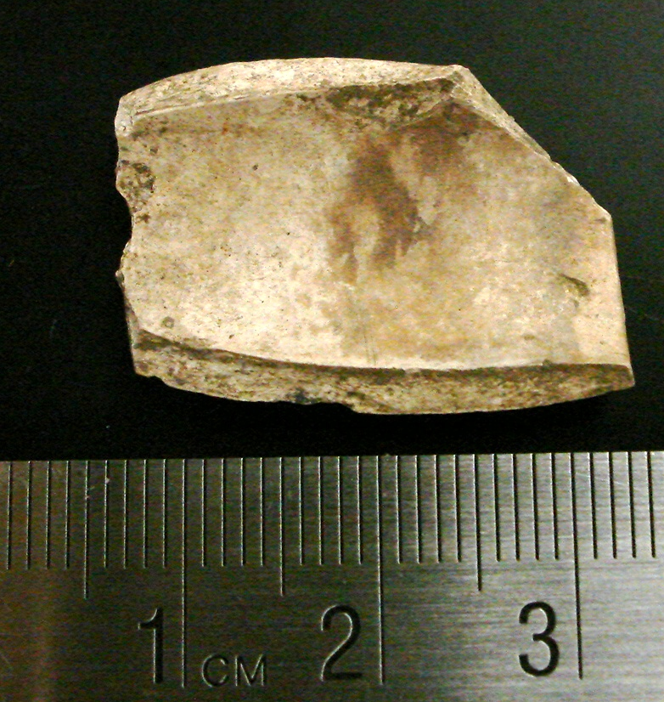
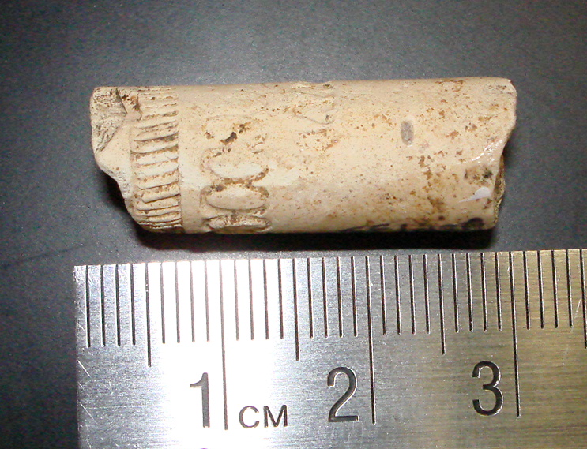
The thinness of the bowl wall (2mm) is also an indication that the JBH12 sherd is of a later date. Manufacturing changes after 1700 resulted in a smoother finish, and allowed the wall of the bowl to be thinner. Comparisons with other tobacco pipe fragments found in Rhode Island demonstrate this change. The pipe bowl from Greene Farm (GF1550, 8897.01, top left) can be dated by its bore hole size of 7/64” which reached its peak of production between 1650-1680 (Harrington). The pipe bowl is significantly thicker then the JBH12 sherd, which is closer in size to a pipe bowl from the site of Smith’s Castle (RI375, N5 24, E600, Level 1, middle left, and compared to the JBH12 sherd bottom left). This pipe bowl dates from the nineteenth century, and suggests that the JBH12 sherd also dates from the nineteenth century, on the basis of the thinness of the bowl wall.
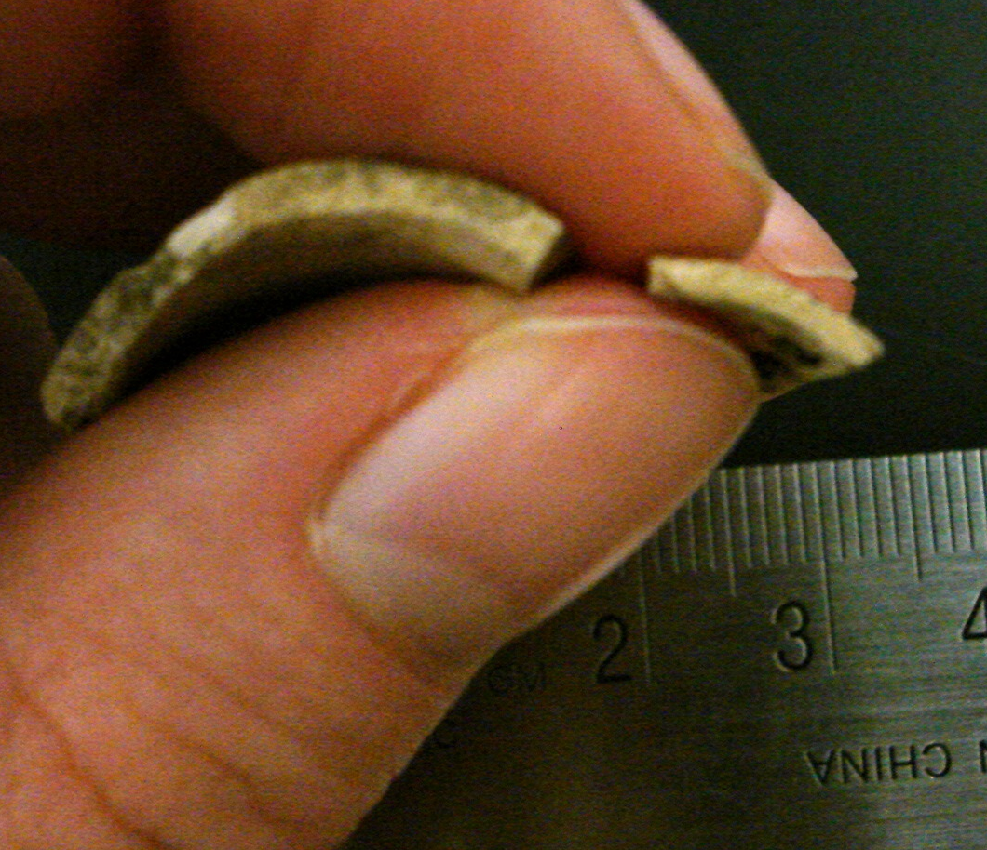
The technology for smoking tobacco in pipe form was adopted from the Native Americans in the sixteenth century, and the earliest description of an English clay pipe comes from William Harrison who wrote in 1588 that “the taking in of the smoke of the Indian herb called Tobacco by an instrument formed like a little ladle...is greatly taken up and used in England.” In 1619 the pipe industry formally began in London when James I granted a chart to the Worshipful Company of Pipemakers in Westminster. The English and the Dutch dominated the pipe making industry until the nineteenth century when the “previously almost non-existent American pipe industry burgeoned.”
Based on this information, and dating the JBH12 sherd broadly to the nineteenth century, it is hard to establish whether it was imported from England or Holland, or if it was manufactured in America. However, considering the large amount of shipping trade that was undertaken by the inhabitants of Providence, it is perhaps more likely that the pipe was part of a cargo imported from Europe on one of the merchant ships.
The sherd was found in the topsoil of Unit 3, along with two glass shards, an iron nail, a piece of coal, two sherds of creamware, and white glazed sherd of ceramic with a mulberry transfer print. The date ranges for the ceramics are from approximately the 1760s-1820, and the date range for cut nails is c. 1790-1900. The artefacts from JBH12 date to similar periods, however the TPQ established for the deposit below is 1963. The pipe bowl sherd is part of a fill that was removed and re-deposited, perhaps more than once, meaning that artefacts from the nineteenth century ended up in contexts above twentieth century artefacts. The disturbance and re-deposition might account for the fact that this was the only evidence of a tobacco pipe across the whole site, despite their ubiquitous nature in the seventeenth to nineteenth centuries, and the smallness of the sherd. The tobacco pipe artefacts from the Greene Farm and Smith’s Castle sites are larger, and it is likely that the removal and re-deposition caused the pipe bowl to be broken into smaller sherds, one of which was recovered from JBH 12.
The nineteenth century saw the production of many decorated pipes, some with coats of arms, and intricate designs such as an eagle’s claw clutching an egg, or a hand holding a wine glass, and even faces on the bowl. These fancy pipes were not the ones smoked by the working class, who used plain clay pipes, often with a shorter stem so that they could be gripped by the teeth. They were called “cutties”, and were smoked by women as well as men. The documentary evidence concerning 327 Benefit Street indicates that there were several buildings apart from the house- outhouses, a carriage house, a woodshed, two barn-like buildings. The Providence directory lists a cook and a butler living there in 1895-6, and a different butler in 1906. The list of buildings and directory information makes it clear that there were servants associated with the property, and it is possible that these working class people would have smoked tobacco in their leisure time. Domestic service is a very different working class occupation from the textile mill workers in Mrozowski’s study, but it is possible that the servants associated with the property at 327 Benefit Street smoked the plain clay tobacco pipe with a rouleted design around the rim of the bowl, a sherd of which was found in JBH12, Unit 3.

Ivor Noël Hume, Artifacts of Colonial America, 1969, p.296
Eric G. Ayto, Clay Tobacco Pipes, Shire Album 37, Shire Publications Ltd., 1979
Diane Dallal, “Pipe Analysis” from Stadt Huys Block Excavation site report, p. 9
Ibid., p. 8
See the Summary of Units 3 and 5 by Elise Nuding
Eric G. Ayto, Clay Tobacco Pipes, Shire Album 37, Shire Publications Ltd., 1979
Stephen A. Mrozowski, Living on the Boott:Historical Archaeology at the Boott Mills Boardinghouses, Lowell, Massachusetts, 1996
For further information about the buildings and residents see Stephanie Yellin’s research on 327 Benefit Street.

