An object biography of green glazed coarse earthenware
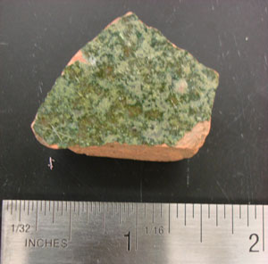

This sherd of green glazed coarse earthenware, measuring 30 x 28 x 9mm, was uncovered in context JBH23, in Unit 3 on 20th October 2008. The glaze is lead based, and the green colouring identifies it as an early glaze. The date range of production for glazed redware coloured dark brown or black is 1700-1770 but the green glaze predates these ceramics. Coarse earthenware is baked clay, fired at a relatively low temperature of 900-1200⁰C (porcelain is fired at 1300-1450⁰C), of porous composition. Glazes are applied to protect the body beneath, and lead glaze is applied to the earthenware using lead oxide as a flux to lower the melting point of the glaze. When the glaze melted onto the surface of the clay, it was fired again. The green colouration is achieved by adding copper oxide to the glaze. The tempering of the earthenware, which reduces the shrinkage, warping or splitting that may occur in firing, was with large quartz grains or pebbles that can protrude through the glaze, and there are a few small protrusions on the artefact from JBH23 that may be due to this stage of the manufacturing process.
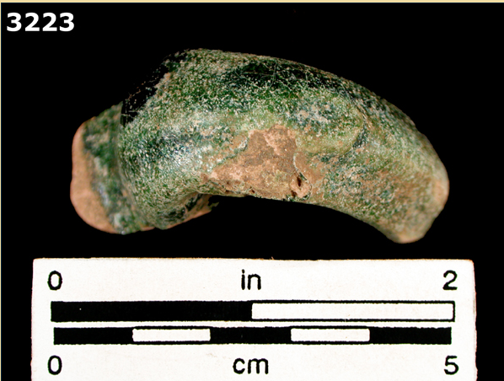
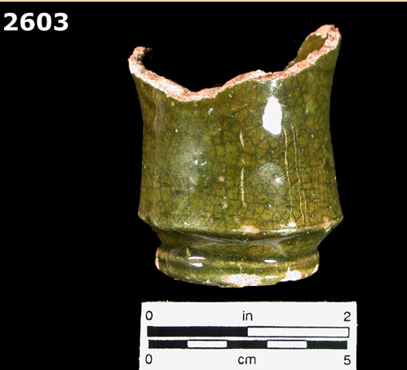
The date range for green lead glazed coarse earthenware on the online digital type collections of the Florida Museum of Natural History is 1490-1650 (two pieces from their collection are shown below), and Deetz informs us that the manufacture of earthenwares by colonists in America began around 1620. Ivor Noël Hume includes some green glazed earthenware vessels in his Artifacts of Colonial America (1969)- an “apple-green” lead glazed coarse earthenware chamber pot discarded c. 1700, glazed inside and out (p.146), a “spouted jug of a hard redware, white slip coated and covered with a green lead glaze, second quarter of the seventeenth century” (p. 77). The sherd from JBH23 is only glazed on one side, however as some of the glaze has flaked off on this side, it may well be that the other side was also glazed, but has not survived. If only one side was glazed, it is likely that it was the inside.
Coarse earthenware was used primarily for utilitarian vessels, and required the glaze to prevent liquid from being absorbed by the porous clay. One of the artefacts in Hume’s publication is an Iberian storage jar, made of “coarse redware streaked externally with white slip and lead-glazed on the inside, common c. 1745-80. Height 32.5””(p. 143). The FMNH, however, describes the green lead glaze as “usually occurring on both sides of the earthenware”, so perhaps it is more likely that the glaze has not survived on the other side of the sherd from JBH23.
The utilitarian nature of the vessels use is indicated by the thickness of the sherd, as the vessel would have received a lot of use. Some of this use is evident in the small scratches in varying directions that can be seen on the glazed surface. The durable nature of this vessel means that it would have had a long lifetime of use. Practical ceramic objects are not subject to changes in fashion the same way as ceramics intended for entertaining, and it is likely that the utilitarian earthenware vessel continued to be used after the production dates given for the green glaze. This time lag in objects is addressed by Deetz when he examines factors that introduce error into the specialised dating methods for ceramics. People of lower social status might have been forced to keep ceramic around for longer through necessity, or might have received some second-hand objects, that could be diagnosed with an earlier date than was actually so.
The sherd was uncovered in JBH23, a context that contained a wide range of artefacts. Architectural artefacts- nails, brick, glass, coal- were found along with artefacts that indicate domestic activity- pink sponge-printed whitewear, several other types of refined earthenware (plain and decorated), two brown glazed sherds of coarse earthenware, and one black glazed sherd of earthenware. These artefacts fall within the date range of the mid-eighteenth century to the mid-nineteenth century, however a pull tab from a drinks can was also found in JBH23, bringing the TPQ for the deposit up to 1963. It is hard to identify whether the pull tab was from the same deposit as the earthenware sherd, as a change in strata that shows up on the north wall was not noticed during excavation, and it is likely that this soil change is a result of two different deposits. However, the pull tab was uncovered after the earthenware sherd meaning it was located below it in the ground, and therefore TPQ of 1963 must apply to the green glazed earthenware. The deposit that contained the artefact must have been removed and re-deposited to explain this sequence of artefacts.
Other coarse earthenware was found in JBH23, and one sherd with a brown glaze also appeared in JBH28. Although a total of five sherds is nowhere near enough of a sample to form conclusive interpretations about the site, the presence of three different glazes within these five pieces suggests that there was a range of earthenware vessels being used. The standing structure in the area of the excavation units from between c.1866 and 1926 was the Hale Ives Homestead, and there would have been domestic activity involving earthenware objects for probably all of that period. Although the range of production dates for the green glazes earthenware ended over a hundred years before the house was built, it is plausible that the storage or utilitarian vessel that the earthenware sherd was part of was an object that was still in use during the nineteenth century.
Ceramics, as every archaeologist knows, are broken easily, but are extremely resistant to corrosion. The experience of finding sherds covered with vibrant and detailed designs that look like they were made a year ago rather than a century ago is familiar yet incredible, and if ceramics can survive in the earth for centuries, it is not hard to imagine that a robust earthenware vessel with a green glaze could survive into the nineteenth century. The glaze dates the manufacture of the sherd from JBH23 to one of the earliest dates we have across the whole site, but due to time lag, the date of use, and the date that it was finally discarded do not correspond to the dates of production.

Florida Museum of Natural History, Mean Ceramic Manufacturing Dates, http://www.flmnh.ufl.edu/histarch/gallery_types
"lead glaze." In The Concise Oxford Dictionary of Art Terms. Oxford Art Online, http://www.oxfordartonline.com/subscriber/article/opr/t4/e989 (accessed December 14, 2008)
FLMNH
James Deetz, In Small Things Forgotten, 1977, p. 70
James Deetz, In Small Things Forgotten, 1977, p. 26
For more detailed information see the object biography on this item by Elise Nuding

