Object biography of a beverage can pull tab

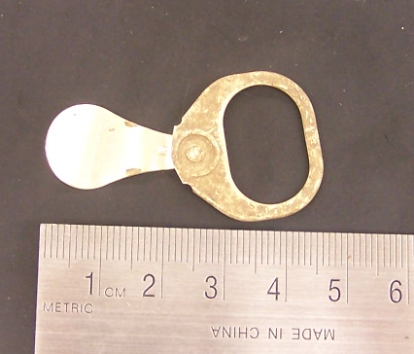

This pull tab from a beverage can, measuring 45 x 23 x 1mm, was uncovered in JBH23 in Unit 3. It is a modern artefact, and due to the high amount of recording and documentation of products that has occurred within the last fifty years it is possible to date it fairly exactly and accurately.
Cans were first used for beverages in the 1930s, and were originally made of steel. Aluminium began to be used in the 1950s, and eventually became the standard material for beverage cans. These early cans had no tab incorporated into the design- they required a can piercer that punched two holes in the lid, a larger one to drink from, and a smaller one to let air in (this device was commonly known as a “church key” in the USA).
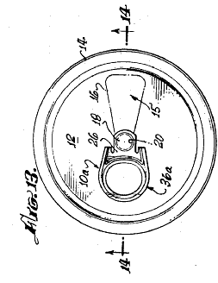
In 1959 Ermal Fraze invented the first pull tab to open cans, supposedly, according to common folklore, as a result of having to resort to a car bumper to open cans when he forgot his ‘church key’ on a picnic. The design consisted of a ring attached to a rivet that would tear out a strip of the can lid, providing an opening to drink from. He seems to have received a patent in 1963, but perhaps modified his design and re-patented it in 1965, receiving a patent in October, 1967. This was US patent number 3,349,949 (one of the drawings included in the patent is shown below), and is almost identical to the artefact recovered from JBH23. Working around this patent, a date range for the artefact can be established. As many as seventy-five percent of beer brewers in the United States of America had adopted Fraze's can by 1965, before this patent was issued. The pull tab had some disadvantages, as they were a common form of litter, and they could cause injuries if dropped inside the can and then accidentally swallowed. Various types of stay tab were invented in the 1970s, and stay tabs, from which the tab on the twenty-first century cans derives, had replaced pull tabs in the Western world by the 1980s. An approximate date range for the artefact from JBH23, therefore, is 1965-1980.
The artefact was found between 23cm and 33cm below the datum point of Unit 3, and as it was the most recent artefact recovered in JBH23, it means the earliest the soil at this depth could have been deposited was 1965. The wide range of production dates for the artefacts in JBH23 (from the seventeenth century to the 1980s) indicates that the context was part of a fill.
The fill in Unit 3 contained another modern artefact that came from the context below JBH23. The key blade was uncovered in JBH 28, just under 6cm into the 10cm assigned for the arbitrary context. During excavation, it seems that a change in strata was overlooked. In JBH23, as the excavators “got nearer to the 33cm below surface level, pockets of mortar began to show up in the context”, and it is possible that this soil should have been assigned a new context, as the profiling of the north wall seems to indicate a change in strata around this depth. If this is so, it is possible that the pull tab was in the same stratigraphic layer as the key blade, as the pull tab was uncovered towards the end of JBH23. Working from this interpretation, the deposit consisting of JBH28 and the end of JBH23 would have a TPQ of 1965 (the key has not been dated beyond being from the second half of the twentieth century), and the strata above this would have to have been deposited after this date. There is not enough information on the activity on site during the 1960s, 1970s or 1980s about when or why removal and deposition of earth occurred that might explain the presence of two modern artefacts approximately 30-40cm below the surface. However, it is clear that the removal of earth disturbed some older artefacts already in the ground that were then re-deposited with the addition of modern material as part of a fill.
1970s aluminium can pull tab
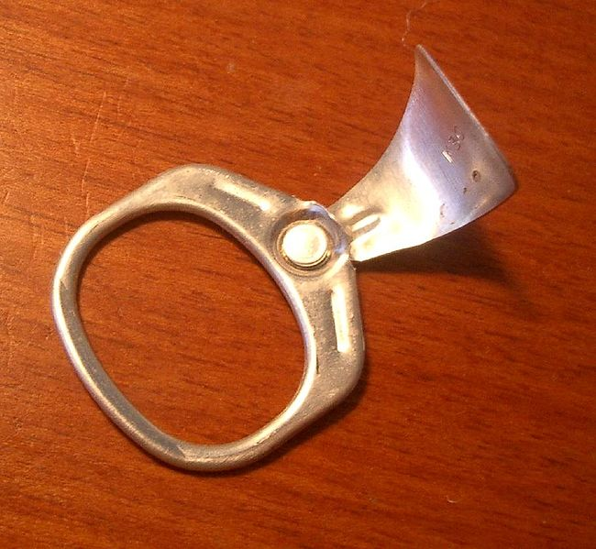
The removable nature of the pull tab created a litter problem, as users would discard the tab after opening the can. This discarding of the tabs is likely how the artefact from JBH23 came to be included in the deposit. As a common form of litter, it could have been associated with any number people, from visitors to the John Brown House, to pedestrians walking down Benefit Street, to somebody mowing the lawn, or even to the people who used the lawn as a hang out (this still occurs today, with beer bottles on the tarps and left items of clothing discovered through the course of the semester). It does not allow us to make any interpretations about the structures on the site, or the people associated with these structures, as they predate the pull tab. It does however give an indication of the way the John Brown House property has been perceived and used since the 1960s, as the person who discarded the pull tab viewed the property as an appropriate place to throw their litter.
The recent nature of the soil disturbance on site is a characteristic of archaeology of the historic, rather than the prehistoric period. Earth removal and deposition occurs very frequently in the modern world, and results in wide ranges of artefacts within one area of soil, as see in Unit 3. As Deetz informs us, “fill is an artefact in itself, and intelligent study of it can be most instructive”. Modern artefacts such as the pull tab and key blade from Unit 3, or the Styrofoam cups, and plastic from Unit 1 can be viewed by excavators as mundane finds that lack the excitement of older materials, such as ceramics. However in Unit 3 the pull tab has been highly significant in understanding the relationship between the strata, and the ways in which the older artefacts have moved around as the soil was removed and re-deposited a number of times.

Online Encyclopedia of Ohio History, “Ermal Fraze”, http://www.ohiohistorycentral.org/entry.php?rec=2637
Elise’s Field Blog, Week Six
James Deetz, In Small Things Forgotten, 1977, p.23

