OBJECT BIOGRAPHIES

Canton Porcelain Fragment
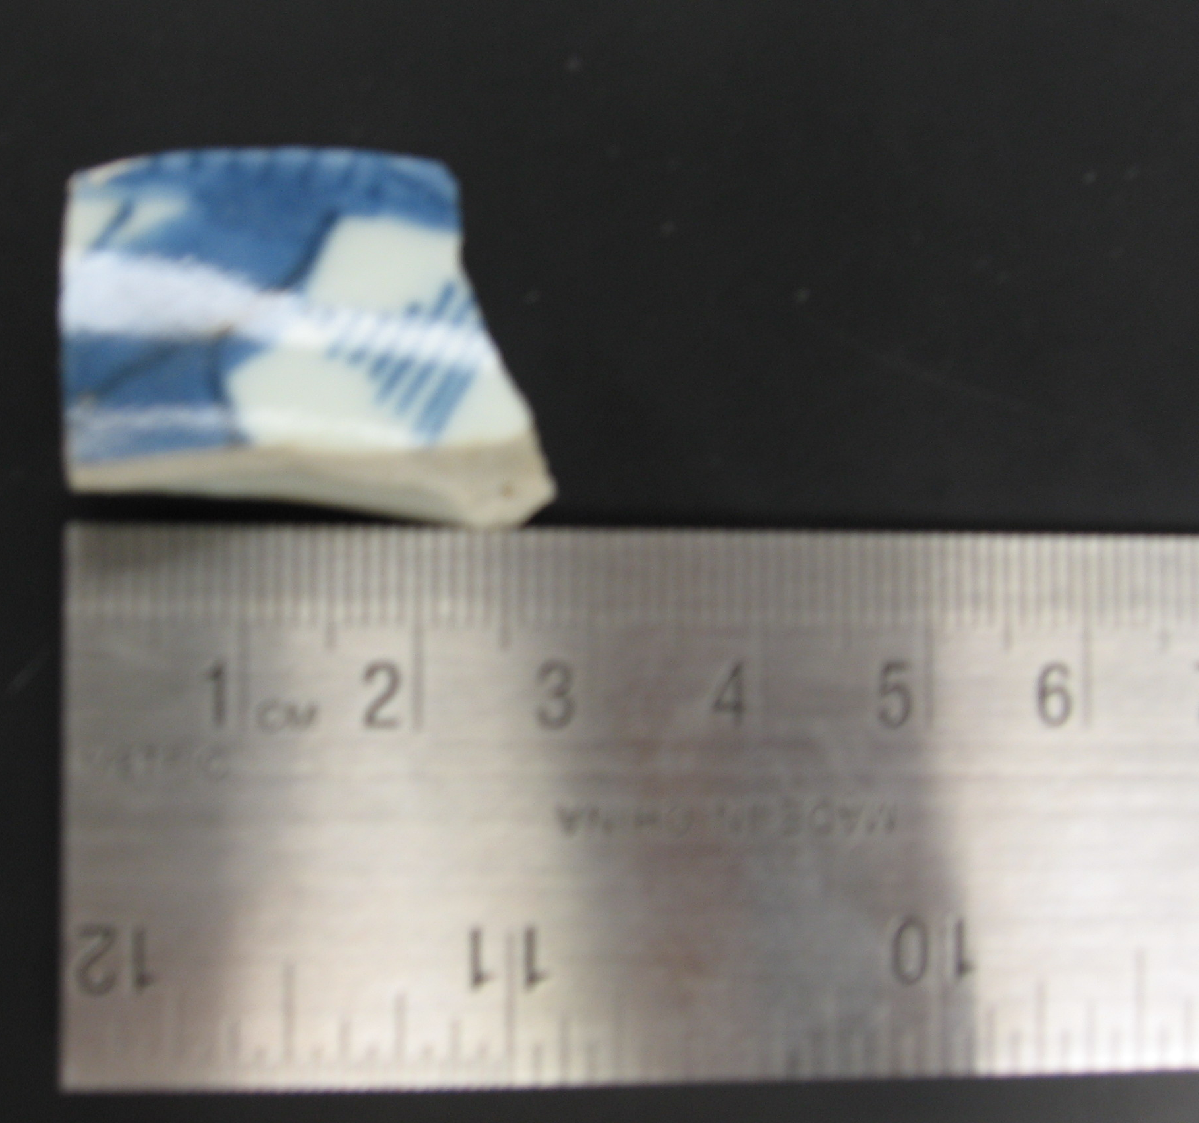
The origins of this type of porcelain are from China—Canton is actually the place where the tableware was sent to be painted before it was exported to America. The Canton style is a specific style of porcelain whose production dates range from 1790-1835. 1800-1860 was the principal market for Chinese export porcelain although there was virtually no production from 1829-1860 as a result of the Opium Wars. There are certain features which distinguish this style of porcelain from other types: it is white or grayish white, often with a glass-like vitreous paste that is slightly thicker than other porcelain types; the glaze is poorer in quality, having a slight oatmeal texture to the surface, with occasional pinholes; the background color is grayish white, and the designs are executed in broad brush strokes using a range of blues (from navy to powder blue); the design execution is simple and always done in a similar way; the motifs in the central medallion might usually illustrate a Chinese garden or village scenes that would include objects like pagodas, bridges, and boats; the rim decoration is a crude blue lattice network with an inner border of wavy or scalloped lines. Its vessel forms include bowls, plates, and platters (www.flmnh.ufl.edu).
These porcelain vessels were mass produced in China after the American Revolution, as an export ware to America. It is sometimes referred to as Ballast Ware for its low cost and the huge amounts shipped to this country. The dinner and tea sets were favored by the likes of George Washington, as well as members of the merchant class. It was thought of as “everybody’s porcelain,” because indeed a majority of Americans were in possession of this table ware. However, within the Canton collection, there were some differentiations. Some was as fine as better trade porcelain, while others had bad decorations and many imperfections. The texture also might have ranged from at its best very smooth and glossy, to at its worst, feeling like the skin of an orange (Gordon).
The recovered piece of porcelain is a little less than three centimeters in width and a little over one centimeter in length. It is definitely a rim fragment; the protrusion on the outside of the fragment would be part of the foundation upon which the dinnerware would rest evenly. The base color on the front and back was a grayish-white and the paintings on the front of the fragment are a navy-royal blue color. The specific design is indecipherable, but the brush strokes are definitely sweeping and broad. The texture of the Canton fragment feels more like an intermediary between the two afore mentioned textures; the texture feels almost like an egg-shell. The particular piece found has about an eight inch diameter and seems to be about one inch deep, giving credence to the supposition that it might have been a soup plate. Because of its texture, it can also be assumed that whoever owned it, was not lower class, but was neither a part of the upper-echelons of society; they were willing to spend more money on the porcelain than the cheapest, but not willing to spend for the most expensive type. The owner of the porcelain clearly had adequate means for both meals and entertainment. Although the owner could have easily gotten the cheapest porcelain, the fact that the middle grade was acquired suggests a possible desire to show the appearance of wealth to the rest of society (Shifting Focus: Archaeology of the Urban Household).
This find also further proves that there was some sort of household on the excavation site—this type of porcelain was clearly used as dinnerware. The production rates of Canton range from 1790-1835, earlier than the date when the house Robert Hale Ives homestead was projected as being built. However, as learned from William Hampton Adams article on dating historical sites, just because the item is dated as being produced between those years, does not necessarily mean that the site can be dated to these years. This item could have been an heirloom, a hand me down, or might have been specially curated due to its fragile nature. The item could have been brought by Mr. Ives from his previous home and then passed down through owners of the house—however, this can never really be determined
We do know for certain the porcelain fragment was found in excavation unit 4, context JBH42. This was the unit running along Benefit Street, which contained what we believe to be part of the foundations for the Robert Hale Ives homestead. This particular context was to the west of the unit at an elevation between about 40 and 50 cm deep. Other artifacts found from that context included ceramic of various types, chunks of bricks, and shards of glass and nails. The pieces of brick along with the already exposed rock feature suggest that the remnants might be part of the outside foundational wall of Robert Hale Ives homestead. The pieces of glass, ceramic, and porcelain point to artifacts which might have been found within the actual house. This porcelain fragment definitely provides evidence of a homestead and even points to certain aspects of character and social positions of the possible occupants of the household.

Bottle Cap
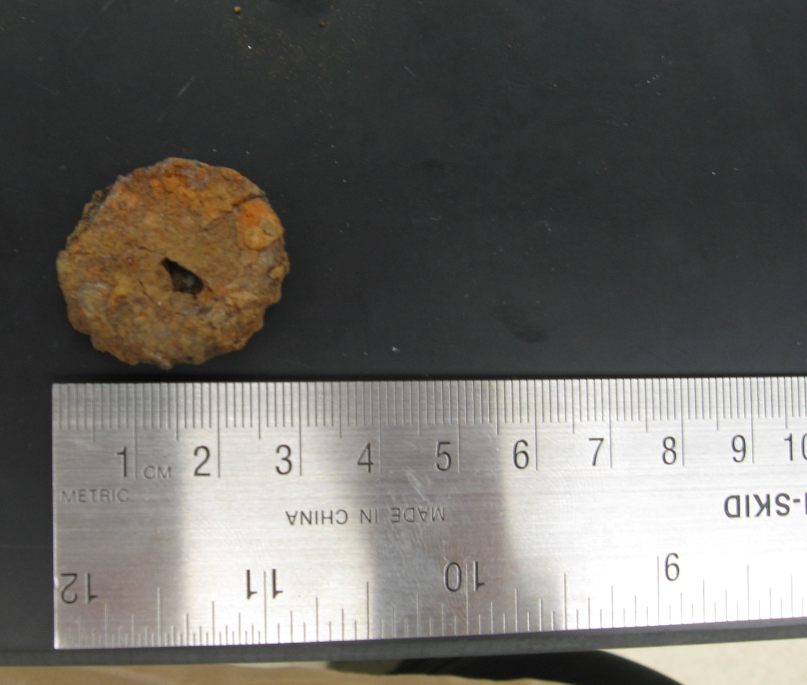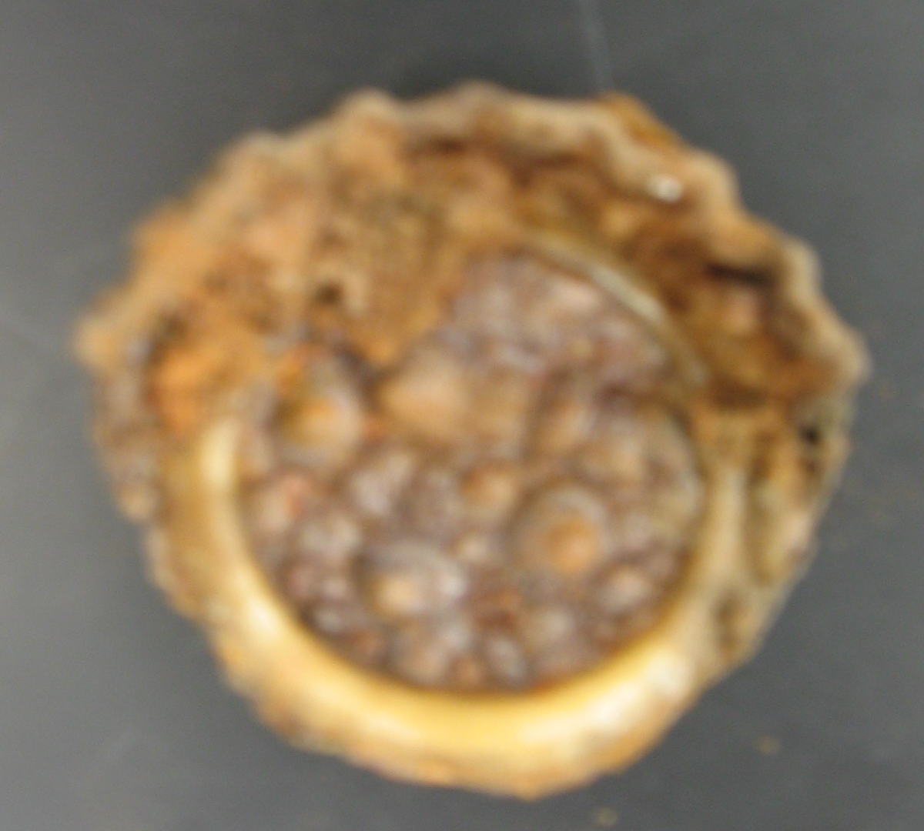
The crown finish and cap was first patented in 1892 in the United States by William Painter. It proved to be the ideal single-use closure for carbonated beverages. Original crowns were plain, unmarked metal. One or both sides of the cap were usually lacquered and there were approximately 20 corrugations around the side skirt. There was also an internal disk of natural cork. Later crowns had proprietor marks on them and discs of composition cork, or as in the case of one of Painter’s competitors, linoleum discs. Modern caps may have had plastic liners. The finish on the crown is distinctive and was part of the original patent—it is a two part finish with a lip that has a flat top and rounded sides over with the skirt or flange of the crown was to hook. Originally, crown finishes were hand made with a finishing tool. However, foot operated crowning machines could reconcile slight variations in lip shapes and seizes to standard crowns. In 1898, Painter introduced the first foot-powered, syruper-crowner. A good operator could fill and cap 24 bottles a minute. The caps appear to have been made in only one size-- in order to fit small mouthed bottles like sodas and beers (Jones and Sullivan, 163-164)
By 1906, bottling had gained more popularity and began to spread quickly. Painter’s company, Crown Cork and & Seal, had opened manufacturing plants in Germany, France, the United Kingdom, Japan and Brazil. By the time Painter died in 1906, the Crown Cork & Seal Company of Baltimore had greatly expanded its manufacturing base in Europe, South America and in the Orient. By around the year of 1919, recovering from major business disruptions as a result of World War I, Crown Cork & Seal started to shift its manufacturing production from beer to soft drinks. This was an adjustment necessary in order to survive Prohibition, which began to seriously impact the bottling industry (www.crowncork.com)
Because of the rust on the cap fragment, it is impossible to find a brand or proprietor mark. The only known information about this cap is that it probably had 20 corrugations like the cap patented in 1892 by Painter (the fragment, roughly ½ of the cap, shows 10 corrugations). However, the inside disc appears to perhaps be made of a grey, shiny material; this material is most likely linoleum. It is definitely not the plastic commonly found in modern caps, or the cork liners which were more common of Painter’s original caps. Perhaps this cap was made from one of Painter’s competitors, sometime in the late 19th or early 20th century. The cap was definitely not made before 1892, but could technically have been produced anytime after that. At this point, the timeline for linoleum line caps is unclear; who exactly they were produced by and when they were produced remains a mystery. The best conjured estimate is that the caps were probably produced shortly after Painter’s patent, but definitely before modern plastic caps were produced.
The bottle cap fragment is about the three centimeters in diameter. Only half of the cap skirt remains, containing ten corrugations in total. Inside of the cap, a white/grey ring outlines the circular shape. The cap is covered in rust and the rust on the inside almost looks bubbly. This particular cap was found in Unit 1, context JBH 8. This was the unit running along Charlesfield Street. The bottle was found in a relatively shallow context, indicating that it might be a more recent find—however, it is impossible to guess what its specific date might be. Other finds in this context included small pieces of brick, glass, a handkerchief, a nail, a small piece of bone, a small piece of glazed ceramic, and paint chips. JBH8 also contained a brick in the central north part of the unit and a large rock at the southwestern corner. The other ceramic finds and the handkerchief suggest that the cap belonged to somebody in particular, not just a random passerby. The cap could possibly have come from an owner of the house, a worker of the house, a boarder of the house, or even a visitor. There were outhouses running along that space until 1925-1926, when the outbuildings (as well as the house) were knocked down. Thus, it is more possible that the cap was in use sometime between 1892 when the cap was assuredly produced and 1925 when the house was destroyed. The presence of the rock and brick further indicate some sort of correlation in time and space to the architectural structure that once stood there. As soda and beer is, and was, drunk by nearly everyone in society, it is impossible to make any social distinctions based on the artifact. Anyone could have bought, drank, or sold the soda.
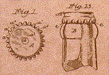
Picture of crown cap

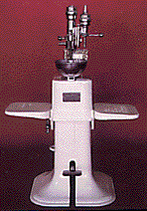

Picture of crowning machine

http://www.crowncork.com/about/about_history.php

Machine Made Cut Spike (Nail)
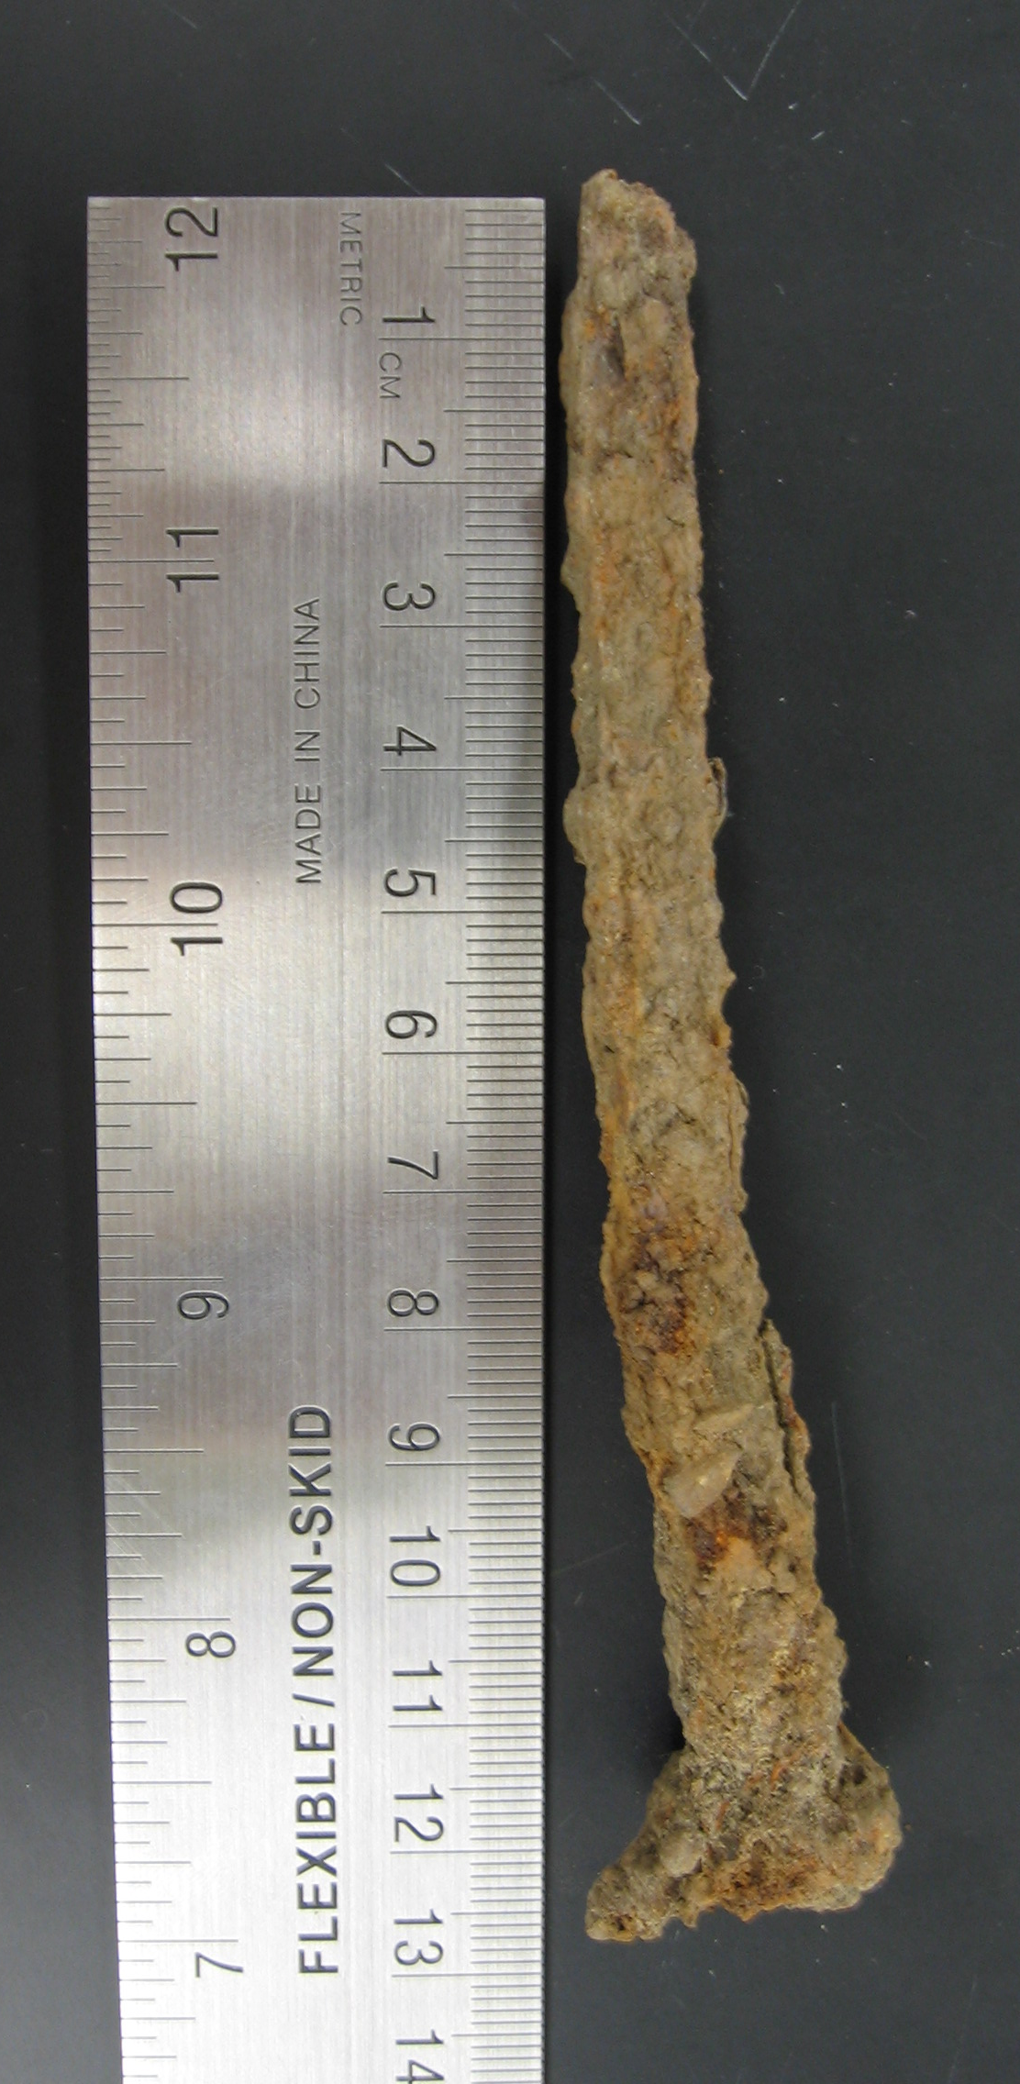
The artifact chosen is a machine made cut spike. Cut nails were historically made by cutting triangular nail blanks from flat planes or strips of iron and then heading the blanks. The only difference between spikes and nails are size; Spikes are any nails which are, in today’s measurements, at least four inches long. Nails were once measured in America in terms of its penny size, written with a number and the abbreviation d for penny (e.g. - 10d). A smaller number indicates a shorter nail and a larger number indicates a longer nail. Spikes are only nails which are measured as being 20d or over. This spike is approximately five inches long, so would thus have a measurement of 40d (www.wikipedia.com).
Nail making machines were not officially invented until 1790, but in 1775 Jeremiah Wilkinson of Cumberland, Rhode Island devised a method for cutting blanks from thin strips of cold iron to make textile card tacks. Later this method would be improved upon. In 1790, Jacob Perkins of Newbury, Massachusetts invented a nail making machine capable of producing about 10,000 nails per day; the invention was patented in 1795. The first machine patented to create cut nails was introduced in 1791 by Sam Briggs Sr. and Jr.—however these nails were still hand headed (Edwards and Wells, 16).
Machines that headed nails were experimented with for several years, but the invention was not patented until 1796 by Isaac Garretson. This machine had essentially three parts. Flat metal strips of around two feet (600mm) in length and the width slightly larger than the nail length was presented to the machine. The first lever cut a triangular strip of metal giving the desired width of the nail, the second lever held the nail in place while the third lever formed the head. The strip of metal was then turned through 180° to cut the next equal and opposite nail shape off the strip. These nails are known as cut nails. Because the nail up until then was handmade, the first machines were naturally designed to re-produce the same shape of product - a square tapered nail with a rosehead, but only tapered down two sides of the shank (www.wikipedia.com).
However, it was not until 1798 that nails up to 20d in size were produced in large quantities in two factories north of Boston. By 1800, cut nails were commonly available in most cities in the northeast. By 1811, three major cut nail factories were in competition in the Boston area, and by 1816, 2/3rds of all rolled wrought iron in the United States was devoted to nail production. Cut nails no overwhelmed hand wrought iron nails completely, driving them into the special purposes market. In the mid 19th century nails were being used more and more in domestic architecture. In 1839, the Burden railroad spike machine was introduced which forged a complete spike in one operation and produced 50 spikes per minute. It was not until 1884 that steel began to replace iron. By 1900, except for roofing nails, the cut nail industry was in serious decline. In 1920, only 8% of U.S. production was in cut nails (Edwards and Wells, 16-18).
Therefore, the spike found was most likely from the early 19th century when machine cut nails and spikes were at their most popular, especially in the northeast where they were being manufactured by three separate factories. Since spikes were not produced in large quantity until after 1798, it can be assumed that the nail was probably produced at that time or later. In addition, the nail was probably produced and used sometime before 1900 when the iron nail industry went into serious decline. These dates fit with the projected time when the Robert Hale Ives Homestead was built. The home was probably built sometime between 1832 and 1857, when the machine cut iron nail industry was at its peak.
One can tell that this five inch nail was in-line grained cut as the point is flat and square, and as viewed from the side, there are sharp corners. The shaft appears more square than circular in formation; there are clear lines separating each side of the nail. The spike found is slightly bent indicating that it was a nail with prior use which was probably pulled out of something. Unfortunately, the nail is too rusted to tell much else about it (although the rust indicates its material as iron).
It is very possible that the spikes were used to build the Robert Hale Ives homestead which was supposed to have been built sometime between 1832 and 1857. Spikes from Louisiana homes were often used in two situations. First, they were used to prevent the splitting and weakening of lap joints in which one timber was notched over another at an angle. The second situation called for spikes where timbers intersected one another at an acute angle, leaving the end of one member in the form of a tapered point (Edwards and Wells, 21). It is very possible that the spikes found on the excavation site were used in a similar manner. The spike was found in Unit 4, JBH 20 running along Benefit Street. The context was on the east side of the rock feature and the nail was found between 8 and 13 cm deep in the ground. Other finds in that context included bricks, nails, and mortar. Two large bricks were founds. Pockets of brown sugary colored sand and beach sand found randomly throughout. Perhaps when the house was destroyed by Marsden Perry, some of the nails and spikes from the foundational structures were buried in the ground.

Adams, William Hampton. Dating Historical Sites: The Importance of Understanding Time Lag in the Acquisition, Curation, Use, and Disposal of Artifacts.

Crown History. http://www.crowncork.com/about/about_history.php

Edwards, Jay and Wells, Tom. Historic Louisiana Nails, Baton Rouge: Geoscience Publications, 1993.

Florida Museum of Natural History. http://www.flmnh.ufl.edu/histarch/gallery_types/type_index_display.asp?type_name=PORCELAIN,%20CANTON

Gordon, Elenor. Chinese Export Porcelain: A Historical Survey. New York: Main Street/Universe Books, 1975.

Jones, Oliver and Sullivan, Katherine. The Parks Canada Glass Glossary. Canada: Minister of Supply and Services, 1985.

Mrozowski, Stephen A. Shifting Focus: Archaeology of the Urban Household. New York: Cambridge University Press, 2006.

Wikipedia. http://en.wikipedia.org/wiki/Nail_(fastener)

