Peter Hatch
Dr. Krysta Ryzewski
Archaeology of College Hill
15 December 2008
Biographies of Three Objects
1. A copper wire
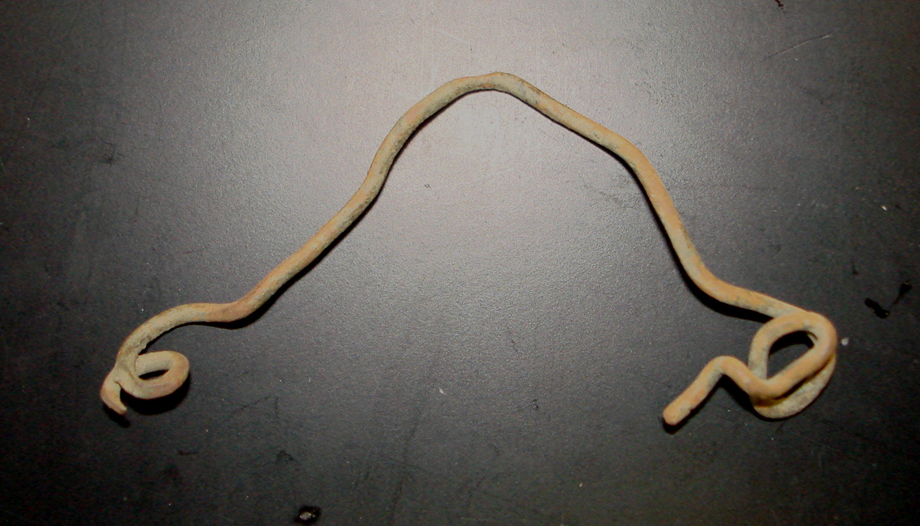
The piece of thin wire pictured, found in excavations at the John Brown House in unit 4, is rather mysterious. It is made of copper, and has been bent roughly into an uneven V shape, with twists and bends in its shape every centimeter or so. If the wire were stretched out flat it would be perhaps five inches long. It is greenish except where the surface corrosion has been rubbed off by being scraped during excavation and subsequent cleaning in the lab. At each end the wire is twisted tightly into loops perhaps half a centimeter in diameter. On one end the wire is bent through two full loops and then trails off before coming to a blunt end, at the other it makes a single loop before coming to a tapered end. Copper itself, because it has been worked by people since for thousands of years, is not at all diagnostic as an indicator of the chronology of the site. We do not have the time or resources to gather information about its exact chemical composition. Therefore the information gleaned from it must come from its shape, and its possible function.
Because copper wire is so commonly used as an electrical conductor, that seems like a good place to start. If that were the case then the tight twists at either end might indicate where it attached to contacts of some kind. If this were the case, the artifact would be diagnostic, since the first major electric company in Rhode Island was established in 1884 by Marsden Perry, later the owner of the John Brown House (Redwood Library 2004). However if this were an electrical component of some kind, it would have had insulation covering it, rather than being bare wire, and there is no evidence of either insulation or marks where insulation would have been stripped off, so this theory seems implausible.
The general inverted v-shape of the object, and the twisted ends are also reminiscent of a hanger or some kind, like one that would be attached to a picture for hanging on a wall. This seems like a plausible hypothesis, but there are no obvious material associations to confirm it, in that no evidence remains of the small nails or screws that would have held it in place in either the context where the object was found or in related ones. Also, there is no reason to suspect that the object was originally that shape, and the fact that the object is so bent indicates that it likely wasn’t, and the tapered end indicates that the wire was perhaps roughly cut or broken from being originally part of a larger whole, so at some time the object has had a lot of force applied to it, an it most likely in its original shape.
Another possibility to consider is that the wire was part of a kind of common late 19th century bottle or jar closure mechanism, called a Lightning-type closure. Also known as a swing-type or toggle closure, this was a very common and popular way of sealing soda and beer bottles for which normal corks did not provide a strong enough seal, and was also very widely employed on canning jars. The type was invented and patented in New York in 1875 by Charles de Quillfeldt as an improved way of sealing carbonated beverages (Lindsey 2008). The mechanism was made up of a stopper (either metal or ceramic with a rubber gasket) attached to a thick wire bail that looped over the top of the bottle and was clamped down by a lever wire, itself attached to the bottle by a thinner tie-wire that wrapped around the neck of the bottle, this mechanism is illustrated in Lindsey, included below. De Quillfeldt sold the rights to several parties, including Henry Putnam who adopted the design for storage jars that began to appear in 1882 (Lindsey 2008). The design was adapted and improved upon but remained popular on many kinds bottles, typically soda and beer, from the 1880s up to the 1920s. The earlier part of this period would seem very reasonable on the late 19th century time frame that historical documents seem to indicate our excavations are associated with (Yellin 2008). There is also the possibility that it was not part of a Lightning-type closure exactly, but similar non-resalable cork closures with wire fasteners that were used on early and mid-19th century bottles which might work even better with our time-frame (Lindsey 2008).
The twisted circles on the ends of the wire are what indicate that the wire could be from something similar to a Lightning-type closure, since many kinds of accidental processes could create its bent and twisted overall shape, but fewer could create the tight and fairly regular loops in the ends. That fact makes the strong resemblance of the object to half of the neck tie-wire of a Lightning-type closure, as in the highlighted portion of the figure, into a plausible explanation of what this object may have originally been. The wire is apparently part of a larger whole from which it was cut at some time, and that whole could be the rest of the closure mechanism. This interpretation is made even more plausible because of how commonly curved glass, likely the remains of bottles of some kind, was encountered in the excavation units at the John Brown House. Whatever force shattered those bottles initially would also have acted on their closures, and closures of other, newer types were found in more modern strata, so it seems very likely that older types would also be similarly discarded, bent and unusable, and thereby enter the archaeological record. Although this interpretation is not definite, it provides a very plausible possibility for the function of this unusual object.
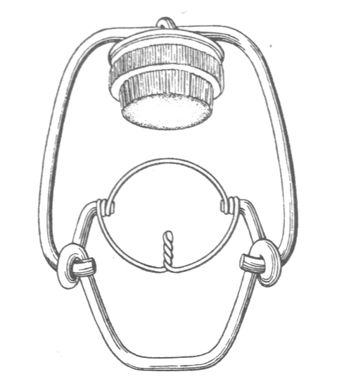
Image: Lindsey 2008.

2. A pair of Lincoln cents
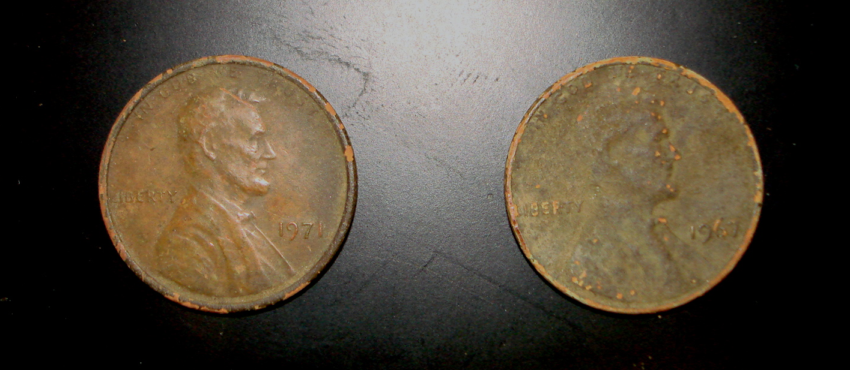
The two pennies pictured are from context JBH 13 of unit 4, at the John Brown House. One is dated 1967 and the other to 1971. Although the United States Mint’s official name for coins of this type is the Lincoln head cent, they are equally if not more recognizable by the colloquial name “penny” and will be referred to as such. These are very familiar objects to most anyone who has spent time in the United States, but since we are less likely to look closely at familiar objects it is all the more important to describe them. Each coin is small, designed to be exactly .750 inches in diameter (19.05mm) and 1.55mm in thickness (U.S. Mint 2008).
The obverse of each coin bears a portrait of Abraham Lincoln in profile facing to the right side of the coin. The portrait is calm and slightly smiling, and his symbolic value as an emancipator underscored by the world “liberty” appearing just behind his shoulder across from the year that makes these objects diagnostic, and the official motto of the United States, “in god we trust” in an arc above the top of his head. The design was originally created in 1909 in commemoration of the centennial of Lincoln’s birthday by Victor David Bremmer, a Lithuanian immigrant well-known as a medalist, who was commissioned by Theodore Roosevelt after he saw a relief statue of Lincoln done by the artist. It replaced the “Indian Head” pennies that had been the design used since 1859 (Wikipedia 2008a). The design was the very first portrait of an individual, rather than a type figure such as the personification of Liberty. Considerable controversy was the result, because of the monarchical associations with having individuals on coins, but this was greatly outweighed by a public love for Lincoln (Margolick 2007).
Initially the design on the reverse was of two wheat stalks, and for a short time carried the initials of the artist, VDB. Later these initials were moved the obverse of the coin, engraved in very small type on the bottom of the Lincoln portrait. The fact that these small letters are not visible on the pennies from the John Brown House is an indication of that they were worn down, either while still in circulation or after being deposited. Additionally the original text on the reverse has remained the same, bearing “one cent” in the largest type, along with “united states of america” and the unofficial motto “e pluribus unum” or “from many, one” in Latin. The initial wheat design was changed in 1959, to mark the 150th anniversary of Lincoln’s birth, and from that point a depiction of the Lincoln Memorial in Washington D.C. appeared. The design on the contemporary reverse side was designed by Frank Gasparro, the Assistant Engraver at the United States Mint at the time and most renderings of this design include the artist’s initials “FG” beside the Lincoln memorial (Wikipedia 2008b) although there is no evidence of these letters on either of the excavated pennies, due to wear or corrosion.
United States coins minted at the Denver mint carry a “D” to identify them as having been made there, because it is the original mint, coins produced in Philadelphia traditionally carry no mark at all (U.S. Mint 2008). Therefore it is usually distinguishable where a penny is made. The 1971 penny has no evidence of a mint mark This is not the case for the 1967 penny, which, although it has no evidence of a mint mark, may have be from either Denver of Philadelphia. This is because of the Coinage Act of 1965, among the provisions of which was a prohibition on mint marks. The bill was an attempt to remove “distinguishing features that could tempt people to remove the coins from circulation while the Mint was striving to meet the country’s need for coins” (U.S. Mint 2008). These coins were minted in an era where rising metal prices made the composition of U.S. coins a major potential issue, just three years after the second coin was minted there was a brief failed attempt to introduce one cent coins made out of aluminum (Wikipedia 2008b). Even so, demand for coins has continued to hold steady, even in this very low monetary denomination, and the penny has continued to be produced in larger numbers than any other denomination, so the most specific thing that can be said about the 1967 penny is that it represents one of 3,048,667,100 created in that year. The origin of 1971 penny can be narrowed down more, and it was one of 1,919,490,000 pennies created at Philadelphia in that year (Wikipedia 2008b).
The 1971 penny is better preserved overall, the 1967 being greener in color and the features of the portrait being very hard to distinguish exactly. A lot of the wear seems to have taken place around the edges of the coins, with the text that arcs around the edges of the 1967 example so worn down as to be barely visible. This is an indication that the coin was in circulation for some time, as opposed to the 1971 penny that is relatively well preserved and, if the two objects were deposited at the same time, could not possible been in circulation as long. In each, where the corrosion layer broken they are orange-brown in color, the result of being made of 95% copper and 5% zinc, as pennies were until 1982, after which that balance was almost reversed, with pennies being made of just a thin copper plating (2.5%) and the rest being made up of Zinc (U.S. Mint). These pennies are therefore heavier than those currently being minted, they would have been 3.11 grams at the time of minting as opposed to the 2.5 grams of current pennies (Wikipedia 2008b). It is interesting to reflect on how an object which is almost worthless monetarily can have such an interesting and varied history when considered in detail.
In terms of what these coins might represent archaeologically, and how they may have been deposited, there are a number of possibilities. It cannot be said definitively where these objects fit in the depositional history of the context in which they reside, since they were found in a stratum that is constantly disturbed by foot traffic, lawn mowing, and whatever else took place on the lawn since they were deposited. These facts about the pennies shed light on archaeological dating in an interesting way, in showing that even when the year of something’s production is stamped on its face, that does not provide any certainty about when it entered the archaeological record, demonstrating the importance of proper context in getting solid information about any archaeologically recovered object. This has larger implications in demonstrating how much can potentially be lost when objects that are marketable in a way these pennies could never be, are looted or otherwise ripped from their proper context in order to be sold. It could be that the coins were introduced separately into the archaeological record at completely different times, but because they were found in the same one by one meter area as one another and in the same soil stratum, it seems plausible that they are associated in some way. That same day a modern ballpoint pen was found, so it is conceivable that all three objects represent the spilled contents of a single pocket, years or decades ago.

3. A sherd with purple decoction
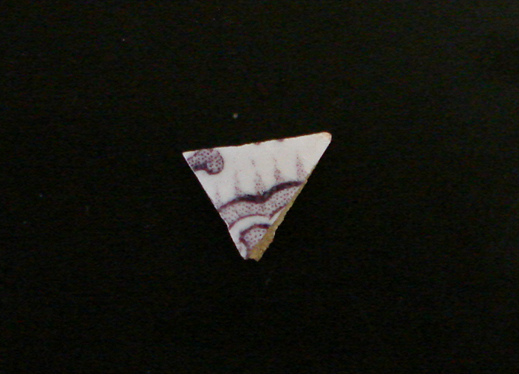
Because pottery in a general sense, as a material that does not degrade, is so important to both prehistoric and historic archaeology, even a single tiny sherd of broken pottery like the pictured piece of English mulberry under-glaze transfer printed whiteware, can be of significant importance to a variety of archaeological approaches. The small details of an already small object can be of great importance. The sherd is small and decorated on both sides in a purple design made up of tiny dots that are regular and uniform in appearance, indicating that it was transfer printed as opposed to hand-painted. Additionally the fact that the It is made of a compact and solid earthenware that is tan in color, and the surface treatment is a very pure white glaze that provides the indication that it is whiteware. From these basic facts, there are a number of ways to interpret this object.
The first angle to explore is to interpret this sherd as the result of technological and economic development. Earthenware decorated in this manner was made in great quantities in England from the 18th century onward in an attempt to capitalize on the demand for ceramics that emulated the style of imported porcelain wares from China. Various technologies were adapted in order to make these wares well and cheaply, most notably in the English pottery producing district of Staffordshire. One such technology was the transfer printing process. This is done by engraving a copper plate with the desired design, inking it, and applying damp paper. The paper is carefully laid out on the piece to be decorated, so that the ink transfers onto the earthenware. This process was invented in Liverpool in 1756 for tiles, and was then adapted for pottery by placing the transfer pattern underneath the glaze and adapting the compounds in the ink to produce different shades of blue, and later other colors, that held up though firing. Another refinement on this technology was the use of “bat” printing, which replaced the tissue paper with a block of glue (Hayden 1912). These technologies allowed for identically decorated full sets of ceramic ware in great mass-produced quantities. Around 1810 a new type of ceramic, producing a truer white than the previous creamware and pearlware shades, was invented (Stelle 2001). Huge amounts were produced and exported to meet the demands of a booming American market, to the point that for some historical archaeologists transfer printed whitewares represent “the most conspicuous surface treatment” if the era (Stelle 2001). One way to view this tiny sherd is as the result of the great technological and economic strides of the 19th century.
In a more directly archaeological sense, this sherd is important because of how readily it can be used to refine the chronology of a deposit in a site. Since types of pottery were made in response to changing market demand, different wares and types were produced and consumed over very definite periods of time. A chronology of popularity can be built form “potters invoices, trade catalogs, and store accounts” and that can be correlated with what has been found archaeologically (Samford 2000). This is even true down to the level of specific colors of transfer-printed whiteware.
This sherd in particular is a shade of purple often called mulberry. One source that has studied the patterns of these color changes separates mulberry and purple, and indicates that purple corresponds to the era 1827-1838 and mulberry to 1837-1852 (Samford 2000). On the other hand, a very similar table from another source seems to conflate the two colors, indicating that this type was produced from 1829-1860 but popular mainly during 1829-1839 (Stelle 2001). The lack of exact agreement between the two sources is notable, and illustrates how even something extremely specific and straightforward can be a source of debate in archaeology.
Another approach to analysis of this sherd is based in an attempt to understand what the owners of the original vessel would have thought about it, before it became trash and thereby entered the archaeological record. Because this vessel is decorated on both sides, it very likely came from a fancy vessel of which both sides would be seen, like a teacup of a bowl. It may have been a status symbol when new, in an era when matching sets of dishes were still rare and taste for whiteware in new colors was coming into vogue. This is evidenced by a history of the Stratfordshire pottery workshops written in 1827, immediately before purple wares began to be made.
Very recently several of the most eminent Manufacturers have introduced a method of ornamenting Table and Dessert Sevices, similarly to Tea Services, by the Black Printers, using red, brown, and green colours, for beautiful designs of flowers and landscapes; on Pottery greatly improved in quality and shapes formed with additional taste and elegance. This potter has a rich and delicate appearance, and owing to the Blue Printed having become so common, the other is now obtaining a decided preference in most genteel circles.” (Shaw 1829, 234-5).
This is a good indication of how the change in taste, the ever-shifting way that people relate to the objects around them, realigns the market so that the latest and greatest thing comes to symbolize wealth and sophistication, is purchased, loses those associations, and is eventually discarded. The ability to compare these kinds of accounts with the material evidence provided by the archaeological record is the unique strength of historical archaeology, allowing us to access how people in the past built, used, and thought about the material world around them.

References

Lindsey, Bill. 2008. “Bottle Finishes and Closures.” Society for Historical Archaeology.
http://www.sha.org/bottle/closures.htm#General%20Closure%20Types.

Margolick, David. 2007. “Penny Foolish.” The New York Times. http://www.nytimes.com/2007/02/11/opinion/11margolick.html.

Redwood Library. “Marsden Jaseal Perry.” Newport Notables. http://www.redwoodlibrary.org/notables/perry.htm.

Samford, Patricia. 2000. “Response to a Market: Dating English Underglaze Transfer-Printed Wares.” Approaches to Material Culture Research for Historical Archaeologists. Ed. Ronald L. Michael. California, PA: Society for Historical Archaeology.

Shaw, Simeon. 1829. History of the Staffordshire Potteries. Reissued, London: Scott, Greenwood and Co. 1900.

Stelle, Lenville. 2001. An Archaeological Guide to Historic Artifacts of Central Illinois. Parkland College. http://virtual.parkland.edu/lstelle1/len/archguide/documents/
arcguide.htm.

United States Mint. 2008. “About The United States Mint.” The United States Mint. United States Department of the Treasury. http://www.usmint.gov/about
_the_mint/.

Wikipedia. 2008a. Cent (United States coin). The Wikipedia Foundation. http://en.wikipedia.org/wiki/Cent_(United_States_coin).

Wikipedia. 2008b. Lincoln cent. The Wikipedia Foundation. http://en.wikipedia.org/wiki/Lincoln_cent.

Yellin, Stephanie. 2008. Presentation to Archaeology of College Hill class.

