Kellie Slater
December 17, 2008
McDonalds Stirrer
McDonalds is an iconic American tradition dating back to the 1940’s. Founded in San Bernardino, California by Dick and Mac McDonald, McDonalds serves nearly 47 million customers daily. Virtually every American has enjoyed a burger, fries and shake from McDonalds. And surely coffee lovers of all age have been enticed by the rich aroma of a McDonalds coffee. However, not all McDonalds coffee drinkers know the rich history of the device they use to stir their milk and sugar into their coffee: the McDonalds stirrer.
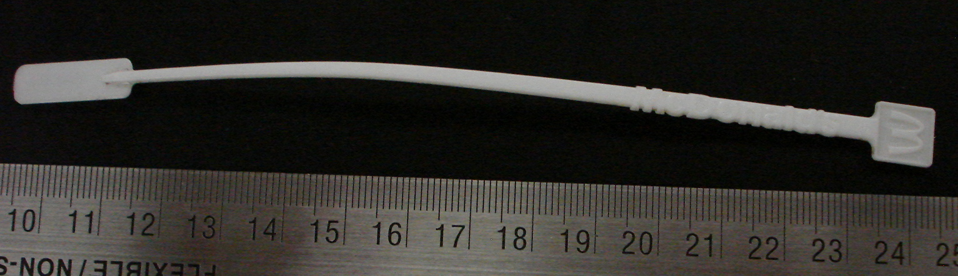
The McDonalds stirrer that was uncovered in the lawn of the John Brown House in excavation Unit 1, context level JBH 24 was surely not used by John Brown himself but it does allow us to draw some conclusions about the use of the lawn over time. The McDonalds stirrer that was uncovered by Maggie, Jacob and Alex is 15.3 cm long. The square on top that houses the famous McDonalds M-arch is 1 cm by 1 cm. The stirrers width is approximately .3 cm and the flat rectangle on the end is 2.2 cm by 0.7 cm. If the stirrer is held horizontally one side contains the word McDonalds. The entire stirrer is an off white color. It has a slight bow shape to it, which I image is a consequence of being buried for so many years; originally this stirrer would have be very straight.
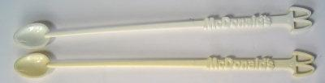
This specific type of McDonalds stirrer was gradually introduced to the public in the 1980’s. Prior to this time McDonalds stirrers had a slightly different design. The earlier design was very similar to the stirrer that was uncovered in the lawn of the John Brown House. It had the 1 cm by 1 cm square with the trademark arches and was approximately the same length; however, the significant difference is that the earlier version had a small spoon at the bottom of the stirrer rather than the flat rectangle. This spoon perfect “for adding very tiny amounts of sugar to your joe” but apparently it was also helpful for cocaine users (Euphrates; 2000). It was the perfect size to measure out cocaine, it eliminated the need to carry around scales because “sets of scales, if found, can be used as incriminating evidence” (BBC; 1998). The stirrers were being used as evidence in drug cases and McDonalds was contacted by law enforcement and the request was made to discontinue using that design… McDonald's immediately complied with the request to discontinue using that design" (Bonisteel; 2007). As such McDonalds redesigned their stirrers and phased them in during the 1980’s.
The type of stirrer that was uncovered in the lawn are provided at no cost to McDonalds customers; in fact, they are usually free to all whom visit McDonalds and are set out on the counter. This stirrer is by no means a luxury item and everyone who wanted one could own one. I am sure there are many different uses for such a stirrer (as cocaine users proved in the 70s); however, it is likely that this stirrer was used for its original purpose of mixing coffee, sugar and cream because it was found with other McDonalds trash deposits that are directly related to coffee consumption.
This McDonalds coffee stirrer was excavated in Unit 1, context level JBH 24. This context has been described as “modern rubbish pit” by a few of our excavators (Jacob’s Field Blog). Within this context we found remains of other coffee paraphernalia, most important for the purpose of determining the original purpose of this stirrer is a McDonalds coffee lid. It is highly likely that these two artifacts were deposited together and it is probable that the same McDonalds coffee consumer left them both in the lawn of the John Brown House.
The new stirrer with the flat end was gradually introduced in the 1980’s. This date fits well with the dates that have been provided by Jacob and Alex for the average date of the other remains found in this context; this context is littered with trash mostly dating to sometimes in the 1990’s. According to Alex’s research “the filling of this depression with modern refuse and loose soil would therefore have occurred sometime between 1984 and 1990” (Ruby; 2008; 17). These dates fit very well with the 1980’s date in which the new design was incorporated. JBH 24 contains a lot of trash including: aluminum foil, a coffee cup lid, cables and wires, bottle tops, a cork, Johnson and Johnson burn cream wrapper, straws, etc. and it is obvious that the McDonalds stirrer fits very well within this context. Before 1984-1990 it is possible that the John Brown House did not put a lot of emphasis on the lawn and therefore this trash heap was allowed. However, it is clear that at some point in recent history the John Brown House decided to focus more attention on the appearance of the lawn and backfilled the trash heap.
The new design was introduced in the 1980’s, but even today the same basic design is being used. I recently visited McDonalds to check out the selection of stirrers. The stirrers that are provided now still have the same 1cm by 1cm square on top with the M-arch, the word ‘McDonalds’ that is read horizontally and the flat rectangle at the end. The only difference between the two is that the new stirrer is black and longer. I would attribute this change in length to the change in consumers taste. Nowadays people want larger coffees and in order to suit consumers needs a new, longer stirrer was required to stir the larger cups of coffee.

Works Cited

Bonisteel, Sara. 2005. Gold Art Object Stirs Up McDonald's 'Cokespoon'
Controversy. 2007. http://www.foxnews.com/story/0,2933,253422,00.html (accessed Dec. 15, 2008)

Combs, Jacob. “Jacob’s Field Blog: October 6, 2008.”
http://proteus.brown.edu/archaeologyofcollegehill/6496 (accessed Dec. 15, 2008)

Euphrates. 2000. McDonald's Coffee Stirrers.
http://www.bigredtoybox.com/cgi-bin/toynfo.pl?mcdonaldscoffeestirrersindex (accessed Dec. 15, 2008)

Ruby, Alexander. 2008. Summary of Activity at Excavation Unit.

Spoons cause drugs stir. 1998
http://news.bbc.co.uk/2/hi/uk_news/234685.stm (accessed Dec. 15, 2008)

