Kellie Slater
December 17, 2008

Sponge-decorated Whiteware

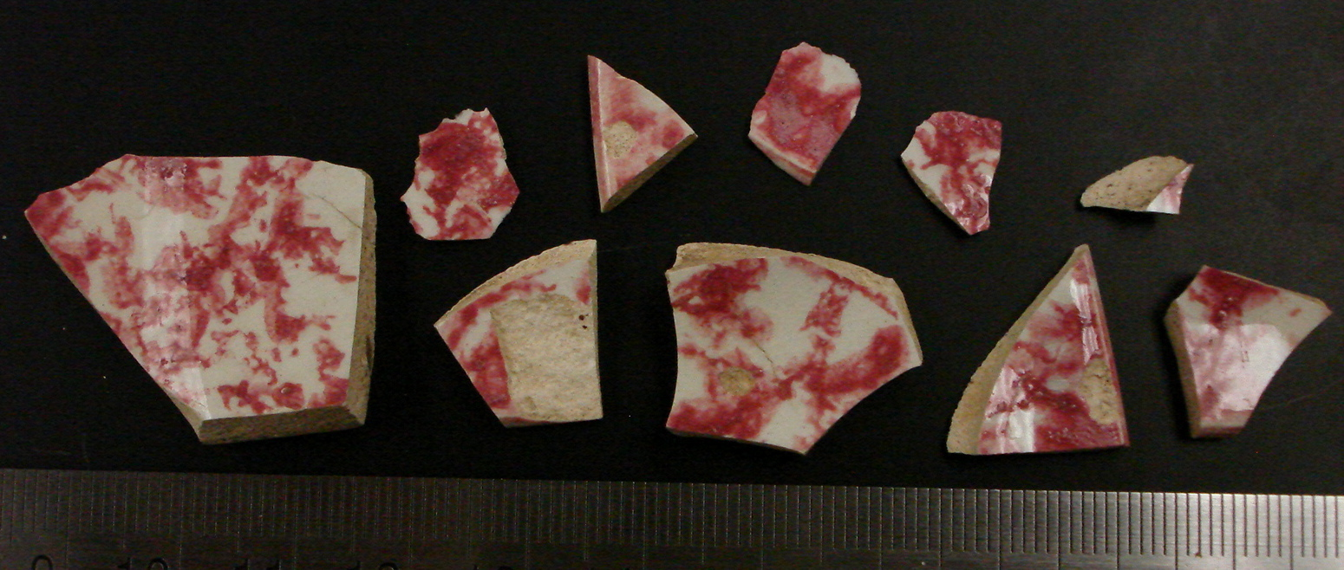
Ten sherds of cut-sponge decorated whiteware were found in excavation Unit 3, context level JBH 23 at a depth of 23cm -33cm below the lawn. All of the sherds are whiteware and were decorated with red paint before the glaze was applied; the paint was applied by a cut-sponge. All of the sherds range in size, shape and thickness but the largest sherd has the dimensions as drawn below. Three of the ten pieces contain part of the rim, which proved useful in identifying the size and use of the original ceramic. Elise, Ben and Moira uncovered these ten sherds but I have the honor of writing their biographies.
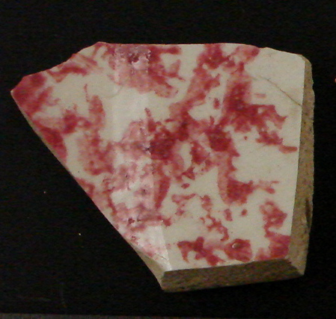
Pearlware and whiteware are very similar, as whiteware was developed from pearlware; whiteware does not have a particular date of introduction but it is known that by the 1820’s it had begun developing from pearlware. Potters were trying to move away from the blue tint and they did so by reducing the “amount of cobalt in the glaze” or by adding “cobalt to the body and give it a very light blue tint which through a clear glaze looks much whiter” (Miller; 1991; 53). The color of the glaze provides the difference between the two types of wares: pearlware has the bluish glaze and is fairly easy to identify, especially near the base where it may puddle, while whiteware lacks this bluish tint. The sherds uncovered from JHB 23 have been identified as whiteware precisely because they do not have the blue tint.
1.3cm
2.6cm
2.1cm
2.2cm
1cm
Approximately 0.4cm thick
The decoration on these sherds was applied by sponge and is therefore referred to as sponge-decorated ware. The sherds that I am examining appear to be purely sponge-decorated, as they do not contain any additional painting. George Miller states: “sponge wares without painting are not common before the introduction into the Staffordshire potteries of cut sponge with simple patterns in the late 1840’s” (Miller; 2000; 91) The late 1840’s date that Miller applies to cut-sponge whiteware holds well against other dates that have been suggested. The Archaeological Laboratory Artifact Codebook dates the range of production of cut-sponge ware from 1845 to 1930 and the Historical Archaeology at the Florida Museum of Natural History website says that “after 1840 decoration was applied exclusively with sponges, cut into desired shapes and without accompanying painting.” With all of these coinciding dates, I am therefore comfortable to say that these sherds of sponge-decorated whitewares were produced no earlier than 1845.
Of the ten sponge-decorated sherds that were uncovered in JBH 23, three of them are pieces that contained part of the rim, which allowed me to get a rough estimation of the diameter of the original ceramic. Two of the three sherds fit together to make a larger piece of the rim and the third piece of rim was also large enough to be used for measuring the diameter. Using the Archaeological Laboratory Artifact Codebook’s rim measurer, both of the rim fragments suggested an original diameter no smaller than 8 inches. A diameter of 8 inches or greater implies that the original ceramic would have been some sort of plate. Pearlware: Origins and Types (Part II), states that cut-sponge decorated wares were nearly all tablewares. Additionally, The Knopf Collectors’ Guide to American Antiques: Pottery and Porcelain says that: “plates were among the earliest pieces with sponged decoration.” All the evidence suggests that this cut-sponge decorated pearlware was originally a plate.
Cut-sponge ware originated in North Staffordshire, England and appears to have been exclusively destined for the American market until approximately 1860. This imported pottery was generally inexpensive: “for their period, sponged wares are usually the cheapest vessel available with decoration” (Miller; 1991; 91).
These ten sherds were found in Unit 3, context JBH 23. The remains from this context were primarily domestic remains: many pieces of ceramic (pearlwares, whiteware), numerous shards of glass, oyster shells, etc. Unit 3 lies near what appears to be a wall or foundation of a once standing structure, which fits well with the fact the remains are part of, what appears to be, a domestic assemblage. Another sherd of cut-sponge decorated ware was found in Unit 5, context JBH 32. This Unit 3 lies very close to Unit 5 and JBH 23 and JBH 32 are at similar depths: JBH 23 lies 23-33 cm below the surface and JHB 32 lies 9-32 cm below the surface. Because Unit 3 and Unit 5 lie close to one another and the contexts are approximately the same depth, it is possible that the sherds from JBH 32 and JBH 23 belong to the same, original ceramic.
According to our (Meghan and Steffi’s) research, we have found that the structure that once stood in the area we were excavating was the Robert Hale Ives homestead. Records show that it was built sometime between 1832 and 1857 and was destroyed between 1925 and 1926. The dates for the Robert Hale Ives homestead fit well with the dates I have found for the sponge-decorated ware.
All of the people that inhabited the John Brown property throughout history were fairly well off. During this time in America many people flaunted their wealth and influence by purchasing expensive tablewares and other ceramics; they wanted to “elevate their status above their daily routine through the acquisition of material goods” (Mrozowski; 2006; 57). However, due to the cheap price of the sponge-decorated ware I suspect that it did not belong to the property owners but rather the servants who were unable to elevate their status.
Robert Ives Gammell lived in the Robert Hale Ives homestead from 1875 to 1915. For part of the time that he inhabited the homestead a cook and a servant lived with him. It is possible that these shards of sponge-decorated whiteware once belonged to the cook and/or the servant rather than Robert Hale Ives or Robert Ives Gammell. This would account for the fact that this type of ceramic was inexpensive for the period.

Works Cited

Ceramic Profiles and Rim Diameters: A Guide to Function. Archaeological Laboratory
Artifact Codebook. University of Massachusetts Boston, Center for Cultural and Enviromental History. 2004.

Florida Museum of Natural History.
http://www.flmnh.ufl.edu/histarch/gallery_types/type_index_display.asp?type_name=PEARLWARE,%20SPONGED%20OR%20SPATTERED

Ketchum, William C. The Knopf Collectors' Guides to American Antique: Pottery &
Porcelain. Alfred A. Knopf: New York. 1983.

Lockett, Terence A. “Pearlware: Origins and Types (Part 2).”
http://www.thepotteries.org/features/pearlware2.htm (accessed Dec. 15, 2008)

Miller, George L. 1991. Classification and Economic Scaling of 19th Century Ceramics.
In R. Micheal, ed, Approaches to Material Culture Research for Historical Archaeologists. The Society for Historical Archaeology: Ann Arbor, Michigan.

Miller, George L. 2000. Revised Set of CC Index Values for Classification and Economic
Scaling of English Ceramics from 1787 to 1880. In R. Micheal, ed, Approaches to Material Culture Research for Historical Archaeologists. The Society for Historical Archaeology: Ann Arbor, Michigan.

Mrozowski, Stephen A. 2006. Shifting Focus: Archaeology of the Urban Household.
Cambridge University Press: New York.

