Kellie Slater
December 17, 2008
Blue-edged Pearlware
Two sherds of blue-edged pearlware were uncovered in Unit 3, context layer JBH 23. It is clear that the sherds are not from the same ceramic because the style in which they are decorated differs slightly. Both have a feathery style, but one has darker blue, inward painted stripes over the lighter blue color. The length of the decoration on each plate also differs: the length of decoration on the sherd with strips is approximately 0.7cm, while the decoration on the strippy decorated sherd is approximately 1cm. Both pieces are very thin and contain pieces of the rim.
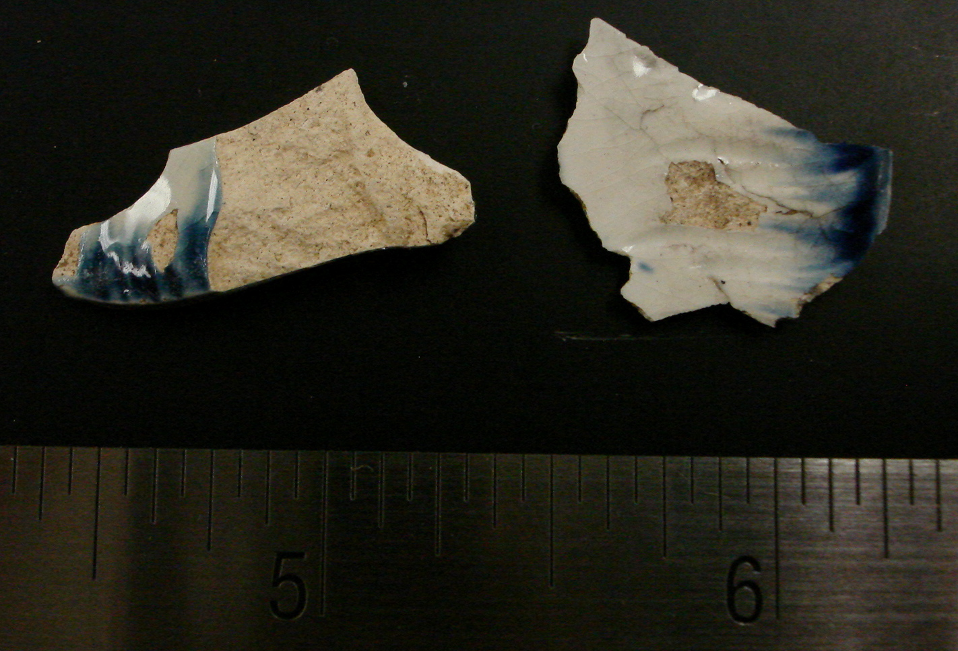
Pearlware was developed in 1779 by Josiah Wedgewood, as a new type of earthernware. It “was created by the simple expediency of covering a creamware fabric with a blue-tinged glaze” (Sussman; 2000; 37). Creamware was a more yellowish color and Wedgewood decided that “a change from ‘creamcolor’ was due” and began to develop pearlware (Sussman; 2000; 37). Pearlware has a blue tint, which comes from the addition of cobalt to the glaze. When this glaze was applied over a blue decoration it gave the appearance of a whiter body. Pearlware is easy to identify because of the blue tint when it pools near the base. Pearlware made its debut in the 1780’s and was common until about 1840.
Pearlware, because it was very similar to creamware, “had to depend on its decoration rather than the nature of the ware,” and many different types of decoration were common (Miller; 1991; 52). But “by far the most common decoration on excavated 18th century pearlware is the molded shell edge pattern….and it was probably one of the first patterns used to decorate pearlware” (Sussman; 2000; 38). Blue and green are the most common colors for this type of under-glaze decoration, with pink occasionally occurring. The production dates of edged pearlware are 1785 to 1840 and throughout this time period subtle changes were taking place. Early examples, 1785-1795, are well painted and the brushwork is drawn inwards in order to create a feathery look but on later examples, dating later than 1800 or 1805, it was a common practice to brush the paint laterally around the plate edge to create a mere strip (Hume; 1969; 131). Many of the rims were also embossed or impressed with different designs and “although they were often better painted than their plain cousins they are unlikely to date prior to 1800” (Hume; 1969; 131).
Both of the sherds that were uncovered in JBH 24 appear to have the feathery design that would have been created by stroking the brush inwards. One of the sherds is also impressed with curved lines. The decoration on both of these sherds would lead me to give them a date of sometime around 1800. Neither of them were painted with a single stroke around the rim, which developed later, rather they have the earlier feathery look and one of them is impressed, which also appeared later.
The rims on both of the sherds proved very useful when trying to determine their original size and diameter. The Archaeological Laboratory Artifact Codebook suggests that both sherds originally had a diameter of 6 inches or greater, which puts them into the plate category. This diameter fits well with other evidence, which says the most common form of pearlware was in shell-edged plates (Hume; 1969; 131). In addition, Miller suggests that “edged wares are generally limited to…a general class known as tablewares” (Miller, 2000; 91).
Edged pearlwares were generally one of the cheapest decorated tableware avaliabe for the majority of the 19th century (Miller; 2000; 91). Evidence from the Boott Mills Boardinghouse also supports this claim. At the boardinghouse blue-edged ware comprised a large portion of the identifiable plate assemblage. Because there is such a large percentage of the blue-egded ware, there appears to be some sort of attempt to “obtain matching patterns of printed ware” (Boott Mills; 1989; 92). The residents of the boardinghouse were by no means wealthy, but because they could afford to try and match this type of ware is strong evidence that it was relatively inexpensive.
The Robert Hales Ives homestead was built on the Brown property between 1832 and 1857. These dates do not directly correspond to my hypothesized date for the edged sherds but it is completely possible that these blue-edge wares were moved to the house shortly after it was built. Another possibility to explain the difference in dates is that these wares may have been heirlooms that were passed down through the family. Another, more plausible explanation, is that the wares belonged to the cook and/or servant that lived with Robert Ives Gammell in the homestead. This would account for the cheap price and the old date of the ceramics. Robert Ives Gammell was probably fairly well off and would have wanted to show his influence through purchasing expensive ceramics, whereas the cook and/or servant would have been quite content with a blue-edged pearlware plate; they would have no qualms using “the out of fashion hand-me-downs” (Bankoff and Winter; 2005; 22).

Works Cited

Bankoff, H. Arthur and F. Winter. 2005. The Archaeology of Slavery at the Van
Cortlandt Plantation in the Bronx, New York. International Journal of Historical Archaeology, 9(4): 291-318.

Hume, Ivor. 1969. A Guide to Artifacts of Colonial America. Univeristy of Pennsylvania Press: Philadelphia, Pennsylvania.

Miller, George L. 2000. Revised Set of CC Index Values for Classification and Economic
Scaling of English Ceramics from 1787 to 1880. In R. Micheal, ed, Approaches to Material Culture Research for Historical Archaeologists. The Society for Historical Archaeology: Ann Arbor, Michigan.

Sussman, Lynne. 2000. Changes in Pearlware Dinnerware, 1780-1830. In M.
Ronald, ed., Approaches to Material Culture Research for Historical Archaeologists. The Society for Historical Archaeology: Ann Arbor, Michigan.

Cultural Resources Management Study No. 21. 1989. Interdisciplinary Investigations of the Boott Mills. The Boarding House System as a Way of Life. Cultural Resources Management Study No. 21

