Megan Algeo
Prof. Ryzewski
ARCH 1900
18 Dec 2008
The Sayre & Fisher Brick
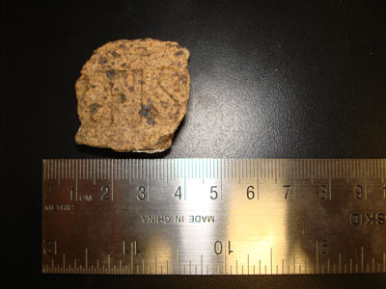
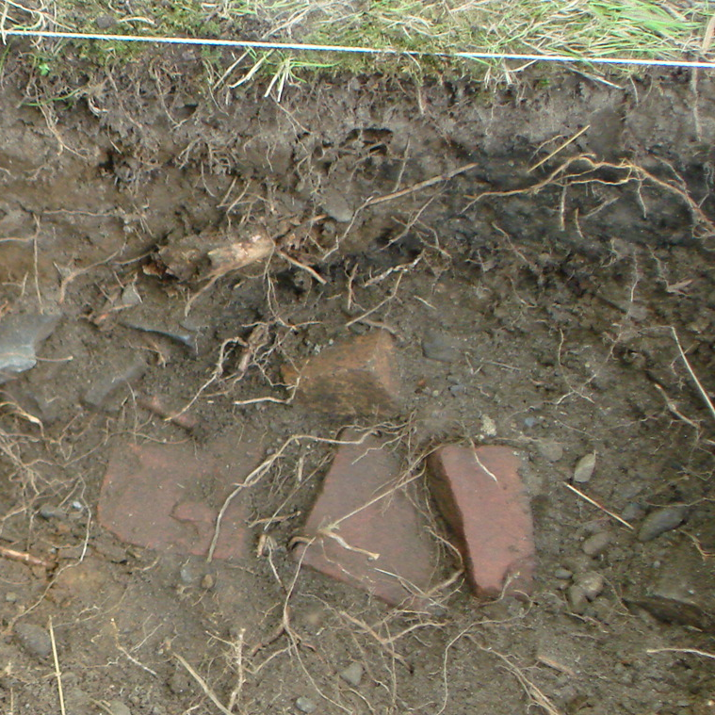
The spotted, red-yellow brick fragment shown in Figure 1 was unearthed in JBH 11, a natural soil context beginning with an uneven surface 7 cm at the shallowest corner and ending at a uniform depth of 20 cm. Field notes describe the soil quality as mottled, and the Munsell value, reproduced digitally from a representative site photo, was .09Y 4.11/1.67. Other notable finds from this context included asphalt, slate, burned concrete, a small plastic tube, quartz, architectural hardware, safety glass, a metal flag emblem, and a whiteware sherd.
Figure 1: The Unit 2 brick sample
Below JBH 11 was the arbitrary context JBH 22, which we believe belonged to the same strata, despite the fact that the stratigraphy was complicated by roots and features obstructing a clear cross section of the wall. Its contents should be considered as well. JBH 22, with a Munsell reading of 10 YR 3/2 contained patches of sand and mortar, and was somewhat rockier, with rocks around two inches in diameter throughout the layer. We unearthed asphalt in the southwest corner. Finds included a screw, foam, bottle glass, whiteware, and most significantly a chunk of brick a few centimeters around made from the same clay as the brick fragment from JBH 11, supporting our theory that JBH 11 and 22 are the same deposit.
Figure 2: The Unit 2 brick sample in situ
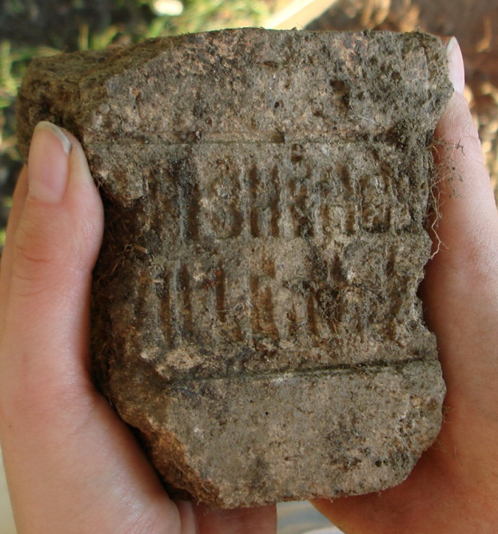
Near the end of the context JBH 22, a brick and rock feature (Feature 5) was exposed abutting the southern wall. The uppermost brick in the feature was another brick in the same style as the previous findds, this time a large corner fragment. A section of Feature 5 soon after its discovery is shown in Figure 2. The relevant brick appears brown, and sits atop three red bricks, disappearing into the wall of the unit. Feature 5 continued until we reached the end of excavation, at 53 cm. Unit 5 found a larger chunk of an identical brick in context JBH 32 (Figure 3), also with a maker’s mark, which reads “FISHER Co./ILLE NJ” (Nuding 2008, 8).
Figure 3: The Unit 5 brick sample
It was originally thought that the brick might have been a part of the original Robert Hale Ives Homestead, under construction by 1857 (Yellin 2008, 1). We knew through historical documentation and maps that Ives had brick walls and brick outbuildings around the area where Unit 2 was situated (Yellin 2008, 7). However, further research revealed the brick could not have appeared on site until 1876, at the earliest.
The maker’s mark allowed us to define an absolute date of earliest production, as well as a more specific, but less certain, date when the brick might have been used in construction. Brick companies began including maker’s marks on some of their bricks in the 1860s, and the practice continued until the 1950s (Vogel, 1995).The letters from the brick fragments provided enough data for an internet search, which turned up the Sayre & Fisher Brick Co. of Sayreville, NJ, a perfect fit for the text on our brick.
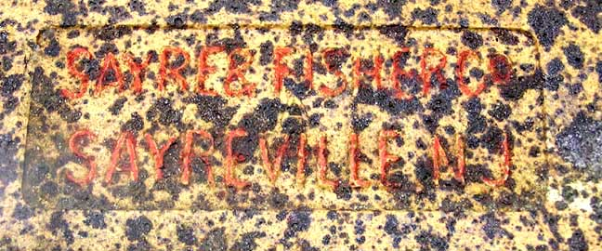
Once the largest producers of brick in the world at its peak, the Sayre & Fisher Brick Company was founded in New Jersey in 1850 (Ecology & Environment 2008). In 1876, the town where the company was located changed its name from Wood’s Landing to Sayreville (Ecology & Environment 2008). Samples of marketing materials from the company contained representations of bricks similar to ours, defining them as “front bricks,” which were of better quality than regular “common brick” (Ecology & Environment 2008). Further research uncovered a photograph from the “Frank and Jane Clement Brick Museum,” a private collection, of a complete brick with striking similarities to the samples from The John Brown House site. The unique clay composition and content of the text are identical, though the typeface used in the maker’s mark is slightly different. The matching brick (pictured in Figure 4), was found at the Darwin Martin House in Erie, PA, which was constructed between 1905 and 1906. Taken together, these dates suggest that a brick would not have contained the new name of the town until after 1876, and that the bricks from our site, while not identical to the brick deposited after 1905 in Pennsylvania, were likely produced around that time.
Figure 4: Brick from the Darwin Martin House, whole and in detail (red paint added). Source:http://www.buffaloah.com

The Sayre & Fisher brick samples were important in determining TPQ dates for deposits in Units 2 and 5. It is possible that these bricks were used in subsequent renovations to the Robert Hale Ives property. The presence of similar bricks, in Western Pennsylvania and in Rhode Island is a testament to the popularity of the company in the late 19th and early 20th centuries. The Darwin Martin House was constructed by Frank Lloyd Wright, the renowned architect, which suggests that the brick was perhaps of superior quality, and expensive to import to Rhode Island, especially given the number of local brickworks, for example the Barrington Brick Works, that could have been substituted (Quinan 2008; Barrington 2008).

Works Cited
Algeo, Megan. Unit 2 summary. ARCH 1900 Final Project. http://proteus.brown.edu/archaeologyofcollegehill/7043. Accessed Dec.. 18, 2008.
Barrington, Rhode Island. Wikipedia. http://en.wikipedia.org/wiki/Barrington,_Rhode_Island. Accessed Dec.. 16, 208
Ecology & Environment, Inc. A History of the Sayre & Fisher Brick Company. Neptune Regional Transmission System, LLC. http://sayre-fisher.com/default.htm. Accessed Dec.. 16, 2008.
Frank and Jane Clement Brick Museum. Group 1 - Museum brick collection from Buffalo, NY, area. http://www.buffaloah.com/a/DCTNRY/mat/brk/clement/1/index.html. Accessed Dec.. 16, 2008.
Nuding, Elise. Summary of Units 3 and 5. ARCH 1900 Final Project.
http://proteus.brown.edu/archaeologyofcollegehill/7043. Accessed Dec. 16, 2008.
Quinan, Jack and Timothy Tielman. Martin House. http://preserve.bfn.org/bam/bflobest/martin/martin.html. Accessed Dec.. 16, 2008.
Vogel, Michael N. Up Against the Wall: An Archaeological Field Guide to Bricks in Western New York. http://www.buffaloah.com/a/DCTNRY/mat/brk/vogel/index.html. Published 1995. Accessed Dec. 16, 2008.
Yellin, Steffi. Robert Hale Ives Homestead. ARCH 1900 Final Project. http://proteus.brown.edu/archaeologyofcollegehill/7043. Accessed Dec. 16, 2008.

