Megan Algeo
Prof. Ryzewski
ARCH 1900
18 Dec 2008
Investigation of a Dark Olive Green Bottle Base Fragment
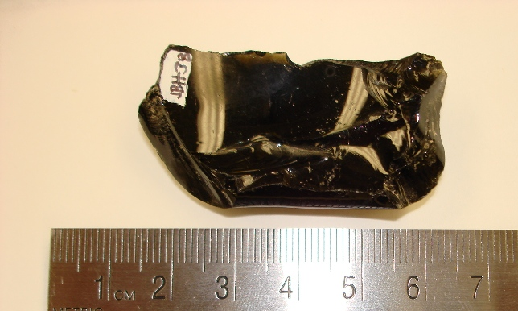
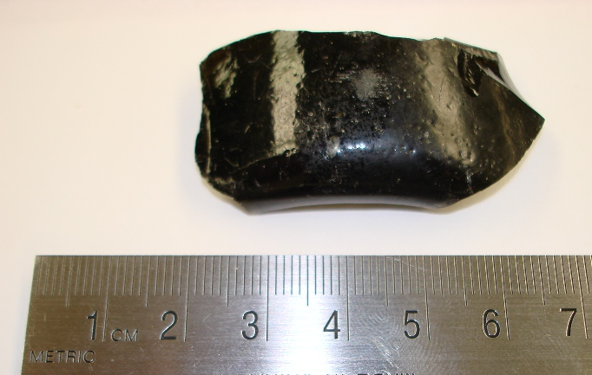
This bottle fragment was recovered from “sandy, mortary soil” in context JBH 38 in Unit 2 on the last day of excavations. JBH 38 was a natural soil context extending from 41 to 53 cm, with a Munsell value of 10 YR 4/3. The glass is so dark and thick that
Figure 1: The inside of the fragment Figure 2: The outside of the fragment

it appears opaque at its widest point. Consequently, the initial field notes misidentified it as “glassy ceramic.” Once cleaned, it became apparent that the object was actually the base of a glass bottle. Using the lab’s glass typology, we determined the color to be a very dark olive green. Though the artifact is nondiagnostic in the sense that no precise date or method of manufacture can be provided, the bottle base can still provide insight into the culture of the site, processes of site formation, and hypotheses about its origins and function.
Very dark olive glass can be classified under the larger category of “black glass,” which also includes amber and purple hues, though the olive color predominates. Its coloring is created by introducing iron, and sometimes carbon, copper, or magnesia (Lindsey 2008). Our sample is much deeper than any of the more moderate olives found in the BLM/SHA online typology consulted as the main source for this analysis, but matched nicely with the black glass samples. The type sample shown in Figure 3 was blown by the New England Glass Bottle Company between 1827 and 1845 (McKearin & Wilson 1978; referenced by Lindsey 2008). According to the BLM/SHA website, “black glass bottles and fragments are ubiquitous on historic sites that date prior to 1870,” often serving as inexpensive containers for alcohol, but becoming uncommon after 1880 (Lindsey 2008).
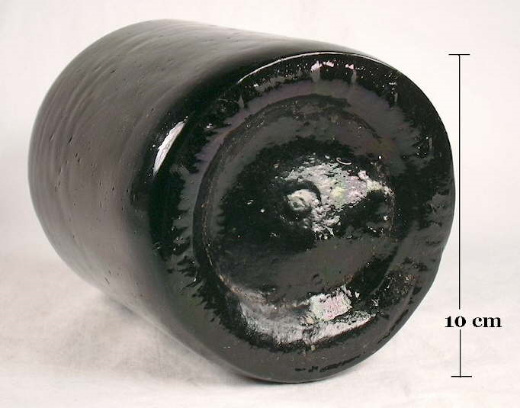
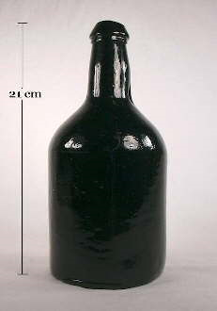
The shape of the base and its thickness suggests a cylindrical bottle, which in turn adds weight to the hypothesis that this is a liquor bottle, as opposed to something such as an ink bottle, which often assumed a more complex shape but was also frequently produced in black glass. If the sample was a part of a liquor bottle, the opacity of the glass aided in the preservation of photosensitive alcoholic beverages (Lindsey 2008). The exact type of cylindrical bottle cannot be determined from the fragment. Fortunately, in this case the dates that we obtained from the classification of the find as black glass are more useful than shape in determining when the bottle was produced.
Figure 3: Two views of a black glass, cylindrical bottle
The tentative pre-1880 date of manufacture also allows us to theorize about the method of production. If the sample is from a liquor bottle, its base could be either free-blown, or mold-blown. The base seems relatively uniform, favoring the use of a mold during production. Of the numerous methods of producing mold-blown bottles, two are common choices for liquor bottle production—the cup base mold and the post base mold. The cup base mold was used after 1880, while the post base mold was employed until 1880, making it a viable possibility for our base fragment (Lindsey 2008). This method would have produced multiple diagnostic seams on the base, none of which are present in our sample. Ultimately, the color of the bottle and the area of the bottle that the fragment came from are the only characteristics we can reliably conclude with such a limited sample to work from.
If we assume that the glass was deposited sometime prior to 1880, this would coincide with the tenancy of Robert Hale Ives, his children, and their grandchildren on the property. Therefore, it would be reasonable to conclude that the bottle may have belonged to a member of the family or someone associated with them. While these bottles were surely possessed by members of varying social classes, their abundance and low cost means that it is possible the bottle belonged to an employee of the family. We know that, at the least, Robert Ives Gammell, grandson of Robert Hale Ives, was living in the home with a cook and a butler around 1895 (Yellin 2008, 1). Perhaps the family had household staff prior to this date, as well, who consumed spirits from the mass produced bottles.
It is equally possible to construct middle class origins for the bottle. During the 19th century, the temperance movement was on the rise, and the middle class, at least outwardly, was beginning to hew to changing social norms. Many bottles produced during this time for supposed medicinal purposes were actually liquors in disguise, allowing members of the middle class to imbibe under the pretense of health (Smith 2008, 80-81). While technically “medicine bottles,” these bottles were used just like liquor bottles in practice, and form would have followed function. Black glass was used to bottle alcohol imported from Europe to the east coast. If this bottle was an import, it is probable that it belonged to someone of middle to upper class social standing. It is also possible that the bottle is somewhat newer if it is an import—European-made black glass liquor bottles were on the decline approximately ten years later, in the 1890s (Lindsey 2008). It is unfortunate that we were not able to recover more diagnostic pieces of the bottle, which would have enabled a more definitive description of the bottle’s morphology, method of production, and function. Hopefully future field seasons will dig below JBH 38 and uncover more historic finds.

Works Cited
Lindsey, Bill. Historic Glass Bottle Identification & Information Website. Managed by the Bureau of Land Management and the Society for Historical Archaeology. http://www.sha.org/bottle/index.htm. Accessed Dec 17, 2008.
McKearin, Helen and Kenneth M. Wilson. American Bottles & Flasks and Their Ancestry. Crown Publishers, Inc., 1978.
Smith, Frederick H. The Archaeology of Alcohol and Drinking. University Press of Florida, 2008.
Yellin, Steffi. Robert Hale Ives Homestead. ARCH 1900 Final Project. http://proteus.brown.edu/archaeologyofcollegehill/7043. Accessed Dec 16, 2008.

