Whitney Knowlton

Pearlware, shell edge, transfer-print:
A small sherd of pearlware was uncovered in Unit 4 JHB 42. This was unlike the other pieces of pearlware found in this context, it was a piece of a molded or embossed shell edge rim decorated with a blue and white transfer print. These three additions to the simple and common type of ceramic, pearlware are important diagnostic features.
Pearlware is one of the most common ceramic types found on early nineteenth century sites. It was produced in England and it is considered to be refined earthenware. “Pearlware deliberately imitated Chinese porcelain, both in color and decoration” (Barker 415). The faint tint of blue in the glaze that is noticeable in the crevices, where small pools of glaze would settle, distinguishes it from creamware. The glaze on creamware would appear yellow or green in the tableware’s crevices.
The Florida Museum of Natural History reports that a pearlware with a shell edge has a date range of production from 1785-1840, with a mean date of 1812. These rims either appear to be scalloped, which is depicted by a wave-shaped profile of the rim, or plain, the rim was standard with a smooth circular profile. If the sherd found had a plain rim it would have been smooth and circular, similar to the standard basic rim found on flatware today. This type of edge is important for deciphering the form of vessel this sherd would have come from. The vessel forms for shell edge pearlware are bowl, plate, or platter. The Ceramic Profiles and Rim Diameters: Guide to Function instructs the user of the rim diameter chart to, “Hold the sherd against the profile chart, or use a ruler, to help determine the function of the tablewares.” After doing this, the rim diameter was determined to be between four and five inches. At the five-inch mark the types of vessel the chart notes are bowl, saucer, cup plate or child’s plate. We can rule out a few of these options based on the shell edge, the sherd found in context 42 most likely belonged to a cup plate or child’s plate.
The technique of transfer printing under the glaze is also a diagnostic feature; the FLMNH’s date of production range for transfer-printed pearlware is 1795-1840, with a mean manufacturing date of 1818. The method of production began with a design engraved onto a copper plate. The plate was then heated to help thin and speak the ink. The ink color was a result of the metallic oxide; the more deeply the plate was engraved, the darker the color on the ceramic. Cobalt produced the blue color seen on this sherd. The copper plates could be used repeatedly. Popular designs were often sold to several manufactures. Similar to blue painted wares, early blue printed earthenwares were also done in Chinese patterns, which remained popular until around the War of 1812. Early in the 19th century the copper plate engravers began to use stipples, small dots, as a shading device allowing the prints to have greater perspective. As a result of the War of 1812, English and American landscapes became a more popular motif.
Patricia M Samford argues that the production of English underglaze transfer-printed wares is primarily based on a response to the market. The author points our that the technique of transfer printing under the glaze had been possible for over two decades, “…it was not until after the War of 1812 that printed wares began to appear in great numbers in America” (Samford 57). The increase after the war was probably the result of the substantial fall in ceramic prices. The design of the print on the sherd shows small flowers, it is likely that is was a floral motif. This type of decoration was popular throughout the nineteenth century. The most prevalent designs had a central floral motif or an overall repeating pattern, known as a sheet pattern. Floral boarders are mainly divided into two types: those with continuous repeating unbroken motifs and those where the motif is broken with unprinted white areas. The artifact found in JBH 42 is too small to determine what the entire vessel’s design would have looked like.
Comparing this piece of pearlware with other artifacts found in the context JBH 42 it is possible to suggest a date range, after which the layer was deposited, terminus post quem. There were several small pieces of plain creamware also found in the context. FLMNH provides a date range of production for this type of ceramic and it states that it would have been produced between 1762 and 1820. This diagnostic information along with the three sherds of redware with a dark brown lead glaze, FLMNH gives 1700-1770 as a range of production, suggest that this context was deposited between the late 18th through early 19th century.

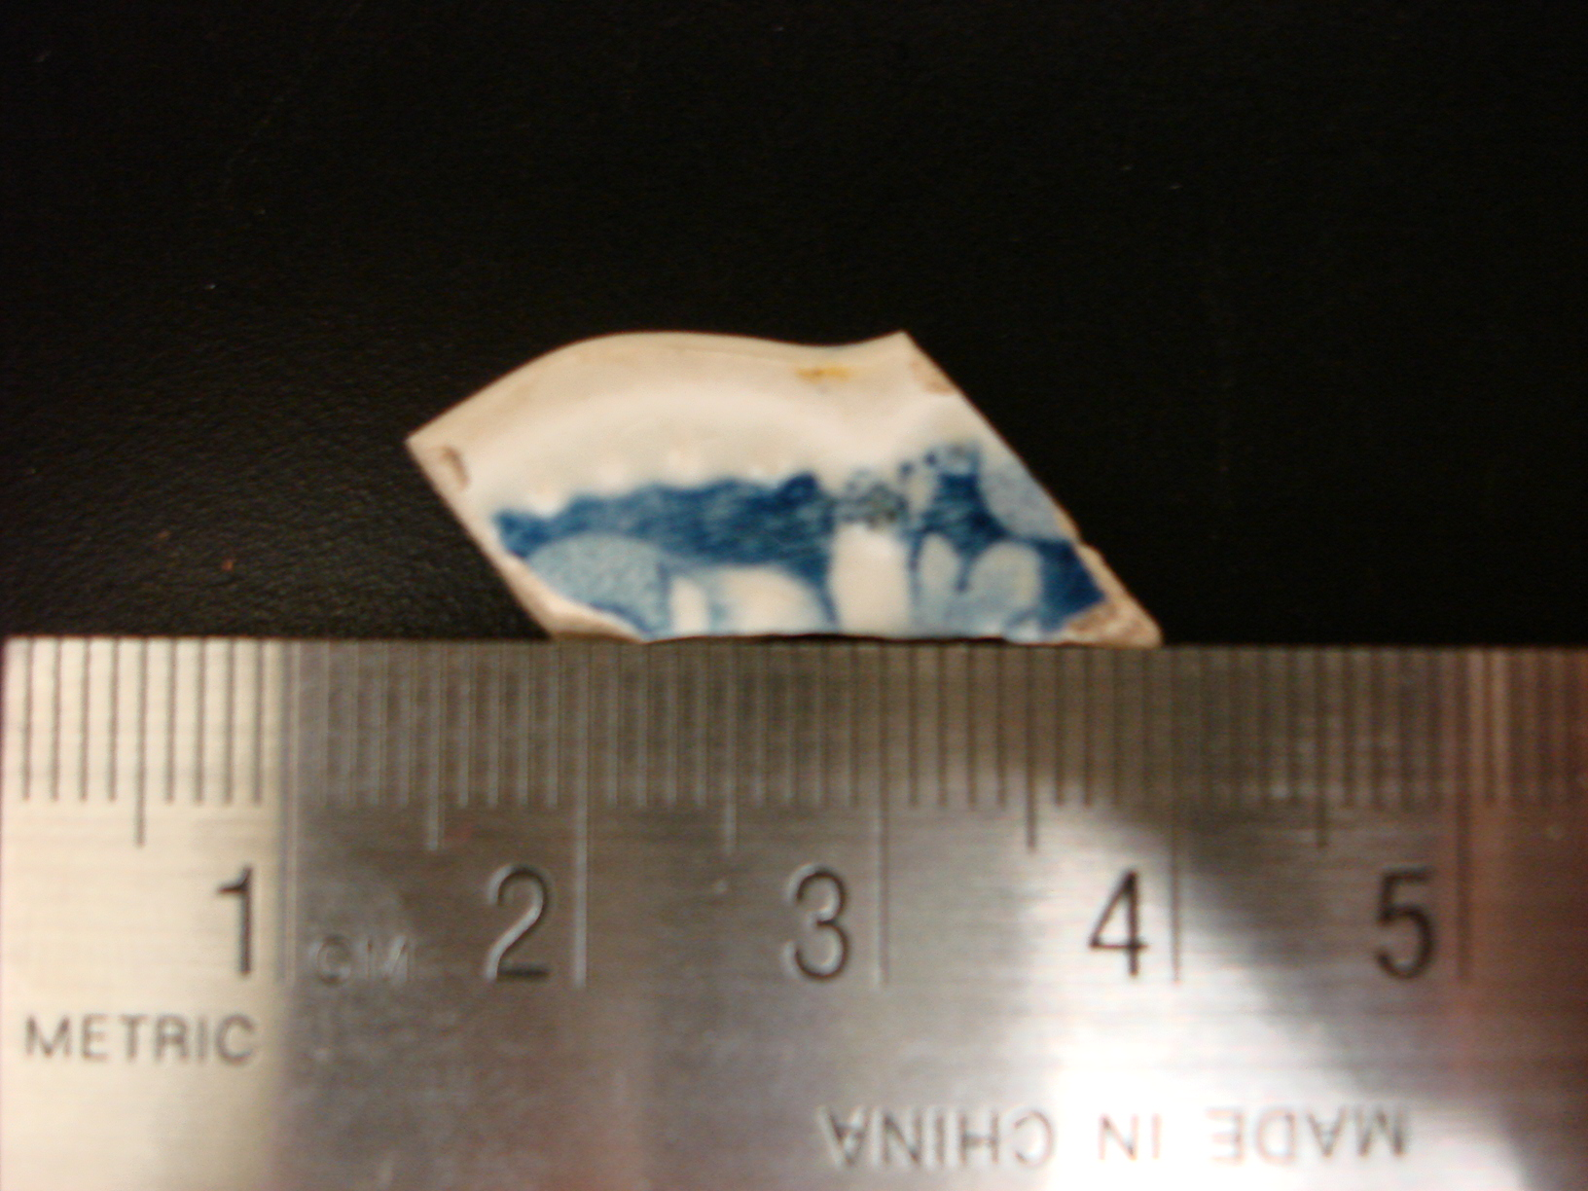

Redware with Lead Glaze:
“The most commonly ceramic found around the globe is red earthenware, commonly called ‘redware’” (Turnbaugh 469). This ware is constructed of red-clay found in abundance around the world. Ivor Noel Hume states that the majority of ceramic pots were of course earthenware, coated with a leadglaze. “Body colors varied from buff coated with an apple-green glaze, to red covered with a purplish-brown tortoise-shell leadglaze” (Hume 146). Basically every western European country had its own coarse earthenware traditions for producing utilitarian vessels necessary for daily life activities. Most earthenwares have similar manufacturing techniques; first they were thrown or formed, then dried, decorated (if at all), glazed and then fired (usually only once). “Utilitarian vessel forms…often look quite similar, so much so that the geographic origins of their clays or slips may be distinguished…only through chemical or spectroscopic analysis…” (Turnbaugh 471).
Redware could be decorated, like other wares, by piercing, incising, or applying molded reliefs prior to firing. The sherds found in context JBH 42 do not show any decoration, however, because of their very small size it is nearly impossible to determine if the vessels from which they came were decorated. The body of the redware is the softest of all the earthenwares because of this it fractures easily. This is why it is usually recovered in small pieces.
Some of the European redware industries were able to export their wares for trade, especially in those countries with colonial interests in the Caribbean and the Americas. English coarse earthenwares reached North America during the seventeenth century. “Typical eighteenth-century English coarse wares included black leadglazed storage jars, dishes, pans and jugs” (Barker 167). Other common seventeenth and eighteenth century English earthenwares include black leadglazed drinking vessels. Three sherds of dark brown to black leadglazed earthenware were discovered in Unit 4, JBH 42. These sherds were probably apart of a utilitarian vessels related to food storage or preparation (these were the dominate forms from this period). In some communities redware forms remained popular until about 1770, when production declined as a result of the increasing availability of refined earthenwares. As a result many local redware potters ended their production.
The Florida Museum of Natural History (FLMNH) gives a production date range of 1700 through 1770 for redware with a dark brown/black glaze. This information alongside other artifacts also recovered from JBH 42, sherds of creamware and pearlware, allow for a terminus post quem of late 18th century to early 19th century for this context. Even though creamware (1762-1820) and pearlware (1785-1840) had a later dates of production than the end date given for this type of lead glazed redware, it is still likely all three types of ware were in use around the same time.
There are several issues surrounding the use of ceramics as an instrument for dating a site. It is important that researchers do not solely use ceramics to date sites, dates need to be complied based on documentary and artifact evidence. Even though there is a large amount of information available on the dates of manufacturing it is very difficult to account for the entire lifespan of a ware. It is important for any researcher attempting to use ceramics to aid in dating their site to understand the context in which the artifacts were found, for example how the finds were originally used and discarded. William Adams study suggests that the lifespan for ceramic tableware vessels can be fifteen to twenty years or longer, “The manufacturing date fact cannot be equated with an artifact’s use date” (Adams 41). The time over which a piece of tableware used depends greatly on the cultural factors surrounding the type of ware. George Foster derived five basic categories that affect the duration of use for ceramics, those are: basic strength, pottery uses, mode of use, cause of breakage, and price of pottery.
The Mean Ceramic Date of a piece of ware can be vital way to gain an understanding of the time when a piece was at its peak in popularity during the time of its manufacturing. However, it is necessary to keep in mind the several factors that can result in a piece of ceramic surviving beyond its popularity curve. William Adams describes what he believes to be the five main categories. The first is the Heirloom Effect, a new house maybe a compilation of new items as well as acquired gifts, heirlooms, from family and friends. Also these types of pieces can be attached to the estate and can be passed from owner to owner. Adams also mentions a frugality effect; since the Brown’s were one of the city’s most distinguished families it is not likely that they took into account a budget when purchasing items. However, the author does note that while this effect is usually linked to people or families with a low income, the behavior can cut across economic classes. A wide range of patterns indicating that pieces were acquired individually rather than as sets is a primary characteristic of the frugality effect. On the other hand, this type of assemblage could also be a sign of the hand-me-down effect, which is more likely on the Brown estate since there is historical documentation of the family owning slaves.

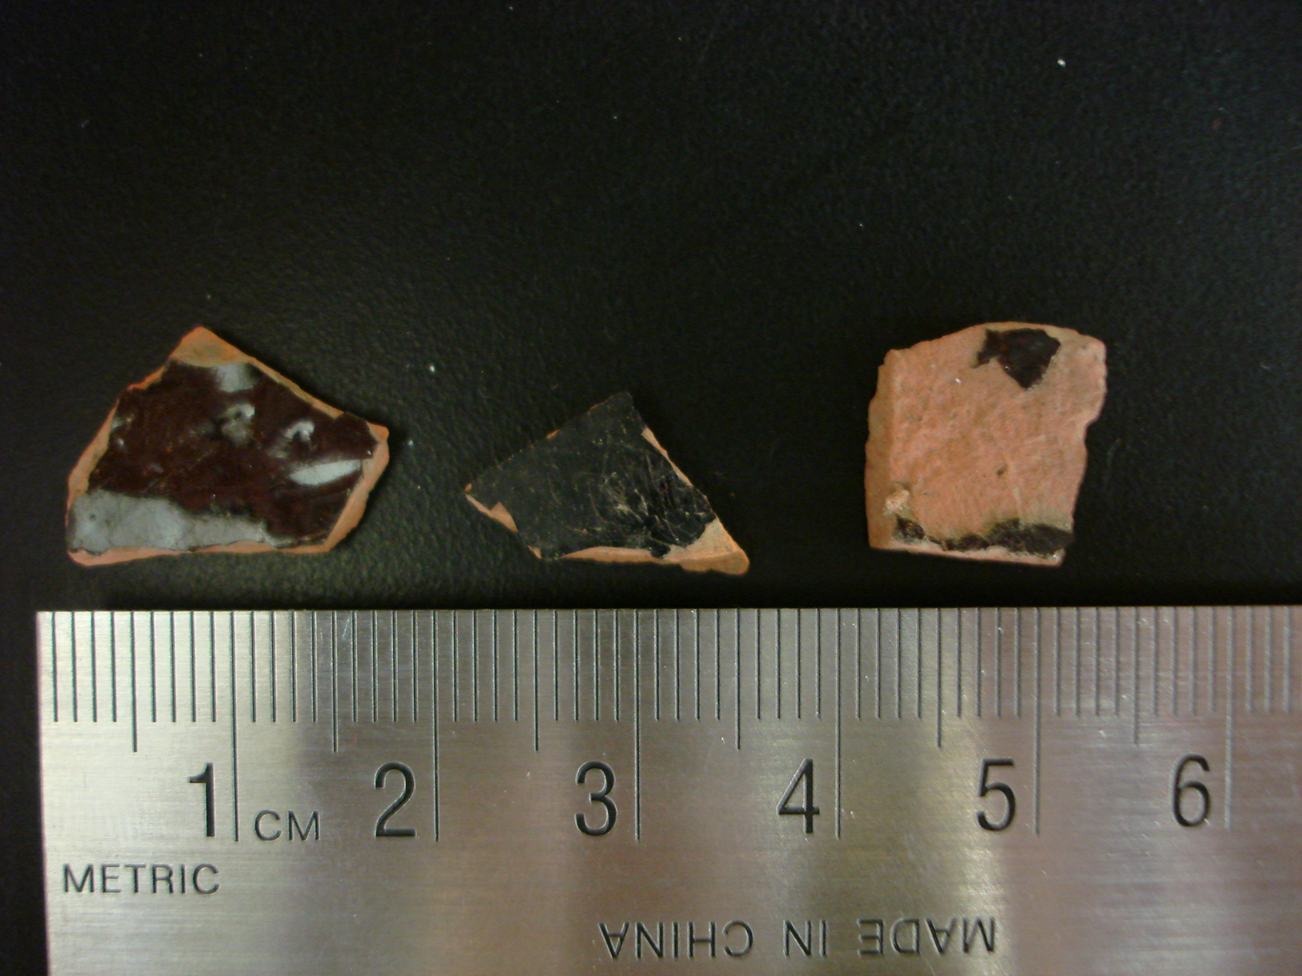
Green Glass Bottle:
During the late 19th century the significant improvements in the finish portion of glass containers in addition to the development of convenient, reliable closures aided in the increased demand for glass commercial containers. “Two very important closures were the crown top for bottles and the Phoenix cap for jars, both patented in 1892” (Miller &Sullivan 161). Around the same time, automatic canning and bottling machinery were being developed. As well as, better knowledge of sterilization and a wider availability of refrigeration. These developments are apart of a broad change in food consumption patterns and emerging brand-name products.
For cataloguing purposes, glassware is divided into several broad categories usually based on functional classifications. For the large fragment of green glass, from the base of the neck up, found in Unit 1, JBH 24 it falls under Parks Canada’s classification term ‘container’. It is a general grouping of commercial bottles and jars; these items would have been acquired for their contents. Although some of the containers in this category would have been purchased for their use, for example nursing bottles. Another category that is of importance, considering the green glass fragment in question, is that of closures. These are regarded as separate items associated with containers.
The artifact being discussed has symmetrical seams running up either side of the neck of the bottle continuing through the string rim and lip. This is the primary characteristic of a two-piece mould bottle. “The base, body, shoulder, and neck of the bottle are formed together in a two-piece bottle mould which is hinged either at the bottom or at the side” (Jones & Sullivan 26). However this type of mould decreases in use during the last third of the 19th century. It seems to be replaced by the two-piece mould with a third base part. The primary characteristic of this type is that the seams begin at the edge of the base part on each side of the bottle and extend up the bottle as high as the finish. In terms of dating this method of bottle production, there is a wide range since this type is still being manufactured in the present. “The two-part vertical mould with separate base part becomes the most common container mould type for the late 19th and early 20th centuries” (Jones & Sullivan 29).
During the late 19th century there was a general move towards machine-made containers. These are holloware bottles and jars that are shaped by machine supplied pressure. There are two types of machines, semi-automatic and automatic. Both allow for several containers to be produced at once. Semi-automatic machines require manually supplied gobs of molten glass; where as fully automatic machines do not require any manual labor. The glass is distributed and given its initial shape by the parson mould. Next the container is relocated to a full-size mould that forms its final shape and size, as well as adds and embossed letters or designs to its surface.
Dating this artifact is somewhat difficult since the fragment does not include any portion of the body or base of the bottle. “Many machine-made glass bottles carry the name of their manufacturer embossed or stamped on their bases” (Orser 69). If that were the case it would be possible using books of makers’ marks to date the bottle fragment found in JBH 24. Even though the artifact is only a portion of the bottle, from the neck up, it is possible to narrow down its possible production range based on its closure type. The closure was an important feature on a bottle because most consumers were purchasing such containers solely for their contents. The producers of the contents would do business with bottle makers who could ensure a secure enclosure. Corks were some of the earliest and popular bottle stoppers. Bottles that used such closures had bores that were either straight or gently sloped. Bottle manufacturers became interested in new closure designs during the 19th century with the invention of products containing gas. “Without question, the crown finish, invented by American William Painter in the early 1890’s, was the most effective closure for carbonated drinks” (Orser 69). The crimped bottle cap characterizes the crown cap and this type of closure is still widely used today. The crown finish on the bottle used to have a lip with a flat top and rounded sides over which the skirt of the cap would hook. “The original crowns were plain, unmarked metal, one or both sides lacquered, with approximately 20 corrugations and an internal disc of natural cork” (Jones & Sullivan 163). Since the crown caps found in JBH 24 are very corroded it is impossible to see whether or not there used to be a design on them. However, the plastic internal disc has survived and is still attached to the inside of all three caps signaling their relatively recent production. The fragment of the bottle in question has a double bead finish indicating its recent production. Although the caps are slightly bent and corroded it is obvious that they fit the bottle in question, further proving that the bottle has a crown finish.
Other finds in context JBH 24 include a piece of duck tape, Styrofoam, and Johnson and Johnson burn cream. Permacel created duck tape in 1942. Styrofoam, otherwise known as polystyrene, is post 1941. On the back of the Johnson and Johnson burn cream packaging it dates 1984. These finds along with the fragment of the bottle and three bottle caps date JBH 24 to the late twentieth century.
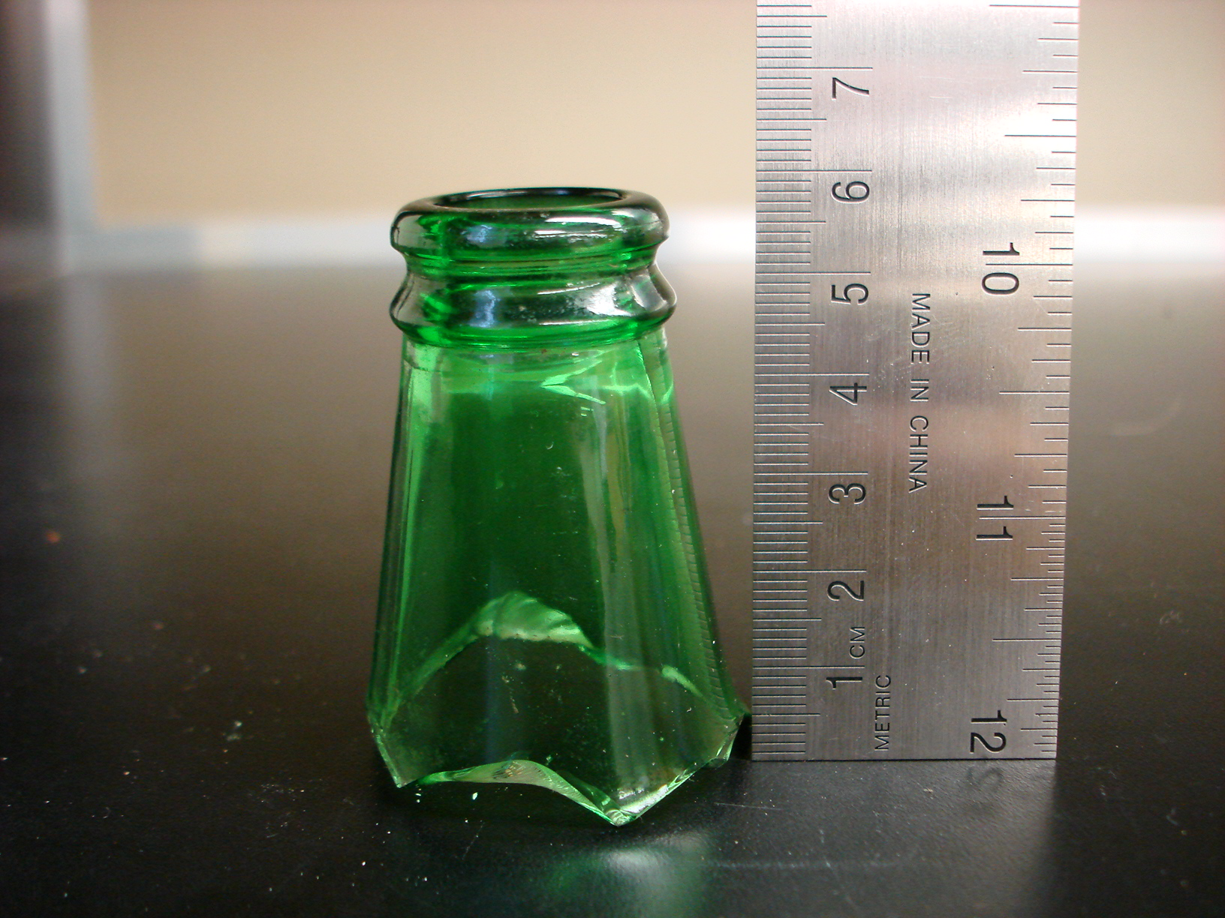
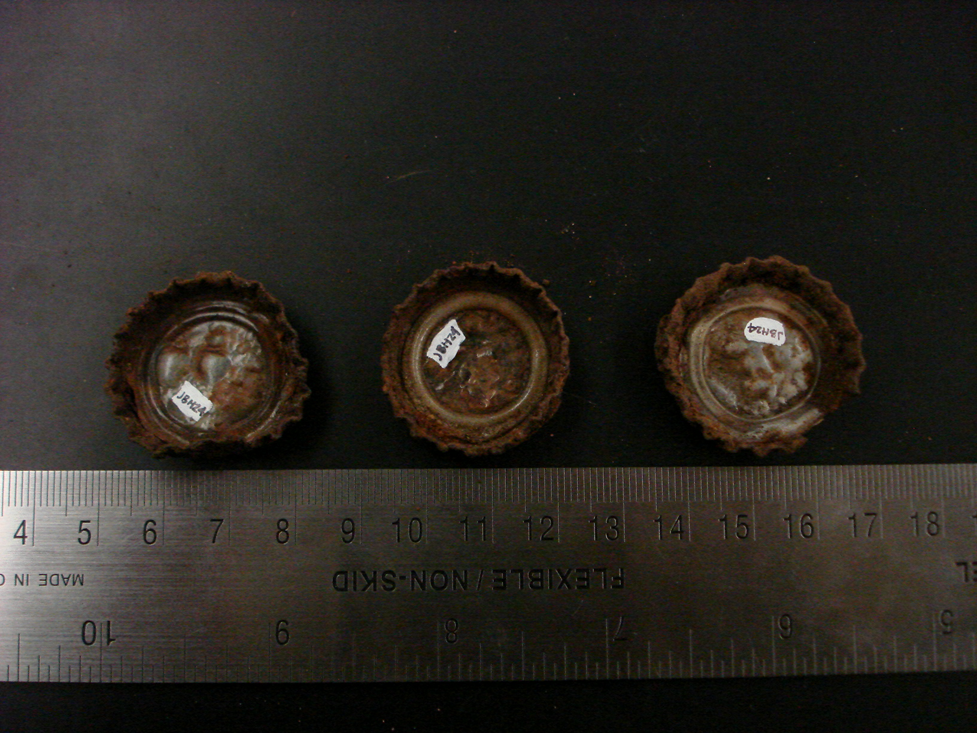
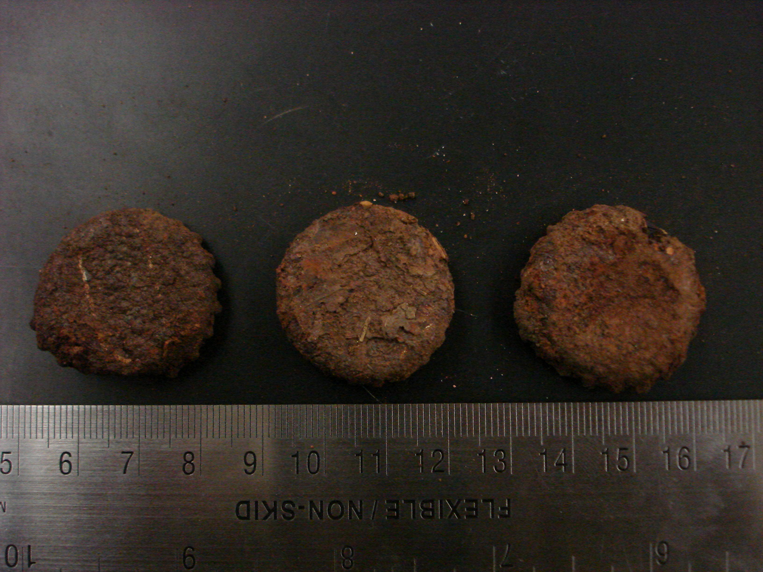
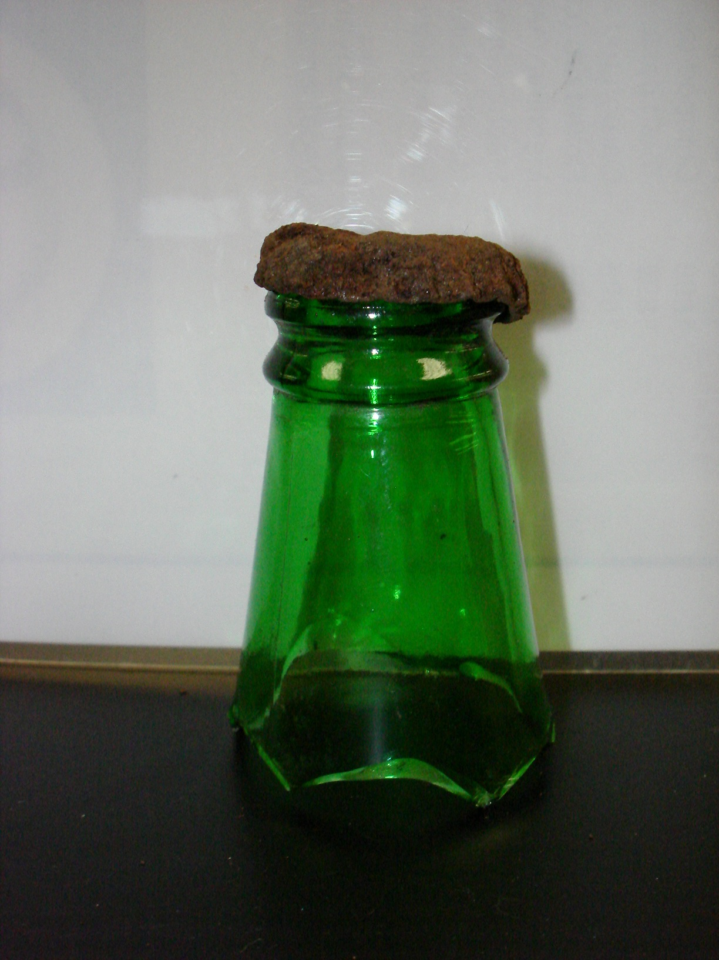

References:
Adams, William Hampton. Dating Historical Sites: The Importance of Understanding Time Lag in the Acquiition, Curation, Use, and Disposal of Artifacts. Historical Archaeology, 2003, 37(2):38-61.

Jones, Olive, Catherine Sullivan, George L. Miller, E. Ann Smith, Jane E. Harris, and Kevin Lunn. The Parks Canada Glass Glossary. Revised Edition ed. National Historic Parks & Canadian Parks Service Sites Environment Canada, 1989.

Miller, George L., and Catherine Sullivan. Approaches to Material Culture Research For Historical Archaeologists. Comp. David B. Brauner. 2nd ed. The Society For Historical Archaeology, 2000. 161-74.

Miller, George L. Approaches to Material Culture Research For Historical Archaeologists. Comp. David B. Brauner. 2nd ed. The Society For Historical Archaeology, 2000. 86-110.

Noel Hume, Ivor. A Guide to Artifacts of Colonial America. Philadelphia: University of Pennsylvania P, 1986. 102-46.

Orser Jr., Charles E., ed. "Bottles." Encylopedia of Historical Archaeology. New York, NY: Routledge, 2002.

Orser Jr., Charles E., ed. "Earthenware." Encylopedia of Historical Archaeology. New York, NY: Routledge, 2002.

Orser Jr., Charles E., ed. "Pearlware." Encylopedia of Historical Archaeology. New York, NY: Routledge, 2002.

Orser Jr., Charles E., ed. "Redware." Encylopedia of Historical Archaeology. New York, NY: Routledge, 2002.

Samford, Patricia M. Approaches to Material Culture Research For Historical Archaeologists. Comp. David B. Brauner. 2nd ed. The Society For Historical Archaeology, 2000. 56-85.

White, John R. Approaches to Material Culture Research For Historical Archaeologists. Comp. David B. Brauner. 2nd ed. The Society For Historical Archaeology, 2000. 139-48.

