Geographic Information Systems Utilization in Archaeology: Artifact Disturbution at the First Baptist Church.

Nicole Poepping

Introduction
Analysis of depositional patterns of objects found during archeological digs using Geographic Information Systems (GIS) can be a powerful tool to understand the evolution of land use, human and plant biology, trading networks, and cultural interactions specific to that area. Not only is it a powerful analysis tool, it creates useful and intuitive visuals which are helpful for understanding the logistics of the dig itself, from trench locations and depth of trenches to artifact locations. GIS was utilized in the First Baptist Church Dig for artifact deposition modeling, specifically looking at twelve artifact classes within the seven trenches. These images provide information about artifact concentrations throughout each trench and soil layer, allowing an understanding not only of the number of each type of artifact at each trench but also what soil layer in which they were located.
Background Information
To understand the outputs and functions of GIS it is first important to understand how the program itself works. GIS is formally defined as “a computer system for capturing, storing, sharing, displaying, managing and analyzing data and associated attributes which are spatially referenced to the earth (or other planetary bodies)” (Carlson, 2007). This program is different from other information systems including Traditional Computer Aided Drafting (CAD), graphic design programs, and remote sensing programs. What makes it unique is that it associates and “image” with attribute information which is all spatially (geographically) referenced. There are several different software packages that can be utilized in GIS, but the one most often used is the Environmental Systems Research Institutes ArcGIS. There are three levels of functionality with ArcGIS- ArcView, ArcEditor, and ArcINFO- with ArcInfo being the most advanced software package with a variety of geoprocessing tools and editing tools.
Within GIS there are several different file formats. The two most common are vectors and rasters. Vectors are discrete geographic features represented by a built collection of points, vertices and arcs (lines). An example of a vector file would be a line file representing the boundaries of a dig site or a point file that represents the locations of trenches and/or artifacts. A raster is a geographic feature across an entire area represented by a continuous set of “pixels” or “cells” (Carlson, 2007). A good example of this might be a file that is color coded by elevation contours, land use, or an aerial photography of a site. Both vector and shapefiles are saved in folders with at least three individual files associated with them, with separate files that contain information about the shape of the file, the records (attributes) associated with the file, and the coordinate system. There are often additional components of a GIS file, but the number and type is highly dependent on the type of information being utilized.
The wide range of file types and tools available in GIS make it ideal for cross-disciplinary use. Although traditionally applied to geological research, within the past decade GIS has started to be utilized in the public health sector, development programs, ecology, least distance mapping for schools and law enforcement and most applicable to this paper, archaeology. Some examples include using GIS to determine areas most suitable for affordable housing units or Brownfield remediation, areas of gentrification in cities, changes in mortality rates or specific health conditions over time in rural villages, the effectiveness of public policy changes over a defined area. In archaeology GIS has been used extensively over the past ten years, and i, it has classically been utilized to map and organize artifact data along with identify unique site attributes in the scope of a large geographical area.
There were several reasons for using GIS particularly at the First Baptist Church dig. First, because archaeology is the study of the spatial dimension of human behavior over time and all archaeology carries a spatial component, GIS was the most suitable program for analyzing the artifact data recorded for each trench and soil layer. Secondly, GIS is a cost effective, accurate, and fast tool for processing data and Brown University has an effective support team and a large server dedicated to GIS work along with the most advanced GIS software package available. Lastly, use of GIS in archaeology not only provides an easy way to acquire, catalog, and visualize data, but it also has the potential to change the way an archaeologist thinks about a space and can help put information into the context of the surrounding geology and historical land use patterns.
Materials and Methods
Several programs were utilized to complete this research project. Because the raw artifact data was processed and cataloged using Microsoft Excel, this program was often used. ArcMap and ArcScene, two different Geographic Information System (GIS) programs were used for the bulk of the analysis. Google SketchUp and Google Earth were used as secondary sources of information and for modeling purposes.
At the site of the FBC six points were recorded in the center of each trench using a GPS unit. These points were recorded as point shapefiles. Once collected, these points were imported to an ArcMap document along with an aerial photograph of the FBC and the area surrounding it. Six polygons oriented N-W were created around the points to represent the actual size of the trenches in the field. A final polygon shapefile of the property outline was created for use in ArcScene.
To create meaningful data to assign to each of the eight polygons, raw data containing individual entries for each artifact was reformatted and organized by trench ID and artifact class. The artifact classes were defined as bone, brick, ceramic, chalk, charcoal, coal, glass, metal, organic, other, plastics, shell. The six different excel tables created throughout this process were imported into GIS and then joined with the corresponding trench polygon. This allowed detailed information about artifact class totals and aggregate totals to be visible in the attribute table of each trench polygon.
Once this was completed the trench polygons and the corresponding trench data were imported into ArcScene along with several new map layers to create a more visually meaningful image. First a digital elevation model (DEM) model was added. This DEM was created using an elevation point shapefile from the RIGIS database. Then the outline of the FBC property was added for reference. Lastly, a model of the FBC was added. This model was created using Google SketchUp and pictures of the FBC taken in the field. Once completed the model was imported into ArcScene as a 3-D symbol for a point (a point shapefile) representing the center of the building and was then scaled up to its actual size. The base heights for all of these layers were obtained from the height of the DEM to ensure they were visible and topographically as accurate as possible. All layers were projected in Rhode Island State Plane (ft.).
Then, the layers were copied into eight different ArcScene documents which contained information regarding the different artifact classes and the total of all the artifact classes. The primary analysis tool used for analysis of each document was the extrusion calculator. Each trench polygon was extruded according to a value in its attribute table using the calculator, creating a bar that extended vertically upward from the trench at a height that represents the number of artifacts defined by the calculator. Through this process over one hundred images were generated that represented artifact totals for each artifact class and soil layer at each trench and the total number of artifacts found at each trench.
Results

Although nearly 120 images were created for this research, only the total number of artifacts per trench and the total number of artifacts at each trench will be analyzed here. The other images will be used at the discretion of the head archaeologists of the dig for more in-depth research.
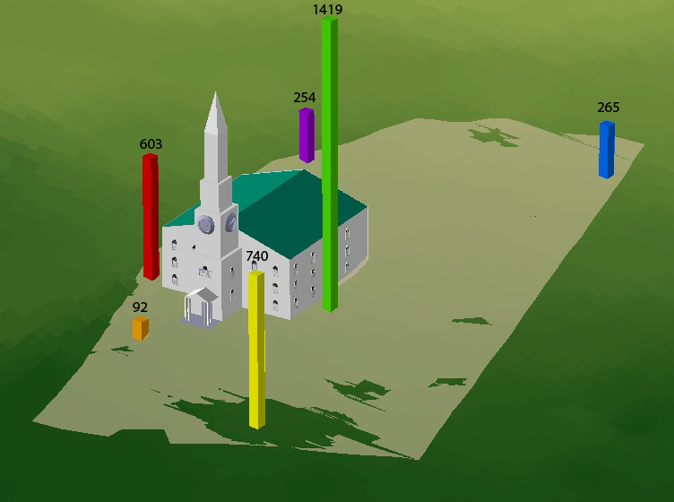
Figure 1 represents the total number of artifacts found at each trench. There were high concentrations of artifacts in trenches D1, D2, and D4 with the lowest concentrations at sites C1 and D3. Within the trenches with the densest artifact concentrations were brick, ceramic, glass
Figure 1: Total number of artifacts found at each trench
and metal (see figures 2, 3, 4 & 5).

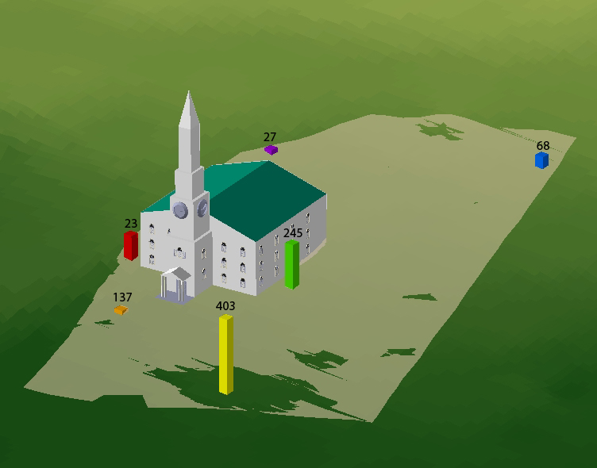
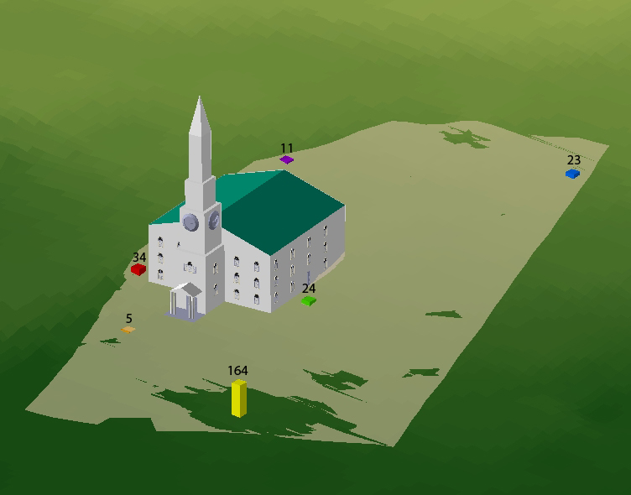

Figure 2: Total number of brick artifacts found at each trench.
Figure 3: Total number of ceramic artifacts found at each trench.
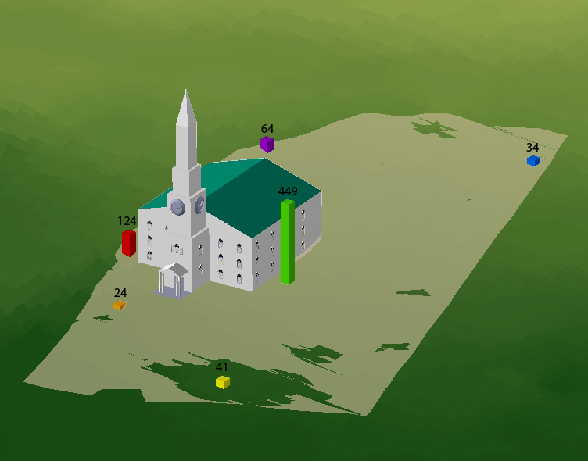
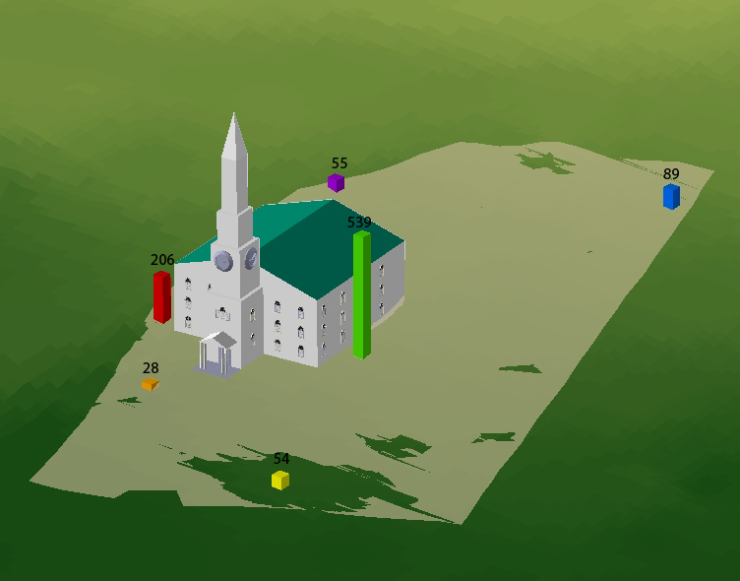

Figure 4: Total number of glass artifacts found at each trench
Figure 5: Total number of metal artifacts found at each trench.

Other images reveal concentrations of bones and shell at trenches D1 and D2 (see figures 6 & 7).

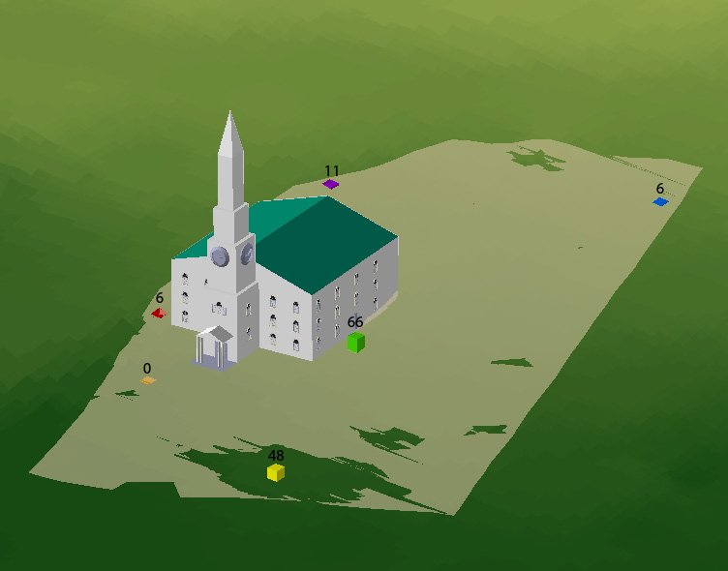
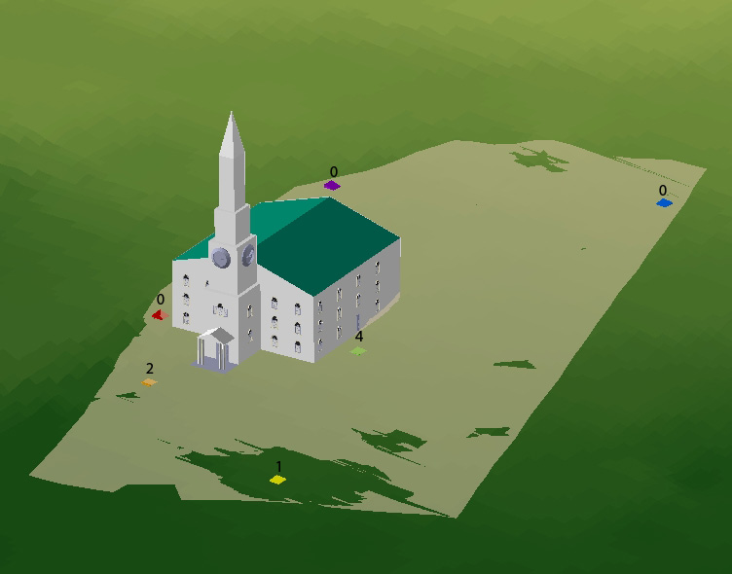

Figure 6: Total number of bone artifacts found at each trench
Figure 7: Total number of shell artifacts found at each trench

Suggestions for Use

These images have the potential to be in several different ways to further understand the distribution of artifacts at the FBC dig. First, comparisons of artifact classes between soil layers would be helpful to understand which artifacts are concentrated in certain soil layers. This would aid archaeologists’ and students’ ability to determine date ranges for artifact deposition. Other uses would be to determine areas that seem to have a number of a specific artifact of interest to the head archaeologist and do further excavations at those sites, publish the images in literature for the First Baptist Church and/or other publications.
Conclusion

GIS is a powerful modeling and analysis program for use in the archaeological field. At the First Baptist Church dig GIS was utilized to create 3-D visuals of the site, trench locations, and artifact distribution. These images, along with the attributes assigned to these trenches in the GIS document, provide useful insight into the use of the FBC throughout time. These images also serve as a base model for future use of GIS in archaeology at Brown University, and can be used for published materials available to the general public.

Carlson, Lynn. Defining GIS and Introduction to Geospatial Data File Formats. Lecture. Introduction to GIS. Brown University. 11 Sept., 2007.
Figure 4: Total number of ceramic artifacts found at each trench

