The First Baptist Church in America has been on College Hill in downtown Providence since 1638

Brown Commencement and this
historic house of worship have been
connected since 1776.

Brown university was once Rhode Island college, then became brown university.
History of the church? Argumentative, first Baptist church, or is the one in Newport, both establish the beginning date as 1638? Or do we believe it’s the one here because we live here, and have a one sided opinion?
http://www.floridabaptistwitness.com/9908.article
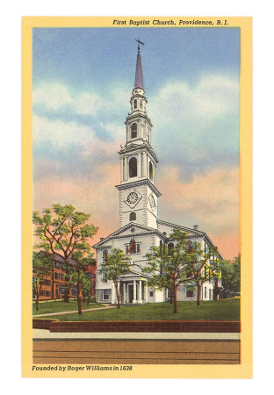

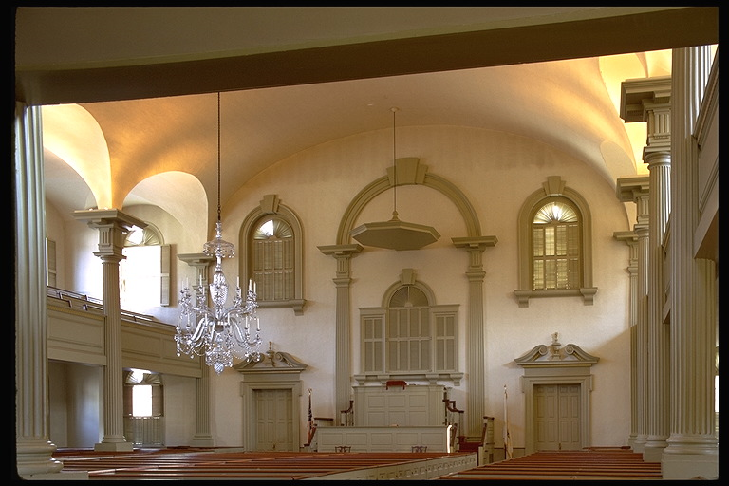

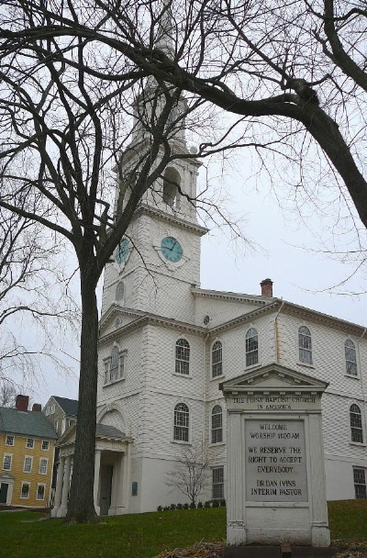

Brown was the first college in the nation to accept students regardless of religious affiliations.

The current meetinghouse of the First Baptist Church was built under James
Manning in 1774-5 partially in response to the need to move commencement at Brown to
the Second Baptist Meetinghouse due to size constraints at the First Baptist. The building was completed in 1775 and was the biggest building project in the
North East at the time, seating 1200 people in a town with a total population of 4000. The
building is typically viewed as a break with previous Baptist structures, in that its
12
Georgian and classical details were in stark contrast to the almost Quaker plainness of the
earlier meeting houses, and due to its possession of a steeple – the first Baptist Church in
America to possess such a feature
William Faunce, the president of Brown University from 1899 to 1929 convinced the
Rhode Island legislature to pass a bill allowing the President of Brown to not be required
to be a Baptist. 1945 its charter was rewritten to sever all ties with any religious denomination
Today both members of the congregation and tourists visit the building regularly,
and Brown commencement still takes place there, as does the annual Latin Carol service,
one of the largest such gatherings in the nation.

1804 First Congregational Church
1832

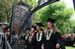

Goodtimes.webshots.com

2007, met on lawn instead of inside the first Baptist church

“because its only a piece, the fact it changed only slightly, wasn’t

Marching and feeling is more important, and walk through alumni, brief moment of pausing was not the climax or anti climax.
Went in the day before dining the baccalaureate ceremony, les well attended just slightly enough for it to be held there.
didnt walk through it at all during the actually day.
