Lauren Schleimer

Omur Harmansah

Art in Antiquity

29 September 2008

Looking at an Object: The Crafting of Appearance by Artist and Age

When the glaze was fresh on the Egyptian hippopotamus figurine, the blue-green faience must have seemed brighter than the Nile. While the wear and tear of thousands of years has scuffed and worn away at the purity of its shine and the integrity of the artist’s original design, the ceramic hippo still retains the bright blue hue and black linear designs meant to reflect his underwater habitat. Indeed, the surface of the figurine is treated as a reference to the hippo’s Nile home rather than an attempt to represent realistically his appearance in a hippo’s natural tones.[1] The artist brought the form to life as the colors and lines define both the shape of the hippo and part of his charming personality. Time, however, has played its part in turn. By transforming the appearance of the object, both its age and its artist define the visual effect of the artifact seen today.

Similar small hippopotamus figures, roughly the size of Snapple bottles with variations in both underlying form and linear design, are commonly found as burial items in non-Royal Middle Kingdom tombs.[2] Contrasting heavily with the charm of these little blue burial figures are the scenes of hippopotamus hunting depicted in wall paintings of tombs throughout both the Middle Kingdom and all ancient Egyptian history.[3] Whether the significance of the hunt is due to the threatening appearance and potential ferocity of the enormous creature—hippopotami range between 5,000 and 8,000 pounds[4] and will rampage if threatened[5]—or its mythical symbolism as the “manifestation of the perverse forces in the world,”[6] great respect was accorded any man who could slay a hippo.[7]

While this characterization of the hippopotamus as manly foe permeates the culture of ancient Egypt, also present is the contradictory idea of a hippo goddess as feminine protector. The goddess Taweret, guardian of pregnant women and childbirth, offers a benevolent contrast to the violence of the hunt.[8] This dual significance of the hippo to the Egyptians as feminine protector or masculine enemy reflects its alternately peaceful and volatile nature. As long as the herbivorous creatures[9] remain unmolested by man or the pangs of hunger, hippopotami will not exert the dangerous aggression that comes with self-preservation. In the case of the blue faience figurine, the hippopotamus represented is happy in his Nile home, peaceable among the lively flora and fauna of the Nile.

The black outline designs painted onto the blue glaze surface both symbolically reflect this happy home and artistically complement the physical forms of the figurine. Facing forward, three painted lines on his face emphasize the three-dimensional curves of the shape of his head. A central line runs straight up from his mouth to his forehead, where it divides itself into the many triangles of an abstract design reminiscent of the blossom of a flower. The two lines on either side mirror each other as they curve with the hippo’s wide snout to end at the hub of a wheel-like floral design centered on either cheek. Two eyes bulge from his forehead, capturing the character of the hippo’s close-set glare with little superfluous detail. The final flourish, a line running from the inward curves of the side of his snout and along its underside, creates the perfect pared down suggestion of a grin to offset his cold stare.

The original linear designs contribute only a part of the hippo figurine’s personality, however, as the manifestation of artist’s original intentions have been impacted by time. While the sharp contrast of blue and black must have been striking when the glaze was fresh, the effects of age have worn away at the surface to reveal earthy brown hues where the blue was once untarnished. This diminishes the intended simplicity of the figure’s design, but adds so much to the visual drama of the object itself that its appearance is fundamentally changed as a result.

The smooth blue shine and clean vertical lines that delineate the form of the hippo’s face are offset by the rough visual and physical texture of the chipped brown pottery revealed underneath. The interaction between the aged and intact areas adds asymmetry to the design, from the noticeable chip missing from the left side of the hippo’s mouth, to the unevenly worn areas that exaggerate the sockets of his eyes and the curve of his snout. The folds in his neck are revealed primarily by the brown that shows through at each indentation, while they would have been much less pronounced in the object as it originally appeared with blue glaze intact.

While in those places, the effects of age have merely augmented and exaggerated the artist’s original designs, the pronounced imperfections in the glaze on the hippo’s left side have resulted in the creation of new, different visual forms. A dark textured ring has been worn down around the hippo’s neck where, on the other side, only the intended fatty folds of his throat have been made clear. Thin cracks in the glaze manifest themselves as squiggled lines that move down the hippo’s rear, and rough brown dots of various sizes poke through the smoothness of the blue. Even though these new effects do not form as a result of the original design, they seem to visually enhance the homage to the Nile. If anything, the squiggly lines are reminiscent of a flowing river, and the earthy pottery underneath reflects the color of the mud of its banks.

Still present, if not overshadowed by the roughness of the brown, the original black design remains, a mirror image of the eye-catching plant motif that appears intact on the obverse side. Here, without the intrusive changes made by time, the artist’s original intentions remain visually dominant. A series of short, curved lines sprout from the hippo’s front foot to form almond shaped segments of a plant. Thin slivers poke out from the joints between segments like wings, and each stalk ends in a small oval bud with wings that seem to lift up from either side. The imperfections in the bright blue glaze are minor and their effect remains a backdrop to the artist’s color and design. Without the heavy interference of time seen on the left, the full whimsical charm of the flora and fauna is realized just as the artist had intended for both sides of the hippo.

The artist’s placement of the black linear motifs reflects this overarching concern for symmetry of design. Just as three lines shaped the face of the hippo, the rear of the hippo is decorated with the complementary forms to match. Black lines ending in flowery wheels spring up from both the hippo’s hind legs and curve onto its side, so that the central plant design has matching flowers on either side. The hippo’s tail, accentuated like the rolls in his neck by the worn down glaze of the indentations in his rear, has the same line and triangular blossom motif that serves as the hippo’s headdress on the other end of his back. In between those two abstract forms, a bird and a butterfly in flight comprise the final details depicted on the hippo of his Nile River home.

When the faience hippo was first made, the understated shape of the object itself—undeniable in its simple representation of a hippo’s natural form—would have allowed the interplay of bright blue glaze and clear black delineations to be the central focus of the hippo’s visual effect. In the object’s present form, however, it is not merely an artist’s creation, but an artifact that has aged with time; this plays an equal part of the artist’s role to define the visual effect of the object in its present form. Where the artist accentuated the original curves of the physical form with abstracted lines and introduced new elements to its appearance by adding pictorial designs, the effects of age perform a parallel function. The worn down areas around the hippo’s eyes serve to augment an element of the design that was already there, while new and different elements are introduced in the arbitrary cracks that mar the glaze on the left side of the hippo. The effects of time serve to transform the appearance of the object, shaping its visual effect in the same way the artist himself did when he implemented his intended design.

Works Cited:

De Jong, Aleid. "Hippopotami." Oxford Encyclopedia of Ancient Egypt. Ed. Donald B. Redford. 2001.

Hippopotamus. Museum of Art, Rhode Island School of Design, Providence.

"Hippopotamus Profile." National Geographic. 28 Sept. 2008 <http://animals.nationalgeographic.com/animals/mammals/hippopotamus.html>.

Lythgoe, Albert M. "An Egyptian Hippopotamus Figure." The Metropolitan Museum of Art Bulletin 12 (1917): 77-78.

Posener, Georges. “Hippopotamus.” Dictionary of Egyptian Civilization. Trans. Alix MacFarlane. London: Methuen and Co. Ltd., 1962. 125-26.

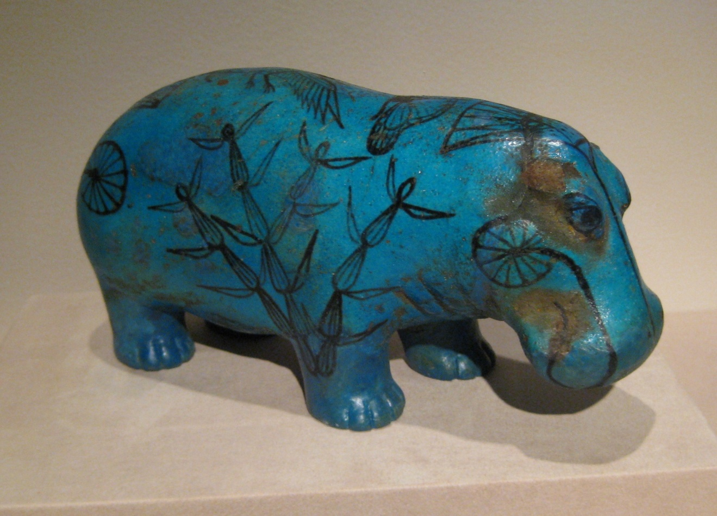

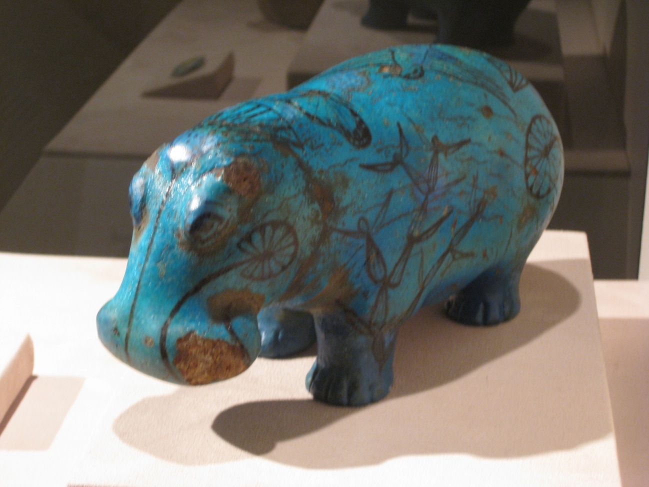

1. Lythgoe, Albert M, "An Egyptian Hippopotamus Figure," The Metropolitan Museum of Art Bulletin Apr. 1917: 78.
2. Lythgoe, 78.
3. Aleid De Jong, "Hippopotami," Oxford Encyclopedia of Ancient Egypt, 2001 ed.
4. "Hippopotamus Profile," National Geographic 28 Sept. 2008 <http://animals.nationalgeographic.com/animals/mammals/hippopotamus.html>.
5. De Jong.
6. Georges Posener, “Hippopotamus,” Dictionary of Egyptian Civilization 1962 ed.
7. De Jong.
8. De Jong.
9. National Geographic website.