Object Bio: Pencil Fragment from JBH48, Unit 6
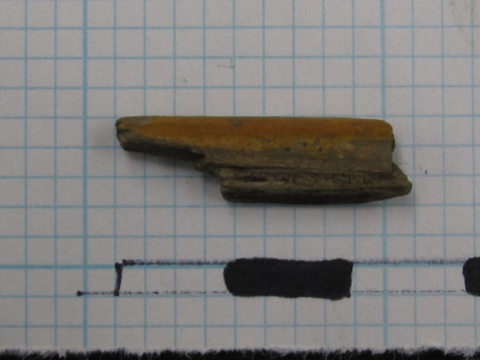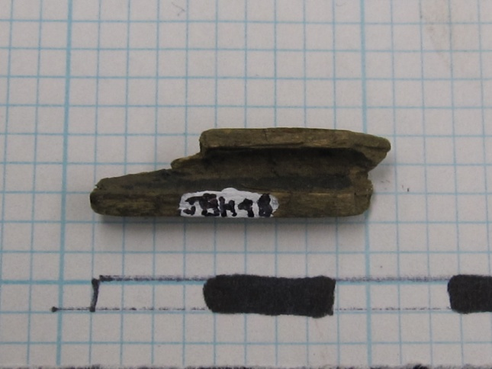
A fragment of a pencil was found in context JBH48, of Unit 6. The fragment only contained a wooden portion of the body of the pencil: any sort of inner lead or graphite was absent, as was an eraser or any sort of ending. The pencil was apparently smoothly rounded. The outside of the pencil retained some of its yellowish-orange paint, although the exact original color is hard to determine since the color has clearly been significantly worn away.
Since pencils of this sort (wooden with a yellow coating) are still being used today, as they have been for quite some time, it is impossible to give a Terminus post quem for the artifact. For all we know, this might be a modern object. However, we can determine the earliest time at which the artifact had been manufactured, and even make a guess as to the earliest it is likely that the object was deposited, based on what we know about the history of the pencil.
The first “pencils” to be in use were thin sticks of lead which were employed by the Ancient Egyptians and Romans to write on papyrus. Graphite has been used for writing in the place of lead starting sometime between 1500 and 1565, when a large deposit of graphite was discovered in England. The first pencil to be “clearly recognizable” as the precursor to the modern pencil was described in 1565, in Zurich.
The original process for crafting pencils in their modern form (wood casing surrounding a graphite core) started by cutting pure graphite into rectangular pieces. A groove corresponding to the thickness of the graphite was cut into a strip of wood (about the length of the desired finished product, and almost as thick). Then the longest straight side of the graphite rectangle was dipped in glue and inserted into the groove. The graphite which extended above the top of the wood was sawed or broken off. More pieces of graphite were inserted in this fashion until the groove had been filled along the entire length of the pencil. Then the top surface of the wood and graphite was flattened, spread with glue, and covered with another strip of wood. After the glue dried the pencil could be cut into the desired shape (round, hexagonal, or octagonal, for example) or left square.
The next innovation in pencil-making came in 1794, when a Frenchman, Nicolas-Jacques Conté invented an alternative to pure graphite, as well as a new method for constructing the pencils. Powdered, pure graphite was mixed with potter’s clay and water and molded into leads. Then the leads were inserted into a groove deeper than their own height, and to finish a thin wood piece was placed into the groove on top of the lead. Modern pencils are made with a piece of graphite between two equal halves of wood.
The first pencil factor in America was, according to the Joseph Dixon Crucible Company (which claims to be the first to mass-produce the pencil), the first pencil factory in America was founded by a now-anonymous school girl, around the year 1800. The first lead pencil in the United States was apparently made in Massachusetts by this girl, in partnership with Joseph W. Wade. In 1866, one of the earliest pencil-making machines was patented by Joseph Dixon, the owner of one of the most popular pencil companies. This machine could process the wood for 132 pencils per minute. By the early 1870s, approximately 20 million pencils per year were being used in the United States.
The best way to date this pencil fragment is by the yellow paint. The earliest documentary evidence of yellow pencils dates to 1854, in an art magazine article on pencil making in Keswick, England. At this time, the yellow paint (and paint of other colors) most likely served to cover up imperfections in the wood. Koh-I-Noor pencils, developed in Vienna in 1890 were the first pencils to be known to be characteristically yellow. The stories for the reason behind choosing the color yellow range from the manufacturers’ desire to include the colors of the Austro-Hungarian flag (the lead would have provided the black) to the suggestion of the Orient evoked by the color, significant because the Orient was known to yield the highest quality graphite. However, even during the time when the yellow Koh-I-Noor pencil was emerging and gaining a reputation as a high quality pencil, it was more common to finish pencils in dark colors (black, red, maroon, purple, or the natural cedar color).
Yellow Koh-I-Noor pencils were imported into the United States between 1893 and World War I, during which the import was cut off. In 1919, the Koh-I-Noor Company was incorporated in New Jersey. However, the pencil found in JBH 48 is not necessarily a Koh-I-Noor, as there were numerous yellow “imitators”, and yellow is now the most common color of pencil. Today, three quarters of pencils are yellow.
Therefore, the pencil could date from as far back as 1854. However, it is extremely unlikely that the pencil dates from this far back. More realistically, the date range for the yellow pencil found corresponds to the dates when the yellow Koh-I-Noors started to be imported into the United States (which are additionally the dates when yellow imitators would have started to appear): 1893. Based on the location of the find, it could have belonged to someone in the Robert Hale Ives Household, which is entirely possible as the house was constructed by 1857, before the probable earliest date for the pencil. However, given the popularity of yellow pencils throughout modern times, it is equally likely that the pencil came from a more modern individual, perhaps a Brown student studying in the yard of the John Brown House.

Object Bio: Plastic Bottle Cap Gasket
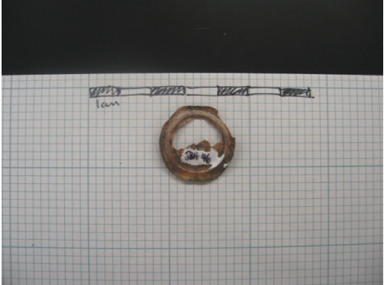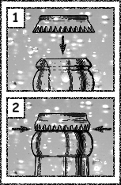
One of the more apparently modern finds in Unit 6 was a plastic gasket from a bottle cap. The gasket was yellowing and eroded in the middle, although the outer ring of thicker plastic was still intact. A gasket such as this one comes from a crown cap. The crown cap was first invented in America, in 1891 by William Painter.
The first known bottle “caps” are cork and wood stoppers, similar to those seen in wine bottles today. The bottle cap started to evolve in the middle of the 1800s, when the use of glass bottles was on the rise. In 1856, the first bottle caps using an insert disk were invented (akin to the one found in JBH 46, although made of cork). These caps were screw caps as opposed to crown caps. The next development in bottle caps was the use of a metal wire attached to the cap to hold the cap down, a trend which was seen between 1856 and 1915.
The original crown cap was a lacquered metal lid with corrugations which would be pressed around the rim of the bottle to hold the cap on, and an internal disk of cork which provided the desired seal. These original crowns were made in apparently only one size, suitable for small bottles, such as for soda and beer. Within 20 years of their invention, crown caps were used on most soft drinks and beer bottles. Not only did Painter invent the crown bottle cap itself, but he worked with bottle manufacturers to create a bottle design which was more compatible with the crown cap. Furthermore, in 1984 he received the patent for the “bottle cap lifter” (more commonly known now as the bottle opener), and in 1898 he received the patent for a foot-powered crowning device to automate the process of sealing bottles. Additionally, Painter founded the Crown Cork and Seal Company, which still today is one of the major manufacturers of bottle caps.
Cork inserts continued to be used in crown caps until the 1960s, when the scarcity of cork materials and the invention of cheaper synthetic materials lead to the switch to plastic gaskets. However, there is not much information available as to exactly when the switch from cork to plastic took place. The information source providing the 1960s date is potentially not the most reliable: the date comes from a website which makes engraved keychains and bottle openers that had a short history of the bottle cap. More reliable sources to date the switch from cork to plastic could not be found. In 1984 a patent was filed for a specific design of soda bottle cap which appears to be the one still in use today, however the patent references “present commercial plastic soda bottles”, and presumably if the bottles themselves were made of plastic then the gaskets surely were, since plastic gaskets are and were even used with glass bottles.
Assuming that the bottle cap gasket came from as far back as the 1960s, it does not appear to be associated with any way to the Hale Ives House, or any other historical occupation of this plot of land. Instead it seems much more likely that the gasket was discarded by a random passerby in modern times. This object is one of the two decisively modern objects found in context JBH 46, the other being a piece of a plastic hot- beverage lid (see the object bio by Alyssa Thelmanique). Due to these two objects, we know that this context was deposited in modern times. The other objects found in the context were a stake, colored glass, a piece of a measuring cup, plastic beads, pieces of brick, a piece of unidentified rubber, whiteware and creamware. All of these items are potentially modern, although some of them could date back to earlier times and have been redeposited.

Object Bio: Wire Spike from JBH48, Unit 6
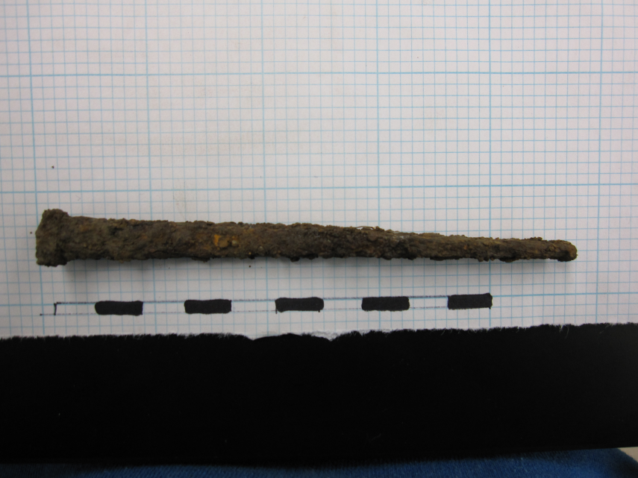
The spike pictured above was found in context JBH48 of Unit 6. This spike was the only one found in this context, and is larger than any of the other nails found in Unit 6. Spikes are distinguished from other nails based on their size: a nail that is longer than 10 cm. This particular spike is approximately 11.5 cm long, or 30d in the nail “penny size”. The “penny size” comes from the old English custom of selling nails by the hundred, where the size of the nail determined the number of pennies one hundred nails would cost.
Nails provide a good way to date a stratigraphic layer, as the history of nail-making is fairly well documented. Up until the end of the 1700s and the beginning of the 1800s, nails were individually hand-wrought by a blacksmith or “nailer”. These nails were made from a square iron rod, crafted by a “slitter” which was heated then driven to a point, with a head then formed with blows from a hammer.1^{, 2} The “slitting mill”, a machine for cutting the iron rods into the necessary size and shape to be crafted into a nail by a nailer was invented in 1590.² In 1790, Jacob Perkins invented a nail-making machine which could mass-produce nails at a rate of 10,000 per day, and in 1791 Sam Briggs Sr. and Jr. invented the first cut nail-making machine.
The first kind of cut nail to be produced was the type A cut nail. This was formed by chopping off a piece of the iron bar and “wiggling the bar form side to side with every stroke to produce a tapered shank”. Originally the heads for these nails were made by hand, but machines were developed to craft a head during the era while type A cut nails were still popular, between the 1790s and the 1830s. In the 1820s, type B cut nails were created. These nails were crafted by setting the cutter at an angle and flipping the nail after each stroke. Type B nails were popular between the 1820s and 1900.³ In the 1850s, machines for making wire nails (the sort most commonly used still today) were invented, however these nails did not gain popularity immediately, and even as late as the 1890s cut nails were used preferentially. The trade-off between cut nails and wire nails is that while wire nails are significantly cheaper, cut nails are harder and sturdier.
The specific nail in question is actually a spike, determined by its size. The approximate date for the spike can be derived from looking at its features and comparing to the known chronology provided by Edwards and Wells in Historic Lousiana Nails: Aids to the Dating of Old Buildings. The spike has a square-shaped shaft, with a taper on 2 sides, and appears to be machine made (based on the relative uniformity). These factors narrow the possibilities to nail types 4-10, which give an overall time range of 1792 – 1894. Due to the amount of rust, it is impossible to tell whether the spike is steel or iron, which hinders identification. However, the point of the spike does appear to be rounded in the side view, which would narrow the possible nail types to 4-6, which would give the spike a date range of 1792 – 1847 based on apparent nail type.
Considering that the nail is actually a spike, it wasn’t until after 1798 that nails up to 20d in size were mass produced in the Boston area. By 1800 cut nails were commonly available in the Northeast. Additionally, the Burden railroad spike machine, capable of producing 50 spikes per minute, was invented in 1839. However, it cannot be ruled out that the spike was created prior to this date by a less efficient machine. Therefore the time frame for the probable date of manufacture for the nail can be narrowed down to 1798 – 1847.
The John Brown House itself was built in 1786, prior to the probable date for the nail. However, the Robert Hale Ives House, which was located in the area where Unit 6 was dug (in fact, the feature found in Unit 6 seems to probably been associated with the Hale Ives House). This house was constructed sometime between 1832 and 1857, based on documentary evidence (a deed for the purchase of the land by Robert Hale Ives and a map showing the house, respectively). Therefore, based on the overlap between the time range for the manufacture of the nail and the probably construction of the house, it seems likely that this spike was used in the original construction of the Hale Ives House.

Object Bios Works Cited
"Bottle Cap History: The Need for Bottle Openers." 2003. Laser Engraved Keychains, Web. 30 Nov 2009. <http://www.laserengravedkeychains.com/bottle-cap.htm>
"Crown Cap." Inventor of the Week Archive. January 2007. Lemelson-MIT Program, Web. 30 Nov 2009. <http://web.mit.edu/invent/iow/painter.html>.
Edwards, Jay D. and Wells, Tom. Historic Louisiana Nails: Aids to the Dating of Old Buildings. Baton Roughe, Louisiana: Louisiana State University: Geoscience Publications, 1993.

Fourshee, Paul. "A Two-Bit History of Nails." The Blueprint. 1. 1992. Web. <http://www.fourshee.com/history_of_nails.htm>.
Jones, Olive, Catherine Sullivan, George L. Miller, E. Ann Smith, Jane E. Harris, and Kevin Lunn. The Parks Canada Glass Glossary. Revised ed. National Historic Parks & Canadian Parks Services Sites Environment Canada, 1989.
Nolan, Robert L., “Bottle Caps”. U.S. Patent number 4,476,987. 7 December 2009.
"Nail (fastener)." Wikipedia, The Free Encyclopedia. 30 November 2009. 5 December 2009. <http://en.wikipedia.org/w/index.php?title=Nail_(fastener)&oldid=328708327>.
"Pencil." Wikipedia, The Free Encyclopedia. 21 Nov 2009. 9 Dec 2009. <http://en.wikipedia.org/w/index.php?title=Pencil&oldid=327139485>.
Petroski, Henry. The pencil. Alfred a Knopf Inc, 1990. Print.
Reinbold, Joan. "Who Invented Bottle Caps?." Beer Masters: Beer Talk for Beer Lovers. 2009. Beer Masters, Web. 30 Nov 2009. <http://www.beermasters.com/content/beer-trivia/who-invented-bottle-caps>.
Visser, Thomas D. "Nails: Clues to a Building's History." UVM Historic Preservation Program. 1996. Web. <http://www.uvm.edu/~histpres/203/nails.html>.
Yellin, Steffi. “Historical Background of the John Brown House Property”. John Brown House Archaeological Report 2008. The Archaeology of College Hill Website. <http://proteus.brown.edu/archaeologyofcollegehill/6292>.

Wikipedia.org, Pencil
Petroski (1989) p. 36
Petroski (1989) p. 61
Petroski (1989) p. 70
Petroski (1989) p. 72
Petroski (1989) p. 93
Petroski (1989) p. 169
Petroski, (1989) p. 138-140
Petroski (1989) p. 191
Petroski (1989) p. 162-163
Inventor of the Week Archive, <http://web.mit.edu/invent/iow/painter.html>.
Bottle Cap History: <The Need for Bottle Openers, http://www.laserengravedkeychains.com/bottle-cap.htm>
Jones and Sullivan, 163
“Bottle Cap History: The Need for Bottle Openers”, <http://www.laserengravedkeychains.com/bottle-cap.htm>
Reinbold, Joan, “Who Invented Bottle caps?”, <http://www.beermasters.com/content/beer-trivia/who-invented-bottle-caps>
Inventor of the Week Archive, <http://web.mit.edu/invent/iow/painter.html>.
“Bottle Cap History: The Need for Bottle Openers”, <http://www.laserengravedkeychains.com/bottle-cap.htm>
U.S. Patent Number 4,476,987, Oct. 16, 1984
Wikipedia.en.org, Nail (fastener)
Visser (1996)
Edwards and Wells, p. 15-16
Visser (1996)
Fourshee, A Two-Bit History of Nails (1992)
Edwards and Wells, p. 60-61.
Edwards and Wells, p. 17-18
Wikipedia, “John Brown House (Providence, Rhode Island)”
Yellin, Steffi, John Brown Hosue Archaeological Report 2008, p. 31

