Sarah Baker
December 14, 2009
ARCH1900: Final Report

John Brown House: Sitewide Stratigraphy Report for 2009 Field Season
Archaeology of College Hill

Introduction

The 2009 Field Season at John Brown House began working at four distinct units. As shown on the map below, Units 6 and 7 were, respectively, in the NW corner and far West part of the property of the John Brown House (JBH). Units 8 and 9 were close to the NW corner of the house itself. Units 6 and 7 were placed in close relationship to units or shovel test pits from last year’s field season. 8 and 9 were undertaken as rescue archaeology, as the NW corner of the house was a possible future location for a geothermal well. Excavation at Unit 9 halted when field workers came down on a live electrical wire, and they moved their work to a nearby shovel test pit (STP). STP3, as it was numbered, was located West of units 8 and 9, between the house’s Western patio and the gravel path in the yard. The STP was located here, because this site has emerged as a more likely spot for geothermal drilling than the previous choice by the house itself.
The 2009 JBH fieldworkers assigned contexts to different stratigraphic layers as they worked. There were three possible reasons for declaring a new context. First, a new context was assigned when there was a clear change in soil color and/or texture. Second, if 10cm of depth was reached in a context without any soil change, an arbitrary context change was assigned. Finally, features and their associated soils were assigned their own contexts.
This report addresses conclusions about sitewide stratigraphy taken from this year’s fieldwork, which spanned September, October and November of 2009. The report has three parts. Part 1 explores the stratigraphy of each of the 2009 units, as well as STP3. For each unit, this part of the report includes a Harris Matrix, an accompanying table of strata, contexts and soil changes, pictures, and a brief discussion of the stratigraphy. Part 2 places the 2009 units in context with one another, and outlines similarities between strata from different units. Part 3 compares this year’s stratigraphy to conclusions from the 2008 field season, and attempts to draw connections across the whole site and both field seasons.
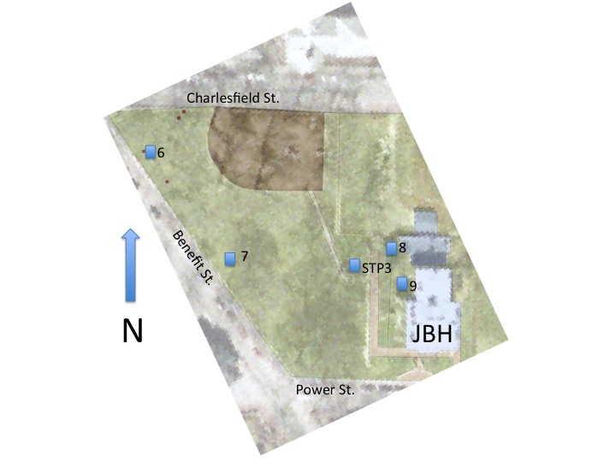
Fig. 1: Geospatially referenced aerial view provided by Krysta Ryzewski; unit locations not geospatially referenced.

Part 1: Site Stratigraphy By Unit

Unit 6

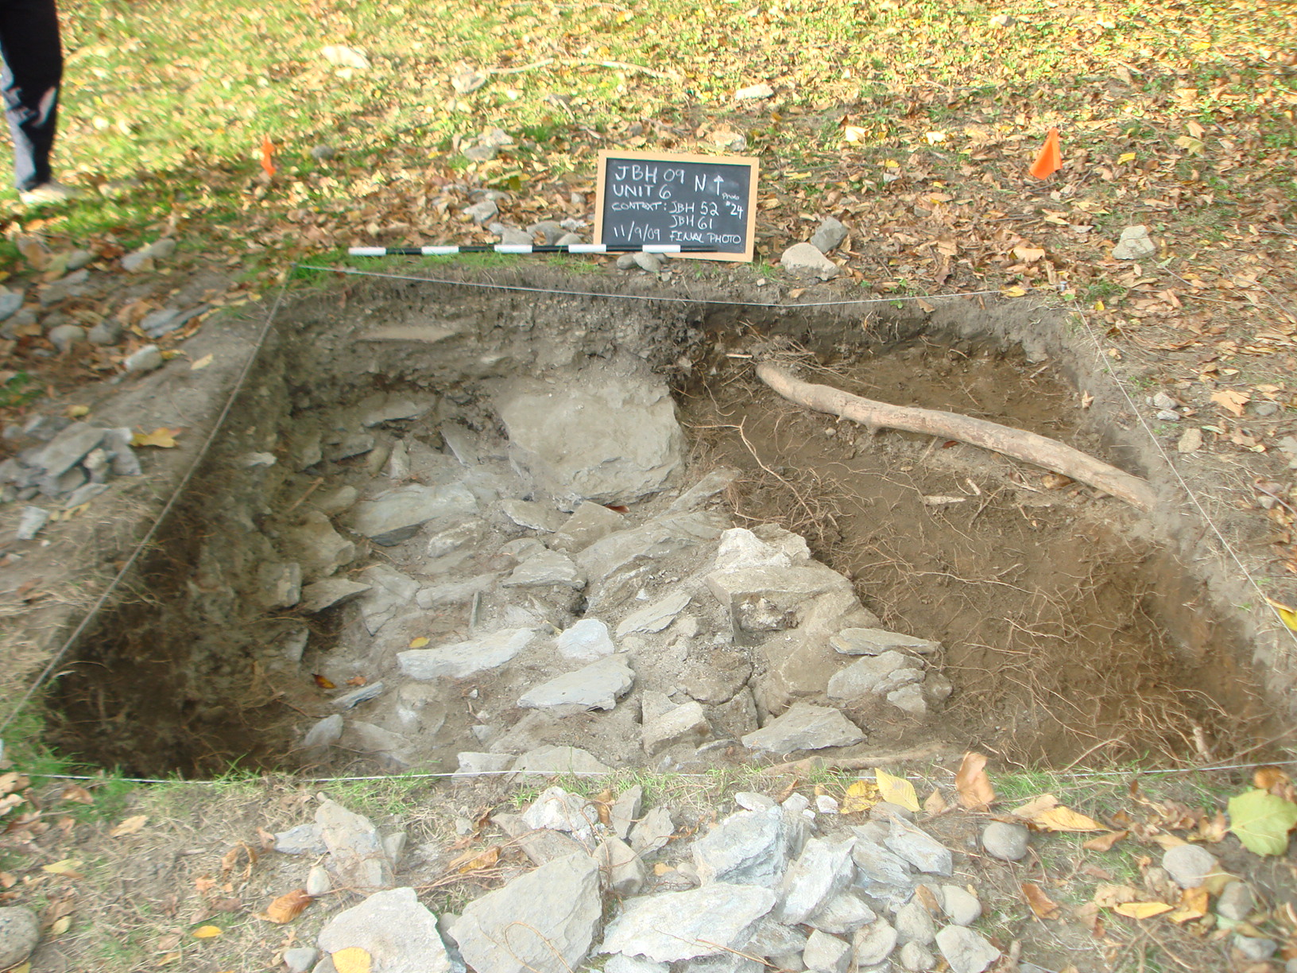
Fig. 2: Unit 6 closing

Stratum | Contexts | Soil (Munsell and/or notes) | Features
1 | JBH46 | 10YR 3/2
2 | JBH48,54 | 10YR 4/3, gravelly fill
3 | JBH52 | yellow/orange mottled soil
4 | JBH61 | gravelly fill, broad stones | 3 - stones in 61
Table 1: Unit 6 Strata

Unit 6 included Unit 5 from last year’s field season; the 1m x 1m Unit 5 was expanded as the 2m x 2m Unit 6. After the sod and first context, JBH46, were removed, two new contexts JBH48 and JBH52 began to reveal themselves. JBH 48 was a layer of gravel-filled soil, with a Munsell value of 10YR 4/3. It cut a wide North-South swath through the unit that corresponds to the line of stones shown in figure 2. JBH52, a yellow-orange mottled soil that was full of roots; it appeared on both the East and West sides of JBH48 and persisted until the closing of the unit.
Excavators at unit 6 perceived a slight soil distinction between JBH48 and JBH54, the underlying context; JBH54 had less rubble and gravel in the soil, and was slightly sandier. However, due to the very similar soil and their close correspondence of overlay within the unit, JBH48 and JBH54 have been combined into stratum 2, as shown in table 1. Excavation ended when JBH61/Feature 3 – a grouping of large, flat stones, and the accompanying fill - was reached. The Harris Matrix below shows the stratigraphic relationships of the contexts from Unit 6.
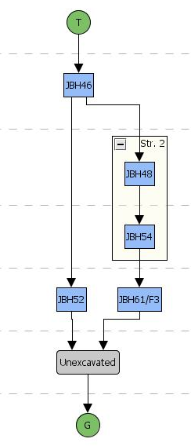
Fig. 3: Harris Matrix for Unit 6
Unit 7
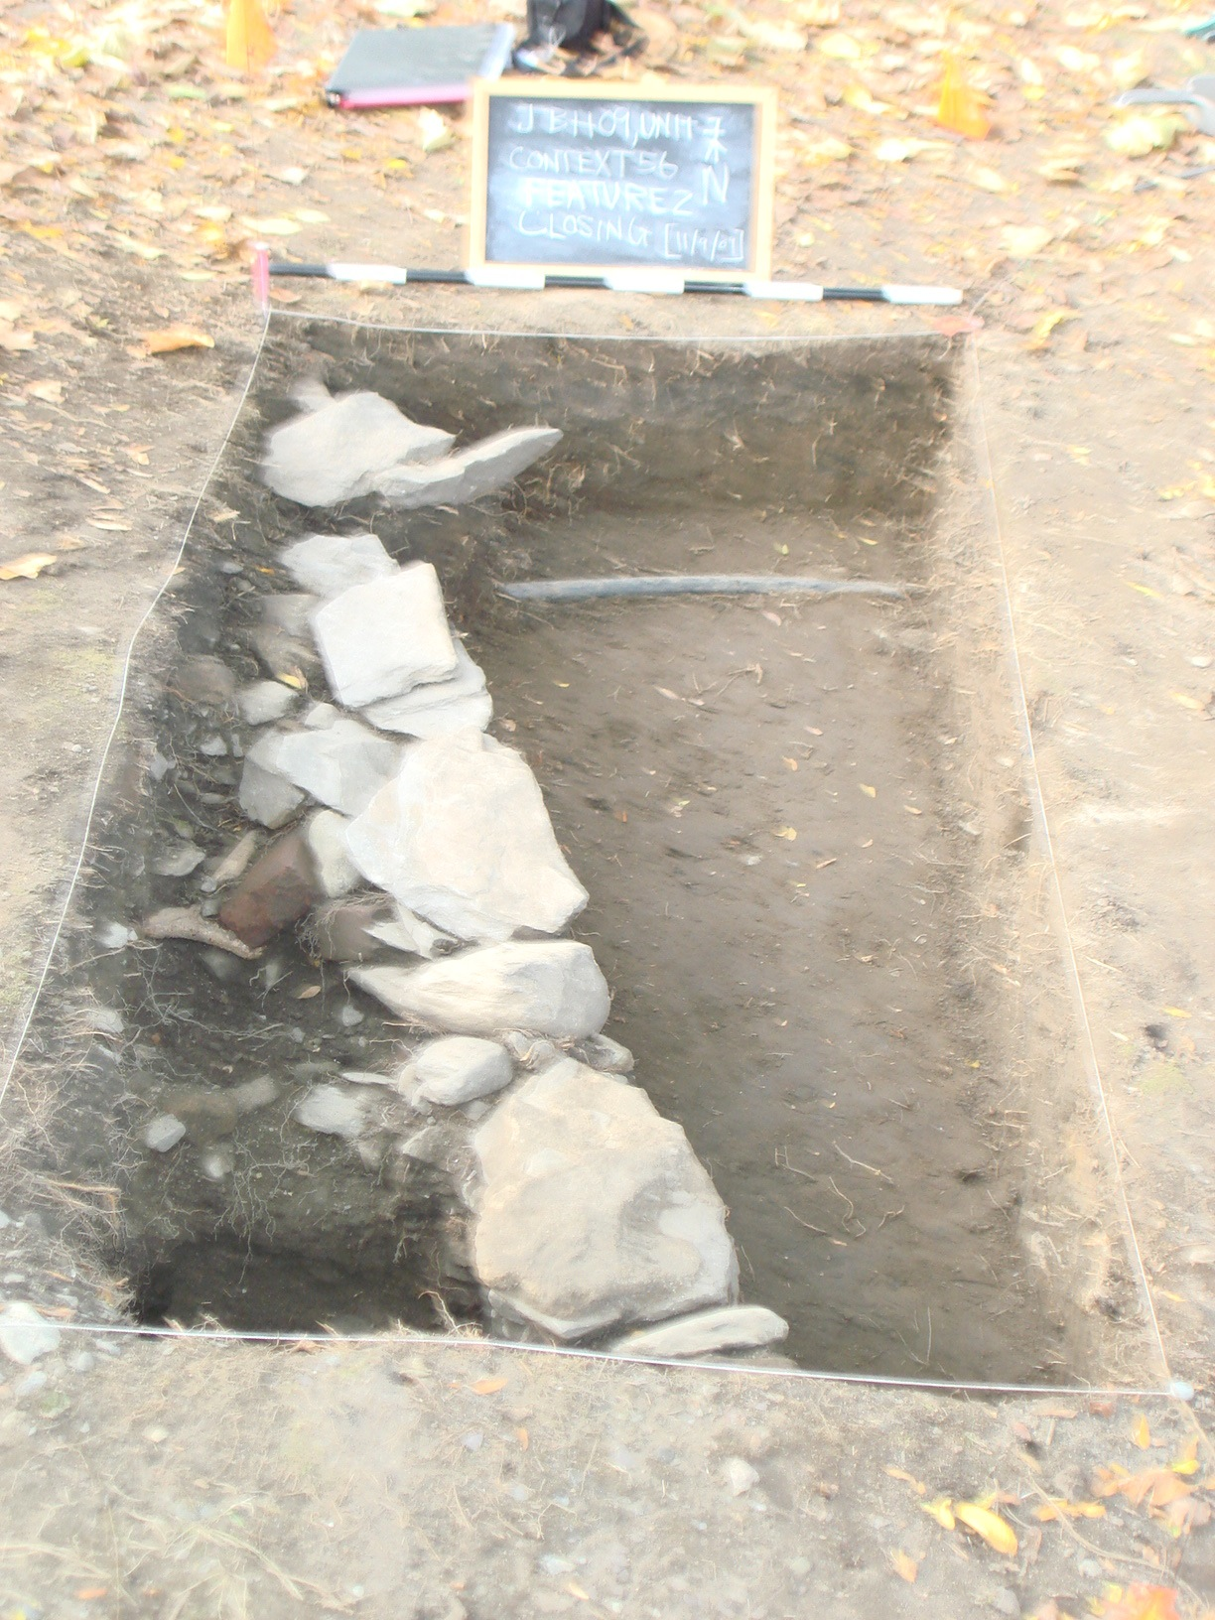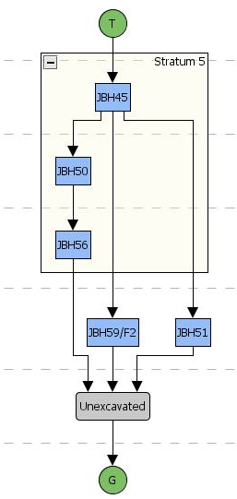
Fig. 4: Unit 7 closing Fig. 5: Harris Matrix for Unit 7

Stratum | Contexts | Soil (Munsell and/or notes) | Features
5 | JBH45,50,56 | 10YR 2/2
6 | JBH51 | 10YR 2/2 (+ rubble)
7 | JBH59 | rubbly fill, broad stones | 2 - broad stones
Table 2: Unit 7 Strata

As shown in the table above, the stratigraphy of Unit 7 was straightforward. After the sod was removed, the first context (JBH45) was assigned a Munsell value of 10YR 2/2, and was a very dark brown, thick clayey soil. This value persisted throughout the unit, with the only exception being the addition of gravel and rubble in JBH 51. Feature 2, a manmade architectural feature consisting of stacked stones, mortar and rubble fill ran North-South through the feature; it began to appear at a depth of about 5-10 cm in JBH45. At this point, the excavation team divided the unit in separate contexts to the West and East of the feature; the feature serving as the dividing line between the two contexts is clearly visible in figure 4, above.
Excavation continued separately on either side of Feature 2/JBH59; the feature itself and the context containing it were not excavated during this field season. JBH51, to the West of the feature, had similar soil to JBH45, but was full of gravel, rubble and architectural fill that seemed to be associated with Feature 2. To the East, excavators reached an average depth of about 35cm with no perceived soil change from the first layer excavated. For this reason, JBH45, JBH50 and JBH56 have been combined into a single stratum. The artifacts seemed to become generally older as more depth was gained on the East side of the wall, but the team was unable to ascertain any clear divisions in the soil or in the age of artifacts found. A further complication to determining the age of these units was a modern sprinkler line that was discovered in JBH56; it can be seen towards the top of the unit in Fig. 4. More information concerning the complicated process of dating these contexts can be found in Colburn’s Unit 7 Summary.

Unit 8
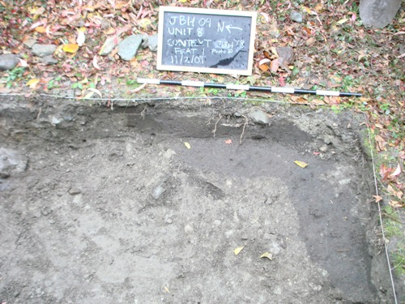
Fig. 6: JBH58/Feature 1
Stratum | Contexts | Soil (Munsell and/or notes) | Features
8 | JBH43 | brown
9 | JBH49,57 | mottled grey-brown w/ green/orange patches
10 | JBH58 | 2.5Y 3/1 | 1 - dark "L"-shape
11 | JBH62 | tarp and underlying gravel
12 | JBH63 | 10YR 2/2
Table 3: Unit 8 Strata

Unit 8 yielded the most contexts of any of the 2009 units. The layer underneath the thick vegetation at the surface was JBH43; this brown topsoil layer only persisted for a few centimeters, before the soil became increasingly mottled with orange and green patches. At this point, a new context number was assigned: JBH49. This context was followed by an arbitrary context of the same mottled soil, JBH57. At a depth of about 22 cm, the SE corner of the unit began to show a soil change. This soil lay in an “L” shape in the corner, and was much darker than the overlying mottled layer, so a new context – JBH58 – was designated and the “L” shape was designated Feature 1. This context is shown in figure 6.
As shown in Figure 7, the excavation team eventually uncovered a black tarp that covered most of Unit 8. It was peeled back, revealing a layer of dense gravel. The tarp and gravel was designated JBH62. Excavators dug to a depth of 72cm in a portion of JBH62, but were unable to ascertain a definite end of the context. This tarp predates many of the historical artifacts found in the overlying soil. This suggests that the contexts overlying JBH62 were backfill placed there sometime after the placement of the tarp; this constitutes a major disruption of the area’s stratigraphy. Finally, on the last day of excavation, there was another soil change underneath JBH58, and a new context, JBH63, was opened; this new layer was even darker than JBH58. Figure 8, below, summarizes these stratigraphic relationships.
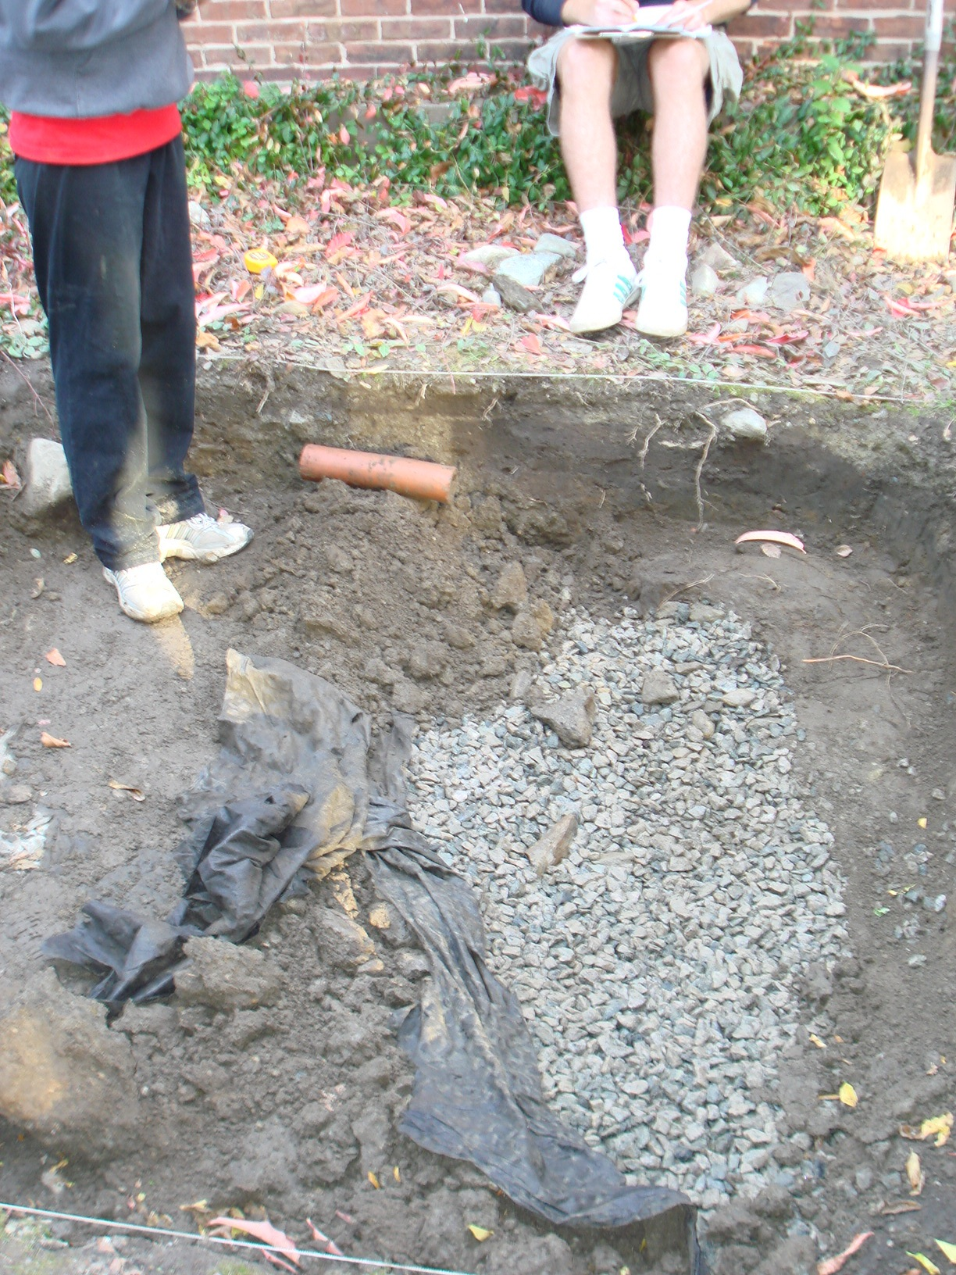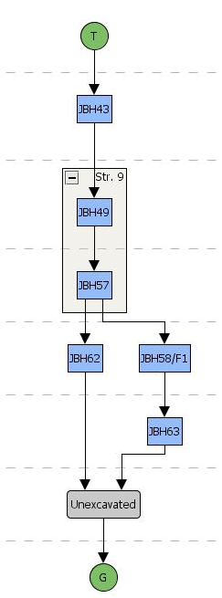
Fig. 7: JBH62 Fig. 8: Harris Matrix for Unit 8
Unit 9

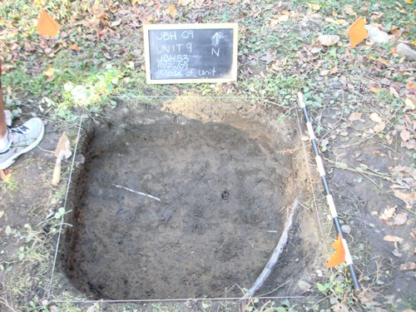
Fig. 9: Unit 9 Closing; Electrical Wire Visible in NW Quadrant of Unit

Stratum | Contexts | Soil (Munsell and/or notes) | Features
13 | JBH44 | 7.5YR 2.5/1
14 | JBH47+JBH53 | 5YR 3/2, 10YR3/2
Table 4: Unit 9 Strata

Excavation at Unit 9 was cut short in the 2009 field season, because field workers came down a live electrical wire, visible in Figure 9 above. The stratigraphy that was excavated in Unit 9 before the wire was found was very straightforward. The first layer of soil (JBH44) and the two underlying layers (JBH47 and JBH 53) each covered the entire unit. JBH44 was a very dark brown/black, and was assigned a Munsell value of 7.5YR 2.5/1. Below that, JBH47 was a “mottled soil with heavy patches of light gray/brown clay” and was assigned a Munsell value of 10YR 3/2. JBH53 was an arbitrarily assigned context, and was assigned a nearly identical Munsell value of 5YR 3/2. As such, JBH47 and JBH53 have been combined as stratum 14 in Table 4. When the team reached the wire in JBH53, a nearly uniform depth of 22cm had been achieved across the entire unit. Figure 10, below, summarizes the brief excavations that took place at Unit 9.
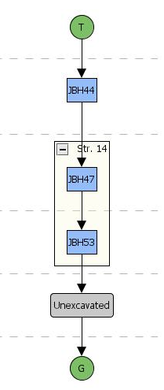
Fig. 10: Harris Matrix for Unit 9

Shovel Test Pit 3

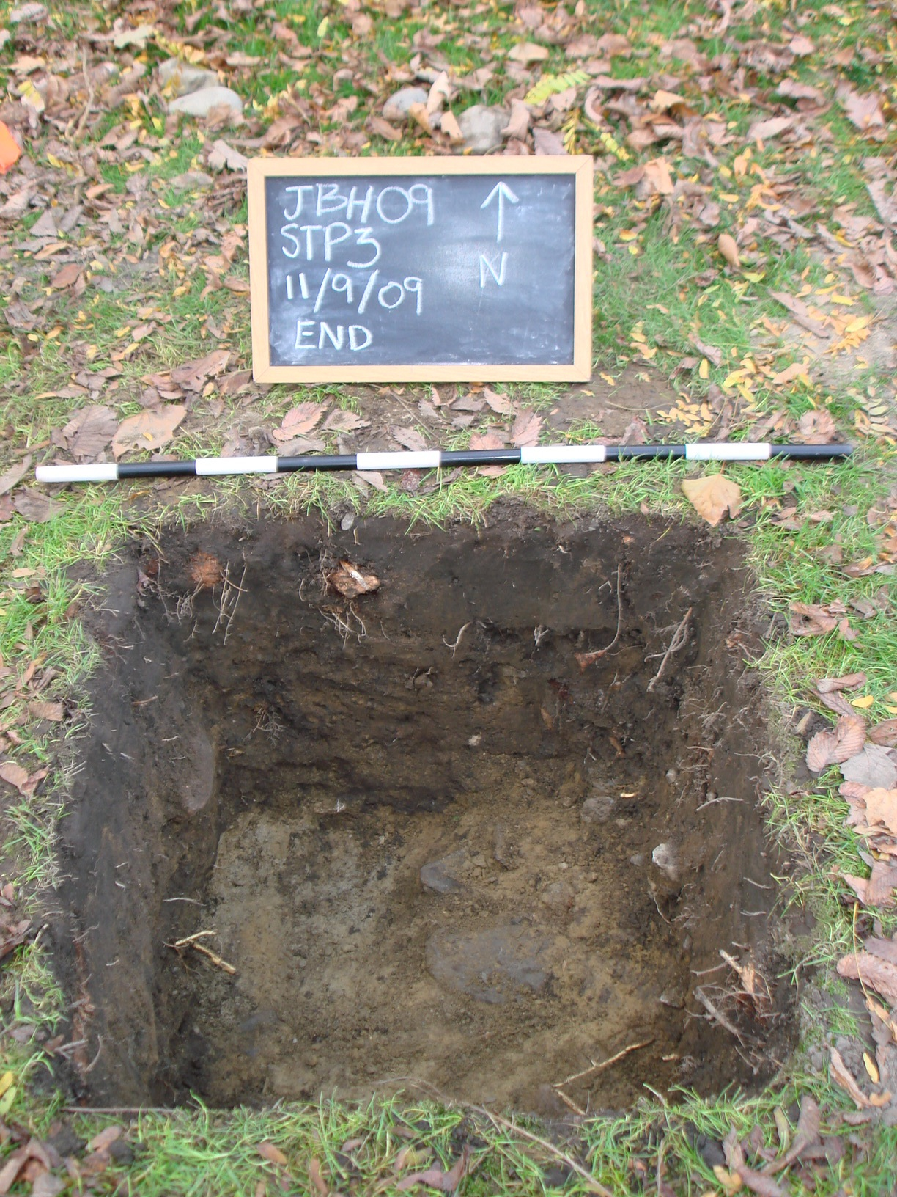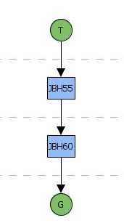
Fig. 11: STP3 Closing Fig. 12: Harris Matrix for STP3

Stratum | Contexts | Soil (Munsell and/or notes) | Features
15 | JBH55 | 10YR 3/2
16 | JBH60 | 10YR 4/3
17 | unnumbered | 10YR 6/6 (glacial soil)
Table 5: STP3 Strata

Shovel Test Pit 3 was opened after excavation at Unit 9 closed due to the discovery of a live electrical wire. The STP achieved a lowest depth of about 40cm, and shows a classic New England stratigraphy. The STP had three layers: JBH55, JBH60, and the original glacial soil layer reached at the end of excavation. These layers rested neatly on top of each other, with a slight slant that was basically parallel to the slant of the yard at this location. The top layer, JBH55, was assigned a Munsell value of 10YR 3/2, while JBH60 was slightly lighter, with a Munsell value of 10YR 4/3. At approximately 20 cm depth, JBH60 gave way to the groundsoil, which was assigned a Munsell value of 10YR 6/6. No artifacts were found in this deepest layer of soil, so excavators posited that they had reached the bottom of the historical soil. This is reflected in Figure 12, above, with JBH60 giving way to the groundsoil.

Part 2: Sitewide Stratigraphy

Completing a sitewide comparison of stratigraphy for the 2009 field season is a difficult task for several reasons. First, the 2009 field season had several goals, such as uncovering resistive features, expanding on 2008 results, and performing rescue archaeology. As such, the units were located in vastly different parts of the John Brown House property and investigated very different soil and feature types. In contrast, the 2008 units were all located relatively near to each in the Northwestern corner of the Yard. Second, the units achieved extremely differential depths, both between the units and within each individual unit. For example, excavations at Unit 9 were prematurely halted at only 22cm, which is shallower than most of the other units. Also, in Unit 7, one half of the context was much more deeply excavated than the other, and the separation of contexts slowed work down such that deepest part was only 24cm.
Nonetheless, understanding the JBH site as a whole is an important part of analyzing the 2009 fieldwork results. Because of their proximity to each other, Units 6/7 and Units 8/9 should be considered as two separate pairs. For both of these pairs, this portion of the report will provide a discussion and Harris Matrix comparison. As a final note, the author has not considered these two pairs as completely unrelated to each other, and encourages the reader and future researchers at the JBH to think about possible similarities or new methods that could connect these two pairs in an effort to provide a broader analysis of the entire JBH site.

Units 6 and 7
Units 6 and 7 were both located in the yard. Unit 6 was in the far Northwest quadrant, near or on the footprint of the Hale-Ives House, while Unit 7 lay almost directly west of the JBH site’s datum in the yard of the John Brown House. Despite this distance, they shared some interesting features, including gravel fill and an architectural feature consisting of broad stones. The Harris matrices in Fig. 13 demonstrate these similarities.
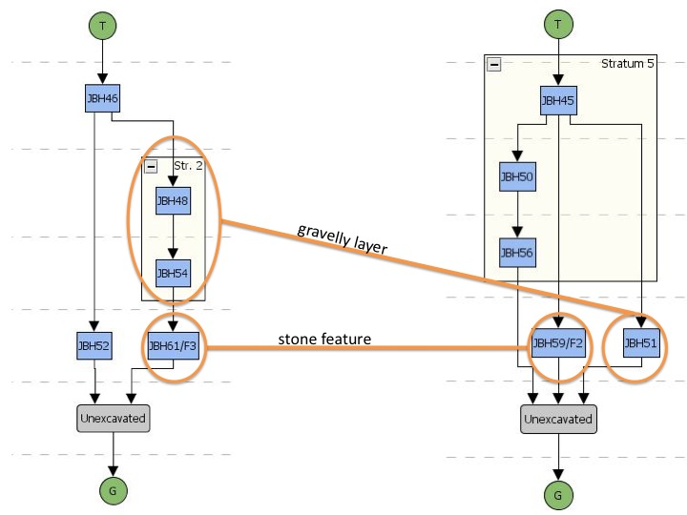 Fig. 13: Comparison of Stratigraphy at Unit 6 (Left) and Unit 7 (right)

While they share gravelly contexts and features, there are key differences between these similar layers in Units 6 and 7. In Unit 6, the gravelly fill was directly on top of the broad stone feature; about 28cm of gravel was excavated before reaching the broad stones in JBH61. In Unit 7, the feature began to reveal itself at a depth of only a few cm, while the fill context lay next to the feature. This is an important distinction in relationships between these two contexts, which on the surface may have initially seemed similar.
The other important difference lies in the stones that formed each of the two features. Feature 3 in Unit 6 consisted of many broad stones, some of which were quite large; these stones lay next to each other, covering a wide swath of the unit. The stones in Feature 2 in Unit 7, on the hand, looked quite different. These stones were much smaller on average, and were stacked up on top of one another, rather than lying flat.
This may suggest that these features had different construction methods, demolition methods or original purposes. Julie Pridham’s chapter on the history of buildings in the yard of the John Brown House delves into this question. On the basis of historical map and photo research, she posits that the feature at Unit 6 was a path. The stratigraphy discussed above could easily match this hypothesis: the layers of gravel lie above the flat paver-like stones, forming a line along what might be the foundation wall of the demolished Hale-Ives house.
It is possible that Feature 2 in Unit 7 was a path as well, with the stones forming the edge of a path that was filled with gravel and rubble. However, this would constitute a very different manner of path construction than the feature at Unit 6. This should be kept in mind when investigating the landscape architecture of the JBH property. Because of the different stratigraphic relationships and characteristics of the features themselves, coming to a decisive conclusion about these features and their functions is very difficult at this point in time. Further fieldwork might expand on Unit 7, to see whether there is a parallel feature to the West of Feature 2. Also, adding more units between Units 6 and 7 in order to establish more data points in these different construction types would be useful in determining their original purposes.

Units 8 and 9

Units 8 and 9 were located only a few meters away from each other near the house. Though Unit 9 was only excavated to a depth of 22 cm, the layers that were excavated very closely reflect contexts discovered at Unit 8. As shown below in Figure 14, after the vegetation was removed, there was a thin context of brownish soil. After a few cm of that context, both units revealed the mottled soil represented by Stratum 9 and Stratum 14.
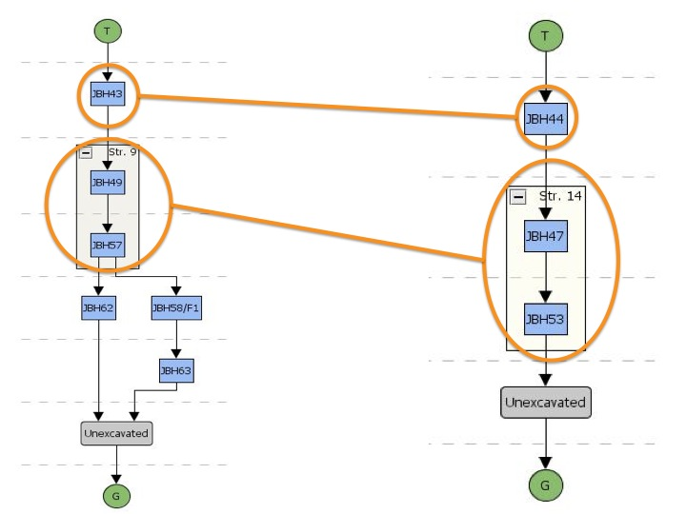
Fig. 14: Comparison of Stratigraphy at Unit 8 (left) and Unit 9 (right)

At Unit 8, below the contexts of mottled soil, field workers found a tarp that was likely much younger than the artifacts coming out of the overlying contexts. This would suggest that the mottled-soil stratum was backfilled over the tarp at some point; it is unknown where this backfill came from the original soil at this location, or was moved from another location. If more depth could have been gained at Unit 9, the team might have found other modern features under the mottled soil, like the Unit 8 tarp. The placement of the electrical wire, for example, likely constituted a disturbance in the stratigraphic relationships of the overlying soil. The presence of this mottled soil across both units suggests that the stratigraphy at this side “garden” of the house has been disturbed on at least one occasion in the recent past. The historical mottled-soil layers may not even have been originally located at this area of the house; this should be kept in mind while interpreting artifacts from these layers.

Part 3: Integration of 2008 results

The four initial units in 2008’s field season were located in the Northwest quadrant of the yard, near this year’s Unit 6. After field workers discovered that one of their initial units (unit 3) was not revealing a resistive feature that they had anticipated from the results of a recent geophysical survey, they opened a fifth unit just 18 inches East of Unit 3. This unit, assigned as Unit 5, was a 1m x 1m unit, and did reveal the feature they were searching for: the broad stones of which this year’s Feature 3 is a part. As mentioned above in the Unit 6 section, expanding on Unit 5 was the impetus for opening Unit 6 in the 2009 season. Because these units directly overlap, a comparison of Units 5 and 6 is crucial to understanding more about the architectural feature they share.
2008’s Unit 4 was located in the Northwest part of the yard, along the same resistive feature as Units 5 and 6. However, the stratigraphy and features from Unit 4 look much more like those of Unit 7 than those of Units 5 and 6. This was initially a surprise, as Units 4 and 7 do not overlap, and are also not located particularly near each other. After a consideration of Units 5 and 6, this section of the report will compare Units 4 and 7 in an effort to understand more of the history of the entire Western line of the JBH property.

Units 5 and 6
Unit 5 is located within Unit 6, so it is unsurprising that they share very similar strata. Integrating the expansion of the original small unit will give future teams working at the JBH a better understanding of the underlying, still somewhat enigmatic feature located here. Below are Harris matrices for both units, and a table comparing notes from both seasons:

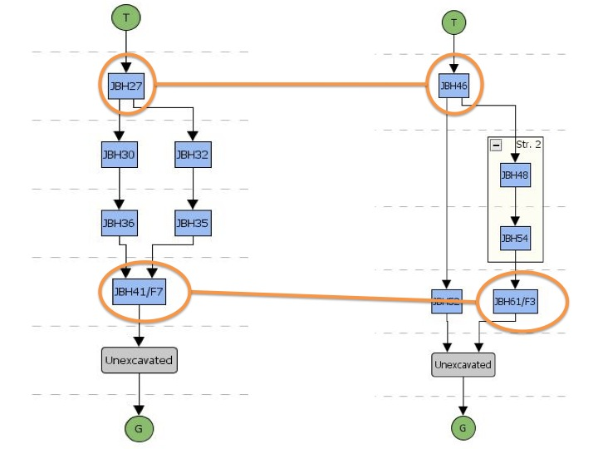
Fig. 15: Comparison of Stratigraphy at Unit 5 (left) and Unit 6 (right)

Table 6: Strata from Unit 5 (bottom) and Unit 6 (top); all Unit 5 soil notes are taken from the 2008 field paperwork

The two units share a topsoil layer (Strata 2009-1 and 2008-17,), and a stratum containing the same feature of broad stones (2009’s Stratum4/Feature 3 and 2008’s Context JBH41/Feature 7). The ending depth of the topsoil layer and the starting depth of the feature were similar between the years, but the distinctions made among the layers in the middle are quite different, as evidenced by the matrices above. In order to sort out these discrepancies, a comparison should focus on 2009’s Stratum 2 (JBH48 + JBH54) and 2008’s stratum 18 (JBH32), stratum 19 (JBH35) and the unnumbered context JBH30.
Similarities certainly exist in the interpretation of these layers between the topsoil and the feature: they all share a common theme of varying amounts of rubble and gravel fill, as well as sandy yellow patches of soil. Despite this theme, however, the two teams interpreted different subtle variations in the stratigraphy. In 2008, the stratigraphy was divided into three separate contexts (JBH30, JBH32 and JBH35), which varied in amount of gravelly pockets and yellowy patches; the soil seemed to became more yellow as more depth was gained. In contrast, analysis in 2009 has considered the entire depth between the topsoil and the feature to be one stratum (2009 Stratum 2).
The different interpretations between the two field seasons may reveal that the Northern half of Unit 6 (where Unit 5 is located) does actually contain more separate contexts, while the Southern half was less complicated. The differences may also be due to two separate teams analyzing their unit at different times and under different conditions; 2009 was a very wet field season for example, and this may have affected the team’s description of the soil. The 2008 team working at Unit 5 also acknowledged that their unit contained “convoluted contexts”. Perhaps related to this confusion, the 2008 notes have inconsistencies. For example, the 2008 fieldnotes delineate JBH27 and JBH36 as very different contexts, with a context between them, while the sitewide stratigraphy report combines these two into a single stratum. Finally, human error in notetaking must be acknowledged as a possible confounding factor. The only safe conclusion in comparing Units 5 and 6 is that they certainly share a topsoil layer and a feature, while the strata between them have yet to be clearly understood.

Units 4 and 7

While Unit 4 was closer to Units 5 and 6, and lay along the same resistive feature in the 2008 geophysical survey, the stratigraphy of Unit 4 much more closely reflects the stratigraphy at Unit 7. As discussed in the Unit 6/7 comparison, Unit 6’s feature lay under several centimeters of gravelly soil, while Unit 7’s feature lay next to the accompanying gravelly fill. Unit 4’s stratigraphy more closely resembled the latter: there was a stacked-stone feature bisecting the Unit, with a non-gravelly, brown soil on one side and architectural rubble and gravelly fill on the other. The Harris matrices in Fig. 16, below, delineate these similarities.
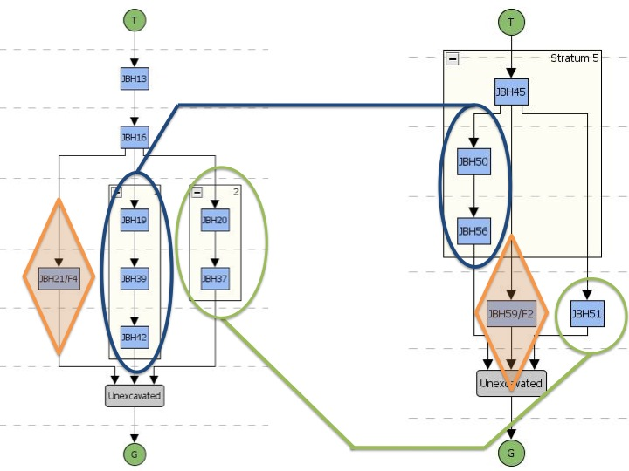

Fig. 16: Comparison of Stratigraphy at Unit 4 (left) and Unit 7 (right)

As shown above, Units 4 and 7 share a number of similar contexts. The two features, noted by orange diamonds in Fig. 16, were both linear rows of stacked stones, which neatly divided their respective units into clearly distinct contexts on either side. On one side was an uninterrupted, smooth, brown soil; these strata are noted by the blue ovals in Fig. 16. Both teams assigned arbitrary contexts in this layer, as there was no perceived soil change in either for at least 10cm. On the other side was the rubbly strata denoted by the green ovals in Fig. 16. The 2008 team also got through 10cm here, and assigned a new arbitrary context; the 2009 team did not achieve a 10cm depth across the whole rubbly context.
The interesting detail in this comparison is that, in the two units, the distinct contexts lie on opposite sides of their respective features. That is to say, in Unit 4, the smooth context lay on the West side of the feature, while the rubble was on the East. In Unit 7, the opposite relationship was observed. This is fascinating, since Units 4 and 7 lie in a line with each other along the Western edge of the JBH property. This may support the hypothesis that there was once a path edged with the stony features found in both years. Unit 4 might show a snapshot of the West edge of part of the path, with smooth soil on the outside and gravel in the inside, while Unit 7 could be part of the East edge of the path, showing a mirror-image of the same relationship. Figures 17 and 18 below clearly illustrate this proposed relationship.

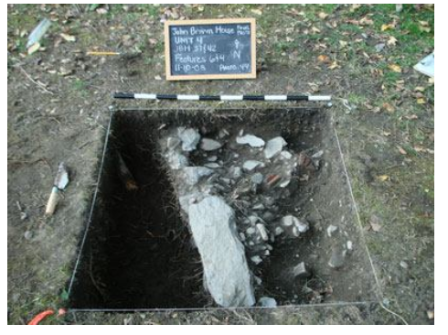
Fig. 17: Features/Strata in Unit 4, 2008 Fig. 18: Features/Strata in Unit 7, 2009

These similarities are cause for further investigation at and around these two units. Perhaps expanding Unit 7 to the West would yield results like Unit 4’s, with identical smooth soil on the other side of the feature. As mentioned in the Unit 6/7 comparison, expanding this unit would also aid a comparison of the seemingly different relationships between the gravel and the features in Units 6 and 7. In any case, further investigation of the resistive features along the West edge of the property should be a strong consideration in choosing the location of future units.

Conclusion

The 2009 field season at the John Brown House yielded many surprises and produced many more questions. Many of these questions deal with stratigraphy: what exactly is going on along the West edge of the JBH property? Are we seeing the same landscape or architectural features, or have some of those features been reused or changed since they were first constructed? Also, when, how and why was the stratigraphy at Units 8 and 9 disturbed?
The goals of this report have been twofold. First, it has attempted to provide a brief overview of the stratigraphic relationships at the JBH discovered during fieldwork in 2009. The following chapters will address in more detail the specifics of the excavation process and artifact analysis in each unit, as well as exploring several histories related to this property. The second goal of this chapter has been to raise and attempt answer some of these questions stated above, or at least to provide future researchers at the JBH with more information as they pursue answers.
As with all archaeological work, our efforts at the John Brown House were an imperfect science. Everyone in the class had minimal or no experience with hands-on archaeology, and we learned on our feet. In an effort to expose all of the students in the class to all parts of the excavation and analysis process, there were different excavators and notetakers every week in every unit. Though I have attempted to iron out as many of these inconsistencies as possible, they likely still played a role this analysis. I take responsibility for any other inconsistencies and mistakes, as human error inevitably plays a role at every point in the process, including synthesis.

“T” in the Harris matrix corresponds to the sod/vegetation layer first removed at the opening of the unit. This demarcation will be consistent throughout this report.
Julie Pridham’s 2009 field blog, http://proteus.brown.edu/archaeologyofcollegehill/9073
Because JBH52 lay outside the area excavated in 2008, I have chosen to ignore it here.
Elyse Nuding’s 2008 Field Blog, http://proteus.brown.edu/archaeologyofcollegehill/6387

