Excavation Summary – Unit 8 – Andrew Seiden

Excavation Methods
Unit 8 was a completely new plot, and was not based around any kind of previous geophysical survey. It does not appear on the original geophysical map made at the start of the 2008 season. Thus, unlike the other units near the Ives House area lower in the yard, the excavators of Unit 8 began with a full square of topsoil and grasses, with no reference (such as a shovel test pit or previous season’s unit contained within the 2009 season unit) to previous excavations or to what they were expected to find. This of course, had its positives and negatives. The group did not benefit from a constant straightforward goal, such as continuing to excavate a hypothesized stone foundation wall, but was able to construct its own goals and ideas based on interesting finds. There was a lot of speculation during the excavation process itself, as to what the finds meant, and as to what could exist deeper in the soil.

Placement of the Excavation Unit
Unit 8 is Located next to the old wood sheds behind the house, and the newer additions to the house made by Perry. Units 8 and 9 are elevated above the rest of the JBH yard, and the other two units. It is on a small gradient, unlike the other units, which are more or less flat.
The unit is 2x2 m, a relatively large size, especially for a team of three. The team consisted of Laura Sammartino, Sarah Roberts, and myself, with Krysta Ryzewski, Alex Knodell, and Elise Nuding supervising and constantly offering a helping hand. It had to be larger in size because we were beginning to uncover a completely new area and needed a wide space to make certain nothing was missed.
One of the main reasons for digging at this location is the potential construction of a new geothermal well as a “cost effective, reliable, sustainable, and environmentally friendly” method of providing heat to the John Brown House area. In this sense, we were conducting a kind of “rescue archaeology” in that we were going to see if there were any notable discoveries that could be made about the area surrounding the house, where the outhouses, kitchens, stables and servant working areas would have been.
Trends in current archaeology tend to focus more on the daily lives of normal people, who give a better sense of the general lifestyles of the time than the rich, whose houses and possessions have been more easily preserved because of their monetary, sentimental, and historical value. In this regard, the John Brown House Museum is certainly no exception; the lives of the Brown family are well documented and the inside of the house, including bedchambers, parlors, and guest spaces are accurately reconstructed and furnished. But the servants’ quarters and outbuildings where they would have spent much of their time are only depicted in a handful of drawings and lists. Like Mrozowski’s Living on the Boott, the Archaeology of College Hill field course focused its attention on the yard in the back of the house, where it is expected that the tasks of daily life and labor would have been performed, but have yet to be substantially recognized through the historical record.

JBH 43
Context JBH 43 was our surface context. As pictured below, there was a decent amount of grass and root coverage that had to be cut and removed before actual digging could take place.
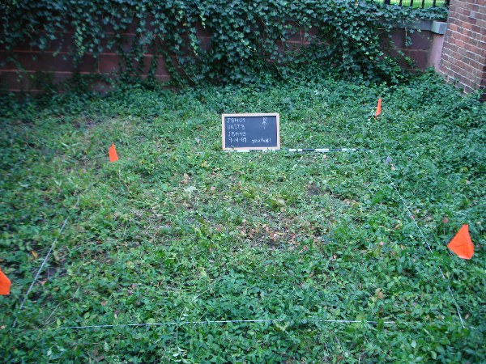
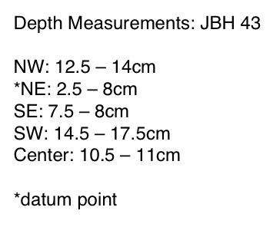
The initial elevation measurements were based off of the highest point, which was the northeast corner of the unit. As was noted, the unit exists on a small incline, so the starting heights vary. See below for the depth ranges of JBH 43.
Pointed shovels and clippers were used to remove roots, grasses, and weeds from the surface of the unit. This was done carefully; the roots were cut not pulled up, because shifting roots and soil underground, depending on the depth, could have potentially displaced or changed the orientation of the artifacts below.
Despite the shallow depth of the surface unit, we quickly began to find small artifacts and fragments in the sifted soil. Some of the many finds from this context are: coal, brick, glass, duct tape, wire nails, a piece of upholstery tack metal, redware fragments, a piece of slate roof, paint chips, porcelain, and a plastic pipe saddle. See below for a list of dated artifacts.
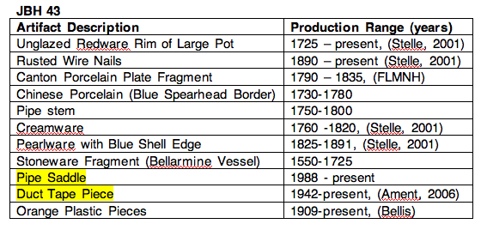
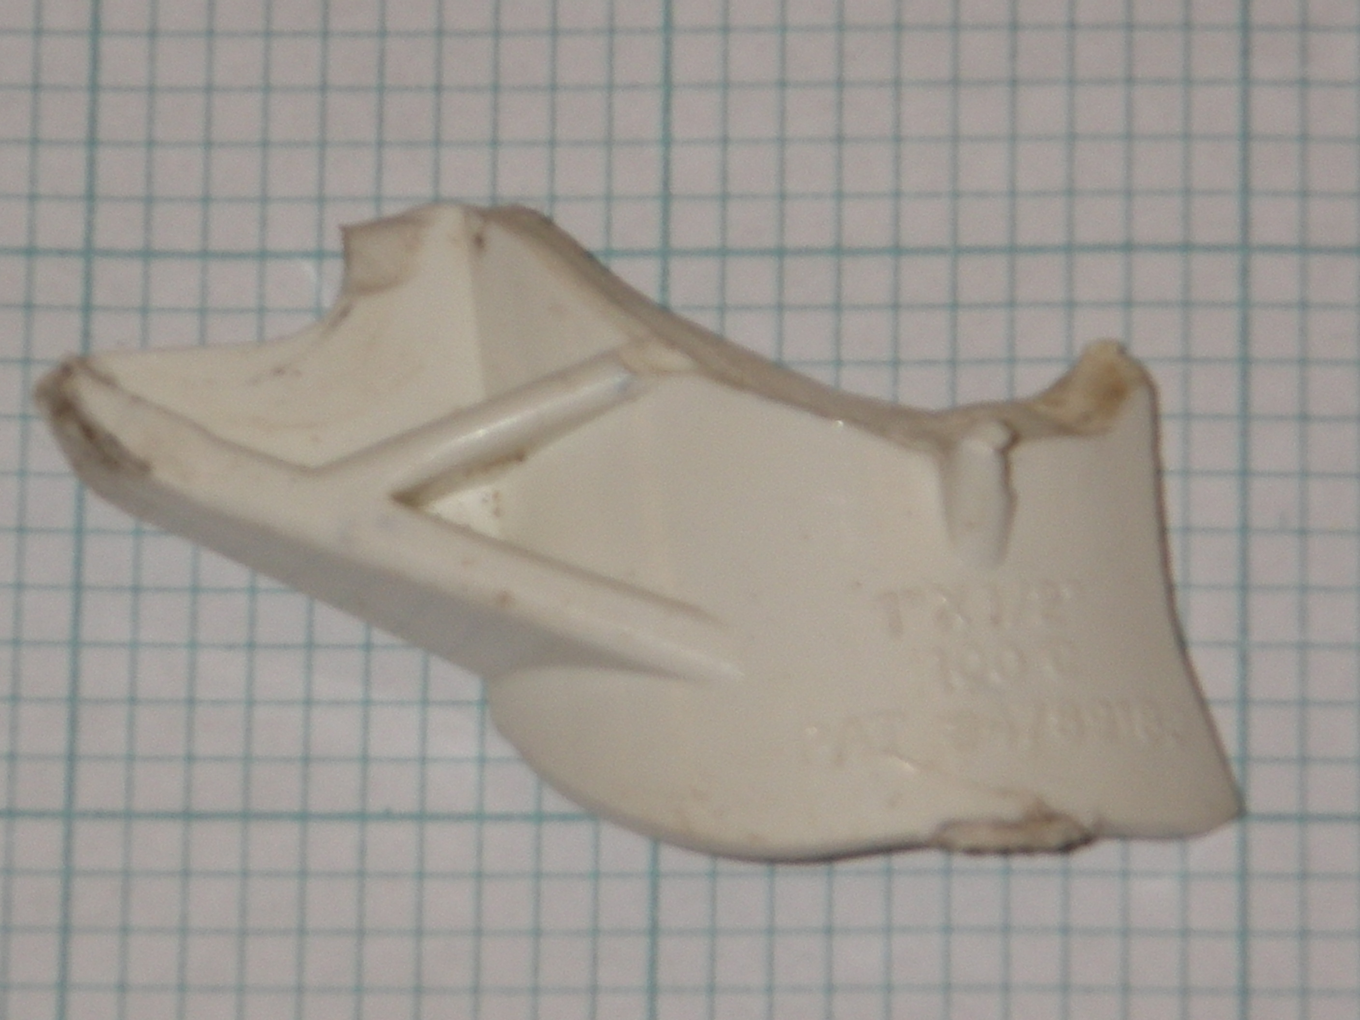
Of note is the range of dates; this context, as we will see is the case for the entire unit, is full of both colonial artifacts from the eighteenth and nineteenth centuries and modern manufactured pieces. The existence of a plastic ‘pipe saddle’ and duct tape fragments alongside Chinese porcelain and stoneware from a Bellarmine vessel makes for a somewhat confusing conception of the order of deposition.,

JBH 49
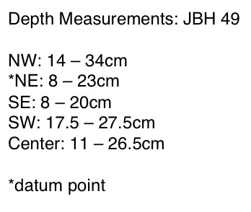
JBH 49 was established below JBH 43 because of a natural soil change. The soil of this context was a mottled gray-brown color with orange and green silty patches, but constant wetness of the soil made it difficult in future contexts to provide accurate Munsell data. JBH 49 also contained more numerous and more sizeable rocks than the previous context did.
No architectural features were found in this context, though there were signs of architectural construction. Pieces of cut metal, slate, coal, brick fragments, and pieces of mortar were unearthed. At the time of excavation, we believed that the prevalence of these construction materials could be due to the unit’s proximity to the newer additions to the house, and could have been remnants of that construction. As we will see, however, the unit’s proximity to the house may not have been a very important factor in the makeup of the artifact remains.
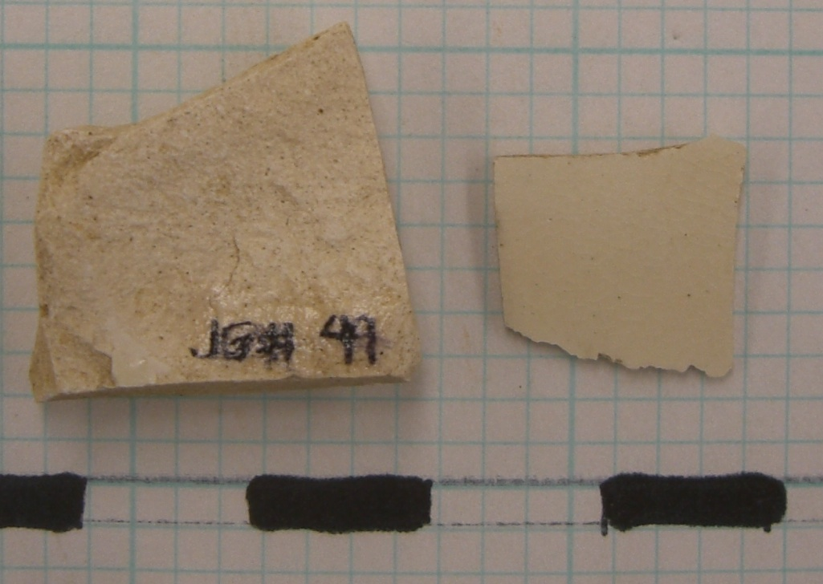
In addition to the construction materials, there were many artifacts recovered, including various porcelain, whiteware, and pearlware fragments.
For a list of dated artifacts retrieved from this context, including a plastic coffee cup lid piece that served as the context’s TPQ (Terminus Post Quem) date, see below.
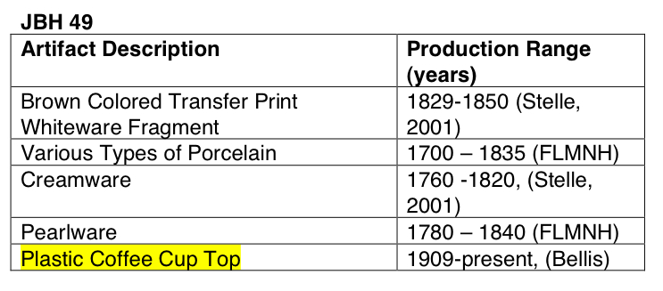
The excavators used a shovel-shaving technique with flat shovels, and used trowels to remove sediment from the unit. Group members at this point began to notice that in the southeast corner of the unit, there was an L-shaped patch of darker, finer soil. This patch would become context JBH 58 or Feature 1.

JBH 57
What began as an arbitrary context change from JBH 49 based solely on depth became one of the most fruitful contexts in terms of artifact and architectural discoveries.
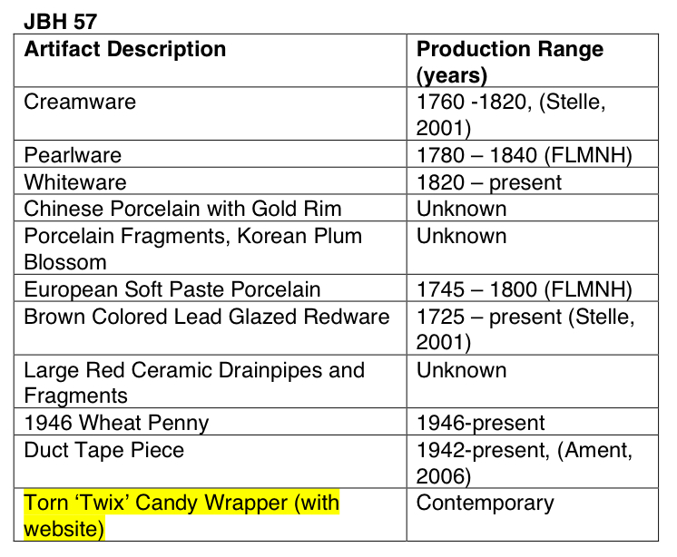
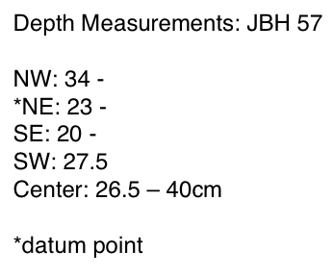
Located below JBH 49, and encompassing the entire unit except for JBH 58 (feature 1) in the southeast corner, JBH 57 is defined, but not solely, by the uncovering of a gray cloth tarp found to underlie almost the whole unit. The soil above this tarp is considered JBH 57, while the gravel below it becomes a new context, JBH 62.
Some other interesting finds from this context are a pair of large terra cotta drainpipe segments (one of which is pictured below), pieces of creamware, pearlware, whiteware, and Chinese and European porcelain fragments.
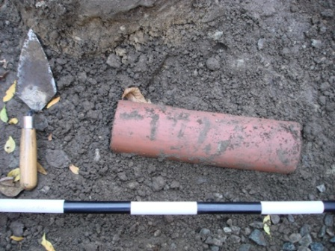
Again, there was this mixture of historical artifacts and contemporary artifacts: there were these earthenware shards, as mentioned, and also pieces of duct tape and part of a Twix candy bar wrapper.
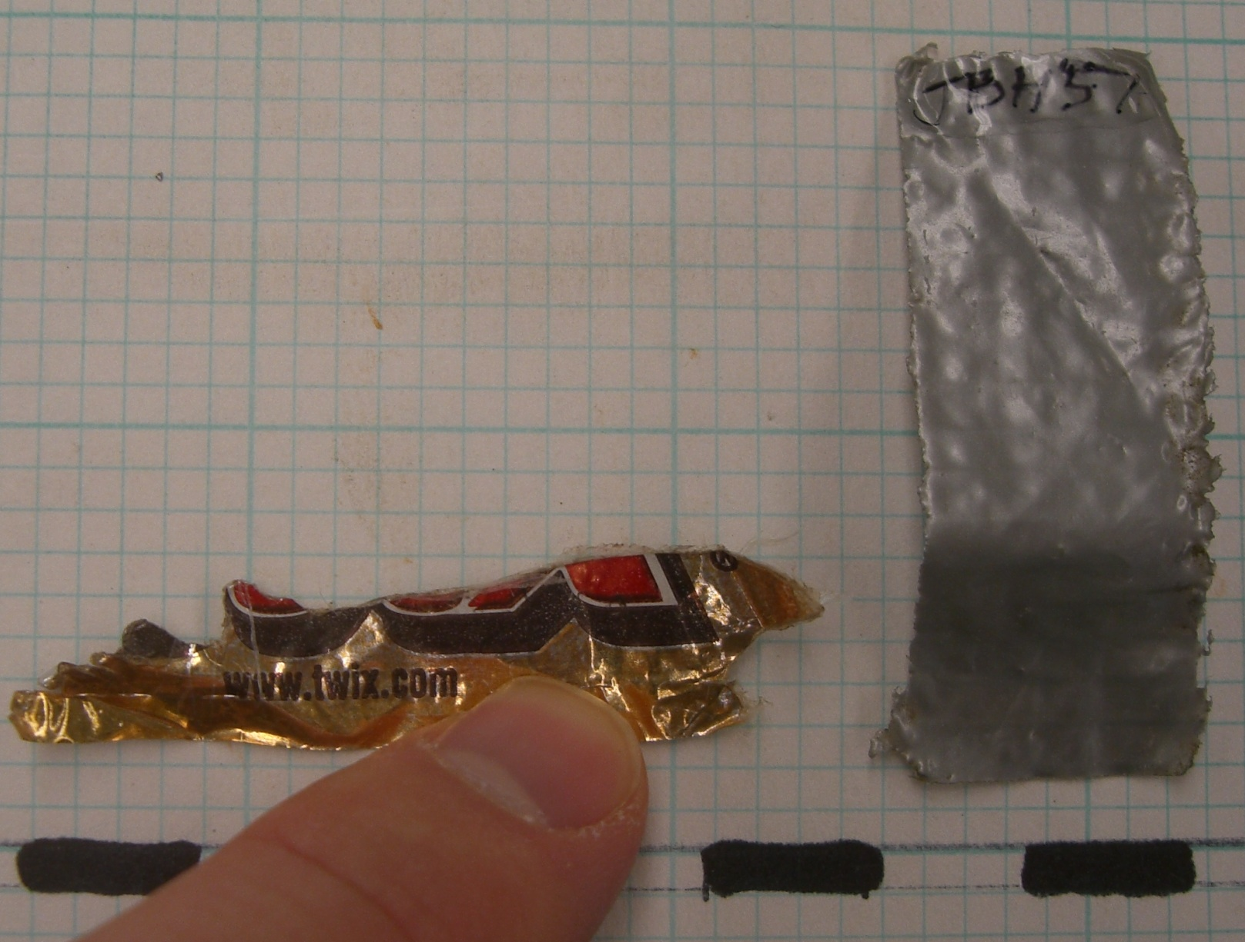
Note that the candy wrapper fragment advertises the company’s website, and thus can be placed in a contemporary context. See the chart for production ranges for dated items.
Since the two terra cotta drainpipe fragments were found perpendicular to one another, and were each situated parallel to the unit’s walls (one near the south wall and one near the east wall, it is one hypothesis of the group that these heavy drainpipe segments were used to weigh down the cloth tarp when it was initially placed on top of the gravel deposit. Therefore it is possible that the soil and artifacts found in JBH 57, as well as the above contexts, were then deposited over the tarp intentionally to cover it up. This is interesting because in this case, the sediment deposition is opposite to a natural type of deposition, in which the deepest layers would automatically be the oldest. Here, there is the possibility that the upper contexts, containing mixed contemporary and historical artifact remains, are older than the gravel fill and tarp that lays beneath it.

JBH 58
JBH 58 is our Feature 1, located in the southeast corner, is an L-shaped intrusion of dark brown fine soil. Here you can see it outlined.
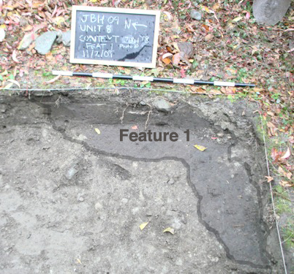
There were very few artifact finds in this context, but the fine soil made it easier to sift them out. Two of the dated finds are listed in the chart for this context.
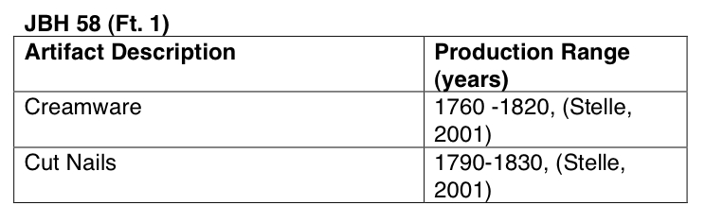
In regard to the limits of this context, the group was undecided on how far Feature 1 really extends. The feature definitely exists through multiple of our contexts, and was not labeled a separate context until we had exposed some of it already. It is possible that some of JBH 58 soil was mistakenly sifted and labeled as JBH 49 and/or JBH 57.
It is also possible that this context extended further toward the west wall, along the southern border of the unit, as it can be seen in the southern wall profile picture.
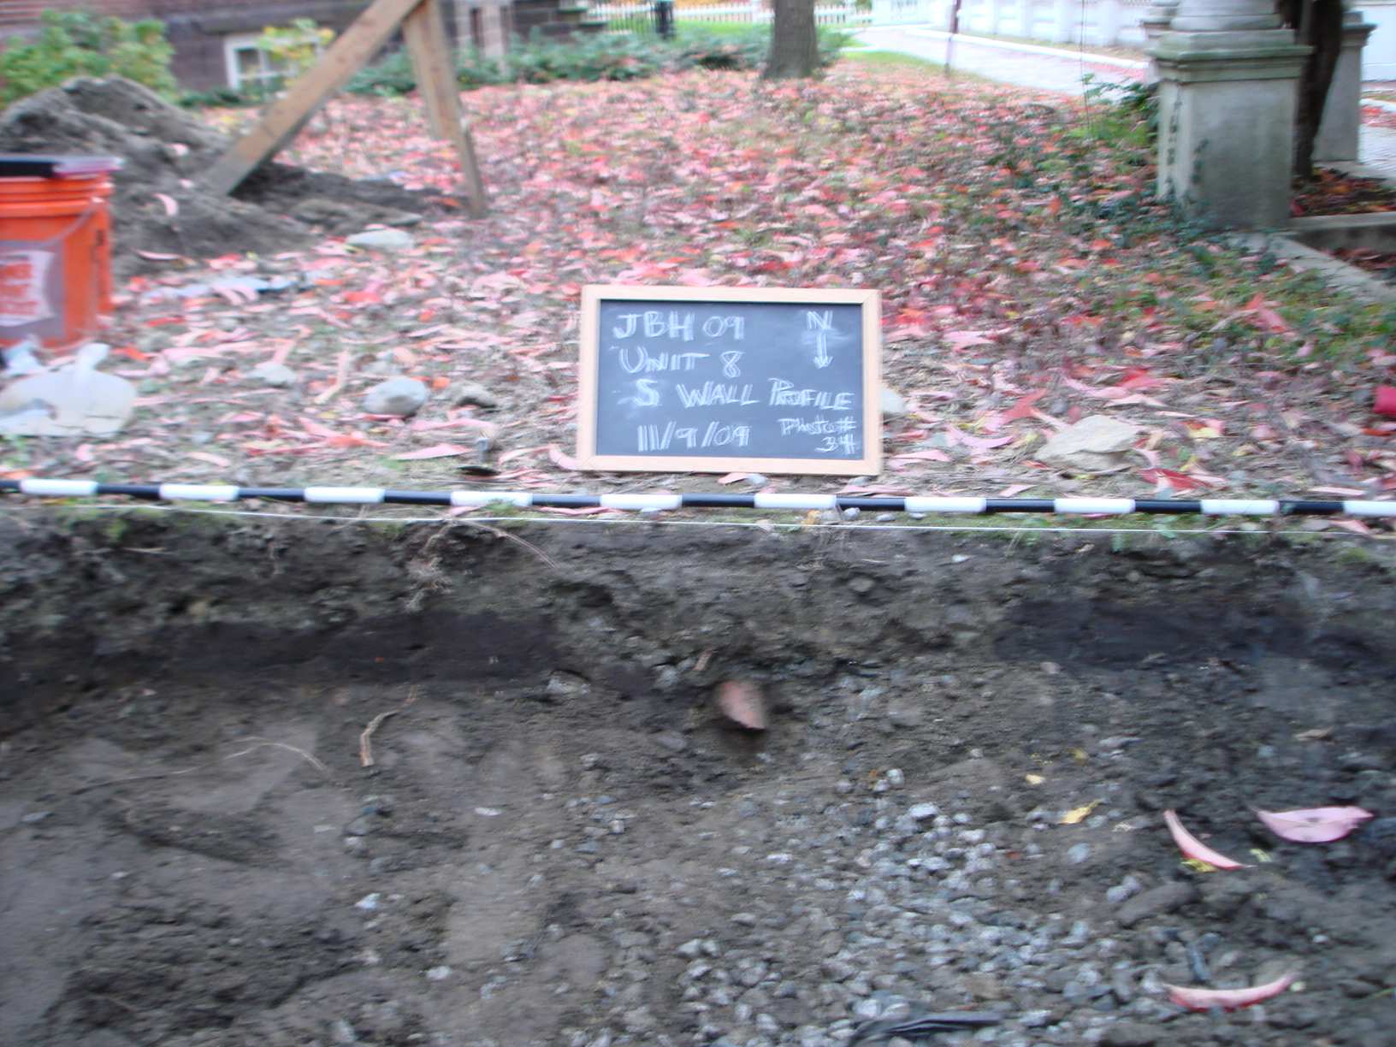
Notice that Feature 1, the dark soil on the left, may have extended past the middle segment of lighter soil, to the right (west) side of the unit as well. But this is not accounted for in the excavation data, as it was not recognized until later. There is also another terra cotta pipe shard that sticks out of the south wall right in the center of the unit, so it was hypothesized that the pipes segments were installed for drainage purposes and that perhaps JBH 58 and this finer darker soil is the remnants of that installation. Therefore, it would be newer than the other contexts around it, even though it is underneath them. All in all, the stratigraphy of Unit 8 is a bit shaky.

JBH 62
JBH 62 consists of everything underneath the cloth tarp, which was, to our knowledge and the extent of our exploration, simply gravel with minimal artifact deposits. See the photograph below of the southern edge of the gravel deposit, with the cloth tarp pulled back.
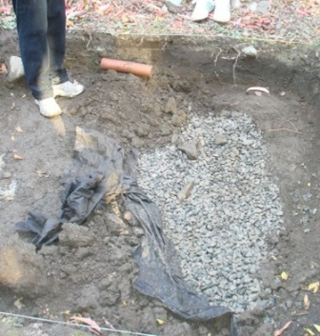
Unfortunately, the group did not fully expose the surface of the tarp until the last half hour of the last day of excavations, so our experience with this context is quite limited but it is of primary importance in analyzing the contents of Unit 8, and drawing conclusions.
After peeling back the tarp in the south section, we utilized the remaining twenty or so minutes to frantically search for the bottom of a homogenous gravel, which, like sand, continually replenished itself from the edges of the hole we were creating. Concentrating on only the southwest edge (20 cm from the south wall), where the gravel met the soil and perceivably was the end of the deposit, we dug to an approximate depth of 72 cm (from the datum point) without hitting anything but gravel before it was time to backfill the whole unit and end the excavation portion of the course.
The one artifact from this context is a clear plastic mesh piece of unknown origin or use (we called it a ‘nozzle’ at the time of the find) but which places the context in the realm of the contemporary and thus newer than some of the porcelain and other items from the above contexts would have suggested.
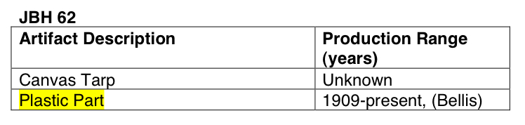
JBH 62 is the most significant architectural find in Unit 8. Before this, there were no divisions in the unit, like those found in the lower yard units 6 and 7, where stone structures divided the space. It is unfortunate that the group did not uncover the gravel deposit until the last day of excavations, but it is also not imperative that future excavation seasons concentrate their efforts on this spot, due to the implications of this find.

Conclusions
It seems apparent that the gravel deposit, due to the cloth tarp and plastic piece that are obviously manufactured, is a more recent intrusion than some of the artifacts of the contexts above it would suggest.
The general hypothesis then, is that after whatever exists below the gravel was filled in and capped, these layers of soil, artifacts and rocks were placed on top of it, perhaps from elsewhere on the property or from nearby. A detailed analysis of similarities in artifact remains and soil composition, perhaps, would be beneficial for predicting the location of the soil’s original context.
This hypothesis would explain why there was relatively little change in soil composition, or diversity of artifact finds across the different contexts. Along with arbitrary context changes based on depth, we made context changes based on quantity and size of rocks within the soil. Essentially, contexts 43 through 57 can be interpreted as a relatively homogenous fill, not layered, as naturally deposited soil would be.
There have been assertions made that beneath the gravel deposit lays an old dry well that was filled in during the 1940s, but documents and other accounts would be necessary to support this conclusion. It is also possible that the high levels of porcelain, creamware, and whiteware found in Unit 8 attest to the unit’s close proximity to the kitchen area and outbuildings, but due to the contemporary nature of the manufactured cloth tarp and homogenous gravel fill found below these artifact deposits, it is more likely that the soil from contexts 43 through 57 was deposited there afterward, to bury the gravel fill. Perhaps wherever this soil was taken from is closer to where the kitchen and outbuildings were located, lower down in the yard, and the earthenware finds from STP3 this season could perhaps shed more light on that situation.

Works Cited
Ament, Phil. Duct Tape. Troy MI: 1997-2007 The Great Idea Finder, 5 April 2006. Online. Available: http://www.ideafinder.com. 30 November 2009.

Archaeological Laboratory Artifact Codebook. University of Massachusetts Boston, Center for Cultural and Enviromental History. 2004.

Bellis, Mary. The History of Plastics. <http://inventors.about.com/od/pstartinventions/a/plastics.htm>.

Fishman, Bernard P. Personal Communication.

Florida museum of natural history artifact identification guide
Arch of college hill 2008

“Geothermal Power.” Wikipedia Online Encyclopedia. <http://en.wikipedia.org/wiki/Geothermal_power>.

Mittman, Alexander. Object Biographies

Mrozowski, Stephen A. Living on the Boott: Historical Archaeology at the Boott Mills Boardinghouses, Lowell, Massachusetts. U of Mass Press: 1996.

Roberts, Sarah. Object Biographies.

Roberts, Sarah. “Sarah’s Field Blog.”

Sammartino, Laura. “Laura’s Field Blog.”

Seiden, Andrew. Object Biographies.

Stelle, Lenville J. 2001. Archaeological Guide to Historic Artifacts of the Upper Sangamon Basin. Center For Social Research, Parkland College. <http://virtual.parkland.edu/lstelle1/len/archguide/documents/arcguide.htm>.

Wikipedia Online Encyclopedia
Mrozowski, 1996.
Roberts, Sarah. Object Biographies.
Mittman, Alexander. Object Biographies
Sammartino, Laura. “Laura’s Field Blog.”
Sammartino, Laura. “Laura’s Field Blog.”
Seiden, Andrew. Object Biographies.
Seiden, Andrew. Object Biographies.
Roberts, Sarah. “Sarah’s Field Blog.”
Fishman, Bernard P. Personal Communication.

