Object Biographies - Assorted Canton Porcelain Pieces, Brown Lead-Glazed Redware Fragments, Terra Cotta Drainpipe Segment – Andrew Seiden

Assorted Canton Porcelain Pieces (Unit 8 JBH 49)
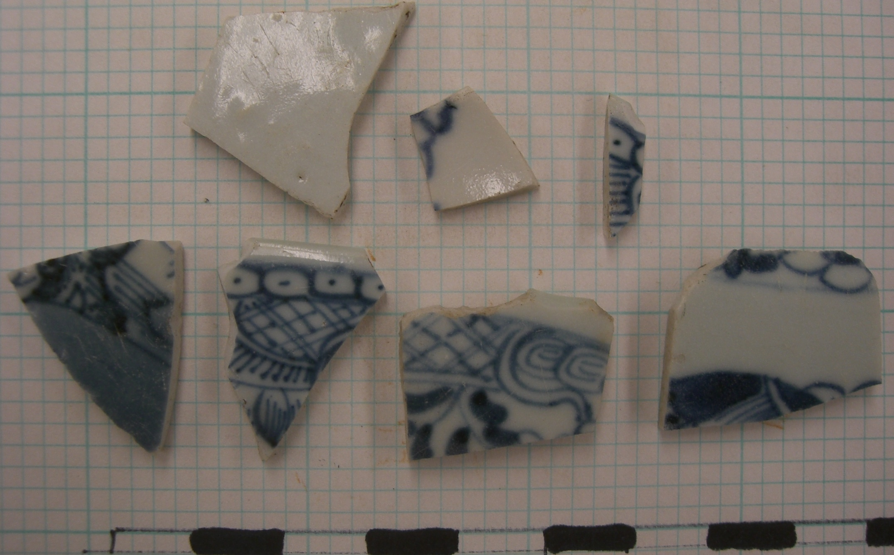
These porcelain fragments were found in context JBH 49 of Unit 8, located on the upper part of the yard, in close proximity to the John Brown House additions, and perhaps to the historic kitchen and outbuildings area. Unit 8 produced a large quantity of porcelain and other earthenware, including redware, whiteware, creamware, and pearlware.
These porcelain fragments were found by sifting through the collected soil from JBH 49, and thus, cannot be attributed to any one section or location within the unit. They may or may not be from the same piece of plate, cup, saucer, etc. or even from exactly the same time period.
The production range for Canton style porcelain is 1790 – 1835, and these were most likely imported from China, where these items were produced especially for export at that time. However, Tindall asserts that “dating much Canton with certainty is almost impossible.” Hume also attests to the difficulty of dating porcelain with no definitive markings: “for every piece of overglaze-decorated porcelain found on eighteenth-century sites there are a dozen or more ornamented only in underglaze blue, and as they are generally without reign marks they are virtually impossible to date with sufficient accuracy to be useful.”
Canton designates porcelain shipped out of the port city of Canton, China, and is the “poorer quality of common blue-and-white China Trade wares in general.” It became a popular American import after the Revolutionary War, when America began to trade with China directly, and was no longer limited by British regulations and taxes. See below for a more complete example of Canton style porcelain.
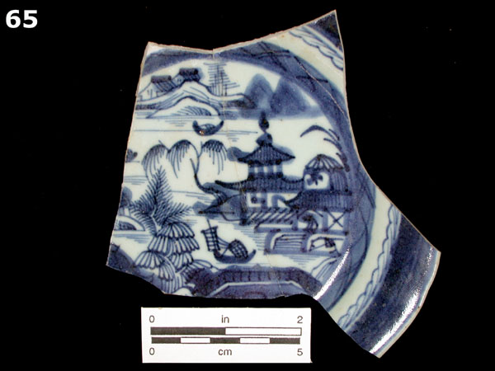
Although the designs and decorations found on Canton and like types, such as Nanking and Fitzhugh, can be found on domestic Chinese porcelain and in Chinese art, this type of porcelain was produced almost exclusively for export. Thus, Canton varies in quality and in color more than other types of porcelain. Some pieces contain imperfections, or are carelessly decorated by unskilled artisans and sold at a lower price. These pieces were produced in an early type of assembly-line fashion. The color can vary from faded light blue to gray-blue to navy, and the surface texture from rough to smooth to glassy. However, none of the porcelain pieces found on in JBH 49, or in the entirety of Unit 8 could be considered ‘rough.’ Whether or not this is an indication that the porcelain from this site is from the more expensive end of the Canton spectrum, and was part of the Browns’ collection is up for debate.
Tindall writes that “Canton was everybody’s porcelain,” as it can be connected to both rich and poor homes. He notes that George Washington’s Canton pieces are on display at Mount Vernon and other museums. The loose implication here is that John Brown and George Washington were relatively friendly, as one can learn from a tour of the John Brown House Museum and the large carriage in the woodshed. This is also an example of the kind of person who owned Canton style porcelain similar to the fragments found in JBH 49.
It is known that John Brown was an avid enthusiast of Chinese exports; many of his pieces are displayed within the museum. It is a likely probability that some of the Browns’ china was used not as decoration but for food and liquid consumption, and perhaps was broken or thrown away, eventually settling in this spot in the JBH yard. The prevalence of earthenware and porcelain pieces in this part of the yard, near where the kitchen and outbuildings may have been located, speaks to the possibility that these fragments were either broken or disposed of in the food-preparation process, due to servant or slave activities. But these assertions are by no means more than educated guesses.

Brown Lead-Glazed Redware Fragments (Unit 8 JBH 57)
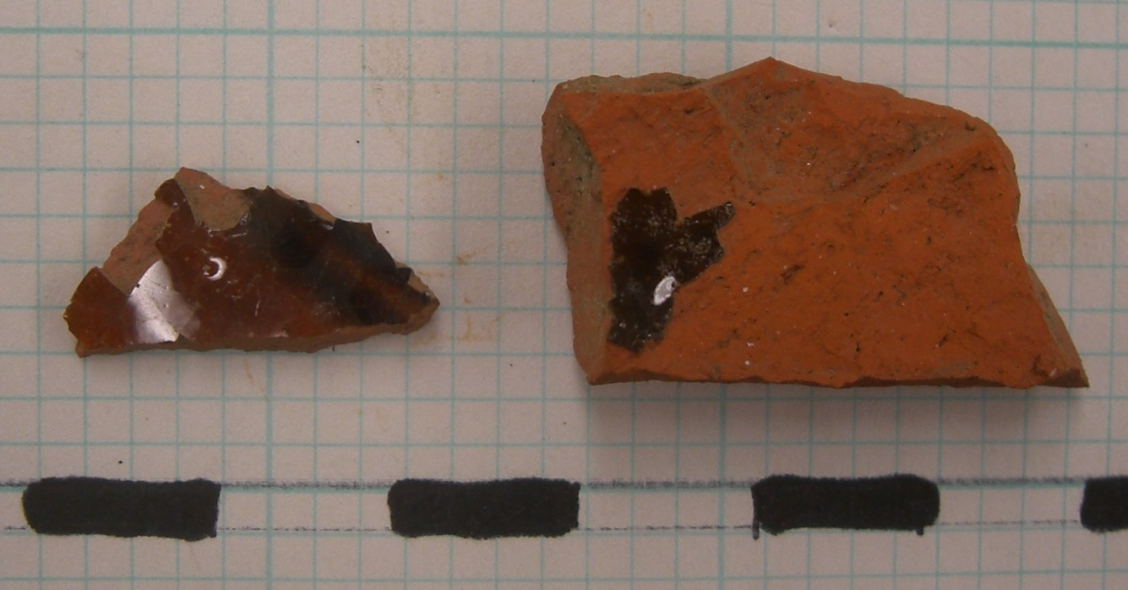
These lead-glazed redware fragments were recovered from context JBH 57 in Unit 8. As the fragments are small, when excavated their original orientation within the context was not preserved. It is possible that they came from the same plate, bowl, etc. but it is not particularly likely, considering that it is likely the soil was moved from elsewhere. Also, these were the only two shards of brown glazed redware in this context, and among the rest of the earthenware finds from Unit 8. Due to the small number of fragments of this type, it is likely that these two pieces have not always rested in this spot.
As the first American-produced form of pottery, redware dates anywhere from 1725 – present, and can found on many sites. Redware is the most fragile of all earthenware, as it is the most porous, and fractures easily. Below is a manganese glazed redware pie plate with a crazing technique that dates to the late nineteenth century.
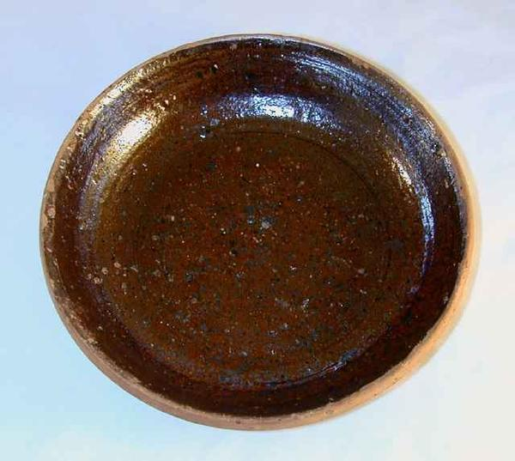
Lead glaze was applied to pottery, in order to make it impervious to liquids, as early as the twelfth century in Europe, and, though other forms of glaze existed, the various ordinary forms of earthenware have been glazed with lead up until the present. In fact, heavy green and brown glazes were used on coarse red earthenware in mediaeval times. Lead-glazed redware pottery was produced and intended for “ordinary use,” was sold at a low price, and was readily replaced when broken. This perhaps speaks to the nature of the fragments at the John Brown House. Perhaps they are the remnants of a piece of redware pottery that was broken and then merely thrown away with the trash. Perhaps most of the original piece was removed from the property with the trash, and only a few fragments fell into the yard by accident.
Due to the difficulty in dating redware based on its characteristics, it exists more as a reference to what kinds of dishes and pottery were used in the John Brown House and then thrown away over the years. The fact that, in addition to porcelain, stoneware, pearlware, whiteware, and creamware found in Unit 8, these shards of redware of a particular colored glaze were found, attests to the magnitude of variety that existed within the Browns’ collection.

Terra Cotta Drainpipe Segment (Unit 8 JBH 57)
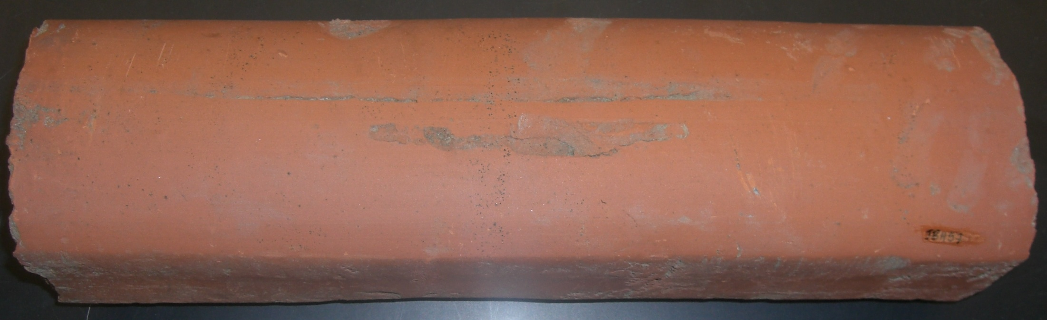
The two terra cotta drainpipe segments (one of which is pictured from two angles) were both recovered from context JBH 57 in Unit 8. One was facing east-west and was located parallel to the south wall, 10 cm from the wall, and the other was found a similar distance from the east wall, facing north-south, parallel to the wall. Each was just above the cloth tarp, which represents the boundary between contexts JBH 57 and JBH 62. The segment by the south wall was found during normal excavations, as was left in its original orientation for some time. The segment by the east wall, however, was not uncovered until the last day of excavations. When the group peeled back the cloth tarp to reveal the gravel fill (JBH 62), the second drainpipe was inadvertently unearthed.
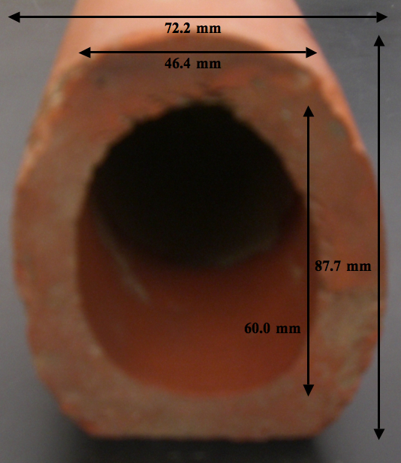
The end of the pipe (shown right) is 72.2 mm in width, and 87.7 mm in height, with edges approximately 25 mm thick. One side is flattened (bottom of the picture above) and the rest are rounded. This is a remnant of the mode of manufacture. The edges on either side of both segments are smooth and flat, so it is not likely that they were broken but instead were cut that way. Below is an example of like terra cotta pieces.
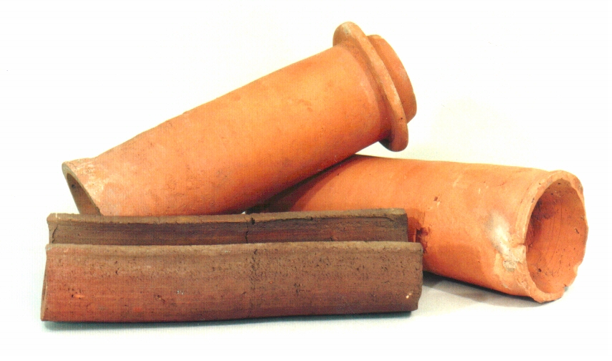
Examples of baked clay sewage pipes like these have been excavated from Babylonian sites and date to approximately 4000 BCE, so these forms are not new by any means.
There are two hypotheses as to what these pipe segments were used for at the John Brown House. However, they are not mutually exclusive. The first is that they were used for some kind of drainage system for the yard. In letters, John Brown makes reference to the drainage problems he has faced in the past, and it is likely that some kind of system had been put in place. Evidence for this lies in the prevalence of these pipes in Unit 8 context JBH 57. There were two whole segments unearthed at different locations within the unit, and another part of one protruding from the south wall (see Unit 8 summary) that was not excavated completely. The fact that these segments were not attached by any means, or that there were not more than three pieces found makes it seem likely that if there had been a water drainage system in place which utilized these actual segments, it has since been dismantled and the pieces spread out. The second hypothesis is in regard to the cloth tarp that represents the boundary between JBH 57 and JBH 62 in Unit 8. These two heavy clay pipe sections were found directly above the tarp, in positions close to its south and east edges. It is possible, then, that they were placed on the tarp as weights, while soil was deposited and the tarp was buried. This said, it is hypothesized that further excavation of the unit will unearth at least two more drainpipe segments or other relatively heavy objects that would have weighed down the north and west edges of the cloth tarp at the time of soil deposition. It is possible that both of these scenarios are true, because the drainage system could have been disturbed during the insertion of the gravel fill below the tarp, and the builders could have made use of these segments in covering the tarp.

Works Cited
Ament, Phil. Duct Tape. Troy MI: ©1997-2007 The Great Idea Finder, 5 April 2006. Online. Available: http://www.ideafinder.com. 30 November 2009.

Archaeological Laboratory Artifact Codebook. University of Massachusetts Boston, Center for Cultural and Enviromental History. 2004.

Barber, Edwin A. Lead Glazed Pottery, Part 1, Common Clays: Plain Glazed, Sgraffito And Slip-decorated Wares. Kessinger Publishing, 1907.

Bellis, Mary. The History of Plastics. <http://inventors.about.com/od/pstartinventions/a/plastics.htm>.

Brown, John. Letter to Edward Dexter. Providence, RI. 16 March 1796.

Deetz, James. In Small Things Forgotten. New York: Anchor Books, 1977.

Florida museum of natural history artifact identification guide
Arch of college hill 2008

“Historical Archaeology at the Florida Museum of Natural History.” The Florida Museum of Natural History Website. <http://www.flmnh.ufl.edu/histarch/gallery_types/type_list.asp>.

Hume, Ivor N. A Guide to Artifacts of Colonial America. Pennsylvania: University of Pennsylvania Press: 1969.

Stelle, Lenville J. 2001. Archaeological Guide to Historic Artifacts of the Upper Sangamon Basin. Center For Social Research, Parkland College. <http://virtual.parkland.edu/lstelle1/len/archguide/documents/arcguide.htm>.

Tindall, Hiram. “The Canton Pattern of Chinese Export Porcelain.” New York: Main Street/Universe Books, 1975.

FLMNH
Tindall, 1975.
Hume, 1969.
Tindall, 1975.
Ibid.
FLMNH
Tindall, 1975.
Ibid.
Ibid.
Ibid.
Stelle, 2001.
Ibid.
<http://www.seeauctions.com/show_item/202745/>.
Barber, 1907.
Ibid.
Ibid.
<http://www.stanglpottery.org/hill_drain_pipe.jpg>.
<http://www.sewerhistory.org/grfx/components/pipe-cly1.htm>.
Brown, 1796.

