Porcelain
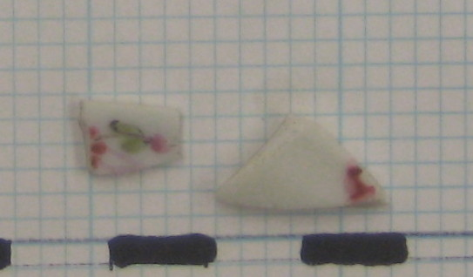
The two small porcelain fragments were discovered in JBH 57 from Unit 8. The artifacts, which appear to have come from the same vessel are classified as Polychrome Chinese Export Porcelain whose dates of production range from 1680-1850. The defining attributes of this type of porcelain, as defined on the Florida Museum of Natural History’s digital type collection database, are as follows, “White, thin, highly vitreous paste that is smooth and translucent. [The] background glaze is well bonded to the paste, white or bluish-white in color, lustrous, and with little evidence of imperfection. [The porcelain is] decorated with opaque overglaze enamels and gilding in a variety of colors, including multiple shades of green, pink, blue, red, black, plum orange and yellow.
Design motifs usually include floral elements combined with animals, birds, insects, geometric designs, symbols and figures. Motifs are detailed and finely executed.” Common vessel forms of this type of pottery include bowls, cups, plates, saucers, and tea pots. Chinese porcelain from this category can be more narrowly dated based on the color palettes and motif themes. These sherds seem to be of the “Famille Rose” palette which is “distinguished by it’s predominantly floral design featuring clear, bright, pink roses detailed in white, and dates between ca. 1720 and 1850” (FLMNH).
Ceramics are highly informative pieces of material culture to archaeologists. Although pottery is fragile, it is virtually indestructible, as fragments are highly resistant to discoloration and corrosion thus remaining similar to their original appearance(Deetz 68). Deetz describes three general classes of pottery, which include the earthenware (“soft, water-absorent body made impermeable by glazing”), stoneware (“hardbodied pottery that does not absorb water”) and porcelain (“highly vertified white ceramic made from a special class—kaolin—and is hard and impermeable to water.”) (69-70). These three classes of pottery are found on most historic sites. Ceramics are also largely utilitarian in function. Through the study of ceramics archaeologists can determine much about the life of their owners.
Porcelains were invented in China and were exported on ships with other cargo including tea, silks, paintings, lacquerware, metalwork, and ivory. Porcelain cargo was generally stored at the lowest level of the ships to provide ballast and because they were resistant to water. Popularity of polychrome overglaze was heavily influenced by European interest in porcelain decorated with coats of arms in the 18th century. The polychrome enamels made this possible as they allowed for extreme detailing, which the typical monochrome cobalt blue palette did not.
Before 1660 in America pottery was essentially uncommon. The pottery that was available was almost entirely imported from England. There was local production of pottery in America, specifically in Virginia and New England. However the markets for the ceramics were local and the production was limited (Deetz 79). After American independence in 1784, the country officially entered into trade with China. Therefore, porcelain is highly unusual in historic sites before the nineteenth century, unless the site had merchant ties (86). The American trade and demand for porcelain helped revitalize the export porcelain industry of China which had been suffering since the creation of porcelain factories in Europe at the beginning of the 18th century (www.metmuseum.org).
The recovered pieces of porcelain from JBH57 are of the Polychrome Chinese Export type, more specifically the “Famille Rose” palette. The nearly rectangular fragment is from the edge or rim of a vessel and is 10.2mm in length and 5.6 and 7.7mm in width and is 1.4 mm thick. The thicker (2.5 mm), triangular fragment has sides of 13.7 mm and 12.5 mm and a hypotenuse of 17.9 mm. The hand painted design in pinks and greens depicts a floral motif of bright pink roses. Only one side of the fragments are painted. Therefore, the fragments are most likely from a plate or a saucer, as those would only be seen from one angle. Due to porcelain’s costly nature it usually serves a socio-technic function, as plates were commonly put in cases on display and handled with care or perhaps used during tea time (Deetz 81).
The fragments were found on November 2, 2009 in the same context as a 1946 Lincoln One Cent. The porcelain is much older than the penny, with possible dates of production ranging from 1720-1850. Many ceramic sherds including other pieces of porcelain were found in Unit 8; one possible explanation for the abundance of the utilitarian artifacts being the close proximity to the house. The porcelain was most likely owned and utilized by the owners of the house for either the purpose of display or the functional purpose of drinking and eating. Additionally, the abundance of porcelain coincides with what is known about the Browns. The Browns were a prominent merchant family in New England and traded with various lands, including China.

Penny
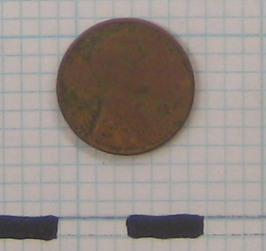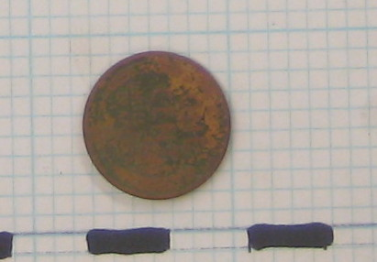

The 1946 Wheat Penny was found in JBH 5, corresponding to Unit 8. The United States Mint refers to this type of coin as the Lincoln head cent, appropriately named to reflect the portrait of Abraham Lincoln on the obverse of the coin. The coin is 19.05 mm in diameter and 1.55 mm thick (US Mint).
The United States government first authorized the minting of the penny, the first currency of any type to be authorized, in 1787, and since then the penny’s design has “symbolized the spirit of the nation from Liberty to Lincoln” (www.pennies.org). Since the time of the penny’s authorization over 300 billion pennies have been minted with 11 different designs. The portrait of Abraham Lincoln, first appearing in 1909 commemorated his 100th birthday and replaced the Indian cent which depicted an Indian princess on the obverse. The new design was the first coin to feature a historic figure and the words “In God We Trust”. In addition to the changes in design, the composition of the penny has also been altered. The first penny minted in 1787 was 100% copper. This pure composition was prevalent until the mid 1800’s. During the time of World War II the composition was 95% copper and 5% zinc (www.ustreas.gov). 1946 pennies were minted in one of three places, including Philadelphia, Denver and San Francisco. The place of minting is identified by a letter, however coins produced in Philadelphia traditionally carried no mark at all. The 1946 penny uncovered in JBH57 is badly worn, making it impossible to distinguish a mark or therefore, the place of production. Philadelphia produced the most pennies, 991,655,000, Denver (D) minted 315,690,000 and San Francisco (S) minted 198,100,000 (www.coinfacts.com). The penny has been produced in larger quantities than any other denominations.
The simple design on the reverse of the coin depicts “two wheatheads in memorial style. Between these, in the center of the coin, are the denomination and UNITED STATES OF AMERICA, while curving around the upper border is the national motto, E Pluribus Unum, which means "One out of Many." The initials of the artist, VDB, were also engraved on the reverse of the penny (www.ustreas.gov).

The penny was uncovered November 2, 2009 from JBH57. The penny was badly worn and corroded, most likely from years of being buried in the soil—soil that was often saturated with water. Also, found in context 57 were noncontemporaneous fragments of Polychrome Chinese Export porcelain of the Famille Rose palette. These porcelain artifacts were produced for over 100 years, from 1720-1850. However, their period of use is likely to have extended beyond 1850, as porcelain was very costly and often only used for the purpose of display. Therefore, the porcelain was usually handled with care and kept in very good condition. The penny on the other hand, clearly did not come from the same owners as the porcelain. The porcelain owners were most likely the Browns, since the dates would correspond to the years the Browns inhabited the house. The earliest possible date of deposition for the penny would be 1946, if it was left on the ground the year in which it was minted. However, despite the accurate date of production for the penny, one cannot possibly determine when it actually entered the archaeological record, other than to say it could not have been before 1946. Therefore, the penny could not have been owned by the Brown’s since the family predates the year of production for the penny. Additionally, the penny and the porcelain are very different types of material remains. The penny does not give the archaeologist any information about the owner, as pennies are used by all levels of society. Also, given that the penny is the most widely produced coin in circulation. Thus, the objects greatly differ in value and rarity.

The porcelain was an import to the country, traveling with similar cargo as well as teas, silks, ivory, etc from somewhere in China. The penny was minted domestically, in one of three United States cities. Although the minter’s mark was unable to be distinguished after lab work, the penny is known to have been produced in Philadelphia, Denver, or San Francisco. It is most probable that the penny was produced in Philadelphia, as that city produced nearly half of the coins minted in 1946.

It is also important to note that the 1946 penny was found below other older artifacts, such as a pipe stem from JBH43, which dated to 1750-1800. Therefore, the soil and deposits in Unit 8 have since been disturbed, allowing the newer artifacts to be mixed with the older artifacts dating back to the time of the Brown’s inhabitation.

http://www.coinfacts.com/small_cents/cents_lincoln_wheat_reverse.html

Pipe Stem

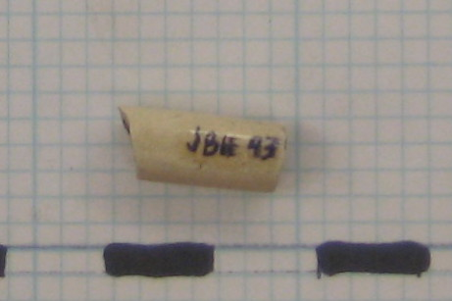

The small pipe stem fragment was uncovered in JBH 43, the first context excavated in Unit 8. The artifact measures 16.2 mm in length and has a diameter of 6.7 mm. The hole in the stem, by which the smoke traveled from the bowl of the pipe to the smokers mouth, has a hole that is 4/64 of an inch in thickness, commonly referred to as a 4. The size of the hole is especially important in dating the artifact with use of the Harrington chart, as a 4 was most commonly in use from 1750-1800. However, a few examples of 4’s have been found from the years 1710- 1750. Typically the shape and style of the tobacco pipe’s bowl is used to most accurately determine a date for the pipe. The evolution of the bowl is easily recognizable in the clear and documented transitions in style and shape from the 17th century through to the 19th century. The English archaeologist, Oswald, was the first to study the bowl’s evolution in 1951. This kind of dating, using stylistic trends, although more accurate, is frequently impossible due to the scarcity of bowls. In general, more pipe stem fragments are found than bowl fragments. Additionally, the correct identification of maker’s marks serves as a third way to accurately date tobacco pipes or fragments.
English Kaolin tobacco pipes were items “manufactured, imported, smoked and thrown away all with in a matter of a year or two” (Hume 296). Although the pipes were cheap and thus used by all economic levels of society, the pipes were extremely durable, as the archaeological record is rich with clay pipe fragments. The prevalence of stem fragments on colonial sites has been attributed to the fact that the stems were long and fragile, and therefore were easily broken into numerous pieces.
The tradition of smoking was begun by the Indians and adopted as a fashionable habit in England around the 1570’s. By the 17th century smoking had become a common practice (Hume 296). The earliest pipes had short stems, 1.75-3.5 inches in length. The length of the stem increased throughout the decades, with some pipes measuring over a foot in length. However, by the 2nd half of the 18th century it was uncommon for a pipe stem to be longer than 9 inches. Additionally, over the years, as the process of making pipes became more refined thinner wires were used to make the hole and thus pipe holes became smaller and smaller. The earliest pipes in America, dating to about 1600 had bores 9/64 of an inch in diameter (Deetz 27). The reduction in diameter of the bore effectively reduced the “amount of matter transmitted through the stem to the smoker’s mouth” (Deetz 28). Decoration of the pipe stem and pipe bowl also went in and out of fashion. Some stems from the archaeological record were decorated. Decorated bowls were common in the 18th century. Less common during this time were glazed or waxed mouth pieces.
After analysis of the pipe stem fragment from JBH43, it is most likely that this diagnostic artifact came from a tobacco pipe that was manufactured and smoked in the second half of the 18th century. This interpretation is based on the Harrington study which states that pipes with a bore hole size of 4/64’’ reached their peak of production between 1750-1800. Since there is no makers mark on the artifact it is difficult to determine the origin of the pipe. The pipe could have been manufactured domestically or imported from England or Holland. Importing tobacco pipes is not unlikely considering the amount of shipping trade undertaken by the inhabitants of Providence and more importantly, the Brown’s, a family of well known merchants. Therefore, the pipe could have been part of a merchant ship’s cargo.
The stem fragment was found on September 21, 2009, the first day of digging. It was discovered in the topsoil of Unit 8, along with wire nail, a tack, a shell fragment, charcoal, some glass, a porcelain sherd, a white ware sherd, and some modern pieces of orange plastic. The range of artifacts from context 43 was interesting to note, as old was seemingly mixed with new (plastic). The nature of the context, including the topsoil, can account for the assortment of artifacts.
The identity of the pipe’s owner is unclear. The various possibilities include the residents of the house, the servants, or any visitors to the John Brown House and yard. The inexpensive nature of the object, along with the fact that smoking was a common habit enjoyed by all levels of society makes determining an owner a difficult and seemingly impossible task.

Laura Sammartino
Works Cited

Pipe Stem:

Deetz, James. In Small Things Forgotten: An Archaeology of Early American Life. New

York: Doubleday, 1996.

Hume, Ivor Noel. A Guide to the Artifacts of Colonial America. Philadelphia: University

of Pennsylvania Press, 1969.

Penny:

“Fact Sheet: Currency and Coins.” US Department of the Treasury. 18 November 2009

<http://ustreas.gov/education/fact-sheets/currency/lincoln-cent.shtml>.

"Lincoln Cents Wheat Ear Reverse." CoinFacts.com - The Internet Encyclopedia of U.S.

Coins. 1 Dec. 2009.

<http://www.coinfacts.com/small_cents/cents_lincoln_wheat_reverse.html>.

“Penny History.” Americans for Common Cents. 1 December 2009.

<http://www.pennies.org/index.php?option=com_frontpage&Itemid=1>.

Porcelain:

Deetz, James. In Small Things Forgotten: An Archaeology of Early American Life. New

York: Doubleday, 1996

"East and West: Chinese Export Porcelain." The Metropolitan Museum of Art, New

York: metmuseum.org. 1 Dec. 2009.

<http://www.metmuseum.org/toah/hd/ewpor/hd_ewpor.htm>.

"FLMNH - Historical Archaeology -Type Index Display." Florida Museum of Natural

History. 10 Dec. 2009.

<http://www.flmnh.ufl.edu/histarch/gallery_types/type_index_display>.

