Marsden Jasael Perry:
A Man of Excessive Taste

ARCH1900: Archaeology of College Hill
12/08/09
Alexander Mittman
Introduction
Marsden Jasael Perry was born on November 2, 1850 in Rehoboth, Massachusetts to an impressive family lineage. One of his ancestors, Richard Perry, was a grantee of the Massachusetts Bay Colony a century before, and Marsden must have noted this fact well. Marsden Perry took great pride in his family’s heritage; his family crest, whether true or mistaken for another’s, takes pride of place on his old player’s piano, “Perry” simply carved beneath it. As the son of a farmer, he did not have many material possessions as a child nor much of an education, having left home at the age of 12 and homeschooled for most of his life before that.
After he had begun to earn his millions, a decade or so later, he developed an obsession for collecting, especially fine Colonial pieces. He owned two Colonial mansions in his lifetime, one at 2 George Street, and the other at 52 Power Street, the property now known as the John Brown House. His other passion was Shakespeare, one he apparently developed while still a child, sneaking a hidden copy of Shakespeare’s Collected Works from his grandmother’s library to read in his bedroom, nights. Years later, his great love fizzled out suddenly when he lost the Devonshire Collection during an auction and was heard to say, “If I can’t have the Devonshires… I will give up collecting. I will not take second place.” It was this fierce competitive spirit that would come to define him and his choices in acquiring his copious collections.
Coming from such a humble background, Perry, as many other nouveaux riches, felt the need to prove himself before the more distinguished millionaires who came from old money. But, for the most part the Providence elite spurned his efforts and in some cases sabotaged his business interests and political power. However, I believe, many of his efforts in collecting – as well as his acquisition of the John Brown House and many of his structural changes to it, including his destruction of the Hale Ives homestead – can be traced to this fundamental desire to impress high society with what he thought of as good taste, more specifically, Georgian, or Colonial taste (the oldest money there is, when discussing America).

A History of the Use of the House
One thing that has stayed fairly consistent through the three centuries that the John Brown House has seen is the use of each room within the house. As stated in Alyssa’s presentation, we believe that the house was used by John Brown, its builder, on the first floor mostly for entertaining, the second for informal guests and the adult bedrooms, and the third for the children.
The Gammells, the late Victorian owners of the JBH, had a similar set-up, as can be deduced from an inventory of all the furnishings in each room of the house made in 1897, five years before Perry moved in. The arrangement of the main house is very simple: four rooms in a square formation, east split from west by a main hallway in the center on each floor. The ell, an addition to the original cubic structure, made by John Brown’s granddaughter, Sarah (Brown) Herreshoff, was enlarged by Elizabeth Amory Ives Gammell and her husband, William Gammell between 1851 and 1875, and a second and third floor added after 1887. It is more complex and haphazard, but not included in the inventory.
The SE room on the first floor is labeled a parlor much like it seemed to be used in John Brown’s time; the list of furnishings includes a music cabinet, a sofa and chairs (valued at $100), and a mirror (much more likely used for its sociocultural value than for any “practical” use; it is the only mirror listed as being in the house). Aside from the mirror, not many potentially decorative items are listed besides carpets in the rooms. The SW room is also labeled “Parlour,” but unlike the other, is filled with at least seven places for sitting ($111 worth of cheaper seats), and a bookcase instead of a mirror. Perhaps the SE parlor was used for dancing during parties (signaled by the mirror and music cabinet), while the SW one was used for more subdued entertainment. The NE room on the first floor (hereafter called 1NE) is labeled on the inventory as “Library.” This was formerly John Brown’s formal dining room. The room is notable as this so-called “library” contains only three bookcases, one “large rosewood bookcase” and two “small walnut bookcases,” coming in at $115 (Marsden Perry, as a noted bibliophile and collector, would have scoffed). 1NW probably served as a dining room in the Gammells' time. It has a cheaper carpet (to avoid costly spills), a dining table and eight “dining chairs.” The “front hall” or first floor hallway contained a $50 velvet carpet (the most expensive in the house), six chairs (worth $100, nearly as much as the chairs in the SW parlor) and two “folding card tables.” These furnishings seem to suggest that the front hall was used for entertaining or some other form of gathering, just as was the parlor.
The east wing of the second floor clearly contained bedrooms (or “chambers” as they must have been called) for the family, perhaps for Elizabeth Ives and her husband, the master bedrooms. They are filled with beds, pillows, and cheap carpeting (apparently not meant to impress, but still worth all together $306 and $367, respectively). The west wing of the second floor is mentioned in the inventory as the “Wing of the House” differentiating it from the east wing for reasons which are unclear. It contained a “Sitting Room” (valued at $60), a “Chamber” (valued at $153), and a “Dressing Room” ($88). This is pure speculation, but the wing could have been for the use of one specific member, separating it from the rest of the house. It could have potentially been for use by Robert Ives Gammell, the son who owned the recently discovered Hale Ives House. The rooms, especially the bedroom, are much less costly (and smaller and more cramped, it seems, as the two rooms, 2NW and 2SW, were separated into three) which would have made sense if he did not use the rooms often.
The third floor contains the most expensively appointed bedroom (3SE) worth $468. It contains a “Child’s Mahogany Bureau” which means it was probably used originally to house the Gammells’ five children before they grew up. 3NW had several bookcases and a music stand (the room, totaling to $239), perhaps used as a nursery or schoolroom. The 3SW is labeled as a “Chamber” but only contains an “Ebony Bedstead” and a mahogany marble-top table. There is actually an explicit reference to this room in an 1889 letter from an “E. Carlile” who mentions, in passing, her memories of visiting “Cousin Anna” in the JBH, probably referring to Sarah Herreshoff’s daughter, Anna Frances Herreshoff, who died almost exactly two years before the letter was written (the Herreshoffs were residents of the house before the Gammells). She fondly recalls staying in the SW “guest chamber” on the 3rd floor. It is safe to assume that the room was used for the same purpose in the Gammells’ time, though it does not seem very welcoming when considering the sparseness that two furnishings would produce in a room that size. The “Main Hall” for the children’s floor was more richly appointed than the hall on the second floor, with chairs and tables, totaling to $80, suggesting once again some other use. One must keep in mind that the Gammells’ children were already grown up by 1897 when the inventory was taken and the third floor hall could have been put to use as another sitting area, however it is interesting, if the floor was not still used for young children, that the bedroom still contained a child’s bureau.
The house’s furnishings, listed all together are valued at $3,953. Increasing the value of the contents is perhaps one of Marsden Perry’s larger changes to the house. He was a collector of the most lavish pieces of Chippendale furniture and had many of the rooms decorated and renovated for outrageous sums of money. The raw property value of the house must have skyrocketed after Marsden Perry bought it. There could have been several reasons for the Gammells’ low valuation of the house: because they were already planning on moving; because they didn’t spend much time in the house; or because they were actually low on funds. If they were planning on moving, they could have already moved their more personal belongings out of the house, leaving the furnishings behind for the next family, or simply did not include the belongings they were planning on taking in their tallying of the property value. It would not be strange if they had considered selling the house, since, after Arthur Gammell’s death, the rest of the family spent most of their time in Newport or Europe and Robert Ives Gammell and his wife had already started living elsewhere on the property since 1876. Also, Elizabeth Gammell had died in April. Another possibility is, because of the document’s official looking nature (Robert and William signed on the last page), that it was a document used for purposes of taxation and they were simply trying to evade paying higher taxes. The possibility that they were not wealthy is not very convincing as the Gammells had done a fair amount of renovating themselves (even less than a decade before).

The Hale Ives House
The house in which Robert and Eliza Gammell lived was the one built in the yard of the JBH sometime between 1832 and 1857. It was knocked down very soon after Perry purchased the property (in 1923) which abuts the JBH. He had bought the land for $100, the same amount as he had bought the property with the JBH on it for. This seems to reinforce the idea that the Gammells had ceased to care about the JBH or else were in dire financial straits, with Perry taking advantage of them. Possibly, there was something more sinister involved, such as blackmail or some sort of deception concerning the preservation of the house. After all, the only change that he announced he would make while in the process of acquiring the JBH – found among these sources – was to install modern plumbing in it. However, this soon proved to be untrue as Perry started making many more major changes to the House and especially to the Hale Ives homestead in its yard.
There is a lot of documentary evidence concerning the chains of ownership of the property on the Charlesfield (northern) side of what is currently known as the John Brown House yard, but most of it has been covered in great detail by last year’s site report. The task of this year’s report is to compare the documentary evidence with the new-found archaeological evidence. As can be seen in Figure 1 below, there is a circle around the area in which the two years’ digs have been excavating to expose the blue, resistant feature that runs along Benefit Street.

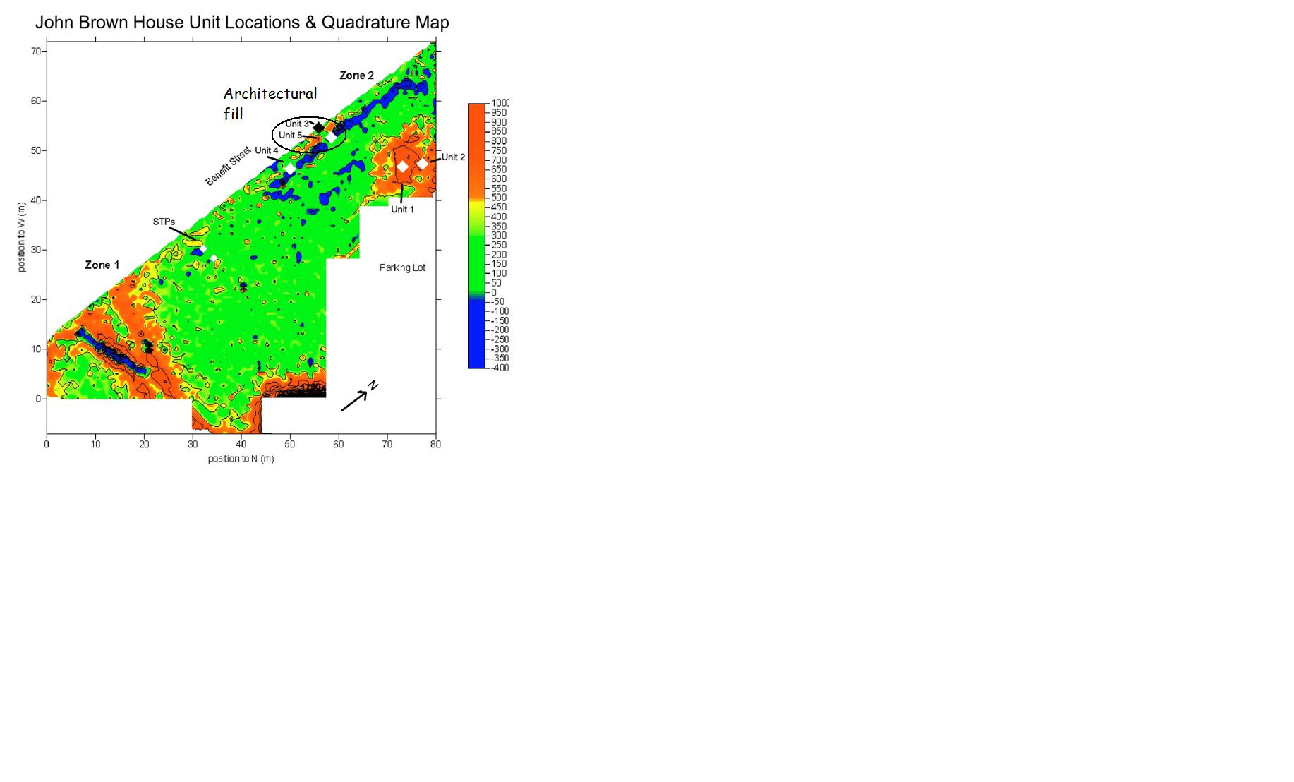
(Figure 1)
The documents would imply that the feature is probably a fill from the demolition or a foundation remaining from when the Hale Ives House was on that same spot. However, as can been seen in Figure 2, a blow-up of a 1875 map of the location (from last year’s report), though the house is in line with Benefit Street on a NW-SE line (as is the feature), there should be considerably more house/remains of the house in Zone 2, completing the outline of the house at least.
(Figure 2)
This could be because the foundation was disturbed when the parking lot was put in, marked clearly in Figure 1, or the geophysical analysis could have been interrupted by the presence of so much accumulated asphalt. If the feature was simply architectural fill (which is what some of contexts seem to be), the buried remains of the demolition, then surely there would have to be more length to the original deposit or else greater depth of deposition (both of which do not seem to exist, unless the architectural fill is deeper in the sections we haven’t dug yet).
Some other inconsistencies remain. Last year’s dig identified four contexts (spread over two layers) excavating over what should have only had two contexts if it is to be consistent with the contexts that were declared over the feature during this year’s dig. This could easily be explained by guessing that the threshold for declaring a new soil change was higher this year. All the contexts declared in both years seem to have various important characteristics in common, however: yellowy soil color, gravel inclusions, and, as the soil approaches the feature, mortar.
The reason for Perry’s destruction, however archaeologically mysterious, is more complicated. It appears to go back to his need once again to impress the older moneyed classes. A house built at least fifty years after the Colonial period – especially one in the yard of the “the most magnificent and elegant private mansion that [Adams had] ever seen on this continent” (as John Quincy Adams once said) – must have paled in comparison, at least in its reputation, no matter how fine or how much bigger the Hale Ives House was (compare Figure 3 [JBH] with Figure 2 from the same plat map).

(Figure 3)

Perry’s Use of the House
Perry had made the most drastic change to the Hale Ives House one could, but did not seem to change many of the uses of the rooms in the JBH. While it is hard to say when Perry decided to change the uses of the rooms he did, it is certainly possible to assign uses to them. 1SE was still probably used as the formal parlor, but 1SW is harder to determine. Possibly it was still used for entertaining, but it is difficult to determine these kinds of things without the amount of detail that the inventory of the house from 1897 gives. Some of the only indications of room uses come from notes made by builders and contractors working on the house and the only notes extant seem to be ones from renovations after 1920. This can sometimes frustrate efforts like these. 1NE was again changed in its use, from dining room (in John Brown’s time) to library to “music room,” shown with the player piano in this photograph from the period (Figure 4).
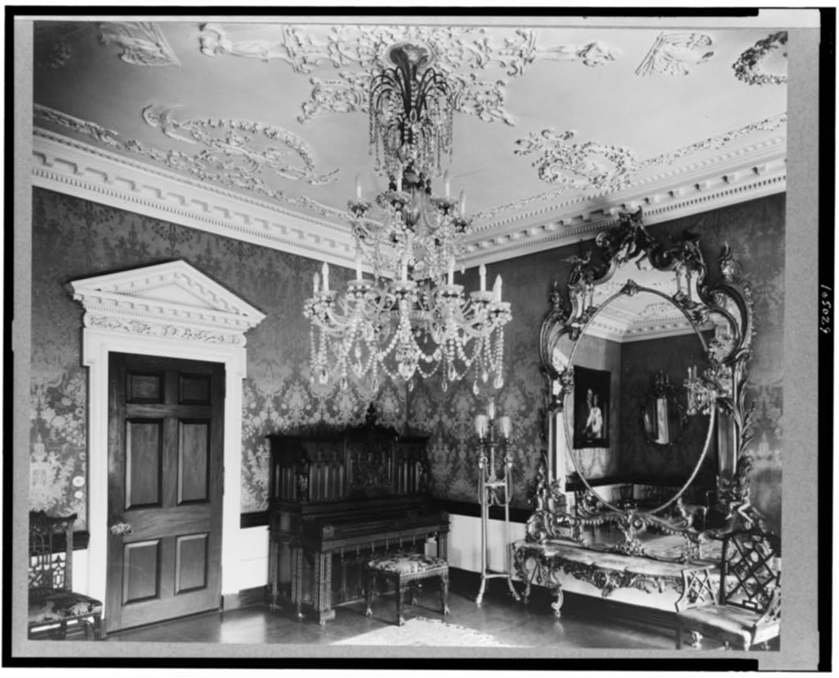
(Figure 4; (Johnston)
The higher value of the furnishings must be apparent even from a cursory glance. Note also that the plaster ceiling decorations are contemporaneous.
1NW was probably the dining room, since the kitchen was still adjacent to this room, in the ell, and a butler’s pantry (built to house Perry’s fine porcelains; also worth noting is that John Brown collected china as well) was put in where the west door used to be. The front hall was probably not used for entertaining like it was in the Gammells’ time. This can be seen in a picture taken at some indeterminate time, but probably before John Nicolas Brown bought the house and took down the Spanish leather wall-hangings. There are no chairs or even end-tables in it; it is disconcertingly empty. But to be truly critical, we must assume that the furniture was taken out of the hall for the picture, perhaps to document the wall-hangings before they were taken down.
The second floor is more mysterious in its usage. 2NW can be fairly definitively named as Perry’s bedroom, whereas the whole west wing in the Gammell house was ill-defined. 2SW, which was connected by an arched passageway to 2NW, might have still been a sitting room. There is, however, an undated “plan of alterations” for the second floor drawn up by Stone, Carpenter and Willson that labels all the main rooms as “Chambers.” It also shows a small walled-off space in between 2NW and 2SW which could have been the third room in the west wing that the Gammells seem to have made. In Perry’s time it consisted of two “Passages” and two closets opening off of one of them. The servants’ quarters are also on this floor and differentiated from the “Chambers” by being called “Bed Rooms.” They seem fairly well-appointed however, each having its own closet and a bathroom shared among them, only a little smaller than one of Perry’s bathrooms on the same floor.
3SE’s use seems to have stayed consistent. It is once again labeled as a bedchamber, possibly for children, though the Perrys seemed only to have one child, Marsden Perry Jr. who is not often mentioned. The rest of the rooms are unlabeled.

Perry’s Move
There are two really clear periods of renovations and changes to the house. When Perry first moved in, he installed plumbing and electricity, but accompanying these necessaries were several more major, but also seemingly “unnecessary” changes. He appeared to stay true to the house’s Colonial past (more than the Gammells had at least, who made some minor changes, like adding delft tiles to the mantel in the formal parlor), while, at the same time, moving towards a forced composition of styles. It appears that he wanted both access to his Colonial past, as well as a more Classical (Western) past, trying to tap into these two reserves of cultural power to demonstrate his unconvincing sophistication and legitimize his newly earned money.
The order and importance of renovations are once again hard to determine, as the records of this set of renovations are scarce, but, if we assume that all the renovations that did not occur in the 20’s occurred in the 00’s, then we can generate a short list.
It must have been around this time (the 00’s) that the marble started to be put in. The driveway was coated with marble and a marble electrical panel was put into the new basement. The entire exterior was covered with marble, obscuring the original façade of brick imported from England, because of its rarity in the colonies., A marble mantel facing (actually consistent with an original marble fireplace elsewhere) is still in the formal parlor (1SE).
Perry also had the rest of a half-finished cellar dug out, even though at one point he needed to reinforce the brownstone in the portico from below with steel beams, taken out by the RIHS in 1990. He put a wine cellar and a Shakespeare library in his new basement, complete with three windows to the outside, fire-proof vaults and a reading room with elaborate brickwork archways with tile ceilings. The question must be asked however, “What were the chances that someone would even actually see his reading room tucked away in the basement, supposedly used for his own intellectual edification and the reading of his private Shakespeare collection?” This seems to be an example of the slightly egotistical nature of Perry’s renovations, his need to prove himself through his large expenditures.
He had the west door that seemed so unusual and so characteristic of the JBH in particular, bricked over, and added the entrance hallway to 1NW. He moved the laundry room to the carriage house he had built kitty corner to the property. He added multiple modern bathrooms with lavish tile decorations and at least one fashionable ribcage shower of the kind that Mott Iron Works used to make. Interestingly enough, Perry (or his executors) seems to have picked a similar design to one that was found in a Mott catalogue for the tiles and tub in one of the bathrooms (the pattern was on a $200 porcelain bathtub) (Figure 4 shows a picture of the tiles).
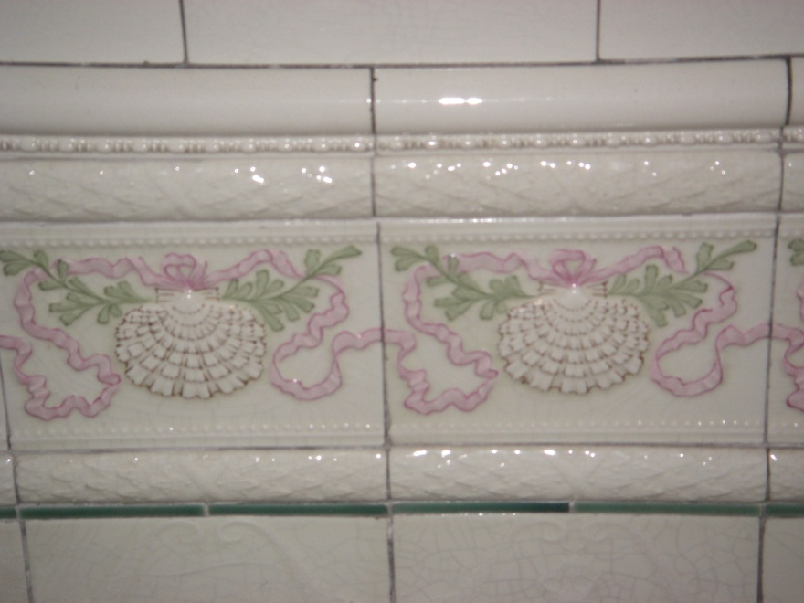
(Figure 4)
Perry’s Late Renovations
The original campaign of renovations in the 1920’s seemed to be geared towards repairing many of the things he had installed in the 1900’s, but it soon snowballed into another round of questionable additions.
A marble pergola (or colonnade) was put into the yard near the ell in 1923 and a marble balustrade next to that with marble running along the brick path. He replaced the brick in the laundry area of his carriage house with brownstone ashlar blocks. He added steps and railings to the western doorway which had been bricked over, perhaps after having realized its interest. The refrigerator he had installed in 1902 was taken to at least three contractors in 1925 before one agreed to add another food compartment to it., This seems to demonstrate a certain element of stubbornness in the character of his renovations as well.
Around this time, Perry had the infamous Spanish hand-tooled leather wall panels with gilt detailing installed in the main hallways on every floor. The panels are very reminiscent of the wall paintings found at Pompeii, with Classical scenes, framed by pillar motifs, bunches of grapes and other natural signs in the Roman style. Though many of his renovations were fairly consistent with the Colonial or Revival styles, these panels seem much more Neo-Classical in their nature. He also had much of the original, slightly loud wallpaper taken down and whitewashed the walls (although he is quoted as saying that he bought 2 George Street for its old, Colonial wallpaper)., This seems very Neo-Classical as well, and part of a campaign of marbling, whitewashing and ivory detailing, all common misconceptions about the “whiteness” of Roman design. As can be seen at sites like Pompeii, Rome was actually a very colorful place.
He made some changes to the landscape around the house as well. He was the first to put in the herring-bone bricks and flagstones around the house, and probably the wall and fence that still surround the house as well (though interestingly enough there is no record of precisely what these things were walling off; after all, there is evidence of an iron fence on the geophysical survey near the Hale Ives House, though why precisely Perry, rather than the Gammells, say, would have built a fence there is unclear).

Concluding Remarks
Perry was certainly an interesting person, if nothing else. To understand the character of these renovations, we must keep in mind his aspirations of upward mobility, his desperate desire for a cultural heritage and his waning political and economic power. After the financial panic of 1907, “Marsden Perry’s active and productive years ended… he was never to regain the power he once commanded.” The years when he and his business partners had owned a senator in the Steering Committee were long gone. These factors could have lent more stake to his other motives and strengthened his drive to achieve the ideal he held of cultural sophistication. In the end, his marks still remain on the house, despite the RIHS’ best efforts, and that’s the way, I think, he would have liked it.

Works Cited
[Front Hall of the JBH with Leather Wall-Hangings Still Up] (at RIHS Library), [Unknown].
[Letter from E. Carlile to Francis Family] (at the RIHS Library), 1889.
"[The Bigges]t Private Shakespeare Collection in the World (from JBH Archive)." The Providence Journal, 1902.
[Unknown]. [Deed of Ownership from Harriet Shaw Safe to Marsden Perry] (from JBH Archive).
[various Stages of Occupation at the Property at 52 Power Street] (from JBH Archive).
Aldrich, Lucy T. [Special Committee Report Considering the Possibility of Acquiring the JBH to use as Headquarters for the RIHS] (at the RIHS Library), 1941.
Antoinette Downing (?). [Notes Fr. A. Downing's Old Files] (from JBH Archive), 1979 (unpublished).
Blanchard, Eugene V., et al. Brown University Honors Theses, 1964, 1964.
Blanck, Carole. "The Family that Lived in the Mansion on the Hill (at RIHS Library)." [unpublished].
Broadhurst, Raymond. Marsden J. Perry and Others (Manuscript at RIHS Library).
Cutter, William Richard. New England Families, Genealogical and Memorial. Vol. 1. New York: Lewis Historical Publishing Company, 1914.
Deetz, James. In Small Things Forgotten: An Archaeology of Early American Life. New York: Anchor, 1996.
Downing, Antoinette F. et al. [JBH Binders] (at RIHS Library).
Gammell, Elizabeth Amory Ives. [Last Will and Testament] (at RIHS Library), 1897.
Gammell, Robert Ives, and William Gammell. [Inventory of the JBH] (at the RIHS Library), 1897.
"History, Reminiscences, Description of Marsden Perry's New House (from JBH Archive)." The Providence Journal, 1901.
Ives, Robert Hale. [Robert Hale Ives' Last Will and Testament] (from Brown University Library), 1875.
"J.L. Mott Iron Works - Wikipedia, the free encyclopedia." 7/17/2009, 2009. <http://en.wikipedia.org/wiki/J._L._Mott_Iron_Works>.
"John Brown House (Providence, Rhode Island) - Wikipedia, the free encyclopedia." 11/7/2009, 2009. <http://en.wikipedia.org/wiki/John_Brown_House_(Providence,_Rhode_Island)>.
Johnston, Francis Benjamin. [Marsden J. Perry Home, Providence, RI. Interior Scene, Detail of Piano, Crystal Chandelier, Mirror, and Door], [between 1924-1950].
Lockwood, Luke Vincent. "Colonial Furniture in America." 8/19/2009, 2009. <http://chestofbooks.com/home-improvement/furniture/Colonial-Furniture-America/The-Period-Of-The-Cabinet-Makers-1750-1840-Part-7.html>.
"Marsden Jaseal [sic] Perry." 2004. <http://www.redwoodlibrary.org/notables/perry.htm>.
McManaway, James G. "Marsden Jasael Perry." Grolier 75. Ed. Alexander Davidson et al. New York: The Grolier Club, 1959, 61.
Mott Iron Works' Catalogue 'R' (from JBH Archive), 1897.
Perry, Amos. The Town Records of Rhode Island: A Report, Volume 7. Ed. J. Franklin Jameson and Amasa M. Eaton.
Providence Journal. "Tuesday, October 8, 1901 Famous Mansion Bought by Marsden J. Perry." <http://proteus.brown.edu/archaeologyofcollegehill/admin/download.html?attachid=4490244>.
Providence Recorder of Deeds Office. [Chains of Ownership Relating to the John Brown House (Plat 16, Lot 530) and the Hale Ives House (Plat 16, Lot 150)].
Ryzewski, Krysta, 2008 Class of Archaeology of College Hill and Brad Sekedat. "John Brown House Archaeological Report." Brown University, 2008. 12/03/2009.
Santos, Dan. . Ed. Alex Mittman.
Stone, Alfred E., and Carpenter, Edmund R. et al. [Stone, Carpenter and Sheldon Papers] (at RIHS Library).
Stone, Carpenter, and Willson. [Plans of Alterations to Mansion on Power Street, Providence, RI for Marsden Perry, Esq.], [undated].
"Vintage Plumbing Bathroom Antiques - The J.L. Mott Iron Works." 2009. <http://www.vintageplumbing.com/thejlmottironworks.html>.
Weidner, Ruth Irwin. [Letter Concerning the Relationship between Marsden Perry's Bathroom Tiles and Mott Iron Works]. Ed. Lawrence Bacon, 199

Marsden Jaseal [sic] Perry, 2004, 11/29/2009 <http://www.redwoodlibrary.org/notables/perry.htm>.
James G. McManaway, "Marsden Jasael Perry," Grolier 75, ed. Alexander e. a. Davidson (New York: The Grolier Club, 1959) p. 61.
ibid.
Dan Santos, ed. Alex Mittman.
Raymond Broadhurst, Marsden J. Perry and others (manuscript at RIHS Library).
Marsden Jaseal [sic] Perry
See Eugene V. Blanchard, et al, Brown University honors theses, 1964, 1964).
Robert Ives Gammell and William Gammell, [Inventory of the JBH] (at the RIHS library), 1897).
Carole Blanck, "The Family That Lived in the Mansion on the Hill (at RIHS Library)," [unpublished].
See Deetz, James, In Small Things Forgotten: an archaeology of early American life. New York: Anchor, 1996.
William Richard Cutter, New England families, genealogical and memorial (New York: Lewis Historical Publishing Company, 1914).
Tuesday, October 8, 1901 Famous Mansion Bought by Marsden J. Perry, 11/13 2009 <http://proteus.brown.edu/archaeologyofcollegehill/admin/download.html?attachid=4490244>.
Elizabeth Amory Ives Gammell, [Last Will and Testament] (at RIHS library), 1897).
Krysta Ryzewski, 2008 Class of Archaeology of College Hill, and Brad Sekedat, "John Brown House Archaeological Report," Brown University, 2008.
Tuesday, October 8, 1901 Famous Mansion Bought by Marsden J. Perry, 11/13 2009 <http://proteus.brown.edu/archaeologyofcollegehill/admin/download.html?attachid=4490244>.
quoted in
Although the source said that the picture was taken between 1900 and 1950, this seems very unlikely. Perry did not formally gain ownership of the house until 1902 (Providence Recorder of Deeds Office, [Chains of Ownership relating to the John Brown House (Plat 16, Lot 530) and the Hale Ives House (Plat 16, Lot 150)].) and did not put plaster ceilings in the music room until 1924 (Alfred E. Stone and Carpenter, Edmund R. et al., [Stone, Carpenter and Sheldon Papers] (at RIHS library).).
Antoinette Downing (?), [Notes fr. A. Downing's old files] (from JBH archive), 1979 (unpublished).
[Front hall of the JBH with leather wall-hangings still up] (at RIHS library), [Unknown].
Antoinette Downing (?), [Notes fr. A. Downing's old files] (from JBH archive), 1979 (unpublished).
Carpenter Stone and Willson, [Plans of alterations to mansion on Power Street, Providence, RI for Marsden Perry, Esq.], [undated].
ibid.
Antoinette Downing (?), [Notes fr. A. Downing's old files] (from JBH archive), 1979 (unpublished).
ibid.
Santos
Tuesday, October 8, 1901 Famous Mansion Bought by Marsden J. Perry , 11/13 2009 <http://proteus.brown.edu/archaeologyofcollegehill/admin/download.html?attachid=4490244>.
Antoinette Downing (?), [Notes fr. A. Downing's old files] (from JBH archive), 1979 (unpublished).
ibid.
Vintage Plumbing Bathroom Antiques - The J.L. Mott Iron Works, 2009, 11/29 2009 <http://www.vintageplumbing.com/thejlmottironworks.html>.
Mott Iron Works' Catalogue 'R' (from JBH archive), 1897).
Antoinette Downing (?), [Notes fr. A. Downing's old files] (from JBH archive), 1979 (unpublished).
Stone and Carpenter, Edmund R. et al.
Antoinette Downing (?), [Notes fr. A. Downing's old files] (from JBH archive), 1979 (unpublished).
"[The Bigges]t Private Shakespeare Collection in the World (from JBH archive)," The Providence Journal 1902.
Antoinette Downing (?), [Notes fr. A. Downing's old files] (from JBH archive), 1979 (unpublished)).
Blanchard, et al, p. 69.
Lincoln Steffens, "Rhode Island: A State for Sale," McClure's Magazine 1905.

