White-ware Sherd | Pipe Saddle | Pendant
White-ware Sherd with Green Transfer-Printing
As can be seen in the picture below, this is a sherd of so-called “whiteware” ceramic, recognizable by its paper-white appearance where glazed.
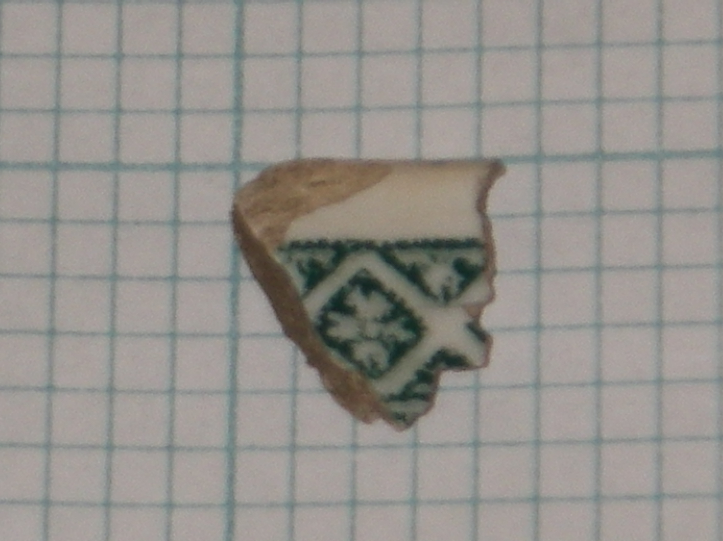
The term is controversial among archaeologists as it is very difficult to distinguish the slight differences in the glazes of the major types of refined earthenware. Creamware, first invented by Josiah Wedgwood in 1750, is said to have a yellowish, creamy glaze, while pearlware is to be recognized by its bluish tint. The sherd here could be identified as whiteware, although what was referred to as creamware was approaching this same color by the 1820’s.
What truly dates this sherd is its transfer-printed design, not its glaze nor its fabric. Color transfer-printing’s origin is disputed. The Battersea factory, the Worchester factory and the firm of Sadler and Green in Liverpool all claim to have invented it some time around 1750. Soon after its invention, Wedgwood caught on and began making transfer-printed creamwares, sending them to be colored in Liverpool. Many of the patterns from the early period of transfer-printing imitated Chinese porcelain designs and were almost always printed in blue to imitate the Chinese color scheme. It wasn’t until the early nineteenth century that other colors and patterns became popular. By the middle of the nineteenth century, however, the transfer-printing industry entered a decadent phase in which multi-colored and complicated patterns seemed to explode out onto the new transferwares, covering every conceivable blank space with floral vignettes and complex landscapes.
This dates the current sherd under discussion most likely to sometime after the blue phase in the late eighteenth century and before the excess of the late Victorians in the latter half of the nineteenth century.
The sherd is clearly from a rim, and as such one might have a hard time figuring out what the main or central decoration was. Chinese-influenced wares often had rims with four-petaled semi-geometric patterns like the one featured on this sherd. Chinese-inspired pattern sets were produced in Britain from 1783 until 1834, and “Orientalized” British scenes (or Chinoiserie) were produced from 1783 to 1873. Repeating geometric patterns on rims in general (a more sure diagnostic feature) were produced primarily from 1784 until 1864.
Transfer-printing, once again, may be used to date the sherd more specifically, though with a few small problems. Green transfer-printing was done on whitewares between 1829 and 1850, which seems to fit with our original hypothesis. However, Chinese-style transfer-prints on whitewares and pearlwares were more common before about 1815. This seems to be a contradiction, but we can certainly imagine a throwback, or cheaper nostalgia piece being produced 15 to 35 years after the style had gone out of fashion. Another problem with dating this object is the fact that the rim seems to be unmolded (neither scalloped nor impressed), whereas scalloped rims with an impressed bud (shown below with green decoration) were put onto many bowls, plates, trays etc. produced between 1813 and 1834. Also, embossed (popular 1823-1835) or impressed rims (1841-1857) were both popular styles. Of course, that does not rule out the possibility of an unshaped rim, but it leaves a few questions anyway.
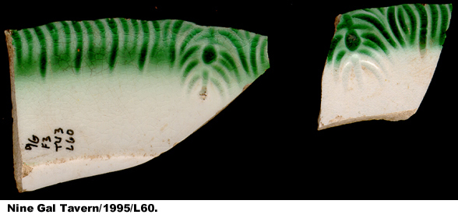
The original object could have been a cheaper model certainly, but why then was it printed in green which at the time was so trendy and popular? Could the whole thing have been a completely passe exercise, a way to use up a factory’s extra green ink and sell an underdecorated ware with an unshaped rim, an style which would have been both popular in the later half of the century and less pricy to manufacture? Or simply the common sort of anomaly?

Pipe Saddle
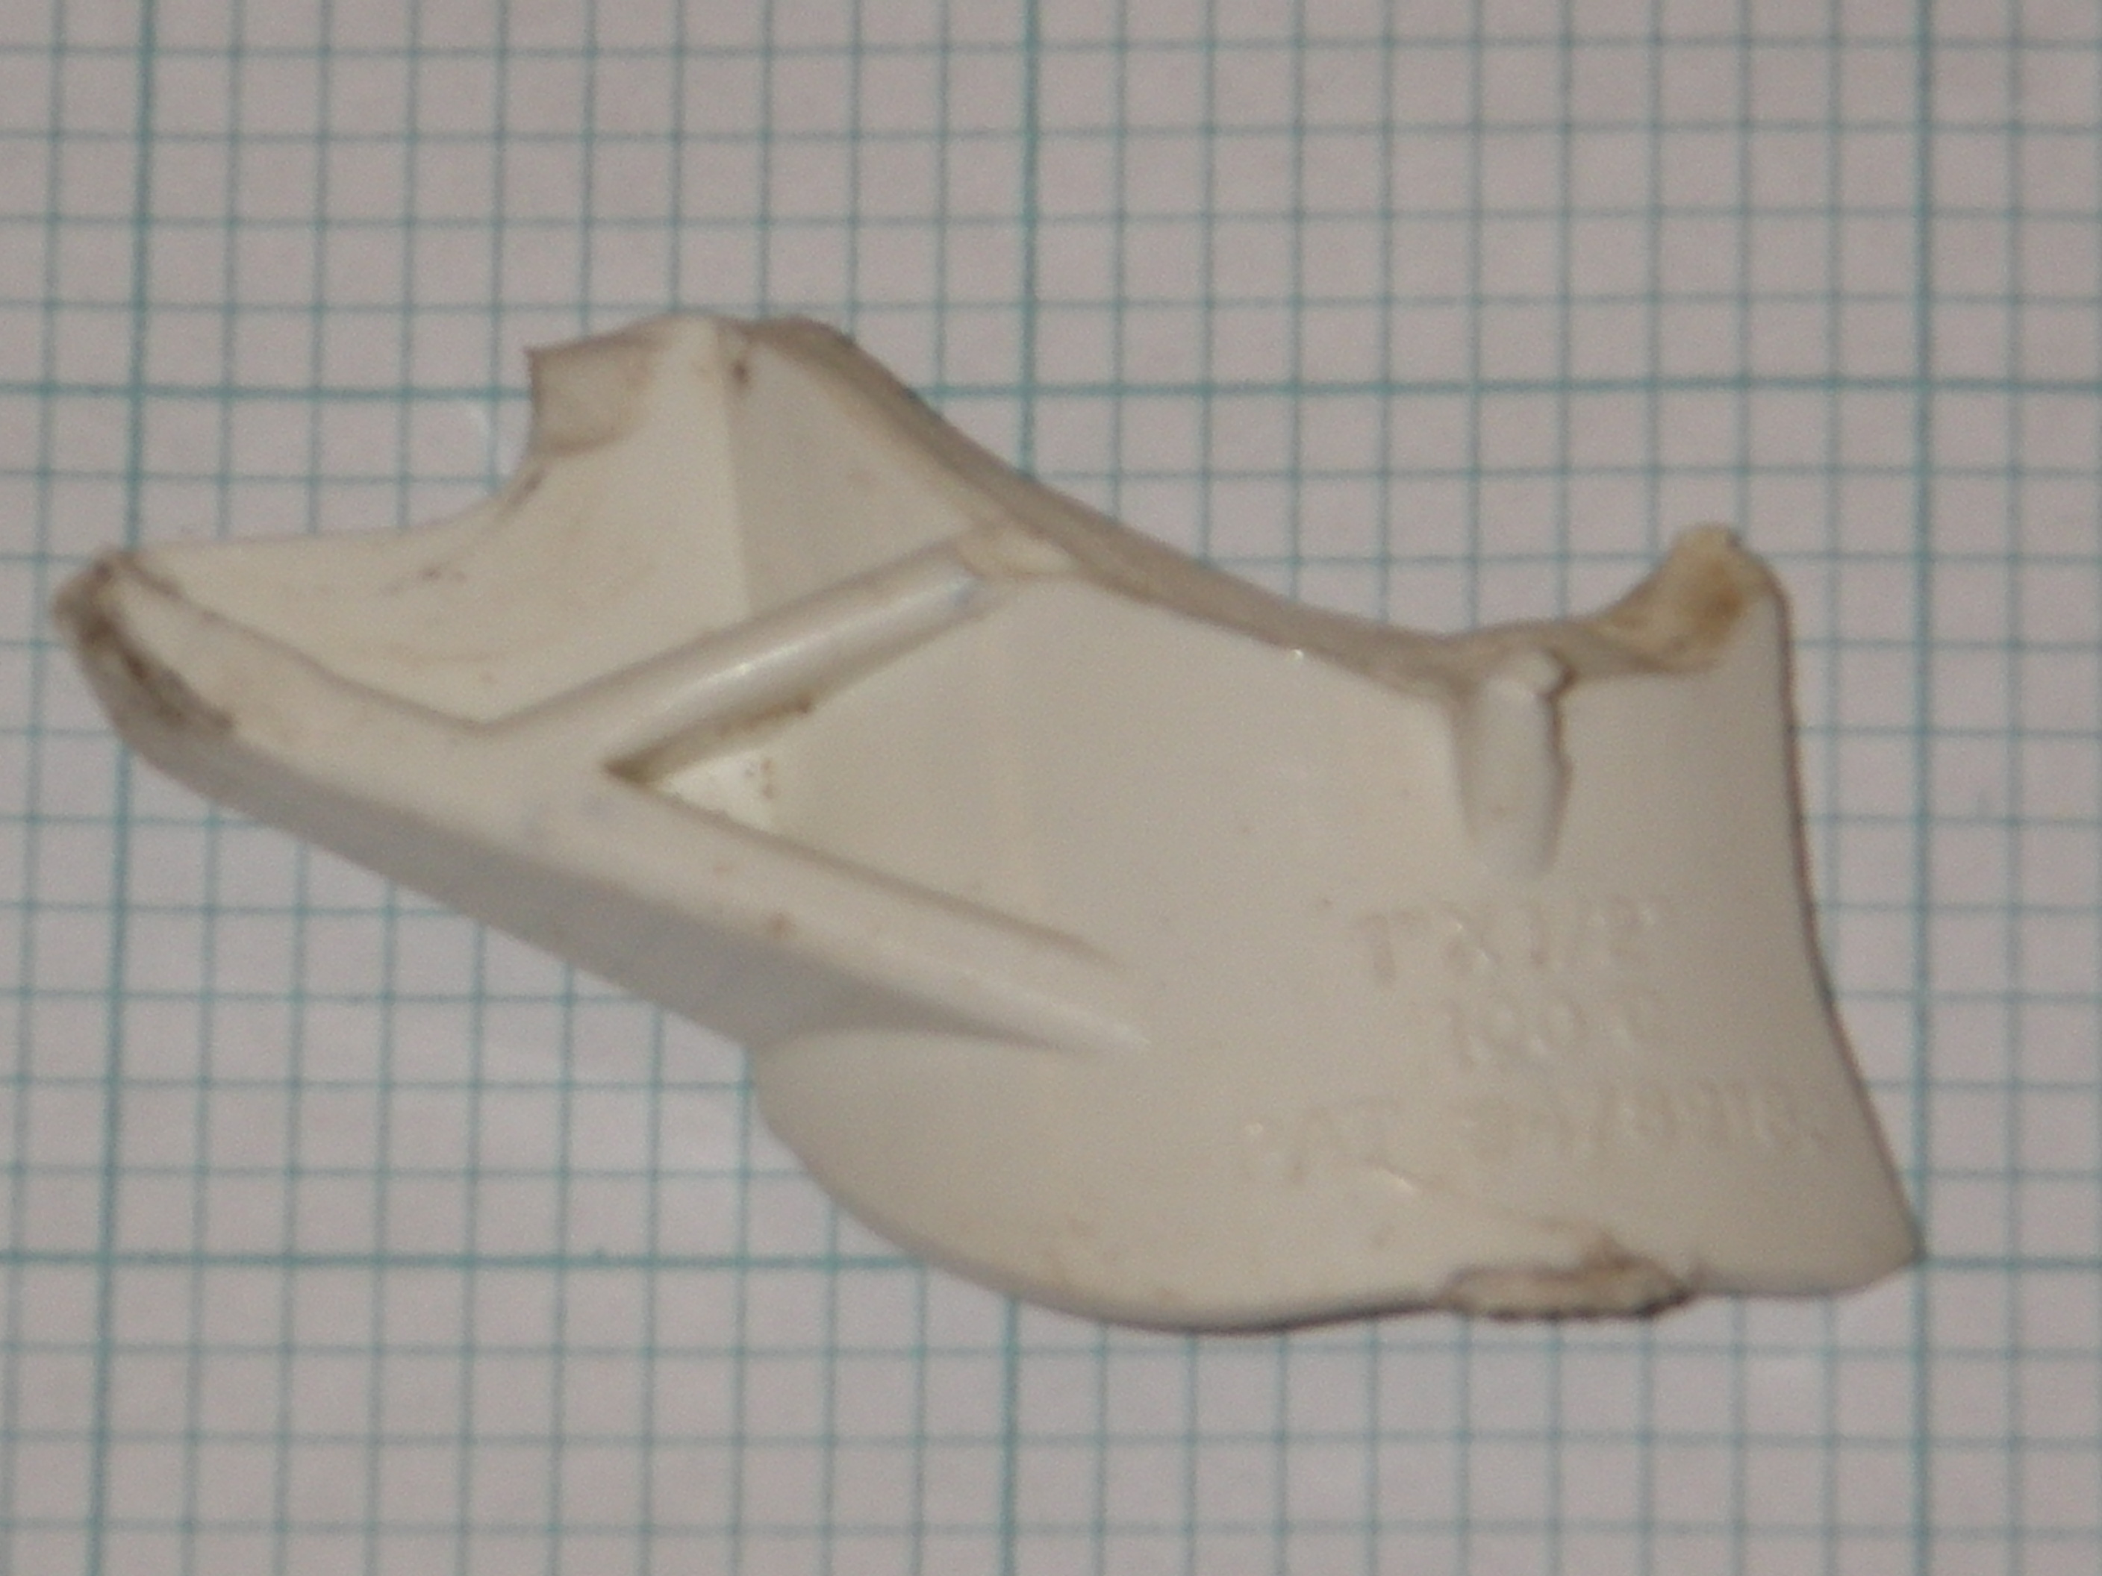
This object was clearly factory-made. The fabric of the plastic where it is broken has waves in it from being poured into a mold and the intentional surfaces are perfectly smooth. This was perhaps the easiest object to identify, not as soon as it was first pulled out of the ground, but as soon as Google Patents could be accessed. As can be seen above, there is relief text in the plastic to the right of the ribs, reading:

1”x1/2”
100C
PAT #4789189
The patent number refers to something known as a “Pipe saddle” which is apparently used to prevent leakage at the junction of two pipes, via a barb seal inside the pipe. This is clearly a fragment of one and may have been discarded by a plumber or gardener after it had fractured and become useless. Or else, some sort of animal could have caused the damage after the saddle had been installed in the underground sprinkler system. The “100C” most likely refers to the maximum temperature the saddle can withstand while covering a pipe, but in that case it is unclear why the degree sign would be omitted in the embossment.
It was hard to determine what was meant by “1”x1/2”” as that set of measurements did not especially describe any dimensions of the pipe saddle fragment. This could be due to the fact that a large amount of it is missing. As can be seen on the patent diagrams, the barb seal is not actually attached to this piece of the saddle, but also, the factory-made model has a cross-piece along the brace that the patent does not include. This kind of discrepancy sometimes occurs between a given prototype or original diagram and the final working product, especially when the piece is not the precise innovation itself (rather the barb seal is).
The fact of the embossed patent number at the bottom seems to establish a terminus post quem of 1988, the year that the patent was granted, as any models of this pipe saddle made before this date would not have been made on machines nor would they have a patent number embossed on them. However, the possibilities for contamination are troubling. If an animal such as a woodchuck were to have broken the original pipe saddle elsewhere on the property and buried the piece here in JBH43, 1988 becomes a completely arbitrary TPQ for the context. In fact, the unusual situation in Unit 8 could explain its deposition without serious problem. The possibility that the fill above the gravel feature which was covered by a tarp was backfill from other parts of the property or someplace nearby seems to explain its discovery in dirt that does not have a pipe system running through it.

Star Pendant
This object is badly corroded, and likely made of brass. It is in the shape of a star pendant. Because of its small size (approx. 16 mm or 7/10 of an inch lengthwise), it was probably used as a “charm” on a bracelet.
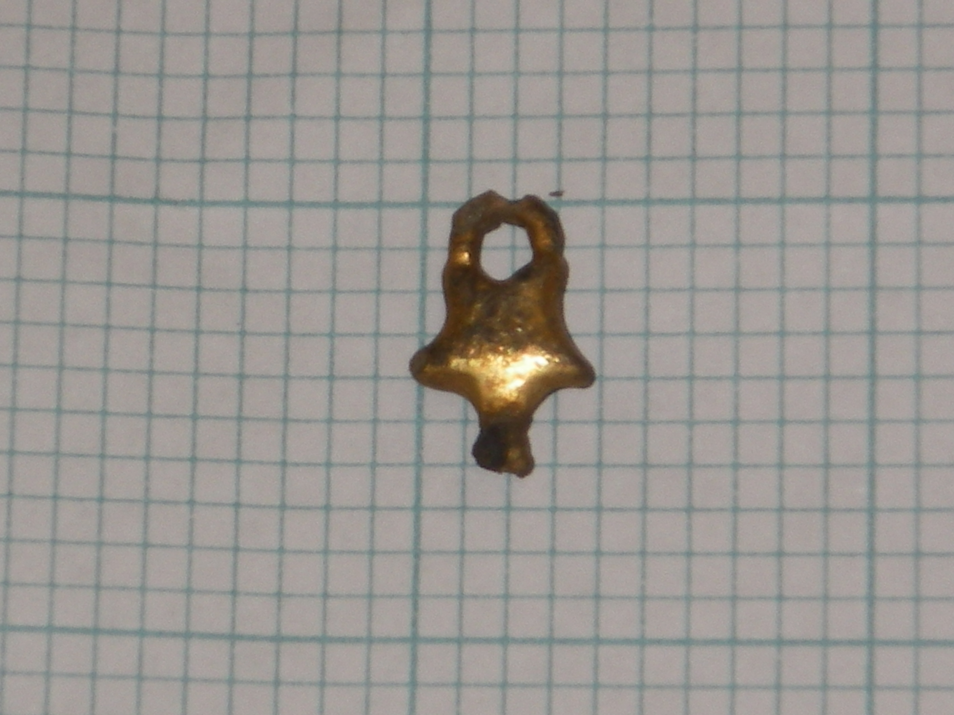
This object brings up a few issues: first of all, who manufactured this utilitarian decoration and how can an archaeologist working contemporaneously (or relatively so) find the company, second, what caused the object to be disposed of, and lastly, how badly damaged was the object, before or after its deposition, until its excavation?
The corrosion certainly post-dates the deposition, as the owner would not have worn this outside their residence if it was so badly damaged. They would have thrown it out, since most of its decorative value has been destroyed by the damage (at least by contemporary standards). As it wouldn’t have left one’s home and no one lives in the JBH anymore or disposes of their household trash in its yard, it may be safely assumed that it was an accidental or else an unplanned disposal.
There is also the question of how exactly then was the bottom damaged and when it was. As can be seen above, there are two nubs at the bottom of the object where clearly something has been broken off. If the object was damaged before its disposal, it could be that the owner threw it out immediately after its fracture while he or she happened to be in the yard for some other reason. The possibility that the bottom snapped on its own without its owner noticing and dropped onto the ground unseen is unlikely, as the pendant seems not to have been corroded or weakened in any discernable way before its deposition, though the bottom could have been the anchor point to the bracelet or necklace (and snapped by accident) and the top loop only decorative (the star would then be right-side-up when worn). Both of them at once could have been loops for the string of a bracelet to allow the charm to sit flush against the wrist. Without the whole object it is hard to tell.
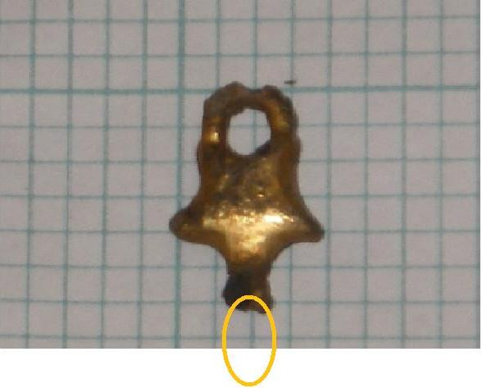
The bottom piece (with a possible reconstruction above) must have become detached while it was in the ground, apparently from corrosive damage similar to that which has severely damaged the ring on the top. The question becomes then (if the bottom was almost as thick as the top and the top was not eaten away into nothing) why was the bottom not excavated from some location near the rest of the charm. The thickness of the bottom part was 3.4 mm before it branches off out where the missing piece was. If we were using a ¼” (6mm) mesh to sift, it could possibly have fallen through the mesh, though closer analysis of the angle of curvature and thickness of the possible bottom piece seems to discourage that hypothesis. The iterations of human error are of course infinite as well; it could have been swept out of the unit, overlooked, or not picked out of the sifter before the dirt was dumped out onto the backfill. Some sort of dislocation in the ground after deposition and corrosion is also a possibility.
To determine how great a possibility, some analysis of the corrosion itself also seems necessary. As the corroded dime, found in the context (dating to 2001) was not nearly as compromised as the charm (and dimes are primarily made of copper, which tarnishes in a similar way to brass), we can assume that the nickel in the dime prevented anything more than the tarnishing effect that typically affects copper (and is sometimes quite desirable for collectors). No dezincification (in which the zinc in the brass is separated from the alloy) appears to have occurred in the pendant, as there is no trademark red tint. This means that the zinc content of the pendant must be below at least 15%, whereas a higher zinc content is often used to prevent corrosion in brass. General attack corrosion (tarnishing) seems to have covered most of the body and the joints and angles at the edges of the object seem to have succumbed to crevice corrosion which works faster and occurs when moisture pools in more vulnerable areas. The lack of aeration seems to preclude this much corrosion but oxidizing materials and other reactants could have been present in the soil. Galvanic corrosion could have caused the accelerated corrosion as well (in which the alloy acts like a battery because of a difference in the two metals’ electrical resistance).
The bottom piece’s disengagement could have also been caused by a common form of stress-corrosion cracking (specifically referred to as season cracking in brass) in which alloys with a higher copper content react with ammonia to form a cuprammonium ion which is water-soluble and dissolves out of the alloy. Thus cracks begin to form in the metal and further stress from other corrosion could have caused the two pieces to disconnect.
As for the artifact’s manufacturer, it is hard to ascertain. The variety of brass used in its manufacture is likely tombac (or rich low brass) which is around 15% zinc and is frequently used in decorative applications due to its ease of manipulation and low expense., But, what the original piece may have looked like is anyone’s guess. It could have been a charm bracelet, part of a necklace, a brooch or even a ring. The fact that we don’t have even an entire piece of the original decorative object makes it hard to discern or even eliminate possibilities. We can only know for sure that it was not practical in its use because of its small size and unusual shape, but in the end, that isn’t a very satisfying answer.

Works Cited

"Brass - Wikipedia, the free encyclopedia." 12/9/09 2009. <http://en.wikipedia.org/wiki/Brass#Brass_types>.
"Brass corrosion." <http://corrosion-doctors.org/MatSelect/corrbrass.htm>.
Coysh, A. M., and K. Henrywood. The Dictionary of Blue and White Printed Pottery 1780 - 1880: Volume I. Suffolk, England: Antique Collector's Club, 1982.
"Diagnostic Artifacts in Maryland: Printed Underglaze Earthenware." 3/1/2009 2009. <http://www.jefpat.org/diagnostic/Post-Colonial%20Ceramics/Printed%20Earthenwares/Printed%20Earthenwares-main.htm>.
"Dime (United States coin) - Wikipedia, the free encyclopedia." 12/1/2009 2009. <http://en.wikipedia.org/wiki/Dime_(United_States_coin)>.
"Eight forms of corrosion." <http://www.corrosion-doctors.org/Corrosion-History/Eight.htm>.
"FLMNH - Historical Archaeology - Type Index Display (Pearlware, Transfer-Printed)." <http://www.flmnh.ufl.edu/histarch/gallery_types/type_index_display.asp?type_name=PEARLWARE, TRANSFER PRINTED>.
Lewis, Griselda. A Collector's History of English Pottery. Suffolk, England: Antique Collectors' Club, 1987.
Robertson, Duane D. Pipe Saddle. Patent 4789189. 12/6/1988.
"Season cracking - Wikipedia, the free encyclopedia." 10/19/2009 2009. <http://en.wikipedia.org/wiki/Season_cracking>.
Stelle, Lenville J. et al. "An Archaeological Guide to Historic Artifacts of the Upper Sangamon Basin, Central Illinois, U.S.A." 05/31/2007 2007. <http://virtual.parkland.edu/lstelle1/len/archguide/documents/arcguide.htm>.
"Tombac - Wikipedia, the free encyclopedia." 11/7/09 2009. <http://en.wikipedia.org/wiki/Tombac>.

Griselda Lewis, A Collector's History of English Pottery (Suffolk, England: Antique Collectors' Club, 1987).
Cf. A. M. Coysh and K. Henrywood, The Dictionary of Blue and White Printed Pottery 1780 - 1880: Volume I (Suffolk, England: Antique Collector's Club, 1982), especially p. 218.
Diagnostic Artifacts in Maryland: Printed Underglaze Earthenware, 3/1/2009, 11/23/09 <http://www.jefpat.org/diagnostic/Post-Colonial%20Ceramics/Printed%20Earthenwares/Printed%20Earthenwares-main.htm>.
An Archaeological Guide to Historic Artifacts of the Upper Sangamon Basin, Central Illinois, U.S.A., 05/31/2007, 11/24/2009 <http://virtual.parkland.edu/lstelle1/len/archguide/documents/arcguide.htm>.
FLMNH - Historical Archaeology - Type Index Display (Pearlware, Transfer-Printed), 11/23/2009 <http://www.flmnh.ufl.edu/histarch/gallery_types/type_index_display.asp?type_name=PEARLWARE, TRANSFER PRINTED>.
An Archaeological Guide to Historic Artifacts of the Upper Sangamon Basin, Central Illinois, U.S.A., 05/31/2007, 11/24/2009 <http://virtual.parkland.edu/lstelle1/len/archguide/documents/arcguide.htm>.
Duane D. Robertson, Pipe saddle. Patent 4789189. 12/6/1988, .
Dime (United States coin) - Wikipedia, the free encyclopedia, 12/1/2009, 12/10/2009 <http://en.wikipedia.org/wiki/Dime_(United_States_coin)>.
Brass corrosion, 11/24/2009 <http://corrosion-doctors.org/MatSelect/corrbrass.htm>.
Eight forms of corrosion, 11/26/2009 <http://www.corrosion-doctors.org/Corrosion-History/Eight.htm>.
ibid.
Season cracking - Wikipedia, the free encyclopedia, 10/19/2009, 11/26/2009 <http://en.wikipedia.org/wiki/Season_cracking>.
Tombac - Wikipedia, the free encyclopedia, 11/7/09, 11/26/2009 <http://en.wikipedia.org/wiki/Tombac>.
Brass - Wikipedia, the free encyclopedia, 12/9/09, 12/10/2009 <http://en.wikipedia.org/wiki/Brass#Brass_types>.

