Parking Lot

John Brown House
Power Street
Charlesfield Street
Benefit
Street
Planet Street
Excavation Unit
Tree
Start/Finish
Path
North
Map not to scale
See Photo 1
See Photo 2

Hale Ives Homestead
View from Benefit St.
C. 1900

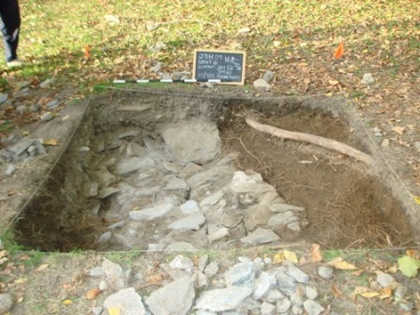

Photo 1

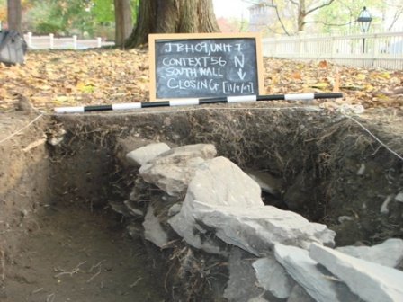

Photo 2
Under the Hill

A Walking Tour of the John Brown House Yard

By Bridget Smith
Brown University

