Alyssa Thelemaque  
ARCH 1900  
Object Biographies  
14 December 2009

**Canton Porcelain Fragment | Plastic Coffee Cup Lid Fragments | Angle Iron**

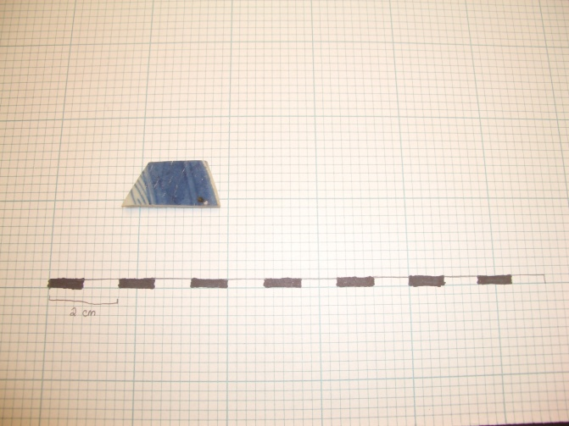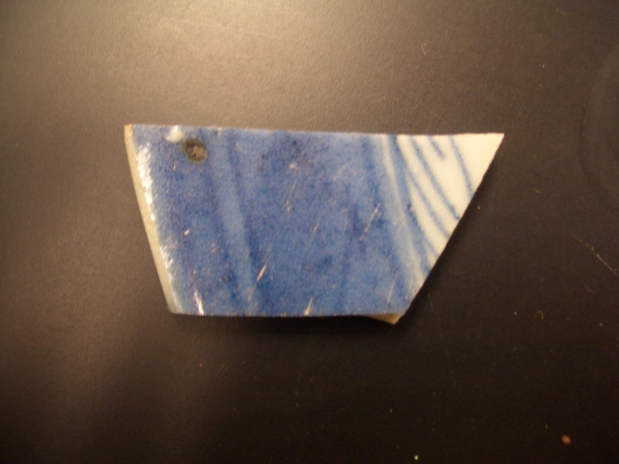

My first object is a small fragment of porcelain that is known as Canton porcelain. Canton porcelain has some easily identifiable features (although in my opinion, easily mistaken for other types of Chinese porcelain ware), and Krysta pointed me in the direction of looking at Canton porcelain.

The production date range of Canton porcelain is 1790-1835. Canton porcelain is composed of a glassy vitreous paste. The color of the undecorated porcelain is white or grayish white and the thickness of Canton porcelain vessels is decidedly thicker than other porcelain types. Since the body of a porcelain artifact is almost impossible to examine unless the vessel is broken, Canton porcelain can also be identified by its glaze properties. The glaze of Canton porcelain is of poorer quality than that of other type and it possesses a slight “oatmeal” texture, that is to say a rippled surface texture, with occasional pinholes and inclusions. In terms of decoration, it is characterized by a grayish white background color with broad brush-stroked designs in shades of blue ranging in color from watery-gray blue to cobalt. The rim would have been decorated with blue lattice-type designs followed by wavy or scalloped lines. Common decorative motifs featured on the central medallion included pagodas, bridges and boats[1].

Like any porcelain, it would have been fired at temperatures of 1300-1450 degrees Celsius. Canton porcelain gets its name from both its decoration and design styles as well as where it was exported from. This type of porcelain was most likely manufactured and fired at the Provence of Ching-Te Chen then sent to the port of Canton to be decorated and exported. Chinese Canton, and most other types of Chinese-manufactured porcelains, was known as “ballast ware” due to the way it was transported to America. Once in America, the Canton sets would have usually found their way to the merchant class—who followed the example of George Washington who favored Canton sets for dinner[2].

This particular fragment is quite small—the bottom is 2 ¾ cm, the slanted side is 1 ½ cm, the top is 1 ¾ cm, and the straight side is 1 ¼ cm. Overall, it has a thickness that that increases from 1mm to 2.5mm. The porcelain is decorated with varying shades of blue. The outer edge is painted with what is simply a decorative pattern while it turns into what would have been part of an actual image or motif as it moves towards what would have been the center of the intact object. While Canton porcelain commonly took the form of a bowl, plate, or platter, this particular fragment is too small to be able to ascertain a diameter that would indicate what type of vessel of which it would have been a part. The brown inclusion is indicative of the slightly poorer quality crafting and glazing that typified Canton porcelain.

This object was found in JBH 57 of Unit 8. Other finds in the unit consisted of creamware (1760-1820), pearlware (1780-1840), whiteware (1820-present), chinese porcelain with a gold rim, other porcelain fragments, European soft paste porcelain (1745-1800), brown colored lead glaze redware (1725-present), large red ceramic drain pipes, 1946 wheat penny, duct tape, and a Twix candy wrapper. The surrounding contexts also featured types of porcelain, but there were some finds, such as a coffee lid in the context above it and a canvas tarp in the context below it, that make it difficult to figure out the context in which the object would have been deposited[3].

The huge range of dates between the objects found in JBH 57 and also the fact that contemporary items (the canvas tarp) was found below this Canton porcelain shard makes it difficult to determine how or why this article got deposited. The fact that this was obviously deposited with a random variety of objects evidences some sort of dumping situation.

I’m going to assume that Unit 8 was the location for a variety of “dumps.” It’s very close in proximity to the 3-story addition made by Elizabeth Amory Ives Gammell in the 1850s and the interior changes to the dining room made by Marsden Perry in the early 1900s[4]. I think one explanation for this wide variety of objects (including this Canton porcelain shard) is that when the house was being built upon, this particular location was used as a dumping ground when the extensive architectural changes were being made close nearby. It’s also possible that when the Rhode Island Historical Society took possession of the home in 1942 and made renovations, that the area was used for a dumping site. Regardless of when, I think that the most credible explanation for how this particular object got into Unit 8 is that it was dumped along with a variety of other objects during some sort of architectural update to the home.

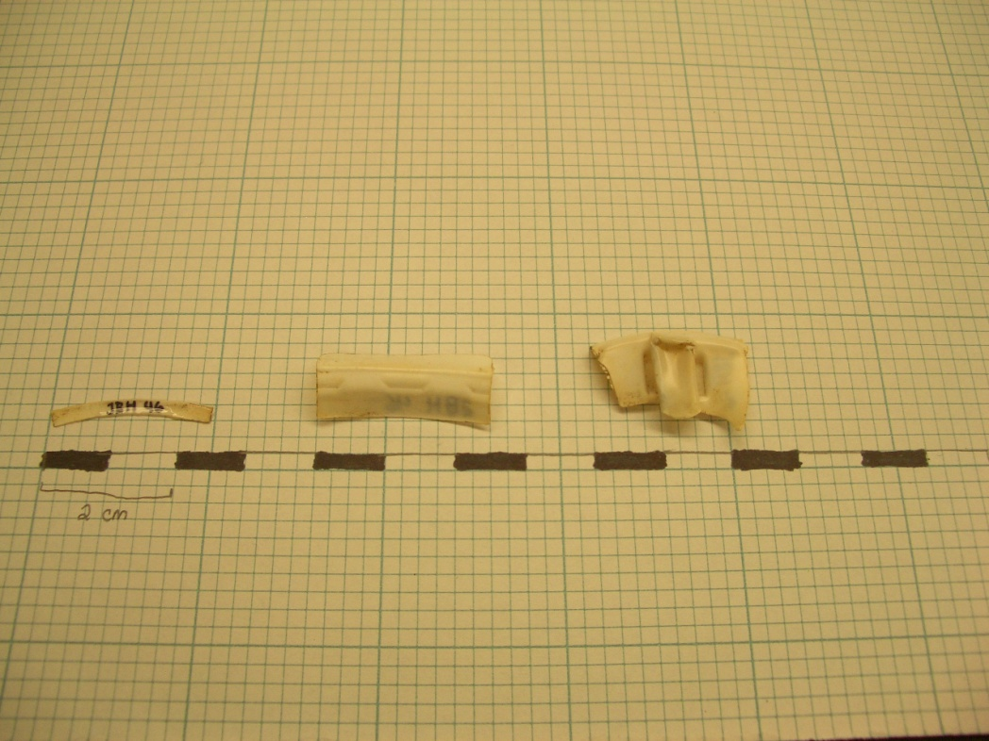

My 2nd object biography is focused on 3 plastic fragments that came from the same object. An avid coffee drinker myself, it was fairly easy to tell that these plastic fragments came from a plastic coffee cup lid. The 3 fragments had fairly similar dimensions. There is a thin curved piece that measure about 2 ½ cm across. There is a wider curved piece with 3 indentations in it, and that fragment also measures 2 ½ cm long. The third fragment is wider and has a sort of tab like protrusion from the center; this fragment measures 2 ¼ cm across. Because of their coloring and construction, it is also safe to assume that the fragments all belonged to the same object.

Although it was fairly obvious that the fragments were once part of a coffee cup lid, the problem with these fragments arises in dating. Although plastic coffee cup lids haven’t been around for hundreds of years, it was still difficult to provide some sort of date for these fragments. After a brief look at the excavation report from 2008, I saw that this lid wasn’t like the McDonald’s lid that had been found in Unit 1[5]. After ruling out that I would be able to date the cup in terms of the history of the company by which it was produced, I had to think of a different way to find a date for the fragments. I wasn’t lucky enough to find some sort of brand name, patent number, or other immediately identifiable characteristics, so I decided to take a look at coffee cup lid patents and see if I could find a type that seemed to match my fragments.

The distinguishing features of this particular lid are in the various indentations and ridges in the design feature. Generally, coffee cup lids patented after 2000 are fairly smooth in terms of their design[6]. The only indentations of these types are in the form of the holes used for drinking, but the lids themselves are fairly simple (think Starbucks coffee cup lids). The earliest plastic coffee cup lid that was specifically marketed for its resealable “on-the-go” characteristics was from 1984[7], but the structure of that type of lid was much bulkier than that of the fragments I found. It was in looking at the patents for coffee cup lids introduced between 1997[8] and 2000 that I found a lot of coffee cup lid types that looked similar in structure to the ones I found.

I would like to say that this particular coffee cup lid is of the variety that was introduced between 1997 and 2000. In looking at various patent images for coffee cup lids introduced around the time, those lids had the same types of decorative indentations and raised areas that I saw on these fragments. Although the Sherri Cup Company introduced their first to-go coffee cup in 1963[9], I don’t think that this type of lid can be dated that far back. Its characteristic indentations and raised tab-like feature really seem to fit with the lids introduced between 1997 and 2000. While this doesn’t necessarily mean that the fragments were deposited within that time frame, it does mean that the earliest the coffee cup fragments were deposited was 1997.

The next question is how did the coffee cup lid fragments get there? At first, one might want to say that somebody was walking by after having finished drinking their coffee, and they dropped the fragments on the ground. But the object’s deposition has to be examined in context with the other objects it was found with. These fragments were found in Context 46 of Unit 6. The other items found in JBH 46 consisted of a wire nail (1877-present), glass shards, fragments of a measuring cup, plastic beads, a piece of brown rubber, whiteware (1830s-present), creamware shards (1762-1820), brick fragments, shell pieces, and a plastic soda bottle cap gasket[10].

Like the Canton porcelain shard, it’s hard to find an explanation for how this object was deposited when it is found underneath objects that are significantly older. Attributing its deposit to another “dumping ground” scenario would account for the wide range of dates that the objects in the context possessed.

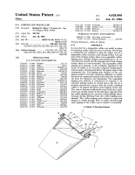 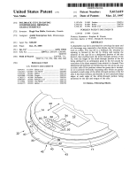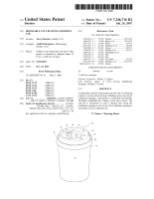

Figure 1: US Patent No. 5613619. Issued March 25, 1997.

Figure 2: US Patent No. 4428498. Issued January 31, 1984

Figure 3: Coffee Cup Lid US Patent No. 7246716. Issued July 24, 2007.

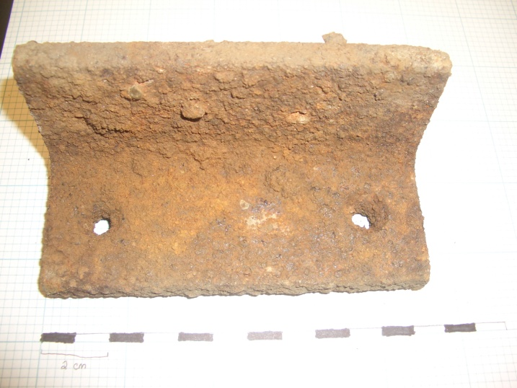 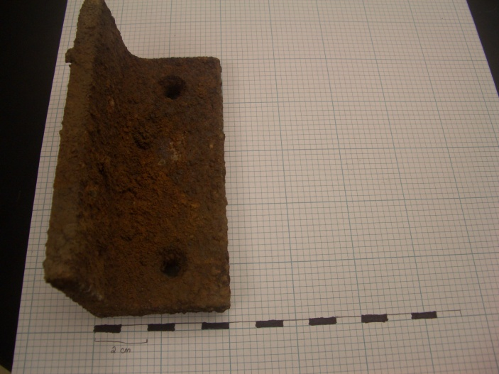

This third object was found in Context JBH 61 of Unit 6. It is a piece of heavily rusted iron that measures 11 ¾ cm across, 4 ¾ cm long, and 4.5mm thick. Because it has neatly perforated holes, smooth edges and a hefty weight, this iron object was probably used for architectural purposes. Because of the sharp 90 degree angle and carefully place holes, it also seems that this object was used as an angle iron or something to anchor some sort of larger feature[11].

Although there were some inconsistencies (plastic report cover sliding bar), the other finds in the unit were consistent with objects that would have been utilized in domestic architecture: mortar, bricks, red tiles, other flat iron pieces, cut nails, and a slab of marble. After being able to safely believe that this was an architectural object, the next task was to find a date for the object.

This task proved to be extremely difficult. The thick layer of rust covered the entire surface, and if there were any identifying features on the object such as a maker’s mark, it is impossible to see underneath the rust. Modern angle irons are fairly thin, so that was my first indication that this particular angle iron is relatively old.

Since the main thing to notice about this object is the rust, I decided to use that to help me date the object. Rust is a form of corrosion that affects metals like iron and steel when they are exposed to air and moisture. Since rusting can happen fairly quickly (a matter of days), I wasn’t able to say that the object was x amount of years old because y amount of rust was present. But, I was able to take the very presence of the rust as something to date.

Today, metal objects—specifically irons and steels—are treated in order to prevent them from rusting, especially if they are going to be used for something like supporting an architectural structure. Galvanization is a method that protects iron from rusting by completely coating the surface with a hot layer of zinc. Galvanization was introduced in the 1830s, and was officially patented by Stanislaus Sorel, a Parisian civil engineer, on May 10, 1837[12]. It wasn’t until after that date that public and domestic architecture began to take advantage of the anti-rusting properties of galvanization.

The anti-rust protection offered by this method can last for decades. While rusting is inevitable, even on objects protected by galvanization, this is only in objects directly exposed to lots of water and sunlight. If this object was indeed an angle iron, it is most likely that it was used to anchor something to the ground. It would have been positioned between the ground and whatever object it was holding to the ground. If that were the case, there wouldn’t have been whole sides of the object exposed to the natural elements.

I think there are two plausible explanations for the appearance of rust on this angle iron. First, that the heavy amounts of rust covering every part of the object’s surface indicate that the object simply sat out in the open air exposed to oxygen or moisture. Or secondly, that the angle iron was indeed partially hidden from the elements, but it had not been treated by galvanization. A lack of galvanization would account for the heavy amounts of rust and corrosion.

In terms of use, if the second explanation is taken to be true, then that would indicate that this object was dated before 1837. If the object is dated to pre-1837, that would mean that the angle iron came from a structure that had been constructed before that date. Knowing the history of the John Brown House landscape, the only architectural changes to the house before 1837 consisted of the construction of the various outhouses that existed in the yard of the property. So it’s possible that this angle iron was never galvanized and therefore used originally used in one of the outhouses constructed on the property before 1803. Another explanation for when this object was used is that the angle iron was used in the construction of the Robert Hale Ives house around 1857 and he simply didn’t use metal objects that had been galvanized.

In terms of deposition, if the object was used in one of John Brown’s outhouses, than it could have been deposited in the ground when the outhouses were destroyed around 1857 for the construction of the Hale Ives house. If the angle iron was used in the construction of the Hale Ives House, than it’s possible that the object was deposited between 1923 and 1925 when Marsden Perry razed the Hale Ives House.

The introduction of the concept of galvanization produces a variety of explanations as to the original use of this iron object and when it was deposited.

Object Bio Bibliographies

Allen, Lorena Overstreet. “Chinese Canton Porcelain.” Antiques and Art Around Florida. 3 Dec

2009. http://aarf.com/fecant98.htm

"Canton Porcelain." *FLMNH.ufl.edu*. Florida Museum of Natural History, Web. 2 Dec 2009.

<http://www.flmnh.ufl.edu/histarch/gallery_types/type_index_display.asp?type_name=P

ORCELAIN,%20CANTON>.

"History of Galvanization." *gaa.com*. Galvanizers Association of Australia, Web. 12 Dec 2009.

<http://www.gaa.com.au/benefits_of_galvanizing/benefits_h.html>.

"The Cup That Launches a Thousand Ships." *NewYorkFirst.com*. The New York First Company,

Web. 12 Dec 2009. <http://www.newyorkfirst.com/gifts/7073.html>.

Untitled. *John Brown House Binder #4 JBH General Information and Description; Room by*

*Room*, John Brown House Museum.

"US Patent No. 5361639." *Patent Storm*. Patent Storm Patent Index, Web. 10 Dec 2009.

"US Patent No. 4428498." *Patent Storm*. Patent Storm Patent Index, Web. 10 Dec 2009.

"US Patent No. 7246716." *Patent Storm*. Patent Storm Patent Index, Web. 10 Dec 2009.

1. “Canton Porcelain,” Florida Museum of Natural History website <http://www.flmnh.ufl.edu>.
2. Lorena Allen, “Chinese Canton Porcelain” Antiques and Art Around Florida <http://www.aarf.com>.
3. See the Unit 8 summary by Andrew Seiden
4. Changes cited in: “Untitled” *John Brown House Binder #4 JBH General Information and Description: Room by Room,* John Brown House Museum.
5. See Ansel’s object biographies from 2008 excavation report
6. See Figure 3
7. See Figure 2
8. See Figure 1
9. “The Cup that Launched a Thousand Ships” (NewYorkFirst.com, 12 Dec 2009).
10. See the Unit 6 summary by Elise Merchant
11. See the Unit 6 summary by Elise Merchant
12. “History of Galvanization,”Galvanizer’s Association of Australia