Object Biography
Gimlet Point Screw—Polychrome Overglaze Chinese Porcelain—Anthracite Coal

Gimlet Point Screw
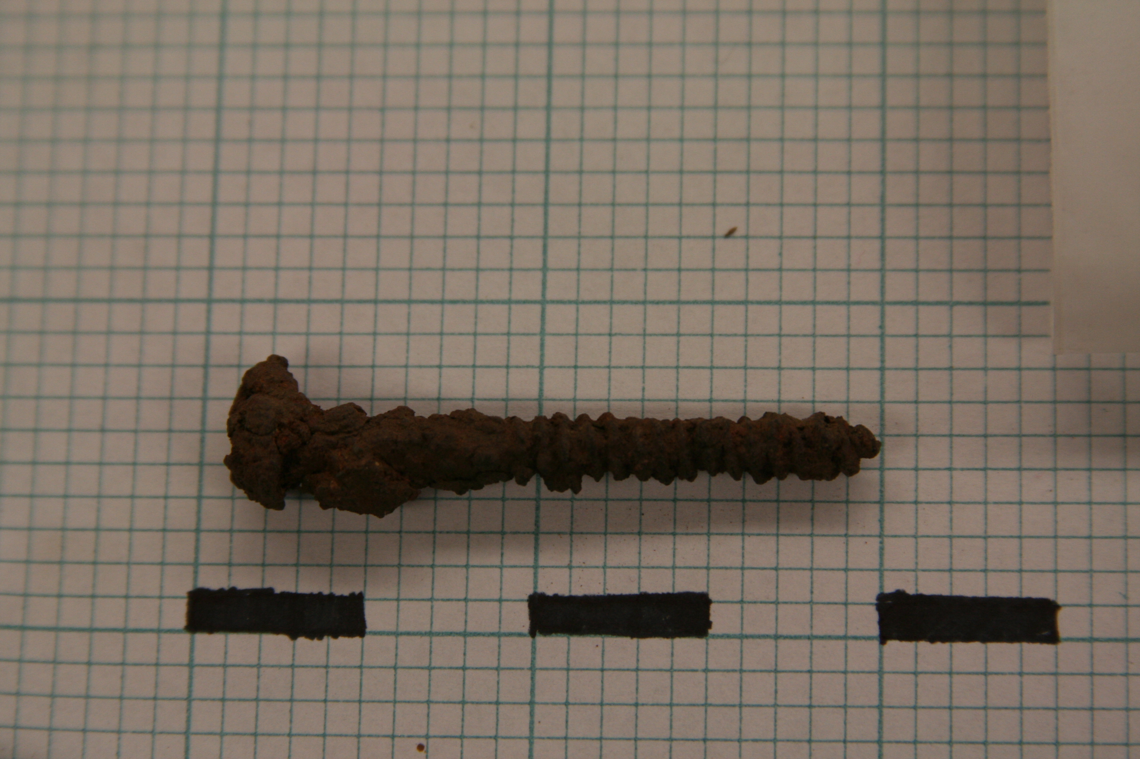
The above screw was found in JBH 47, a natural stratigraphic context level in Unit 9. Instantly, an intuitive reflection would illuminate the connections between the use of screws in building projects and the close proximity to the house—in addition to providing an impetus for further excavation as we were searching for possible outbuildings. The screw was greatly covered by iron-oxide corrosion and since this process is caused by the introduction of liquid to the metal surface, it is in agreement with John Brown’s account in his letter to Edward Dexter Sr. about the land being a “muddey place”. Amidst the lumps of corrosion near the head of the screw, the artifact is easily distinguishable. It measures 47.8 mm long, which doesn’t seem to be altered by breakage as the tip appears to be intact, 5.0 mm wide on the lower shaft, and the head is 8.5 mm wide. Although it is impossible to decipher whether the screw has a crosshatch in the head or otherwise without the use of advanced corrosion-removal methods, we can note the rounded shape of the head. Screws with this type of head are often used as machine screws, which would not have been the case during the early years of the John Brown House, thus extending the range of possible dates.
The preceding point disagrees with the implications founded by examining the shaft and threads. Early colonial screws, dating from the mid-18th century to the mid-19th century, were more often a product of hand-made practices. This created a crudely cut screw with threads of rather high pitch (their width in relation to the body of the shaft). The artifact from JBH 47, although laying claim to threads that appear regular and refined, consists of a high thread pitch that indicates a shaft of thin proportions, suggesting an earlier date than the ‘machine-screw’ hypothesis might suggest. The V-thread, a common indicator of hand-made screws, is clearly apparent on this screw. The constant recurrence of building projects on the John Brown House lot—1786-1854 Brown Family, 1854-1901 Robert Hale Ives, 1901 Marsden Perry—gives rise to a wide sense of ambiguity for the dating of such architectural artifacts as the screw.
Clearly the screw can be dated well into the late-20th century due to its resemblance to a machine screw; therefore, the focus must be centered on finding the earliest possible date of its manufacturing range. I pointed out the high pitch of the thread as a reason to believe that the screw is hand-made; however, the tight wrap (2.3 mm separating the crests of eat thread) and the regularity of grooves overwhelmingly supports a machine-made screw. Instantly, we could date the screw to 1760 as the year marked the first use of a lathe for making screws in America. It is important, however, to compare this screw to those made during the early years of lathe production. The picture above embodies the crudeness of a screw forged around 1795. Also observable is the common practice of producing very short screws and continuous tapering threads, which resulted in a screw that did not securely engage the wood. Furthermore, screws produced by early manufacturing are identifiable by longitudinal scratches that remain from the wire-forming process—an attribute that is absent in later screws (and this artifact) due to higher operating speeds of threading tools. The most notable event which caused the dating of this artifact was the development of a gimlet point. The gimlet point is a tapered (threaded) cone point which often has an angle of 45-50 degrees. This promotes the insetting and hold of the screw, fixing the problem of earlier screws. This point was imitated in early production but often through continuous tapering of the threads, as seen on the 1795 screw. Instead, this innovation suddenly increases the angle of taper at the point. Sloat and Springsteen filed for U.S. Patent 154 upon their invention of the threaded cone in 1837, thus giving us the earliest date to which the JBH 47 screw can be manufactured; however, the first screws to be manufactured with this gimlet point date to 1849 by Cullen Whipple at the New England Screw Company.
The JBH 47 screw, which dates 1849-present, is importantly found in close proximity to the house’s addition that was added by Marsden Perry, together in close association with cut nails. This suggests that the screw could have been used in the building of said addition, or that of underlying outbuildings. As noted in the Excavation Summary, the preceding context (JBH 44) consisted of many non-diagnostic fragments of hand-cut wood, slabs of slate, and pieces of red-clay brick; and the following context (JBH 53) produced a screw, a handful of cut nails, and a cut iron stake. This conglomeration of evidence implies the presence of a building project at some point in this area’s history. JBH 47, as a uniform context, can not be dated within the early range of the screw as JBH 53 consists of objects that are manufactured as late as 1993. The installation of the sprinkler and electrical systems must have caused disturbance to the underlying context, resulting in backfill and the random dispersal of objects from various date ranges.
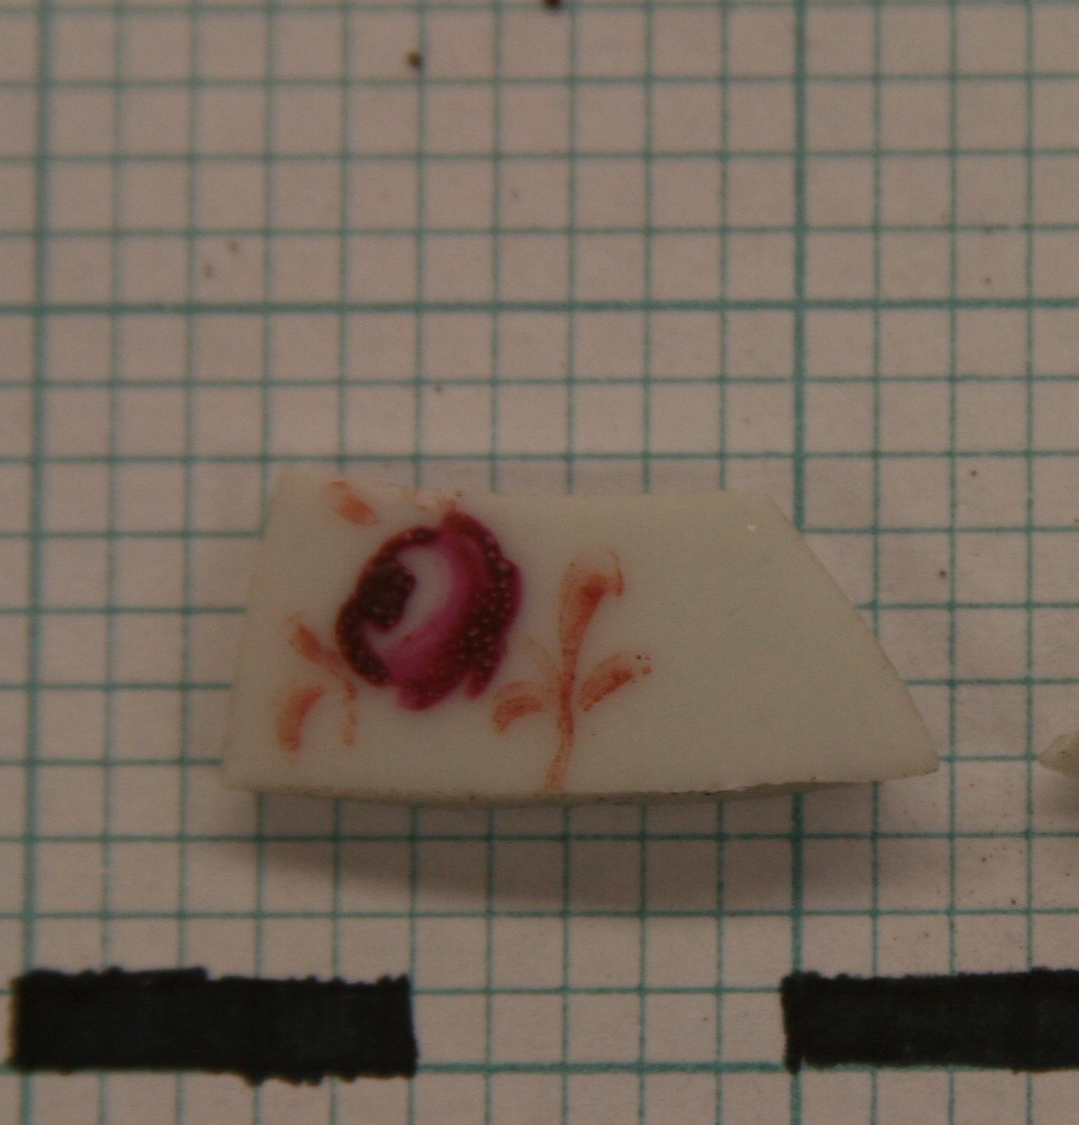
Polychrome Overglaze Chinese Porcelain
The prevalence of trade throughout the early years of the John Brown House best suggest the presence of internationally-imported artifacts, notably ceramics and porcelain which indicated a sense of societal status, a concept intricately intertwined with the various owners of the plot. John Brown was greatly associated with the international trade of Nicholas Brown & Co. upon the advent of the 19th century. Much of the trade included the Orient, notably the East India Trading Company. A century later, Marsden Perry, a man of high income who eccentrically attempted to be accepted into the elite society of the Providence wealthy, acquired and filled his collections with priceless objects such as Chinese porcelains. These historical events importantly define the significance of the porcelain sherd found in JBH 47.
The artifact is pearl white in color with a crimson and gold overglaze design—an effort of intensifying the decoration on the vessel. Unlike most hand-painted porcelain imported into the colonies, this sherd does not have a blue underglaze or overglaze. However, similar methods used to produce the floral motifs in “Chinese Imari” porcelain overglaze decoration are present in this case. Thus, this artifact-measuring 15.9 mm on the short side, 23.4 mm on the long side, 10 mm tall, and 2.7 mm wide—is Chinese in make. As aforementioned, the decoration on the face of the sherd is emblematic of a floral design, although it is rather unrefined in comparison to some vessels. The central rosette is finished in a crimson color, bordered by gold accents which bear resemblance to leaves or vines. The visible brush strokes are evidential of hand-painted rather than a transfer-print—a practice which takes a prefabricated image and prints it on the ware. The lack of intricate detail in the design could be due to a period of mass production and exportation from its manufacturing location; such occurrences can be dated to the mid-late 18th century between the chief Chinese port, Canton, and the European-market, in turn, that the American-market, as well. Much of Europe’s wealth during the 17th and 18th centuries was a direct result of sea-borne commerce and trade. Since Europe, notably Great Britain, had a thriving trade exchange with China and America, they acted has an intermediary in much of the porcelain trade. This presented opportunities for wide dispersal of Chinese porcelains, not simply exclusive to the most prominent citizens; this further supports the dating of this artifact sometime during the 18th Dynasty.
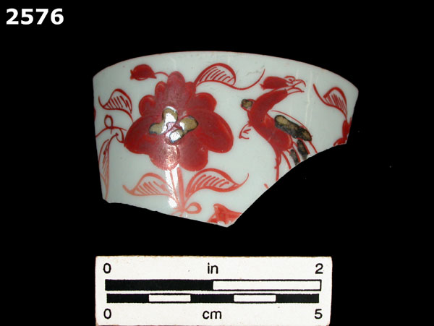
It is difficult to find a suitable category that this sherd fits with; however, it is suggestive of the common mid-18th century development of famille rose porcelains, which were made primarily for export in the Western-market rather than domestic use in China. In addition, the patterns bear similarities to later motifs of the 19th century such as the Rose Medallion and Mandarin porcelains. Since these patterns were derived from the figural designs of the famille rose porcelains, we can more accurately date the artifact to the 18th century. The Florida Museum of Natural History presents a fitting typology for the artifact, categorized as Ching Dynasty Polychorme Overglaze porcelain dating between 1700 and 1750. This agrees with the previously stated, historically based conjecture. The defining attributes describe specimens of this category as being white, thin, highly vitreous paste that is smooth and translucent—closely comparative to the description of our artifact.
As noted, this porcelain sherd was the product of JBH 47 in Unit 9. This context consisted of many inclusions; however, only two other artifacts were pottery sherds—a piece of plain creamware (1762-1820) and a Ching Dynasty Blue on White porcelain (1644-1912). Considering the three artifacts together with the high abundance of anthracite coal and the proximity to the addition of the house that held the kitchen, suggests a common use as kitchenware followed by the possible discarding of broken vessels. Notice the much wider date range of the blue on white porcelain; the widespread use of such wares did not occur for the polychrome overglaze porcelain. This could help to localize the context to a short, specific time span. However, numerous artifacts were found in the following context, JBH 53, that are more recently dated. The common theme of soil backfill and modern disturbance may be the cause of such circumstances. In addition, the concept of time lag, in which ceramic artifacts have lifespans of as much as 15 years and more beyond their manufacturing ranges, notes the possibility of the artifact being used well beyond 1750, thus fitting into the range of the context.

Anthracite Coal
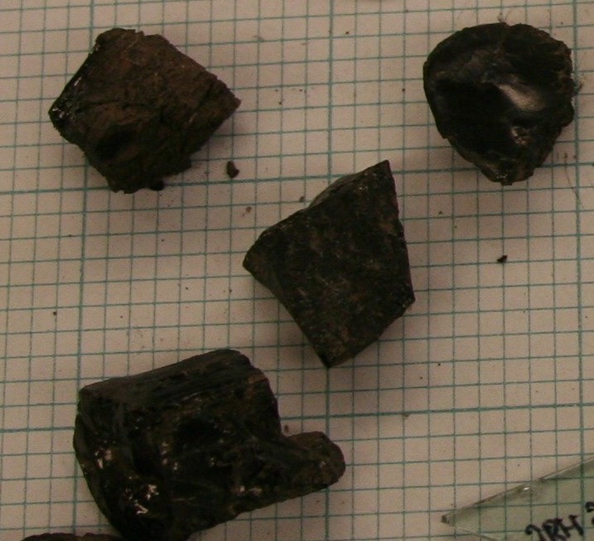
Anthracite coal was a common visitor in every context my group excavation in STP 3 and Unit 9. The fragments varied in size and abundance; however, their consistent presence provided each context with an easily diagnostic artifact. The above pieces, a part of JBH 60 from STP 3, are the largest specimens of this organic mineral, each measuring at least 1 cm wide with the largest (the piece in the bottom left corner) claiming a width of 2 ½ cm. Although these artifacts are small and not as aesthetically pleasing as porcelain sherds, anthracite is an extremely significant artifact that suggest the early wealth of the John Brown family and multiple possibilities of use by Marsden Perry and, now, the Rhode Island Historical Society.
Emblematic of the picturesque anthracite fragments found in numerous resources, these fragments are dark black, consist of sharp cleavage, and exhibit a high luster. They are debased by the mud and grime which clings on to the edges; however, this is due to relatively futile cleaning methods with a toothbrush. Further cleaning is required for the fragments to match their initial appearance. Also referred to as black coal, hard coal, and stone coal, anthracite has the highest carbon count and fewest impurities of any type of carbon. Anthracite is widely used as a fuel for producing heat; therefore, the fragmented chunks may be how they appeared during their use by the JBH-owning families, as small fragments burn at a quicker rate than whole pieces.
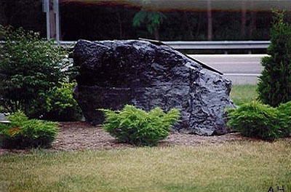
Coal seams were first discovered by Connecticut settlers in 1762, with the first use of anthracite being dated around 1768. Mining capabilities did not develop to a mode of production for nearly another decade; therefore, no indication of its use is available until 1788, when the first industrial use for heating and drawing iron for making nails was recorded. We cannot accurately date the fragments from JBH 60 to 1788, although conjecture might argue such a statement due to the use for heating, as the sources of coal were a significant distance from Providence and cross-country travel was not a common occurrence and definitely not the most ideal. At this time John Brown had just laid down the large investment of constructing the house on Benefit Street, thus the expenditure of retrieving a fuel source of such a low calorific value can be deemed unnecessary. The revolution of industrial development and growth that began in “The Coal Region” of Northeastern Pennsylvania, most likely reached the eastern seaboard after the 1790 discovery on the Schuylkill River and the experimental use in residential heating in 1808. Due to the Brown’s prominence and wealth, it would not be a stretch to suggest that they owned an iron furnace for use of anthracite residential heating. Although we can now date the anthracite fragments from 1790-present, it seems more likely that the artifacts are a result of the ownership of Marsden Perry. Throughout the 19th century, anthracite use was relatively young and underdeveloped, with the first mining company not being established until 1820. The turn-of-the-century witnessed the steep incline following the 1890 strike; employment reached a maximum of 180,000 workers in 1914 and production peaked over 100 million tons in 1917.
As aforementioned, the presence of anthracite was a recurring theme in all five contexts of Unit 9 and STP 3. Once again, the close proximity to the house might suggest this high prevalence—as it could be assumed that furnaces were present in the kitchen and rear of the house. Although this point is unsubstantiated by relevant evidence, modern uses of anthracite for purposes such as electrical steam-generated power and landscaping should be considered. Especially in the case of STP 3 and its location near a walkway for a National Museum, the artifacts from JBH 60 could be resulting pieces from the movement of larger fragments of landscaping anthracite.
Works Cited

Adams, William H. Dating Historical Sites: The Importance of Understanding Time Lag in the Acquisition, Curation, Use, and Disposal of Artifacts. Historical Archaeology 37(2). 34-64.

AnthraciteCoal.com, Inc. Landscaping. December 15, 2009. < http://www.anthracitecoal.com/welcome.htm>

Archaeology of College Hill: References & Resources. John Brown Letter. 16 March 1796. December 14, 2009 < http://proteus.brown.edu/archaeologyofcollegehill/6499>

Archaeology of College Hill: References & Resources. The Providence Sunday Journal. 13 October 1901. December 14, 2009 < http://proteus.brown.edu/archaeologyofcollegehill/6499>

Black Diamonds: Experience Pennsylvania’s Anthracite Mining Heritage. History. Schuyl, Inc. < http://www.pacoalhistory.com/history.html>

Chapter II: The Development of the Lathe Since the Introduction of Screw Threads. 21 February 2009. December 15, 2009. <http://chestofbooks.com/home-improvement/woodworking/Lathe-Operation/Chapter-II-The-Development-Of-The-Lathe-Since-The-Introduct.html>

District 1- Coal Mine Safety and Health. History of Anthracite Coal Mining: Time Line. United States Department of Labor: Arlington. December 15, 2009 < http://www.msha.gov/District/Dist_01/History/history.htm>

Encyclopedia Britannica: Online. Screw. Singh, Shiveta. 26 November 2008. December 15, 2009 <http://www.britannica.com/EBchecked/topic/529876/screw>

Find A Grave. Marsden Perry: Grave Memorial #9072786. Swan Point Cemetery: Providence. 9 July 2004. December 15, 2009 <http://www.findagrave.com/cgi-bin/fg.cgi?page=gr&GRid=9072786>

Gordon, Elinor. Chinese Export Porcelain: An Historical Survey. Main Street/Universe Books: New York. 1975. pg. 165-66

Historical Archaeology at the Florida Museum of Natural History. Porcelain, Ching Polychrome Overglaze. Florida Museum of Natural History: Gainsville. 1995. < http://www.flmnh.ufl.edu/histarch/gallery_types/type_index_display.asp?type_name=PORCELAIN,%20CH%20ING%20POLYCHROME%20OVERGLAZE>

White, Christopher. Observations on the Development of Wood Screws in North America. Museum of Fine Arts: Boston. 2005

Wikipedia: The Free Encyclopedia. Anthracite Coal. 15 December 2009. December 15, 2009. < http://en.wikipedia.org/wiki/Anthracite_coal>

Wikipedia: The Free Encyclopedia. John Brown House. 7 November 2009. December 15, 2009. <http://en.wikipedia.org/wiki/John_Brown_House_(Providence,_Rhode_Island)>

Archaeology of College Hill: References & Resources. John Brown Letter. 16 March 1796. December 14, 2009 < http://proteus.brown.edu/archaeologyofcollegehill/6499>
Encyclopedia Britannica: Online. Screw. Singh, Shiveta. 26 November 2008. December 15, 2009 <http://www.britannica.com/EBchecked/topic/529876/screw>
Chapter II: The Development of the Lathe Since the Introduction of Screw Threads. 21 February 2009. December 15, 2009. <http://chestofbooks.com/home-improvement/woodworking/Lathe-Operation/Chapter-II-The-Development-Of-The-Lathe-Since-The-Introduct.html>
Wikipedia: The Free Encyclopedia. John Brown House. 7 November 2009. December 15, 2009. <http://en.wikipedia.org/wiki/John_Brown_House_(Providence,_Rhode_Island)>
White, Christopher. Observations on the Development of Wood Screws in North America. Museum of Fine Arts: Boston. 2005
White, Christopher. Observations on the Development of Wood Screws in North America. Museum of Fine Arts: Boston. 2005
Archaeology of College Hill: References & Resources. The Providence Sunday Journal. 13 October 1901. December 14, 2009 < http://proteus.brown.edu/archaeologyofcollegehill/6499>
Find A Grave. Marsden Perry: Grave Memorial #9072786. Swan Point Cemetery: Providence. 9 July 2004. December 15, 2009 <http://www.findagrave.com/cgi-bin/fg.cgi?page=gr&GRid=9072786>
Gordon, Elinor. Chinese Export Porcelain: An Historical Survey. Main Street/Universe Books: New York. 1975. pg. 32
Historical Archaeology at the Florida Museum of Natural History. Porcelain, Ching Polychrome Overglaze. Florida Museum of Natural History: Gainsville. 1995. <http://www.flmnh.ufl.edu/histarch/gallery_types/type_index_display.asp?type_name=PORCELAIN,%20CH%20ING%20POLYCHROME%20OVERGLAZE>
Gordon, Elinor. Chinese Export Porcelain: An Historical Survey. Main Street/Universe Books: New York. 1975. pg. 23-24
Gordon, Elinor. Chinese Export Porcelain: An Historical Survey. Main Street/Universe Books: New York. 1975. pg. 165-66
Historical Archaeology at the Florida Museum of Natural History. Porcelain, Ching Polychrome Overglaze. Florida Museum of Natural History: Gainsville. 1995. < http://www.flmnh.ufl.edu/histarch/gallery_types/type_index_display.asp?type_name=PORCELAIN,%20CH%20ING%20POLYCHROME%20OVERGLAZE>
Adams, William H. Dating Historical Sites: The Importance of Understanding Time Lag in the Acquisition, Curation, Use, and Disposal of Artifacts. Historical Archaeology 37(2). 34-64. pg. 34
Wikipedia: The Free Encyclopedia. Anthracite Coal. 15 December 2009. December 15, 2009. < http://en.wikipedia.org/wiki/Anthracite_coal>
District 1- Coal Mine Safety and Health. History of Anthracite Coal Mining: Time Line. United States Department of Labor: Arlington. December 15, 2009 < http://www.msha.gov/District/Dist_01/History/history.htm>
Black Diamonds: Experience Pennsylvania’s Anthracite Mining Heritage. History. Schuyl, Inc. < http://www.pacoalhistory.com/history.html>
District 1- Coal Mine Safety and Health. History of Anthracite Coal Mining: Time Line. United States Department of Labor: Arlington. December 15, 2009 < http://www.msha.gov/District/Dist_01/History/history.htm>
AnthraciteCoal.com, Inc. Landscaping. December 15, 2009. < http://www.anthracitecoal.com/welcome.htm>

