Caitlin Deal
ARCH 1900
Site Proposal: Andrews House

The history of Brown University stretches back for almost 250 years, but this is not true for most of the buildings that now belong to the university. Among these younger structures is the building called Andrews House. Once a private residence, the building became the Faculty Club and then the campus Infirmary. Due to the history of the building and the various functions that it has served in its relatively short history, Andrews House could prove to be an interesting and unique site on which to do a historical archaeological excavation.
The house was constructed at 13 Brown Street in 1901 for James Coats and it later became the residence of his son, Alfred P. Coats. From 1915 to 1921 it served as the Governor’s Mansion for R. Livingston Beeckman (Mitchell, ‘Andrews’). While there is not much information that is both reliable and easily accessible concerning the Coats family and their lives at the property, there is some material concerning the building while it was the residence of Governor Beeckman. The house was filled with butlers, maids, valets, and wood-burning fireplaces. The governor himself had his clothes imported from England, and his underwear from Japan (Patten). He both hosted and attended extravagant parties and very regularly dressed for dinner in a tuxedo—even when eating in the dining car of a train. His automobile was nicknamed the ‘Shark’ and “The only craft like her was owned by Alfred Gwynne Vanderbilt until he went down with the ‘Titanic’” (Patten). After the extravagance of Governor Beeckman’s occupation, the house at 13 Brown Street was acquired by the University in 1922 and was the first building to house the Faculty Club. During this time, the club rooms were on the first floor and furnished by the faculty, and the upper floors were rented as living quarters to single faculty members, assistants, and graduate students (Mitchell, ‘Faculty’). The Faculty Club moved to the Ely House at 1 Magee Street in 1938, when the plan was accepted to recreate the house at 13 Brown Street into a new infirmary for the university.
The transformation from Faculty Club to “one of the finest and most completely equipped college infirmaries in the country” (News Release) was possible through the generous gift of $330,000 by Charles Henry Hare, class of 1885. An additional $60,000 was gathered from various other alumni and friends of Brown (Unknown, ‘50-Bed’). It was opened as a 50-bed infirmary on January 4th, 1939, replacing the old, smaller infirmary at 10 Manning Street (Mitchell, ‘Andrews’). It was given the name of Andrews House in honor of President E. Benjamin Andrews, because after the abandonment of Andrews Field due to the construction of new athletic facilities, there was no structure at Brown left to honor his memory (Mitchell, ‘Andrews’). The first floor of the building was converted into doctor’s offices, consultation rooms, an emergency room and a library lounge. Five of the large second-story rooms, most with fireplaces and adjoining baths, were fit with furnishings to accommodate two to five students each. Twelve smaller rooms on the third floor were used to isolate and observe individual students, and if needed as extra beds. The building also included a diet kitchen, a lounge and living quarters for the matron and attending nurses, and a dental exam room and x-ray equipment that were “among the finest of their kind”, according to Dean Samuel T. Arnold, who was appointed Chairman of the Board of Management (Unknown, ‘50-Bed’). Plans were made, and later executed, to build two fireproof stairwells, one at each end of the building, and to install a service elevator (Unknown, ‘Andrews’). Health Services can still be found at Andrews House, and while there has been a considerable amount of interior redesign and construction, there have been no such changes to the exterior of the building.
If one was to do an excavation at or around Andrews House, I would first suggest trying to locate the area where the midden was when the building was a private residence. While this may be difficult or even nearly impossible to do, it would be worth it to try due to the artifacts that one might find there due to the residents being as wealthy as they were. However, if the probable area of the midden cannot be (relatively) easily determined, or if even the existence of a midden cannot be verified, I would then suggest excavating near a window or doorway, close to the side of the building. All three uses of the building have the potential of having had people regularly spending time outside the house, and subsequently dropping things or leaving them outside for the elements to bury. There is also the probability that various residents of the house, during each of the three stages of occupancy, dropped or threw things out of the windows, again leaving them to be buried and (possibly) for future generations to find. However, there would be some problems that one would have to work around if one wished to excavate at Andrews House. It is currently still in use, and so there is the concern of continuing traffic in and around the area. However, this concern is lessened due to the fact that the property is fenced in, and so the area around the house does not receive nearly as many visitors as some other places on campus. At the same time, though, due to this semi-privacy there might be fewer artifacts left from passer-by than could be found at other sites. Also, there are many trees in the area, and the possibility of there being root systems crossing underneath much of the ground should be considered.
Excavating at Andrews House would be a unique opportunity to examine the transition of a site as its purpose changes over time. One could examine if there are visible breaks or changes in the material remains as the building went from being a private residence, to a members-only club, and then to an infirmary used by much of the student body. The three stages of occupancy of the site are so different that this would be truly interesting, as one can only guess that the material remains left behind by each stage (if indeed remains were left behind) varied just as much as the use of the site itself.
There are various resources that can be used to further research Andrews House and its purpose, mostly to be found within the archives at the John Hay Library. These resources include newspaper articles from various points in time; personal correspondences between administrators and city officials, equipment suppliers, and others involved in the redesign of the house; news releases from the university; memos and minutes from board meetings; reports from various boards to the university and/or public; infirmary records and bills; and health services notices to administrators and/or students. Floor plans are also available with special permission from Facilities Management, and are not located at the John Hay Library.
Even though Andrews House may not number among the oldest buildings on campus, it is an uncommon building in that it has been used for widely differing things in a relatively short amount of time: the whole transition from private mansion to the end result of university infirmary took less than twenty years. This is something not to be found with the majority of buildings either bought or built by Brown, and so is cause for further interest and investigation.

Visual References
A map showing Andrews House and the surrounding area and buldings, from the Facilities Management website: http://brown.edu/Facilities/Facilities_Management/maps/#category/AUXILIARY
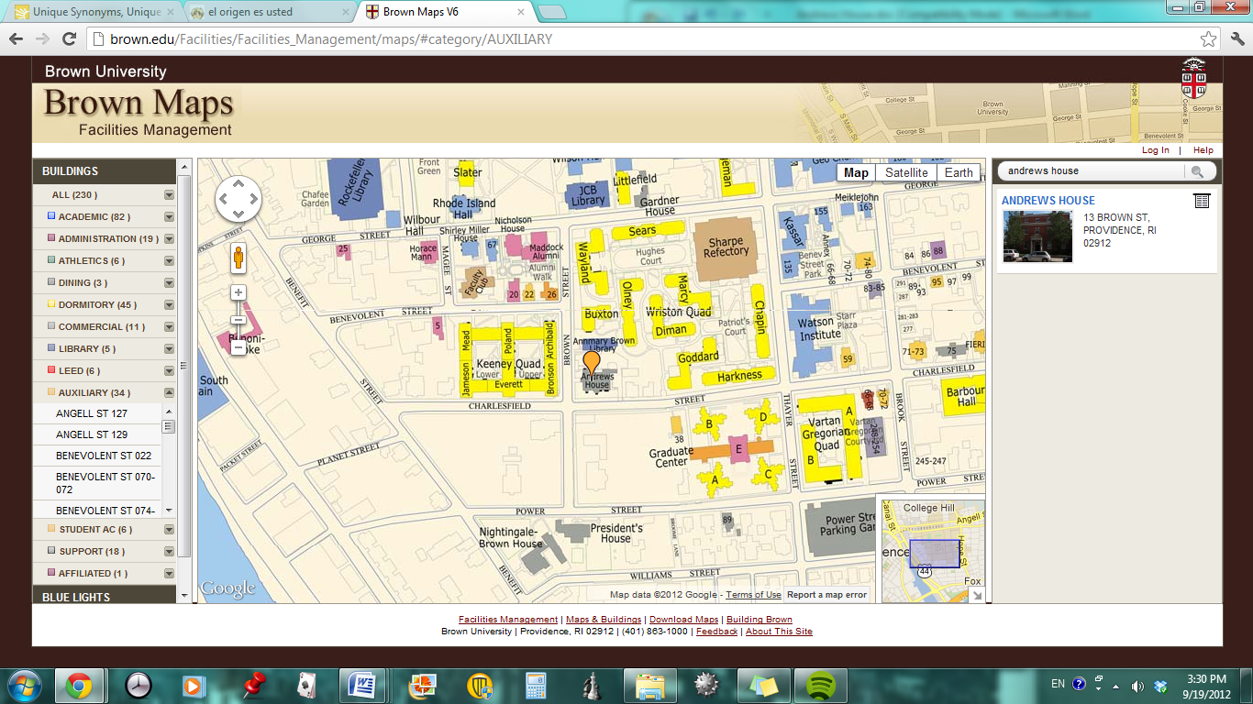
Pictures of Andrews House from the same website:
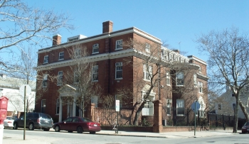
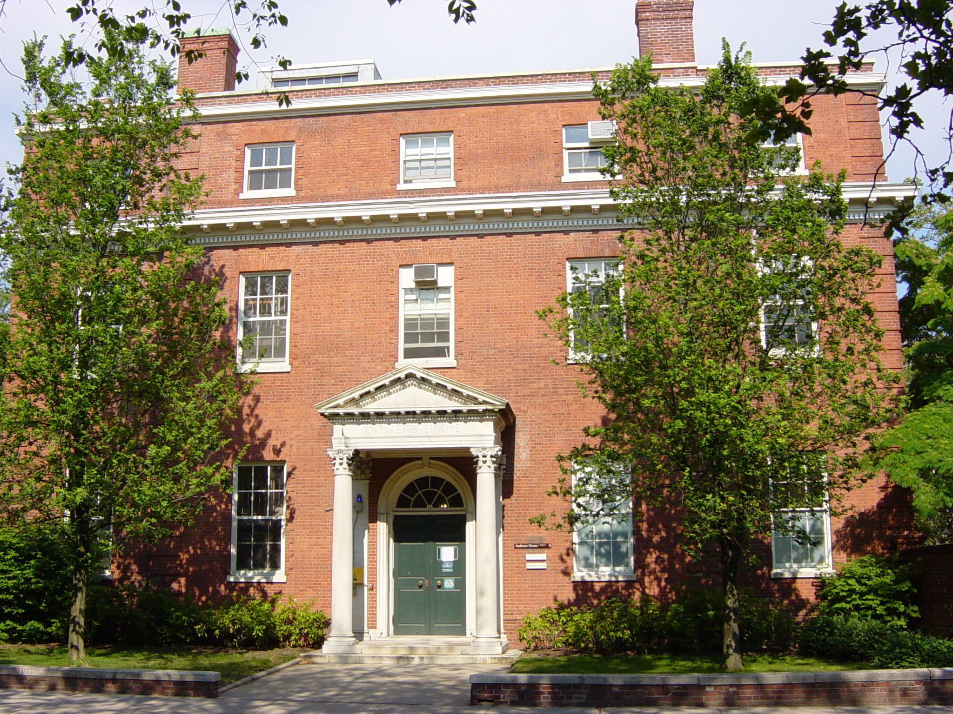

Sources Cited (all sources located at either the John Hay or the John D. Rockefeller, Jr. Libraries)
Author Unknown. "50-Bed Infirmary Opened at Brown." New York Times 07 Jan 1939, n. pag. Print.
Author Unknown. "Andrews House, New 50 Bed Infirmary, Will Open Today." Brown Daily Herald [Providence] 04 Jan 1939, 1. Print.
Mitchell, Martha. "Andrews House." Encyclopedia Brunoniana. Brown University Library, 1993. Print.
Mitchell, Martha. "Faculty Club." Encyclopedia Brunoniana. Brown University Library, 1993. Print.
News Release. January 5, 1938. News Bureau, Brown University, Providence RI. Print.
Patten, David. "Beeckman Era Proves Lesson in High Living."Providence Journal 22 Mar 1954, n. pag. Print.

