Christina DiFabio

9/20/12

ARCH1900

Site Report: Pembroke Field

Although my first suggestion, the Nightingale-Brown house, is undoubtedly a very important part of the Brown family history as well as the city of Providence, I reconsidered and changed the location of my site report after reviewing a certain passage from Deetz’s *In Small Things Forgotten*. The passage considers that historical archaeology is usually focused on important figures in history. While this can be very interesting and helpful in learning about the lives of these people, it “make[s] questions of general cultural significance secondary”, and “if we were to depend only on such data for our interpretation of the American past, the picture would be decidedly skewed in the direction of greater affluence and status” (Deetz, 41). Also considering that the past few years of excavation for this class have been at the John Brown House, which gives a view of the elite society as well, I focused instead on Pembroke Field. This area is not quite as old as other areas of campus previously considered, especially the quiet and main green areas, but has a promising archaeology regarding the daily life of students and the University’s past relationships with College Hill residents.

Pembroke Field is located at the north end of campus, by the athletic complexes (see Image 1). The field is bound by Brook and Hope Streets, running north and south, and Cushing and Meeting Streets, running east and west. There is a fence bordering the area, except for entrances on Brook, Cushing, and Hope Streets. A paved walkway bisects the field into unequal sections. The north section, bordered by Cushing, Brook, and Hope Streets, contains a building named Pembroke Field House in the far west side, as well as a volleyball court which accounts for most of the north section. The south section, bordered by Meeting, Brook, and Hope Streets, is free of construction and landscaping other than a few trees. While a seemingly overlooked section of campus now, it has an interesting history, and still is the site of customs for the Brown and wider community.

As reported by the Encyclopedia Brunoniana, Pembroke Field was formerly known as an estate owned by the brothers Charles T. Aldrich and Henry L. Aldrich, graduates of 1875 and 1876, respectively. The estate was left to the University after the brothers’ deaths, which were within four days of each other in 1931. They were sons of the founder of a textile mill, and grew up to be philanthropists: they were especially generous to Brown. According to Charles’ obituary in the *New York Times*, they were both involved in athletics at Brown, and “in 1924 they gave to Brown University $100,000 to help complete the college stadium, known as Aldrich Field”. A short history of the land was described in *Plats of Brown University and Their History: 1770-1938* by Edwin A. Burlingame:The brothers left the estate now known as Pembroke Field to the University with the intention that it might serve Pembroke College. The history of this land in the context of the Aldrich family is interesting archaeologically due to some renovations after the donation: “the house [of the Aldrichs] was torn down; the land was graded for use as a playing field with the borders landscaped; and the old brick barn has been transformed into a field house for the use of Pembroke College” (Burlingame). The dedication of Pembroke Field took place on October 24, 1936.

Survey and possible excavations of Pembroke Field may lead to significant finds about the past use of the field as a family estate; focusing in particular on the site of the leveled house and the renovated barn. The site of the former Aldrich house is more difficult to locate than the barn, since the barn is what is now known as Pembroke Field House. It was dedicated on January 14, 1938, and included renovations such as window replacement and the conversion of the second floor into a lounge (Mitchell). Although there is much concrete surrounding Pembroke Field House, a potential site for an excavation is nearby the building. There is some green space around the south/southeast corner of the house as well as to its east (see Images 1-4); this would be an interesting site because the excavation could provide information about the past farm culture of the area. Soil analysis (although we would not have time for a chemical analysis) and potential finds relating to farming could be very informative. If it is possible to locate the past site of the Aldrich house, an excavation site could also give great insight into the lives of the past residents. The obituary lists the Aldrich home as 230 Hope Street, which, according to Google Maps and Google Earth, is located at the intersection of Cushing and Hope Streets (and is consequently paved over), but a more in-depth investigation should be done to confirm this. Construction plans, blueprints, and maps from the era should be consulted to pinpoint the exact location. In the archives, there should be a construction plan mapping out when, where, and how the Aldrich house was torn down. In addition, the reports published by the University President during this era, Clarence Augustus Barbour (who served as President from 1929 to September 1926, just before the dedication of Pembroke Field) could be consulted to see if he recorded anything about the construction. One source to be consulted would be *Clarence A. Barbour Papers, 1923-1937*, located in the Hay Archives.

While investigating the past of the Aldrich family is interestingly historically, this again relates back to the issue of studying only the most affluent people of the past. However, since the transformation of the Aldrich estate to Pembroke Field, the space has been an important part of University and can provide archaeological history of Brown students. For example, since the field was donated with the intention of providing space for Pembroke College, the area has been especially important for women. In keeping with the relationship of the Aldrichs and athletics, “at the dedication athletes from Radcliffe College, Jackson College, and Wheaton College [all historically women’s colleges] joined Pembroke in games of hockey, deck tennis, soccer, and fistball” (Mitchell). Investigating the role of this area within the former Pembroke College would be especially timely, since the John Hay Library recently had an exhibit entitled “120 Years of Women at Brown”.

Today, Pembroke Field is still an area used by students. It would be interesting to investigate the site not just in the historical contexts of the Aldrich family and the Pembroke era, but also the modern and present-day activities of students and community members. It is still an area of athletic activity: in addition to the volleyball court, clubs such as Ultimate Frisbee use the space for practices. While the Pembroke Field House can be studied as a renovated barn, it can also be studied as a modern meeting place, since it is still used by the Brown Club of Rhode Island, which converted the building to an alumni center in 1971 (Mitchell). Pembroke Field has also served as the site for the Spring Thaw Pow Wow (which began in 2002 and was originally held in Sayles Hall) sponsored by Brown University’s Native American Student Services.

While Pembroke Field is a bit farther from the main campus, the isolation could be advantageous in minimizing disturbances of the excavation sites, since it does receive less traffic than places such as the middle of the Main Green. Further research on the area could yield significant results, since Pembroke Field has significant historical value as well as modern use. It can be approached as an investigation of a part of an estate, a part of a past college, and a part of an extant university; and it would be very interesting to combine these three approaches to broadly look at how the space has transformed over time. From the ownership of the space by Brown alumni Charles and Henry Aldrich, to the modern Spring Thaw Pow Wow, Pembroke Field has served as a medium between the University, its students, and the surrounding community.

Images

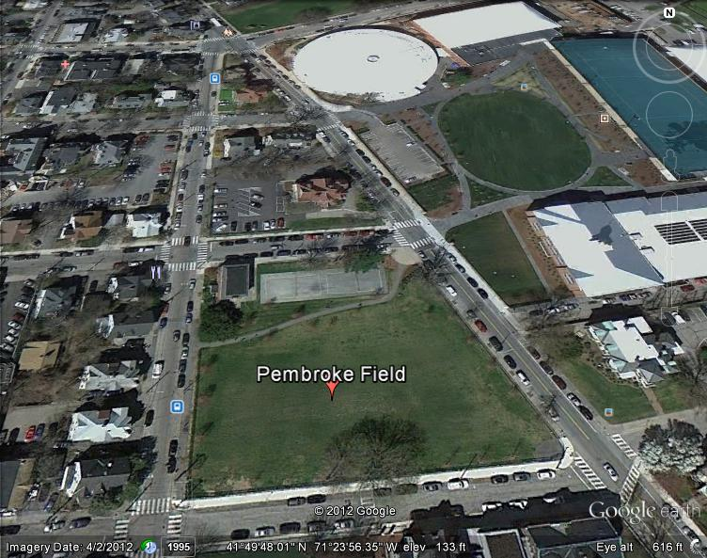

1. Google Earth Image of the current Pembroke Field. Rectangles represent areas of possible excavation by the Pembroke Field House.

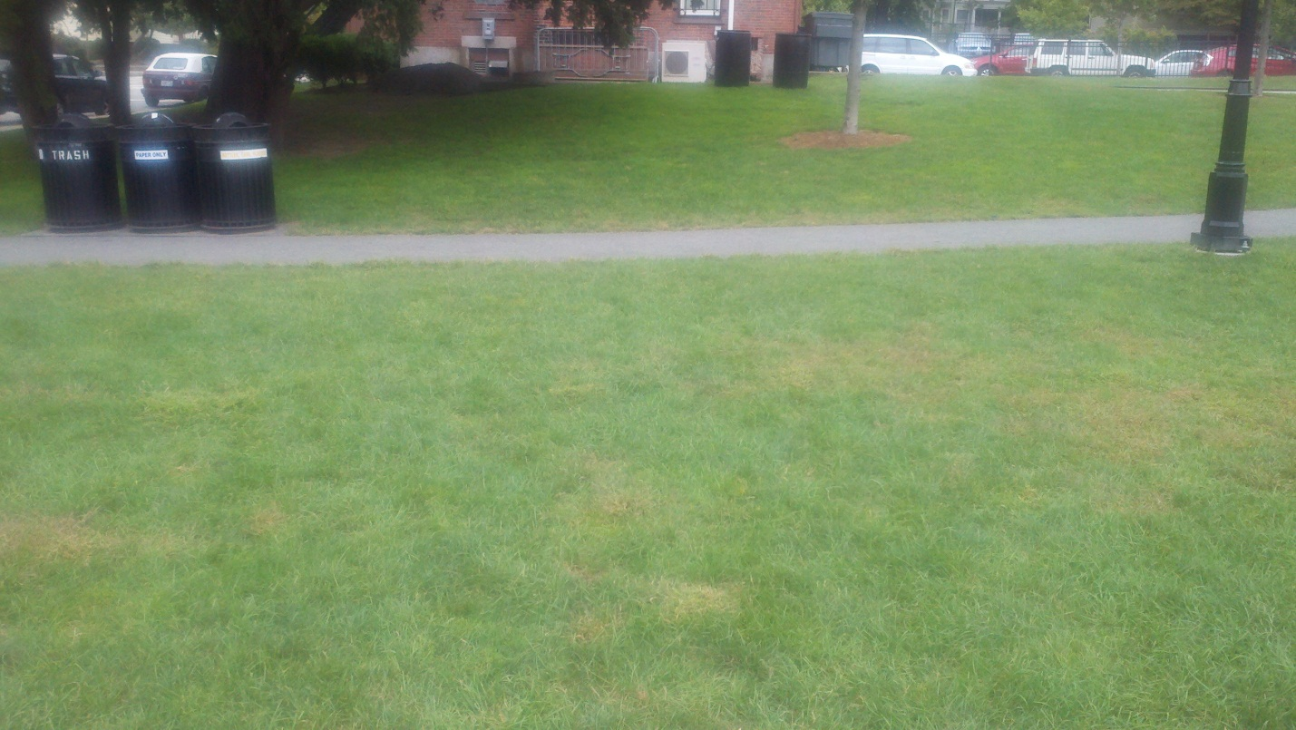

1. Picture of the back (southern wall) of Pembroke Field House.

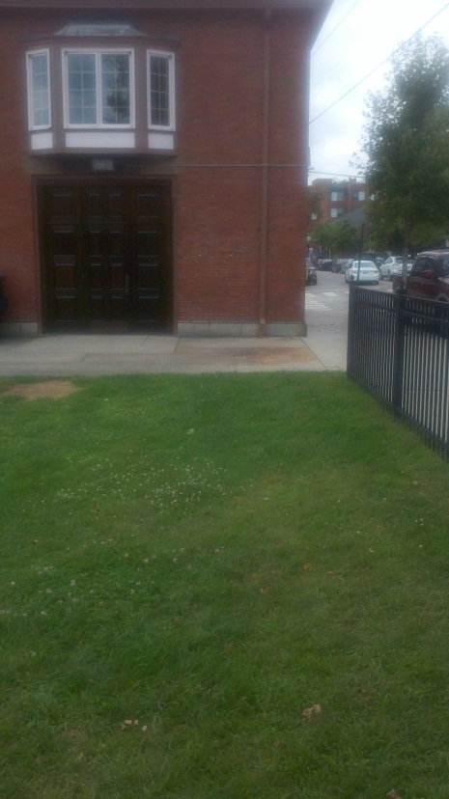

1. Picture of eastern wall of Pembroke Field House, with Cushing Street to the right.

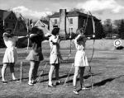

1. Women from Pembroke practicing archery on Pembroke Field, with Pembroke Field House in the background, signifying the importance of the field to Pembroke College. From Brown Athletics History, <http://www.brownbears.com>

Bibliography

“120 Years of Women at Brown”. Brown University Library Special Collections. http://blogs.brown.edu/bulspecialcollections/2012/05/05/120-years-of-women-at-brown/

Burlingame, Edwin A. *Plats of Brown University and Their History: 1770-1938*. Providence. 1938.

“Charles T. Aldrich, Benefactor, Dies.” *The New York Times*. June 18, 1931.

Deetz, James. *In Small Things Forgotten: An Archaeology of Early American Life*. New York: Anchor Books. 1977.

Mitchell, Martha. “Pembroke Field”. *Encyclopedia Brunoniana*. 1993. http://www.brown.edu/Administration/News_Bureau/Databases/Encyclopedia/

“Pow Wow”. Brown University Native American Student Services. http://www.brown.edu/Student_Services/Native_Student_Services/powwow.html

Other sources to consult include: *Clarence A. Barbour Papers, 1923-1937*, Brown University’s acquisition records in the 1930’s, CAD files of the utilities of Pembroke Field from the Department of Facilities Management, and possible construction plans and blueprints from the University Archives.