The President’s House
Christopher Thompson

The Old President’s House is of great archaeological importance to Brown University. Built alongside University Hall, it plays quiet brother to its academic neighbor in memory and documentation. However, home of the first four presidents of the University (Encyclopedia Brunonia 1993:President’s House) this house hosted and fed the men that sighted the trajectory of the University. The excavation of pottery, cutlery, and other small things, would offer Brown University students, faculty, and visitors a glimpse into the more personal narratives of that large brick building we know as University Hall.
Furthermore, archaeological excavation of the foundation of the old President’s house would offer an interesting companion to our knowledge of the construction of University Hall. Records of the expenses for the construction of the two buildings were kept together and pose questions (Guild 1938:153): Were they built simultaneously? Did separate construction crews work on each? Does the foundation of University Hall show characteristic similarities to that of the President’s House? The expense report lists Powder purchased for “blowing rocks” – what geographic features might this have been used for (Cooke 1771:image 4)?
The specific location of the old President’s House is necessary for excavation. The President’s house was two and a half stories and was referred to loosely as being northwest of University Hall (Bronson 1938:57). It was buffeted by stonewalls to the north and west (Guild 1864:157), and gardens that stretched all the way to what is now Hope Street to the east (Bronson 1914:5). Brooks criss-crossed this section of College Hill, and played a role in the pronged property of the University in 1770, which shot-out in 12 foot wide prongs on both the east and west sides of the property to encompass brooks (Burlingame 1938:6). In 1840 the President’s House was moved to College Street, where it was eventually demolished to make way for Rhode Island School of Design buildings. (Burlingame 1938:7)
Identifying the specific and original location of the President’s house (and whatever may be left of it) is necessary for this excavation. A plaque near Carrie Tower commemorates the President’s House as standing, “Near this location was the first official residence of the President of Brown University from 1770 – 1880.” This is the northwest corner of the quiet green and so satisfies the account that it stood northwest of the College Edifice. This placement seems to correspond to an engraving titled, “A S.W. View of the COLLEGE in Providence, together with the PRESIDENT'S HOUSE & GARDENS” which is dates from around 1795 (Emien 2012). In this engraving the President’s house appears a distance northwest from University Hall. If the foundations of the house lie in this area, questions must be asked: did the construction of Carrie Tower and the tunnel running from it to the John Hay library possibly disrupt the foundation and earth on which the house stood? Could the foundation lie under Prospect or College Street, which intersect only a few feet from the plaque?
However, according the Plats of Brown University, this plaque is off by half of the Green. A scaled, although denuded, map of University Holdings in 1770 indicate that the President’s house stood approximately 113 feet west and 50 feet north from the northwest corner of University hall (Burlingame 1938:College Holdings 1770). This is tens of feet farther south than the location of the plaque. The map indicates a well standing a few feet south east of the President’s house. This well could act as an important feature; the remnants of this well may still be buried and offer a reference point from which to narrow the area of possibility. However, University curator, Robert P. Emien discusses the president’s well existing west of the house, which conflicts with the Plat’s depiction of the well being near the southeastern corner of the house. Emien also refers to a family privy behind the house.
The accuracy of this plat from the collection, “Plats of Brown University” must be considered – the placement of the buildings on the plat may be inaccurate. The orientation of standing University Hall could be compared to the one presented in the map. If they correspond closely than a degree of confidence is understood. The forward of “Plats of Brown University” claims that the plats, while drawn in 1938, are taken directly from original deeds and titles of the property.
It is important to note that the actual land holdings of the University in 1770, delimited by this plat do not include the northern strip of what is now the Quiet Green. According to this collection of plats, this strip of land did not come into University possession until 1822 with the construction of Hope College (Burlingame 1938:College Holdings 1770). Until then, 125 feet lay between the edge of the University property and what is now Waterman Street. This further discourages the idea that the old president’s house stood in what is now the northwest corner of the quiet green.
The location of Manning Hall in relation to location of the President’s house identified by the plat presents an interesting orientation. Since campus was centered on what is now the Quiet Green, the buildings faced westward. This meant that Manning hall, built in 1834, would have faced directly toward the President’s House between 1834 and 1840 when both buildings stood on the green (Encyclopedia Brunonia 1993:Manning Hall). This is striking, because according to the plat, there are only twenty-five feet between the front of Manning Hall and the President’s house. This close proximity seems inconvenient, especially given the land holdings of the University that lay east of the College Edifice (Burlingame 1938:College Holdings 1770). Only six years after the construction of Manning Hall in 1840 the President’s house was moved, possibly done so as a result of this strange orientation. This move may have been planned with the construction of Manning and only carried through when funds were established, (it may have depended on the final donation by Nicholas Brown before his death) (Bronson 1914:225). It is also important to note that at this time the University grounds were “graded and adorned” (Bronson 1914:224).

Further research must be done to locate original deeds, blueprints, or other property records that can specifically and confidentially locate the placement of the house. The “Early History of Brown University” refers to the sixteenth page of the Record of Deeds, in which the purchase of the “northern half of the original College Premises” from Oliver Bowen by the Corporation is recorded (Guild 1864:138). This plot corresponds to the one outlined in “Plats of Brown University,” which shows “the original College Premises” as two plots whose respective northern and southern borders run along the other. A deed, blueprint, or other property record from the time of the President’s House, or just prior, should be compared to the plan offered by the plat and the accuracy investigated.
Accounts of the 1840 move of the President’s house detailing how it was done could offer important insights into what may be left in the Green now. If this were impossible to come by, accounts of common procedure of moving houses at this time would offer general insights into what may be left in the ground.
Modern CAD layouts from the Planning Office should also be examined, not just for the layout of large trees, pipelines, and sidewalks, but also the existence of a buried well that may be recorded, and corresponds to the well indicated in “Plats of Brown University” or curator Robert P. Emien.
The excavation of the original President’s house would illuminate the personal going-ons of the men who were there when the charter was signed, the seal designed, and land chosen. It would act as interesting commentary on our history of Presidents, especially considering the departure of Ruth Simmons and the stepping-up of Christina Paxson, as well as the not long off 250th anniversary of Brown University. Most importantly, I think this excavation would give more of a voice to the story of the building that in 1795 was proudly engraved next to University Hall.

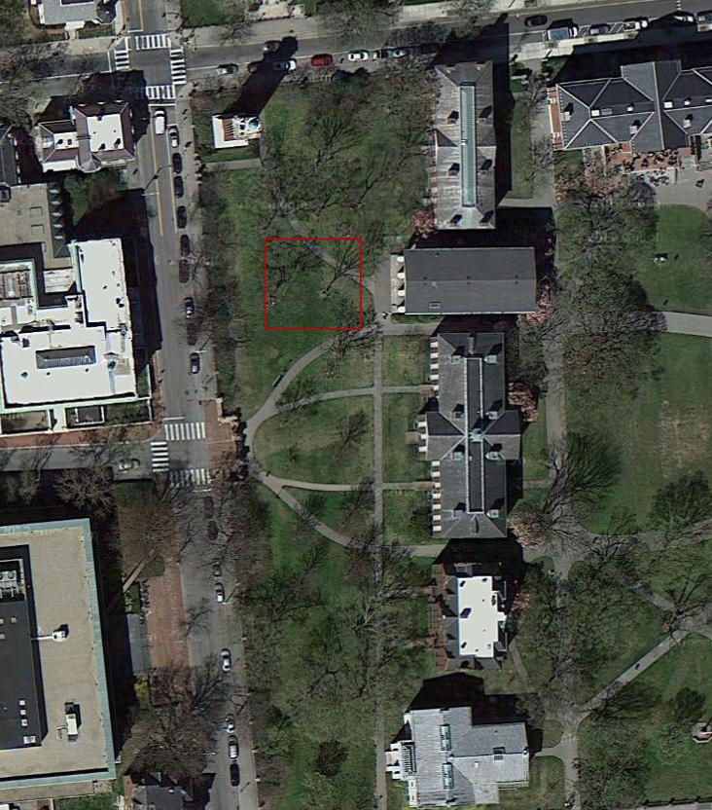

General area of old President’s house according to “Plats of Brown University”

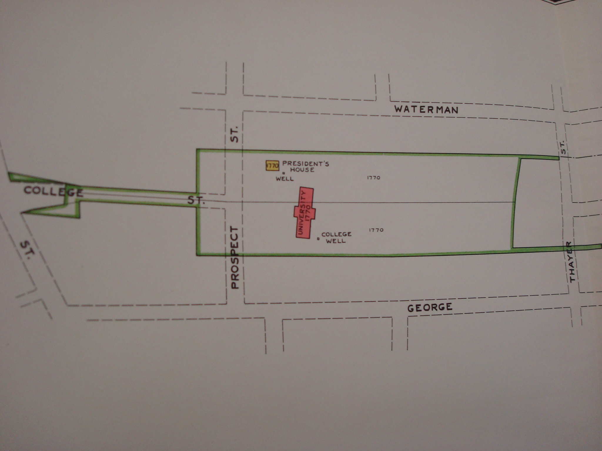

1770 Land Holdings of Brown University according to “Plats of Brown University”

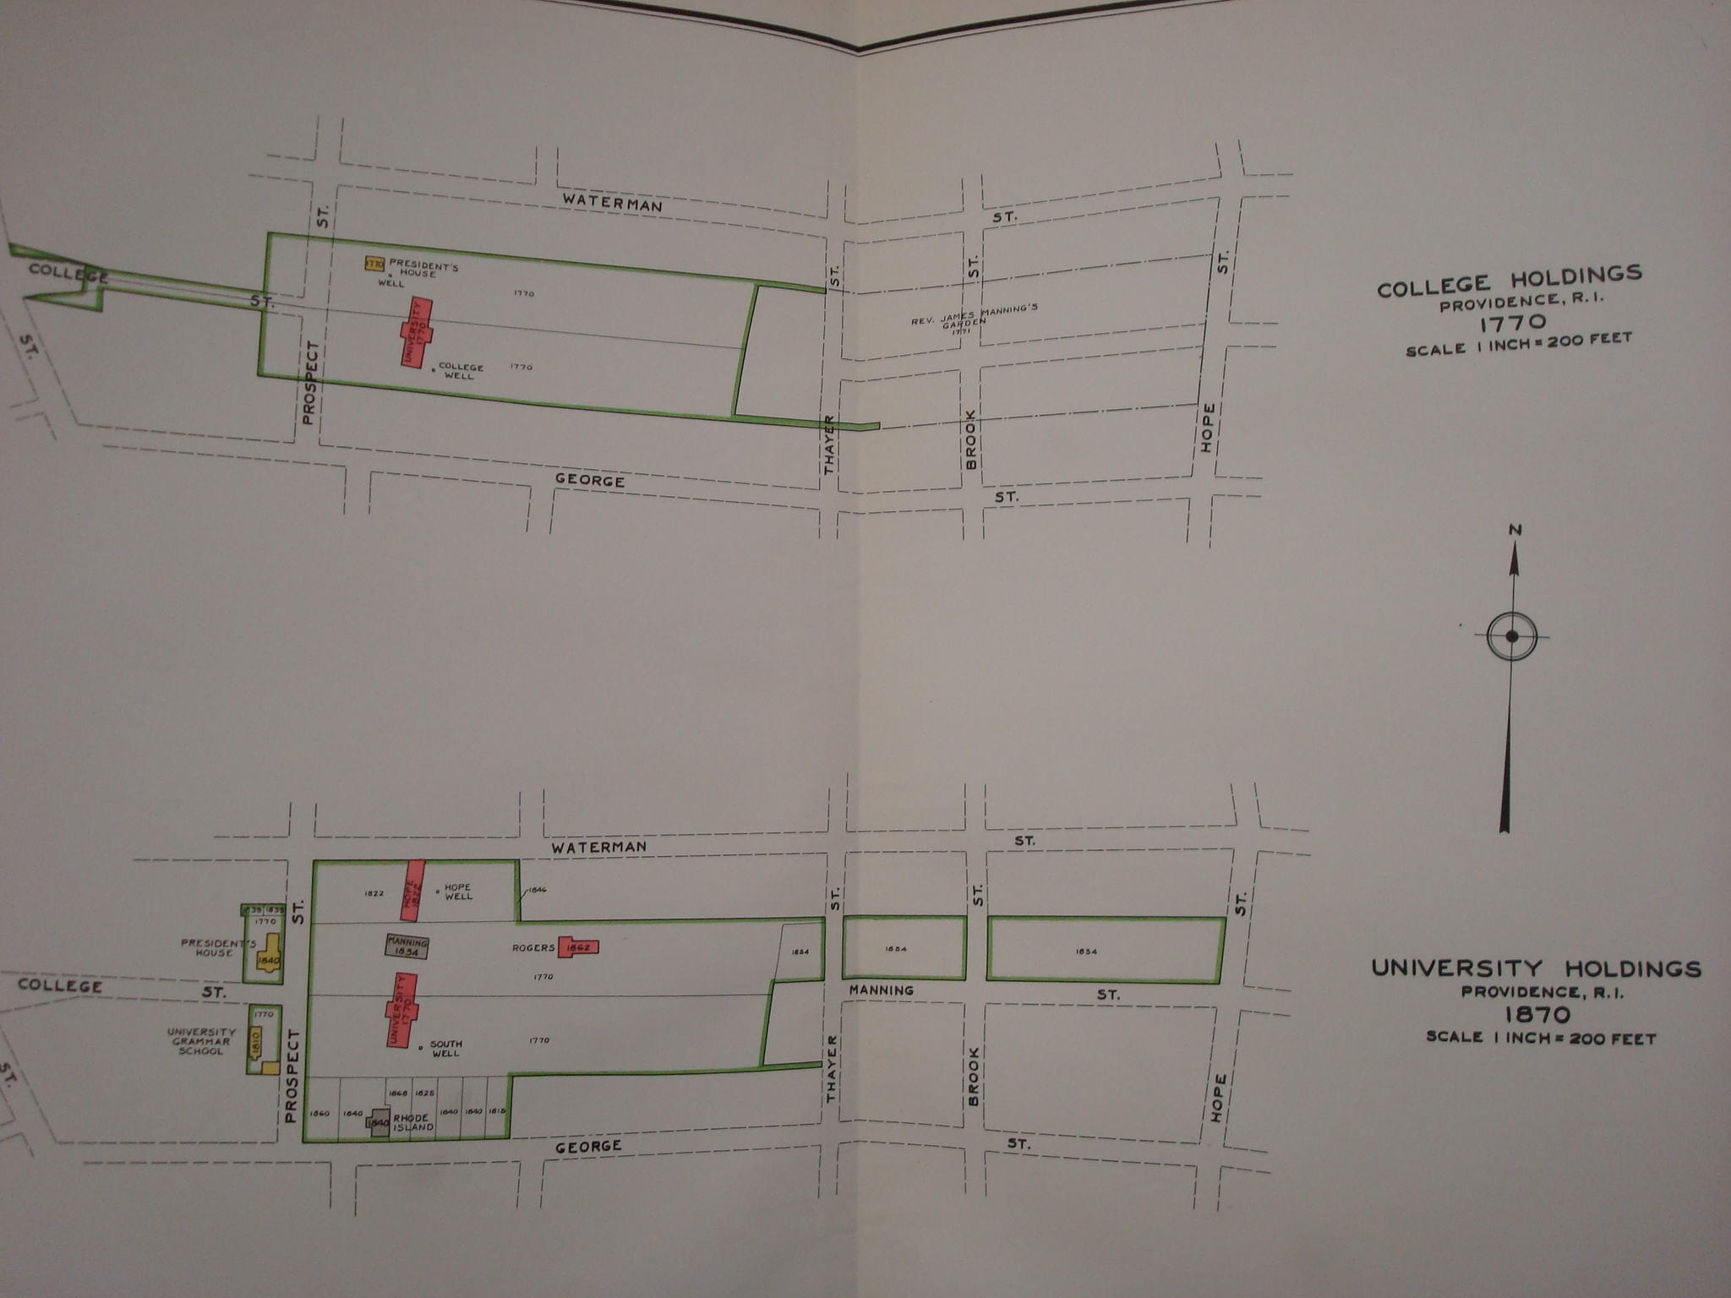

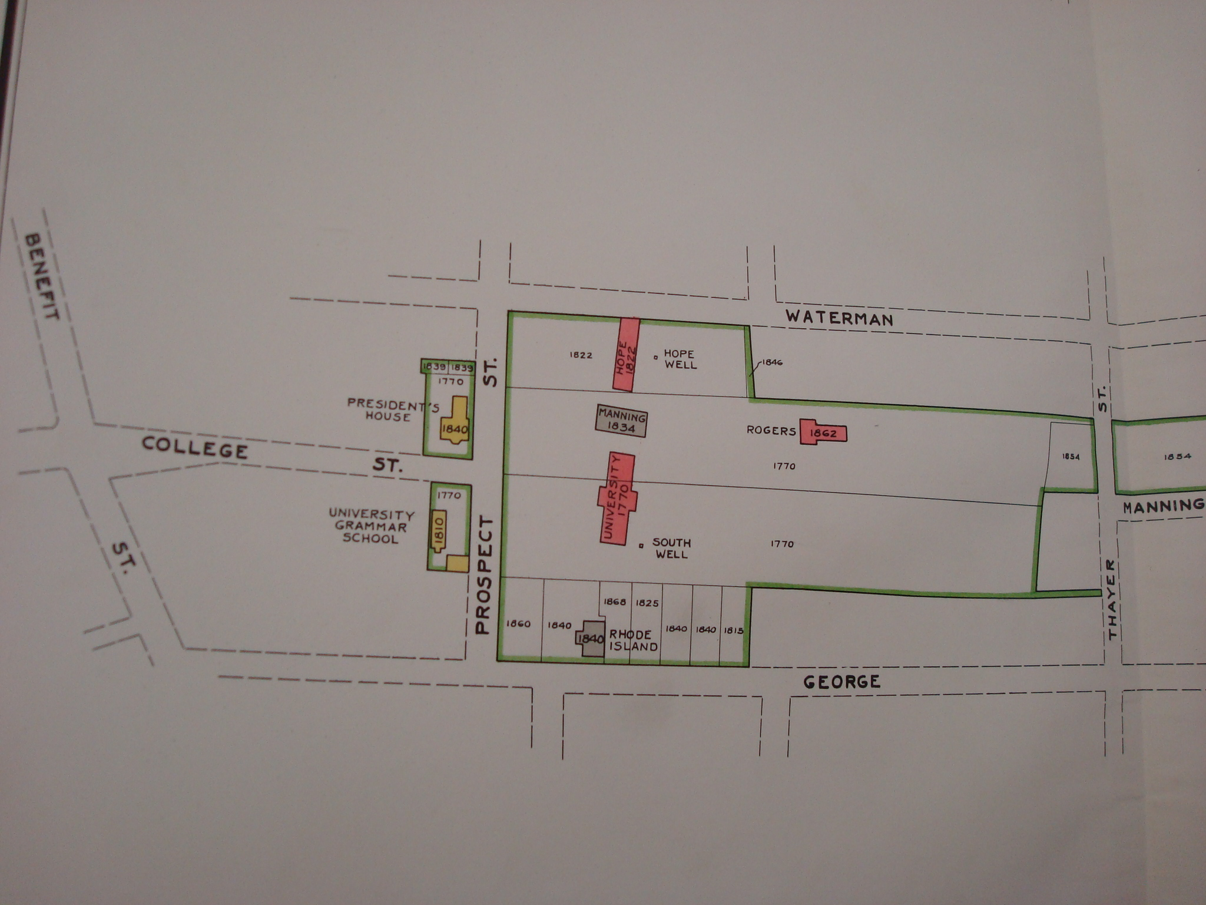

Bibliography

Bronson, Walter C.
1914 The history of Brown University, 1764-1914. Providence: The University.

Brown, Robert Perkins, Henry Robinson Palmer, Harry Lyman Koopman, and Clarence S. Brigham
1909 Memories of Brown; traditions and recollections gathered from many sources.. Providence, R.I.: Brown Alumni Magazine Co.

Burlingame, Edwin A.
1938 Plat of the Rhode Island College property of 1770, and plats of the succeeding Brown University properties in 1870, 1904 and 1938: together with an abridged history of these properties. Providence: [The University].

Guild, Reuben Aldridge
1864 Life, times, and correspondence of James Manning, and the early history of Brown University. Boston: Gould and Lincoln.

Mitchell, Margaret
1993 "President's House." Encyclopedia Brunonia. www.brown.edu/Administration/News_Bureau/Databases/Encyclopedia/search.php?serial=P0390 (accessed September 18, 2012).

Robert, Emien
2012 "Images of Brown."Brown University Library. N.p., n.d. Web. 19 Sept. 2012. http://library.brown.edu/testzone/images_of_brown/emlen/

Cooke, Darius Sesions, Joseph Russell
1771 “The College to Nicholas Brown and Company”
Rhode Island College miscellaneous papers, MS-1E-1, Brown University Archives.

