Ariana Gunderson

Archaeology of College Hill

**Excavation Site Proposal: Original President’s House**

An excavation on the north side of the Quiet Green could provide archaeological information about several aspects of Brown’s history, most notably regarding the original President’s House. With a relatively small written history, the archaeological record of this building would significantly add to the known history of Brown University.

**History**

The original President’s House was built in 1770, located northwest of the College edifice.[1] The President’s House remained in this location until 1840, when a new President’s House was built at the corner of College and Prospect and the original house was moved down College Street to the property of Charles Potter.[2] The University Archives do not contain much information about the original President’s House, excepting its general location.

**Additional Features of the Site**

The northern side of the Quiet Green has been home to more than just Brown’s first presidents. Originally called the Front Campus, what is now the Quiet Green was once the main greenspace for Brown’s campus, and has thus been the site of many other structures important to the history of Brown University.

The most prominent feature of the northern Quiet Green is Carrie Tower. The tower was built in 1904 by Paul Bajnotti as a memorial for his wife, Caroline Brown, granddaughter of Nicholas Brown, for whom Brown University was named.[3] The 95-foot high structure is richly decorated with fruit, urns, and most notably, clocks.[4] Guy Lowell designed the tower, and J. W. Bishop Company built the structure.[5] The tower has no utilitarian purpose but was constructed purely for the aesthetic enhancement of Brown’s campus. [6]

Located across the Quiet Green from the Carrie Tower is Hope College. As the second oldest building on Brown’s Providence campus, Hope College and its surroundings represent some of Brown’s earliest history. Financed by Nicholas Brown and built by Daniel Hale and Samuel Staples in 1822, Hope College was named for Nicholas Brown’s sister and has functioned as a dormitory for the entirety of its history.[7]

**Archaeological Significance**

The opportunity to examine the residence and possessions of Brown’s first Presidents is a thrilling one, especially in light of the paucity of information on the house currently in the University Archives. With a lack of written records, the only way to acquire new information on the site is through archaeological excavations.

The original foundations for the house are most likely still underground in the house’s original location. Naturally, they may have been disturbed in the course of landscaping and construction initiatives in the area, but assuming that the remnants of house are primarily intact, material culture from the house may surface in addition to the foundation. The possessions of Brown’s first presidents, such as dishes, jewelry, tools, and other household items may remain where the house once stood.

The objectivity of the archaeological record would present an honest and vivid representation of the life of Brown’s first presidents. Four presidents resided in the original President’s House, and at least one of them owned a slave.[8] Perhaps the relationship between the president’s family and their servants or slaves would be reflected in the foundations and material culture left behind. Questions like this that are as yet unanswered by the written record could be answered through an archaeological excavation of the site.

Additionally, excavation in the area of the President’s house could reveal artifacts disposed of or lost during construction of the Carrie Tower, when the ground would have been disturbed. Though the results would be interesting in their probable relationship to construction at the turn of the century, excavating exclusively in the immediate vicinity of the tower would most likely not provide extensive evidence relating to daily life because of the tower’s exclusive role as an aesthetic addition to the Green. Objects lost, dropped, or buried by students over the years may be uncovered in an excavation, but the tower was not the site of many day-to-day activities.

An excavation of the area surrounding Hope College would yield material culture from the time of its initial building as well as possibly from the period of renovation in 1891, during which the cellar was dug, or from 1959 when the building was once again reconstructed.[9] Additionally, as with the vicinity of the Carrie Tower, the area surrounding Hope College might contain artifacts dropped by students over the years, especially from the time in which the Quiet Green served as the major greenspace for the University. The former exit, now blocked off, should be particularly rich in artifacts due to its higher rate of traffic during the time of its use.

**Logistical Concerns**

In order to excavate in the location with the highest potential for success, the exact location of the President’s House must be confirmed. According to a plat of the college’s buildings and lands in 1770, the southwest corner of the President’s House was 57.14 ft west and 40.74 ft east of the northwestern most corner of the original College Edifice (now University Hall) and was approximately 36 ft by 26 ft.[10]

To confirm the location of the house, a geophysical survey of the area might reveal the remains of the house’s foundations. Additionally, a well associated with the President’s House is also located on the plat. This well’s location might be noted on more recent maps of the area made by the planning office, and from there the location of the original house could be confirmed.

Digging in this location would be extremely convenient. The Quiet Green is centrally located with regards to the campus at large. Additionally, security would not pose significant problems because there is so little traffic and student activity in the area. The northern section of the Quiet Green is nearly entirely free of underground wires and pipes, significantly simplifying the logistics of choosing a specific trench site. The only significant obstructions in the soil are the gas line passing in front of Hope College and sidewalks cutting through the area.

Modern landscaping may have shifted soils surrounding the foundation of the President’s House so severely as to contaminate the possible information gained through excavation. Similarly, the construction of the Carrie Tower and laying of modern sidewalks may have also affected the position of the President’s House original foundation.

**Further Research**

Having the blueprints for the original President’s House would, of course, enable a more targeted excavation of the area. With an understanding of how the house was structured, a specific area of interest could be explored. Additionally, in order to determine the best possible trench locations, more precise data about landscaping in the area and renovations of University Hall and Hope College must be sought out.

**Conclusions**

Conducting an excavation in the area surrounding the original President’s House could produce archaeological information about several aspects of University history. In addition to discovering information about the original President’s House, a subject about which the University Archives have few written records, an excavation might uncover material culture from the construction and use of Hope College and Carrie Tower. The northern side of the Quiet Green is conveniently located in central campus and is nearly free of underground obstructions, providing an ideal location for an excavation in a potentially rich archaeological site.

**Figures**

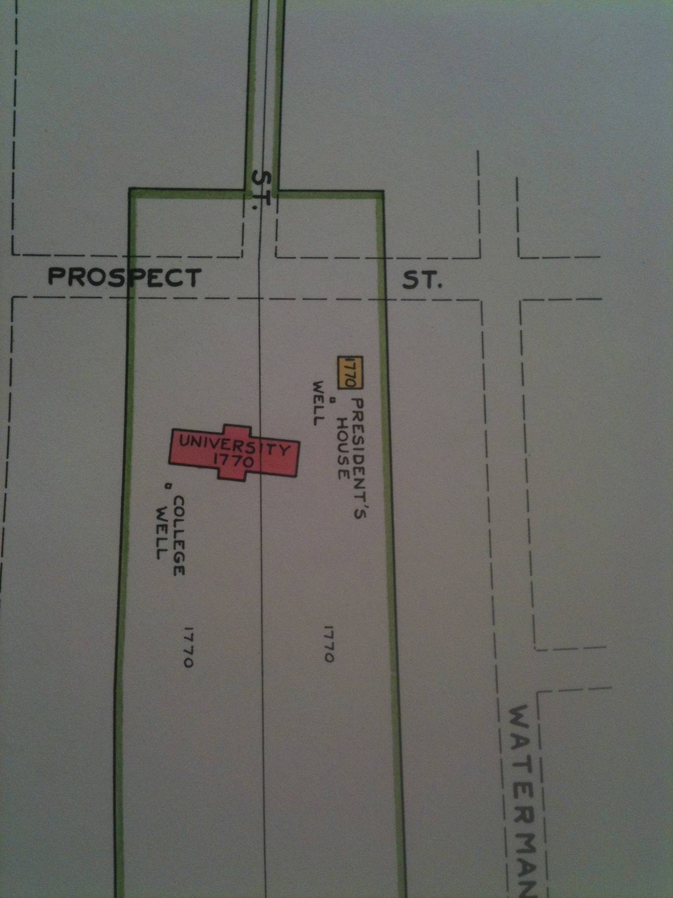

Plat 1 from Burlingame, *Plats.*

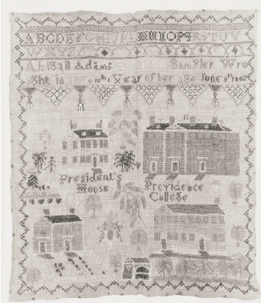

Sampler made by Abigail Adams Hobart from Phillips, *Brown University*.

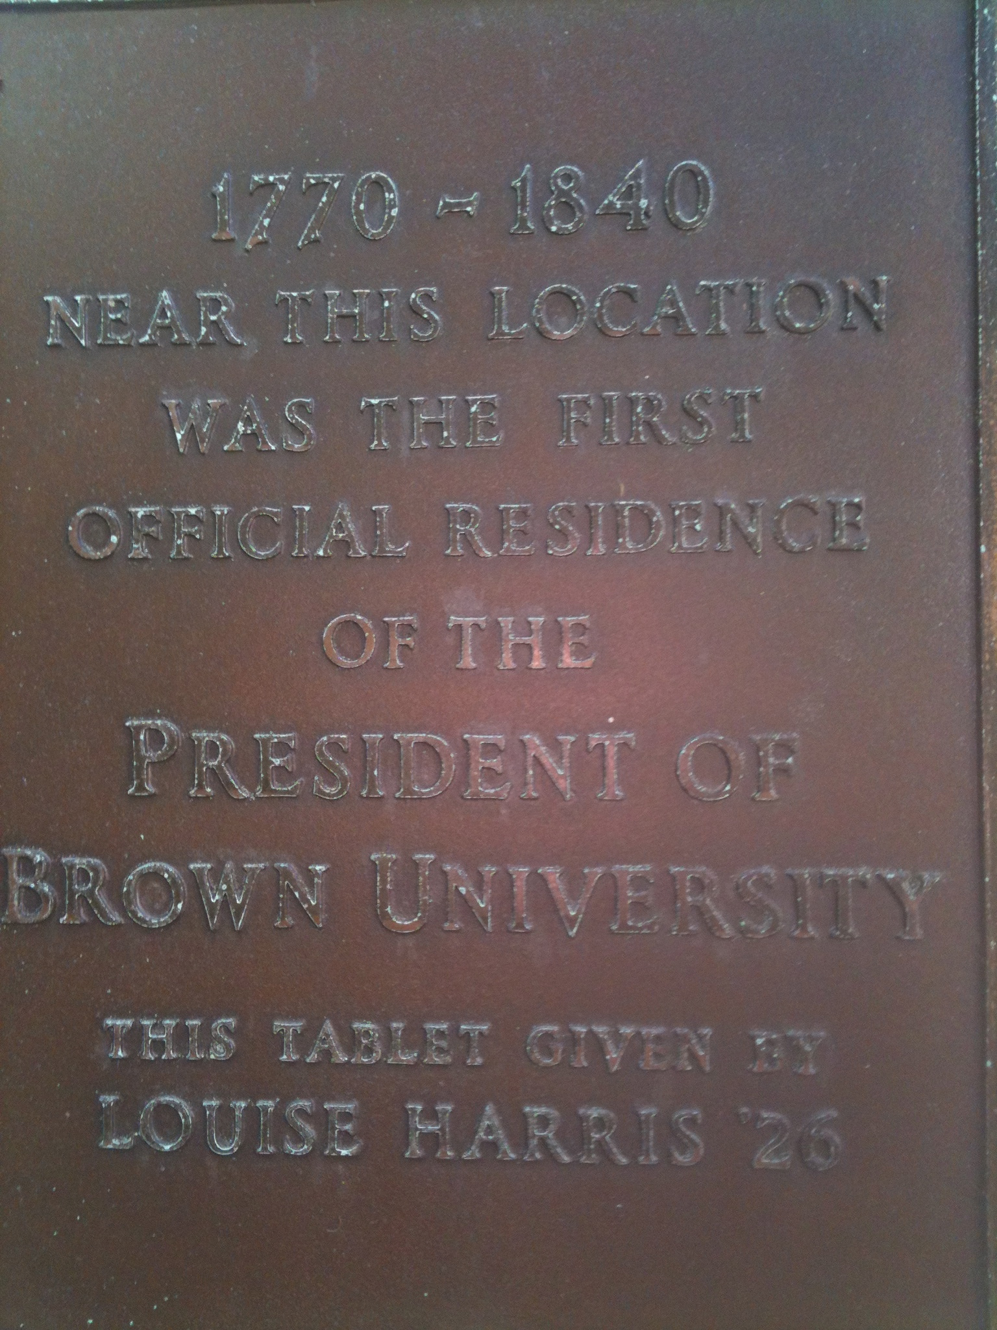

Plaque commemorating the location of the original President’s House.

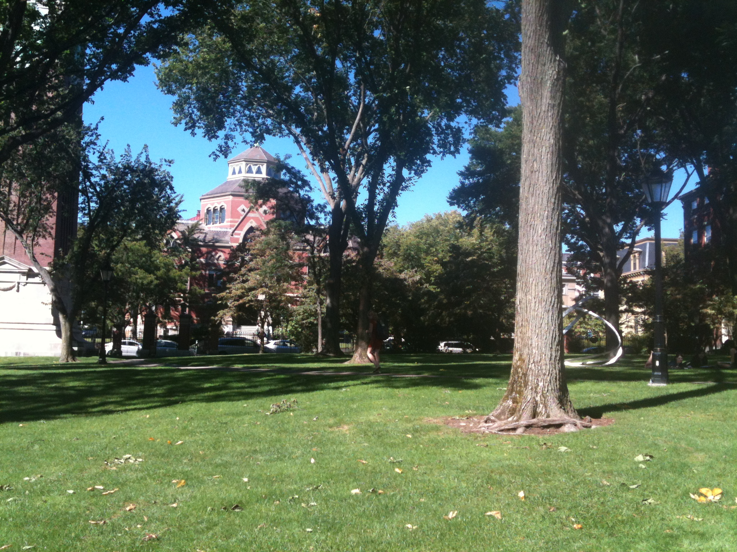

Northern Quiet Green, September 2012.

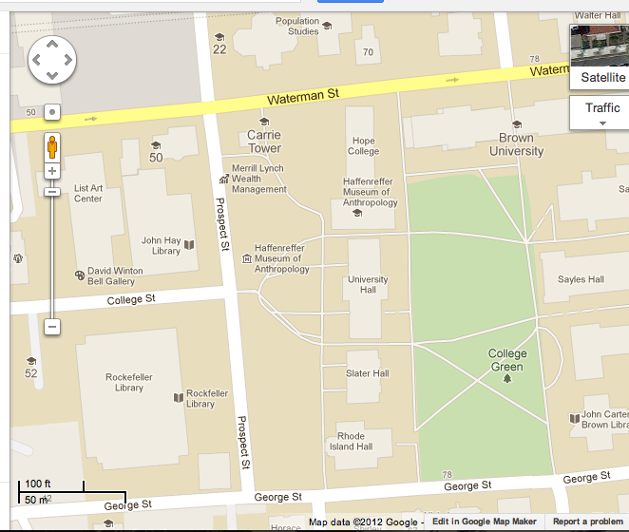

Probably location of the original President’s House, from Google Maps.

**Bibliography**

Burlingame, Edwin A. *Plat of the Rhode Island College Property of 1770 and Plats of*

*the succeeding Brown University Properties in 1870, 1904 and 1938*. Providence:

The Akerman-Standard Co., 1938.

Mitchell, Martha. "Carrie Tower." *Encyclopedia Brunoniana*. Brown University

Library, 1993.

Mitchell, Martha. "Hope College." *Encyclopedia Brunoniana*. Brown University

Library, 1993.

Mitchell, Martha. "President’s House." *Encyclopedia Brunoniana*. Brown University

Library,1993.

Phillips, Janet M. *Brown University: A Short History*. Providence: E.A. Johnson

Company, 2000.

R.M.Kliment & Frances Halsband Architects. *Campus Heritage at Brown University:*

*Preservation Priorities: February 2006.* Providence, 2006

1. Mitchell, Martha, "President’s House," *Encyclopedia Brunoniana*, Brown University Library,1993.
2. Mitchell, “President’s House.”
3. R.M.Kliment & Frances Halsband Architects. *Campus Heritage at Brown University: Preservation Priorities: February 2006,* Providence, 2006, 26.
4. Mitchell, Martha, "Carrie Tower," *Encyclopedia Brunoniana*, Brown University Library, 1993.
5. Mitchell, “Carrie Tower.”
6. Mitchell, “Carrie Tower.”
7. Mitchell, Martha, "Hope College," *Encyclopedia Brunoniana*, Brown University Library, 1993.
8. Phillips, Janet M., *Brown University: A Short History*, Providence: E.A. Johnson Company, 2000, 25.
9. Kliment, *Campus Heritage*, 26. According to the Encyclopedia Brunoniana “Hope College” entry, the cellar was dug in 1890.
10. Burlingame, Edwin A., *Plat of the Rhode Island College Property of 1770 and Plats of the succeeding Brown University Properties in 1870, 1904 and 1938*, Providence: The Akerman-Standard Co., 1938, Plat 1.