Fieldwork Summary for October 22, 2012

Christopher Thompson and Caitlin Deal

Today Chris Kim was charged with taking pictures throughout the class period, mostly of contexts being opened and closed but also some of the work in progress.

A team consisting of Caitlin Deal, Ariana Gunderson and Peter Johnson worked with Linda on the continuation of Context 4 of QG 1, which some students had also worked on during Family Weekend.

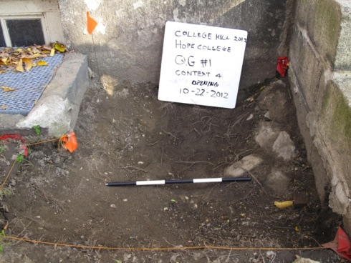

A line of rubble was evident along the south end of the trench near the stairs, so as we tried to reach the lighter-colored soil of a new context, we also defined the individual stones. These stones turned into a pile of rubble that was termed Context 5. After photographing the stones, we removed them and the level underneath became a part of Context 6.

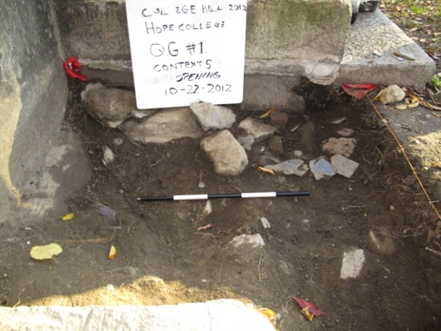

During the digging and sifting of Context 4, we had one bag for ceramics, one for glass, one for metal, one for the metal bullet, one for pieces of charcoal, and one for plastic items. The piece of plastic looks like it came from a comb, indicating that we are not yet so far into the ground that, when the items were deposited, plastic was not a popular material. The metal pieces that do not include the bullet casing are probably nails, and students are still coming up with different theories of how the bullet casings ended up in the trench, as this is the third one. There were a few pieces of particularly interesting ceramics that were different colors (blues, white, and black), and some were patterned. Most of the glass pieces were too small for us to conclude anything at their discovery, but there were a few pieces that were light green in color. Another piece that we found just before the end of class (and the closing of Context 4), was tubular in shape and larger than any of the other pieces that we had previously found. As we worked through Context 4 we could also see a long, curved, purple object within Context 6 that, unfortunately, we did not have time to excavate. Another unusual discovery was that of a hole in the southeast corner of the trench that appears to be relatively deep, which quickly got larger as we learned that the rocks and dirt around it easily came away. The hole can be seen in the picture below, near the bottom-left corner of the whiteboard.

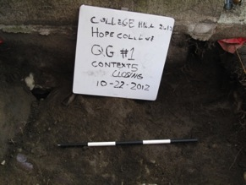

Contexts 4 and 5 were officially closed by the end of class.

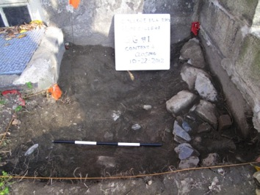 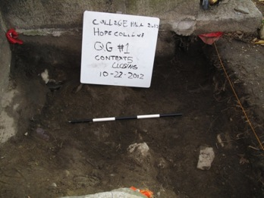

A second team opened Trench #2. This team consisted of Christopher Thompson, as recorder, Joey Mallen, Christina DiFabio, and Caity Mylchreest under the supervision of Alex Knodell. The trench is situated approximately five feet from the base of the stone steps that lead up to the western entrance (now defunct) of Hope College. The trench straddled what we assumed would have been the location of a path exiting the dormitory.

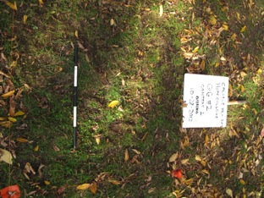

The second trench is labeled GQ #2, indicating trench #2 on the “Quiet Green.” It is 1 meter by 1 meter. The total station coordinates corresponding to the northeast corner of the trench is point 46, to the southeast corner is point 47, to the southwest corner is point 44 and to the northwest corner is point 45. Morgan Albertson took the total station points.

Excavation began. Within the first couple of centimeters we found three pennies dating from 1975, 1980, and 1982. The third penny was found in the southeast corner of the trench and is pictured below.

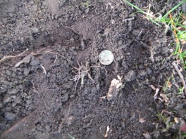

There was an extensive root network of small roots, as well as several thicker ones, which were cut with larger shears. The soil was consistently compact below the first couple of centimeters of soil, and had to be scraped away. We used a sifter with ¼’’ mesh and found many pieces of glass, some pieces of plastic trash including a striped plastic straw, a few small pieces of ceramic, a nail, and a shell.

The discovery of a greater concentration of objects prompted us to close context #1. Of particular interest we found directly east of the center of the trench a piece ceramic with blue design. It was bagged as “ceramic.”

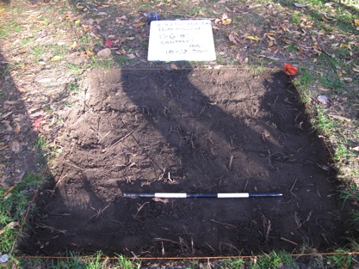

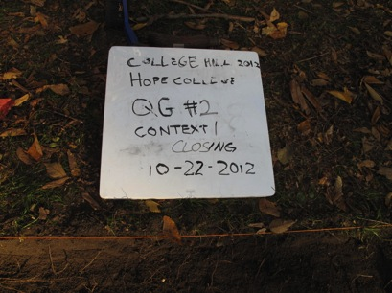

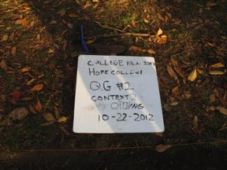 We opened context 2.

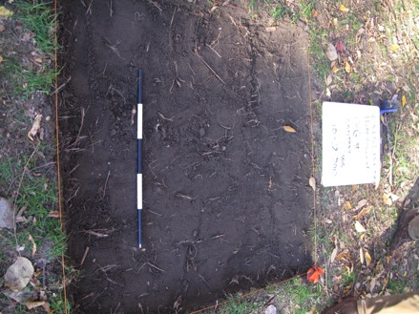

Time limited us to a few centimeters of excavation of context #2. Extensive roots still crisscrossed the trench and had to be cut away. There was a greater number of small rocks and glass fragments than in the context #1. We found a stone that looked similar to obsidian, although Alex Knodell expressed doubt of it actually being obsidian. We ended the excavation soon after, as the class was over for the day. The trench was covered in a plastic tarp.