Morgan Albertson, Eddie Cleofe

11/7/12

***Week 9 Fieldwork Summary***

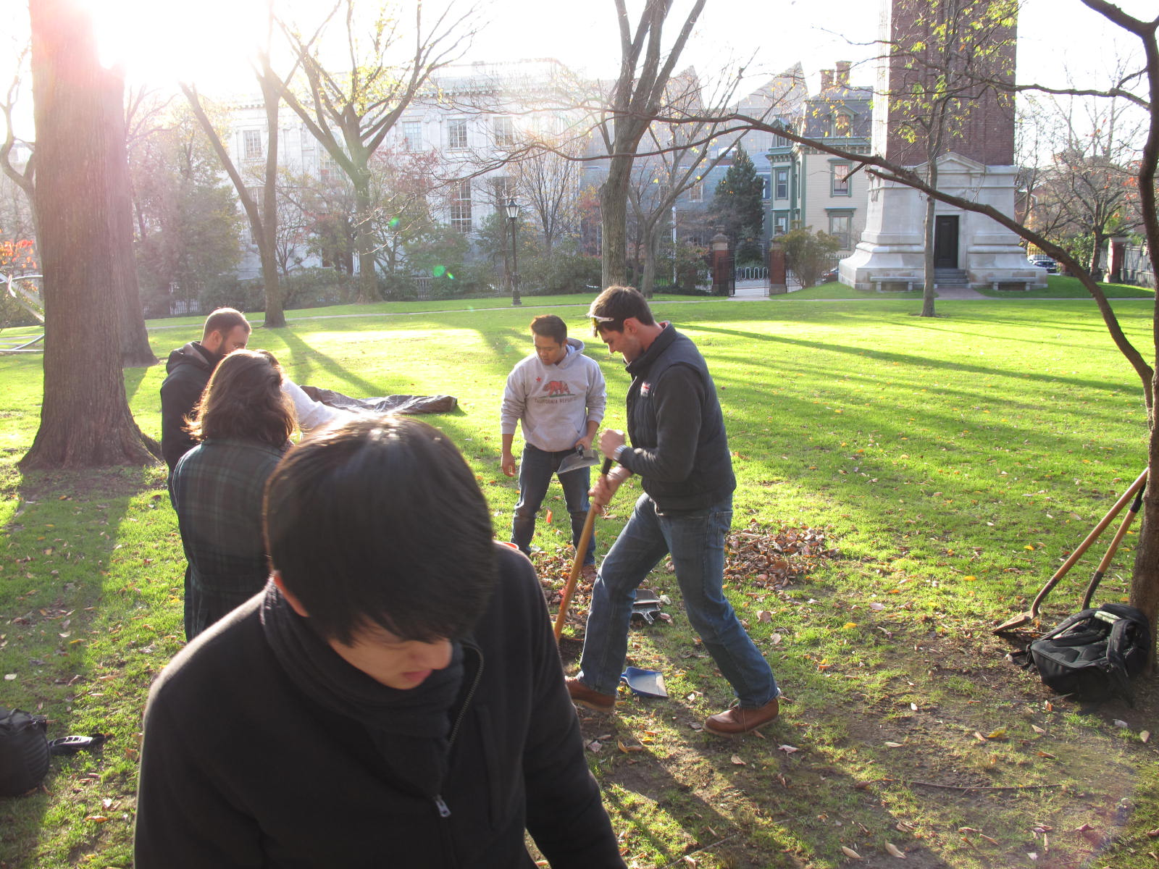Excavation for the week of October 29th was canceled because of hurricane Sandy, which resulted in strong winds and heavy rain in Providence. We were able to continue with our excavation on the Quiet Green on November 5th.

Pete Johnson was in charge of taking photos this week. For QG2 he took one photo facing south for the closing of context 2 and opening of context 3. For QG1, Pete took six photos, all facing east. These included the opening of context 6, two photos of pipes found within context 6, two photos of the closing of context 6, and the closing of context 7.

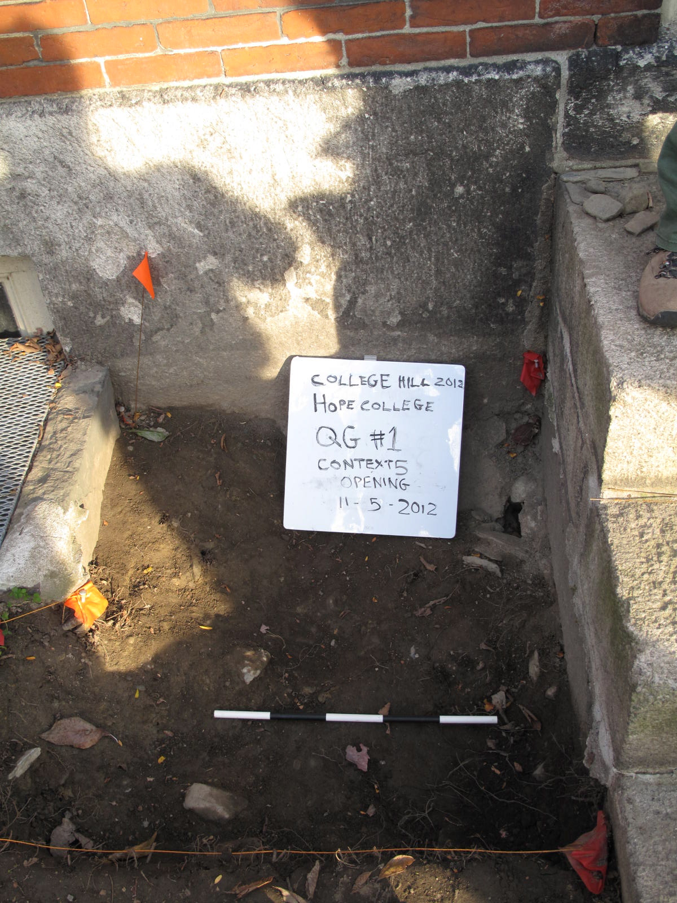

Ariana Gunderson, Peter Johnson, Caitlin Deal, and Chris Kim all worked on QG1 this week under the supervision of Linda Gosner. Excavation began with the opening of context 6.

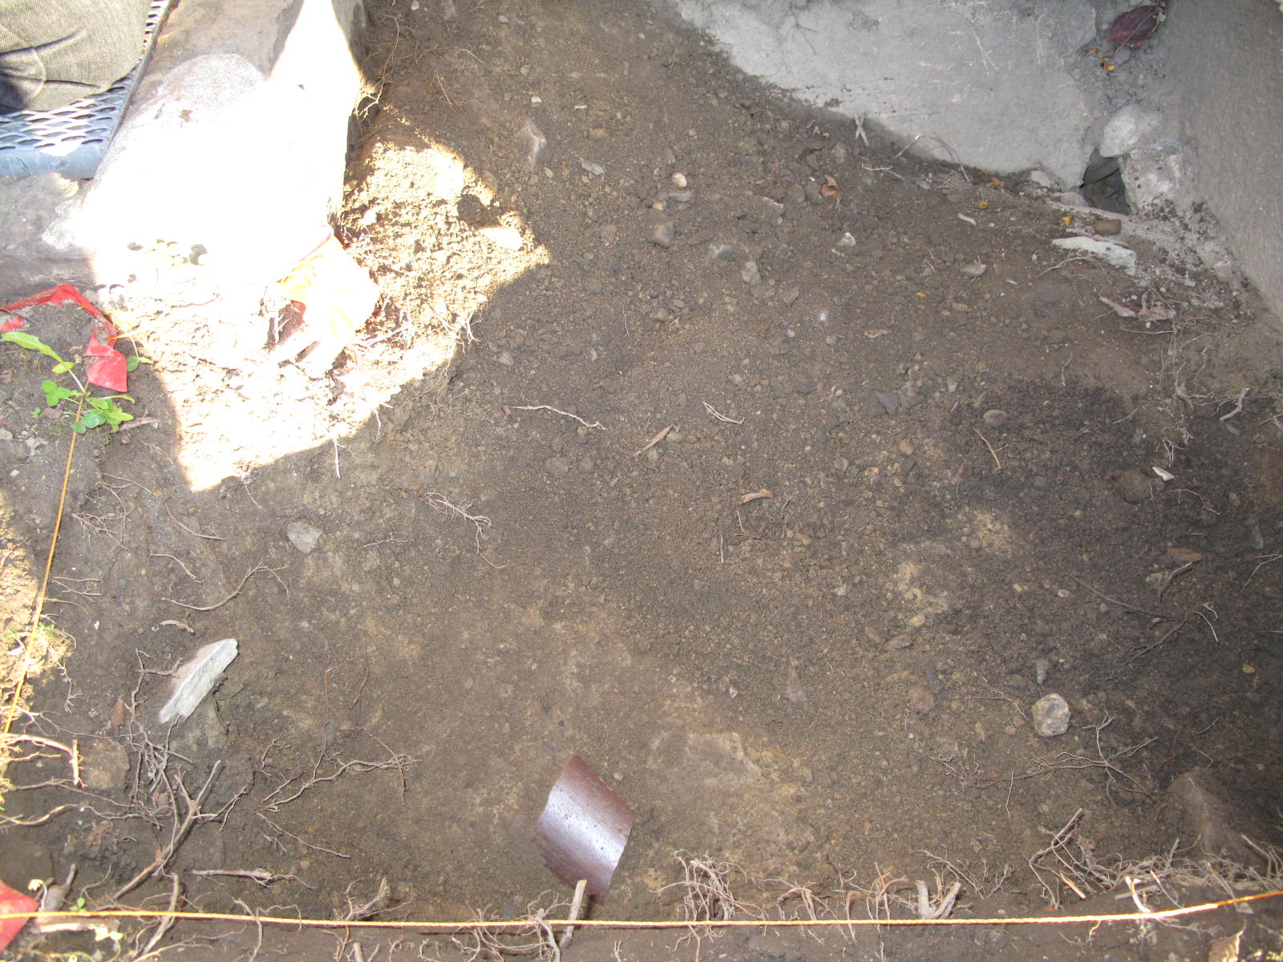Because of the hurricane, the trench was significantly more moist and full of leaves as compared to our previous field days. The soil in context 6 was characterized as sandy with many small pebbles. The excavators continued finding pieces of ceramics and glass, however the amount of glass was much less than in previous contexts. Pieces of large, glazed, purple ceramic were found and identified as a part of a ceramic pipe, most likely used for the flow of water. These large pipe pieces were scattered throughout the context. While slate has been found in previous contexts, the slate fragments found in context 6 are very large and are possibly from the old roof of the building. A lot of small pieces of charcoal were also found in context 6. Finally, the team this week found pieces of cigarette butts, the white fibrous part, in context 6. It is unclear at what rate this material degrades but the presence of organic material may indicate significant disturbance even in this layer. As the soil became gray in color with lots of pieces of rocks and brick, the team closed context 6 and opened context 7.

Morgan Albertson and Christina DiFabio took closing points with the total station of context 6 closing.

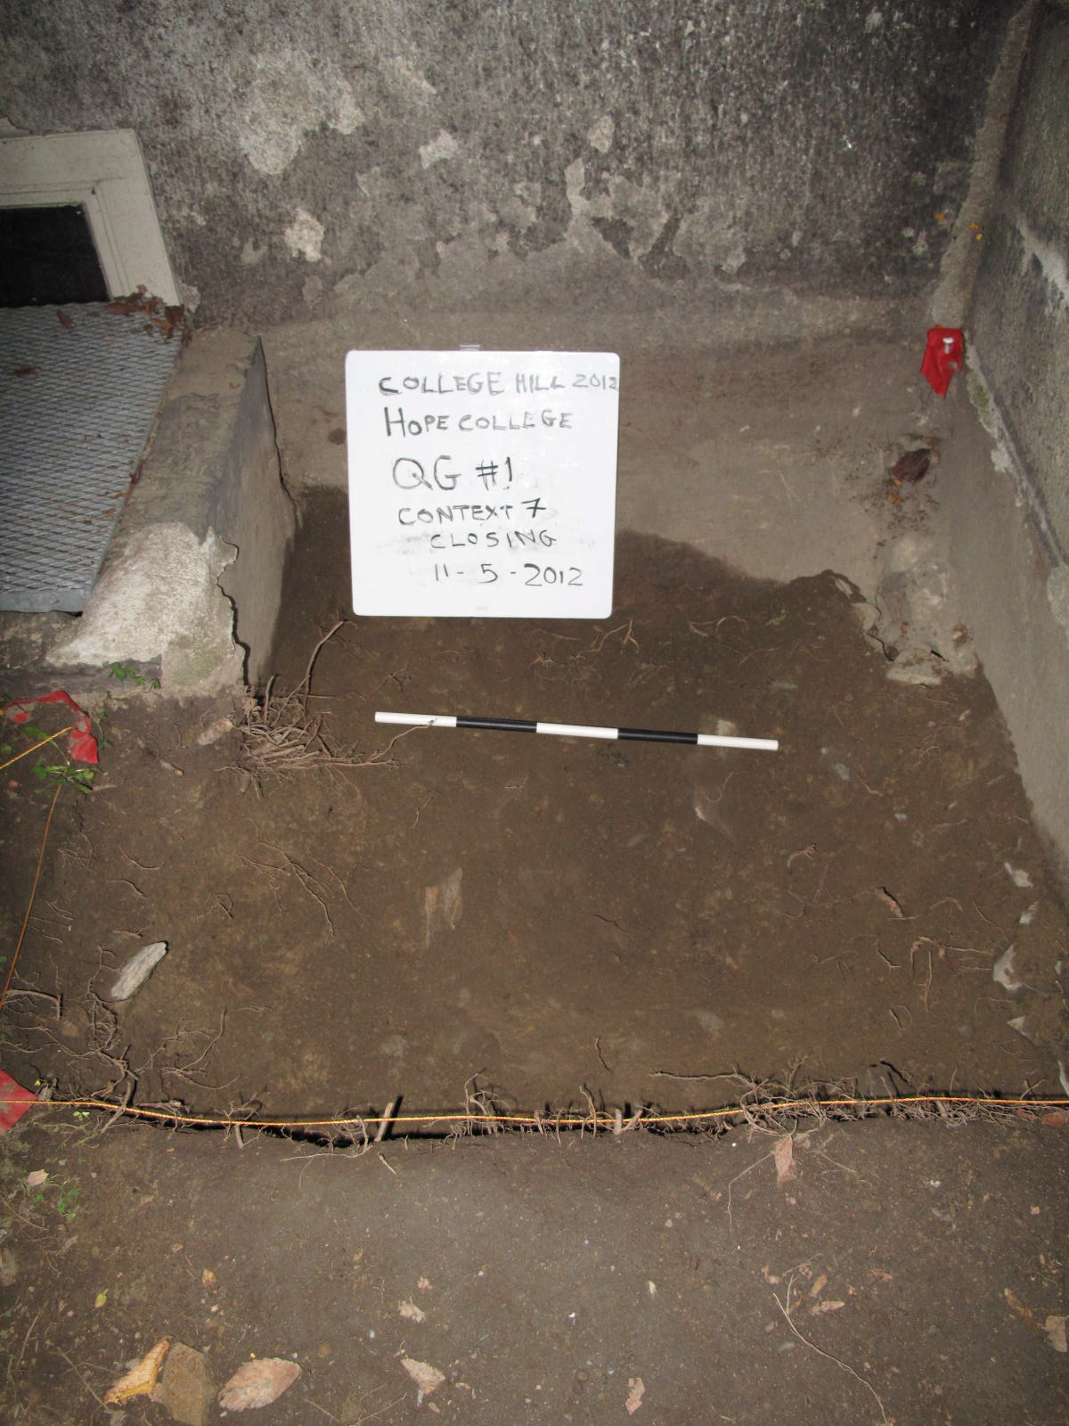

The soil of context 7 is brown with lots of gray streaks throughout and had many rock, charcoal, and brick inclusions. There was not enough time to start digging context 7 however the hole in the southeast corner of the trench was identified as a feature in this layer. We will continue to work on this layer next week.

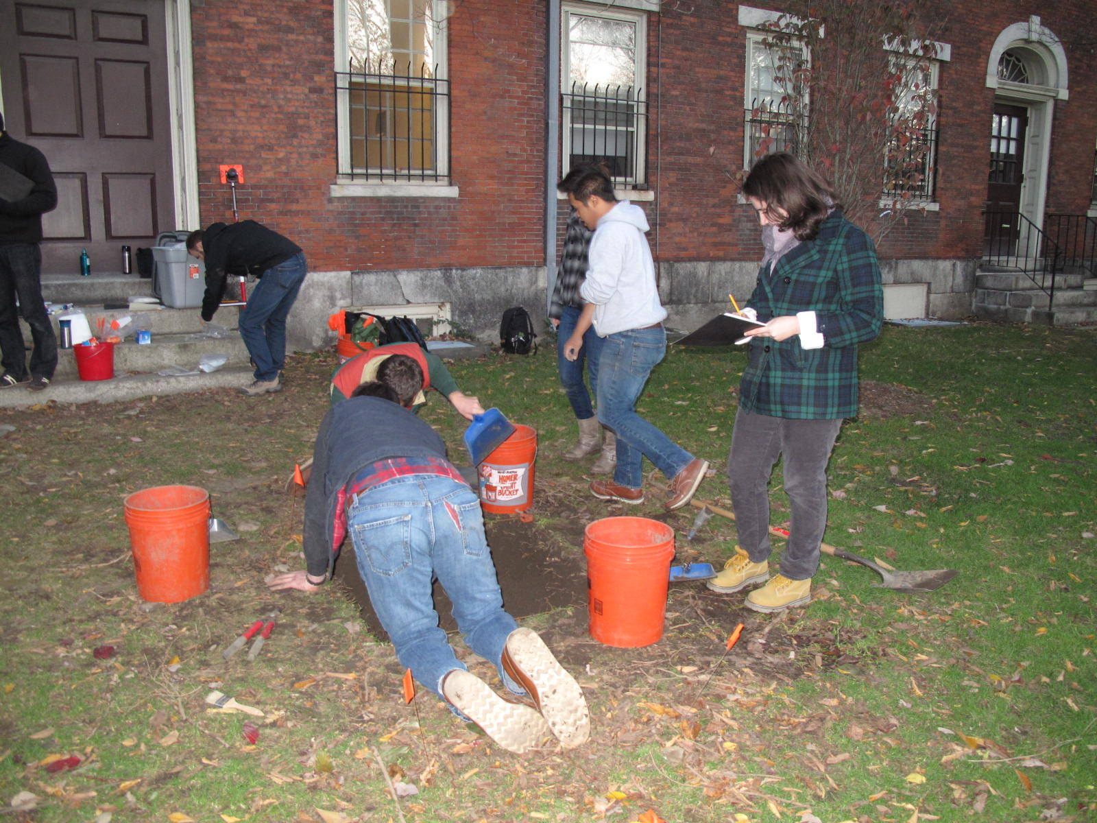

QG2 was similarly affected by Hurricane Sandy. The tarp itself was covered with a layer of wet leaves, and its removal revealed moist soil topped by more leaves. The excavation team for QG2 was composed of Caity Mylchreest as recorder, Joey Mallen, Chris Thompson, and Eddie Cleofe. Excavation began with manual removal of the leaf layer. With the bottom of the trench properly exposed, Chris Thompson and Joey Mallen removed a top layer of soil with shovels in order to more quickly excavate. Caity Mylchreest and Eddie Cleofe sifted the resultant backdirt.

Sifting revealed the same types of material culture as found in previous contexts, namely glass shards, ceramic bits, and the occasional rusty nail. A few more centimeters of digging through heavily rooted revealed the flat face of a large rock and the top of a modern irrigation pipe. Both objects were excavated around using a technique known as pedestaling, thereby leaving the soil beneath untouched and the objects where they were initially buried.

The Total Station Team, composed of Morgan Albertson and Christina DiFabio, walked the probable line of the exposed pipe and located a control valve cap. The cap was totaled in as a further reference point.

Some noteworthy items found in Context 2 are a shell and an unidentified nail or stake that has been filed to a point.

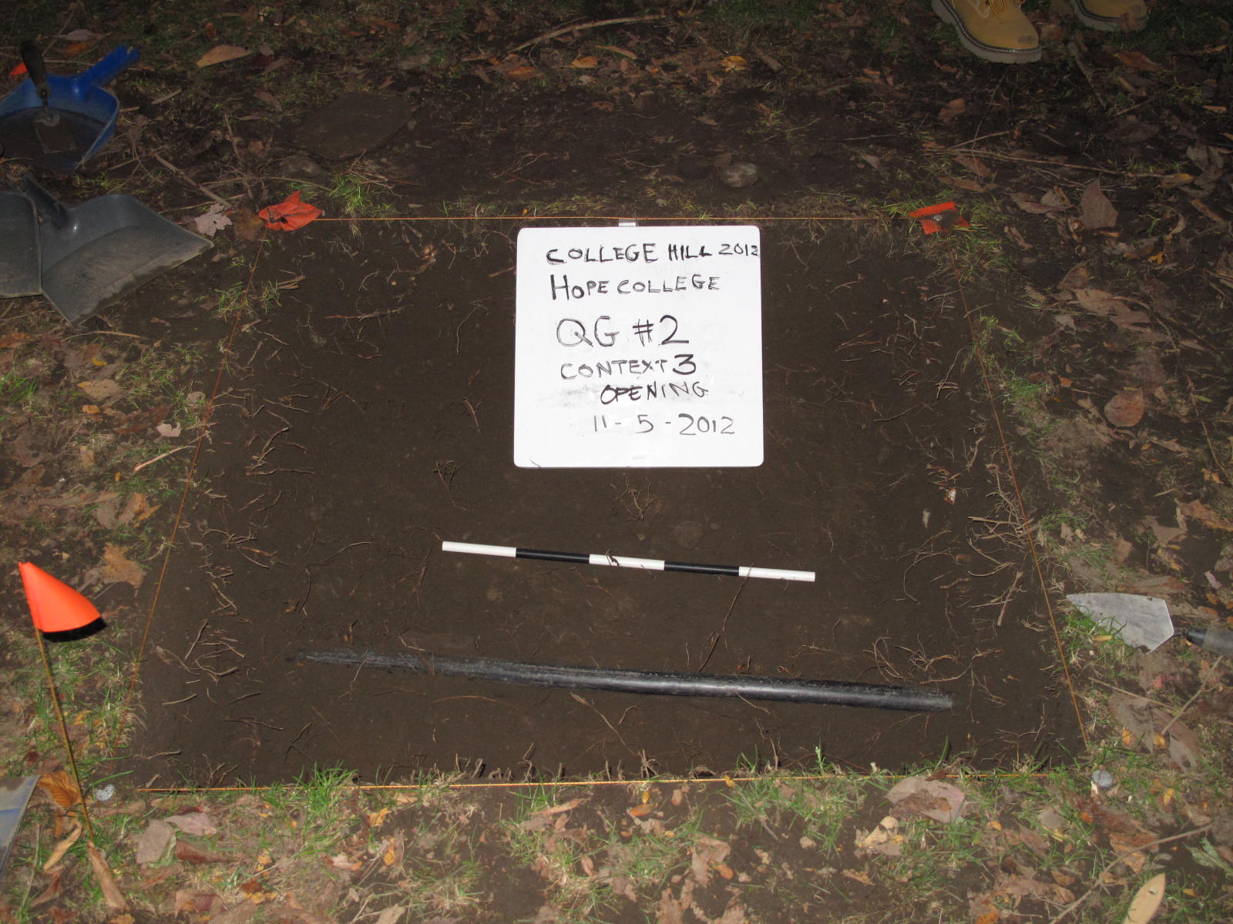As QG2 continued to be excavated, the soil at the bottom of the trench started changing in color and consistency. The soil, now more yellow and with more clay present, was the first true dramatic change in soil qualities—Context 2 was opened due to a sharply noticeable increase in artifact density.

QG2 was excavated until its entire floor was composed of the same new soil type. The Total Station Team totaled in six points, four corners and two interior, and the trench was photographed and closed.

By 5pm the sun was setting and it was getting to dark for excavation, therefore we closed the trenches and covered them with the tarps and flagged the corners.