November 12, 2012: The Last Class for Excavation by Caity Mylchreest and Joey Mallen
Morgan Albertson and Christina DiFabio worked to set up the total station. When the setup was finished, they joined the excavation teams; Morgan working on QG #1 and Christina on QG # 2. They took measurements at the end of the day, which are noted in the project field survey journal.
Ariana Gunderson, Peter Johnson, Caitlin Deal, and Chris Kim all worked on the trench Quiet Green #1 (QG #1) this week under the supervision of Teaching Assistant Linda Gosner. Excavation continued on Context 7 that was opened a week prior on November 7, 2012.
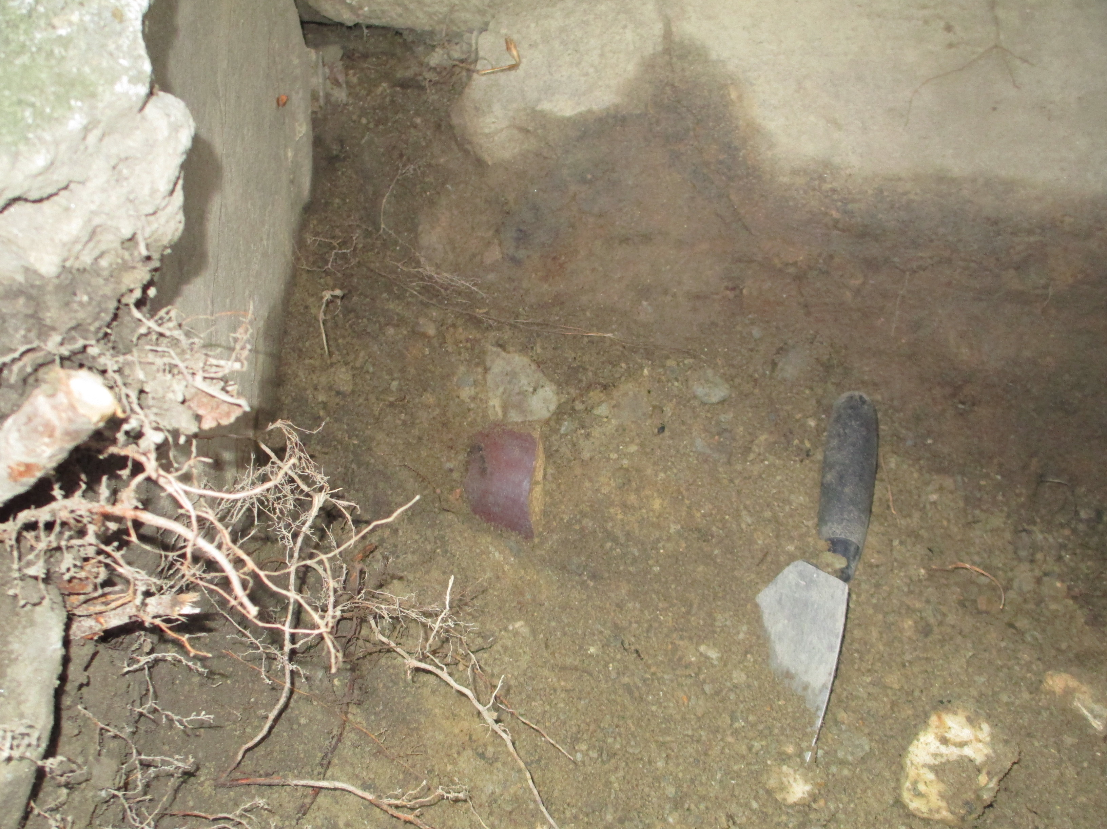
The soil in Context 7 was gray in color with many of pieces of rocks and brick. The excavators continued finding pieces of ceramics and glass, however the amount of glass was much less than in previous contexts. In this context excavators continued to find of large pieces of glazed ceramic. It can be assumed that these pieces are the remains of a ceramic pipe that was possibly used to supply water to the building. These large pipe pieces were scattered throughout this context; they were collected and placed in context bags.

Team members also continued to find pieces of grey slate fragments in Context 7. While slate has been found in previous contexts, the slate fragments found in Context 7 are significantly larger than before and are very similar to those that cover the roof of Hope College. Due to the trench’s proximity to the building, it is a definite possibility that these fragments are simply bits of old roof shingles that have fallen to the ground. Many small pieces of what was determined to be charcoal were found in Context 6 but upon further review it seems possible that these are pieces of asphalt based off of the smell of oil that they emit. Pebbles, rocks, brick fragments, and asphalt chunks dominate Context 7. It can be guessed that this layer is a layer of fill dirt or left over debris from the renovation of Hope College in 1959. Fill dirt could have been used on the Quiet Green to cover an old path. This layer of fill would have then be covered with debris filled dirt and sod laid over it.
Fill dirt is often brought in from another location therefore materials not native to the trench location can be distributed throughout the layer. Because of the presence of Brick fragments it my also be possible that this layer was the result of the renovation of the building in 1959. The building was heavily altered and it is possible that we have simply hit the layer or construction debris. Articles found in this context on November 12 include a piece of ceramic with blue deigns on it, more larger pieces of brown glazed ceramic, and a large piece of unidentified corroded metal.
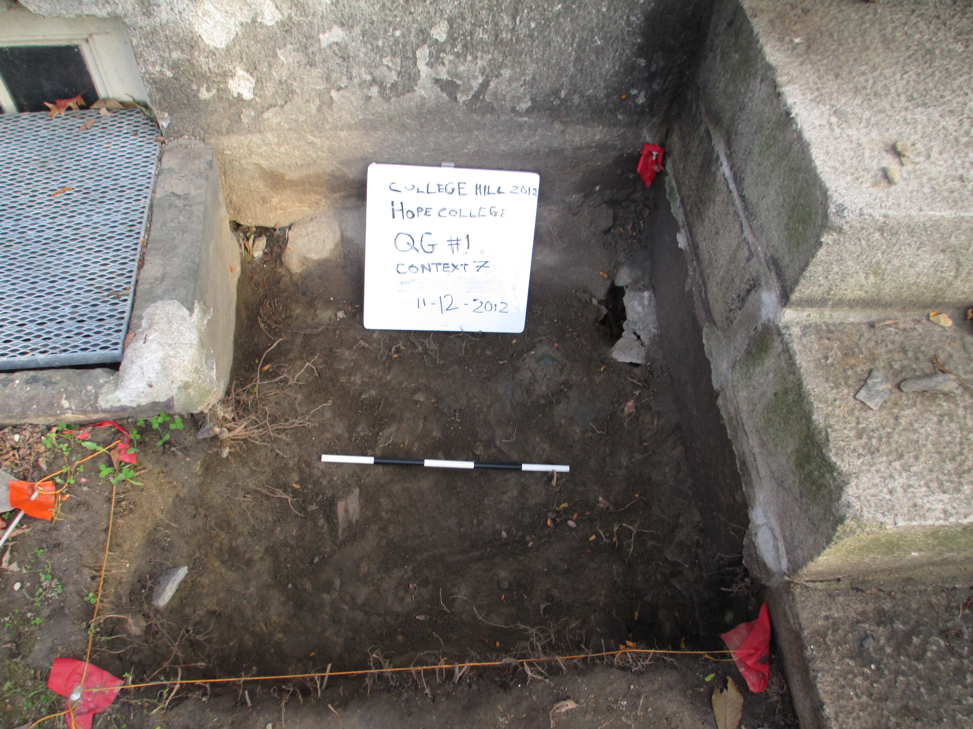
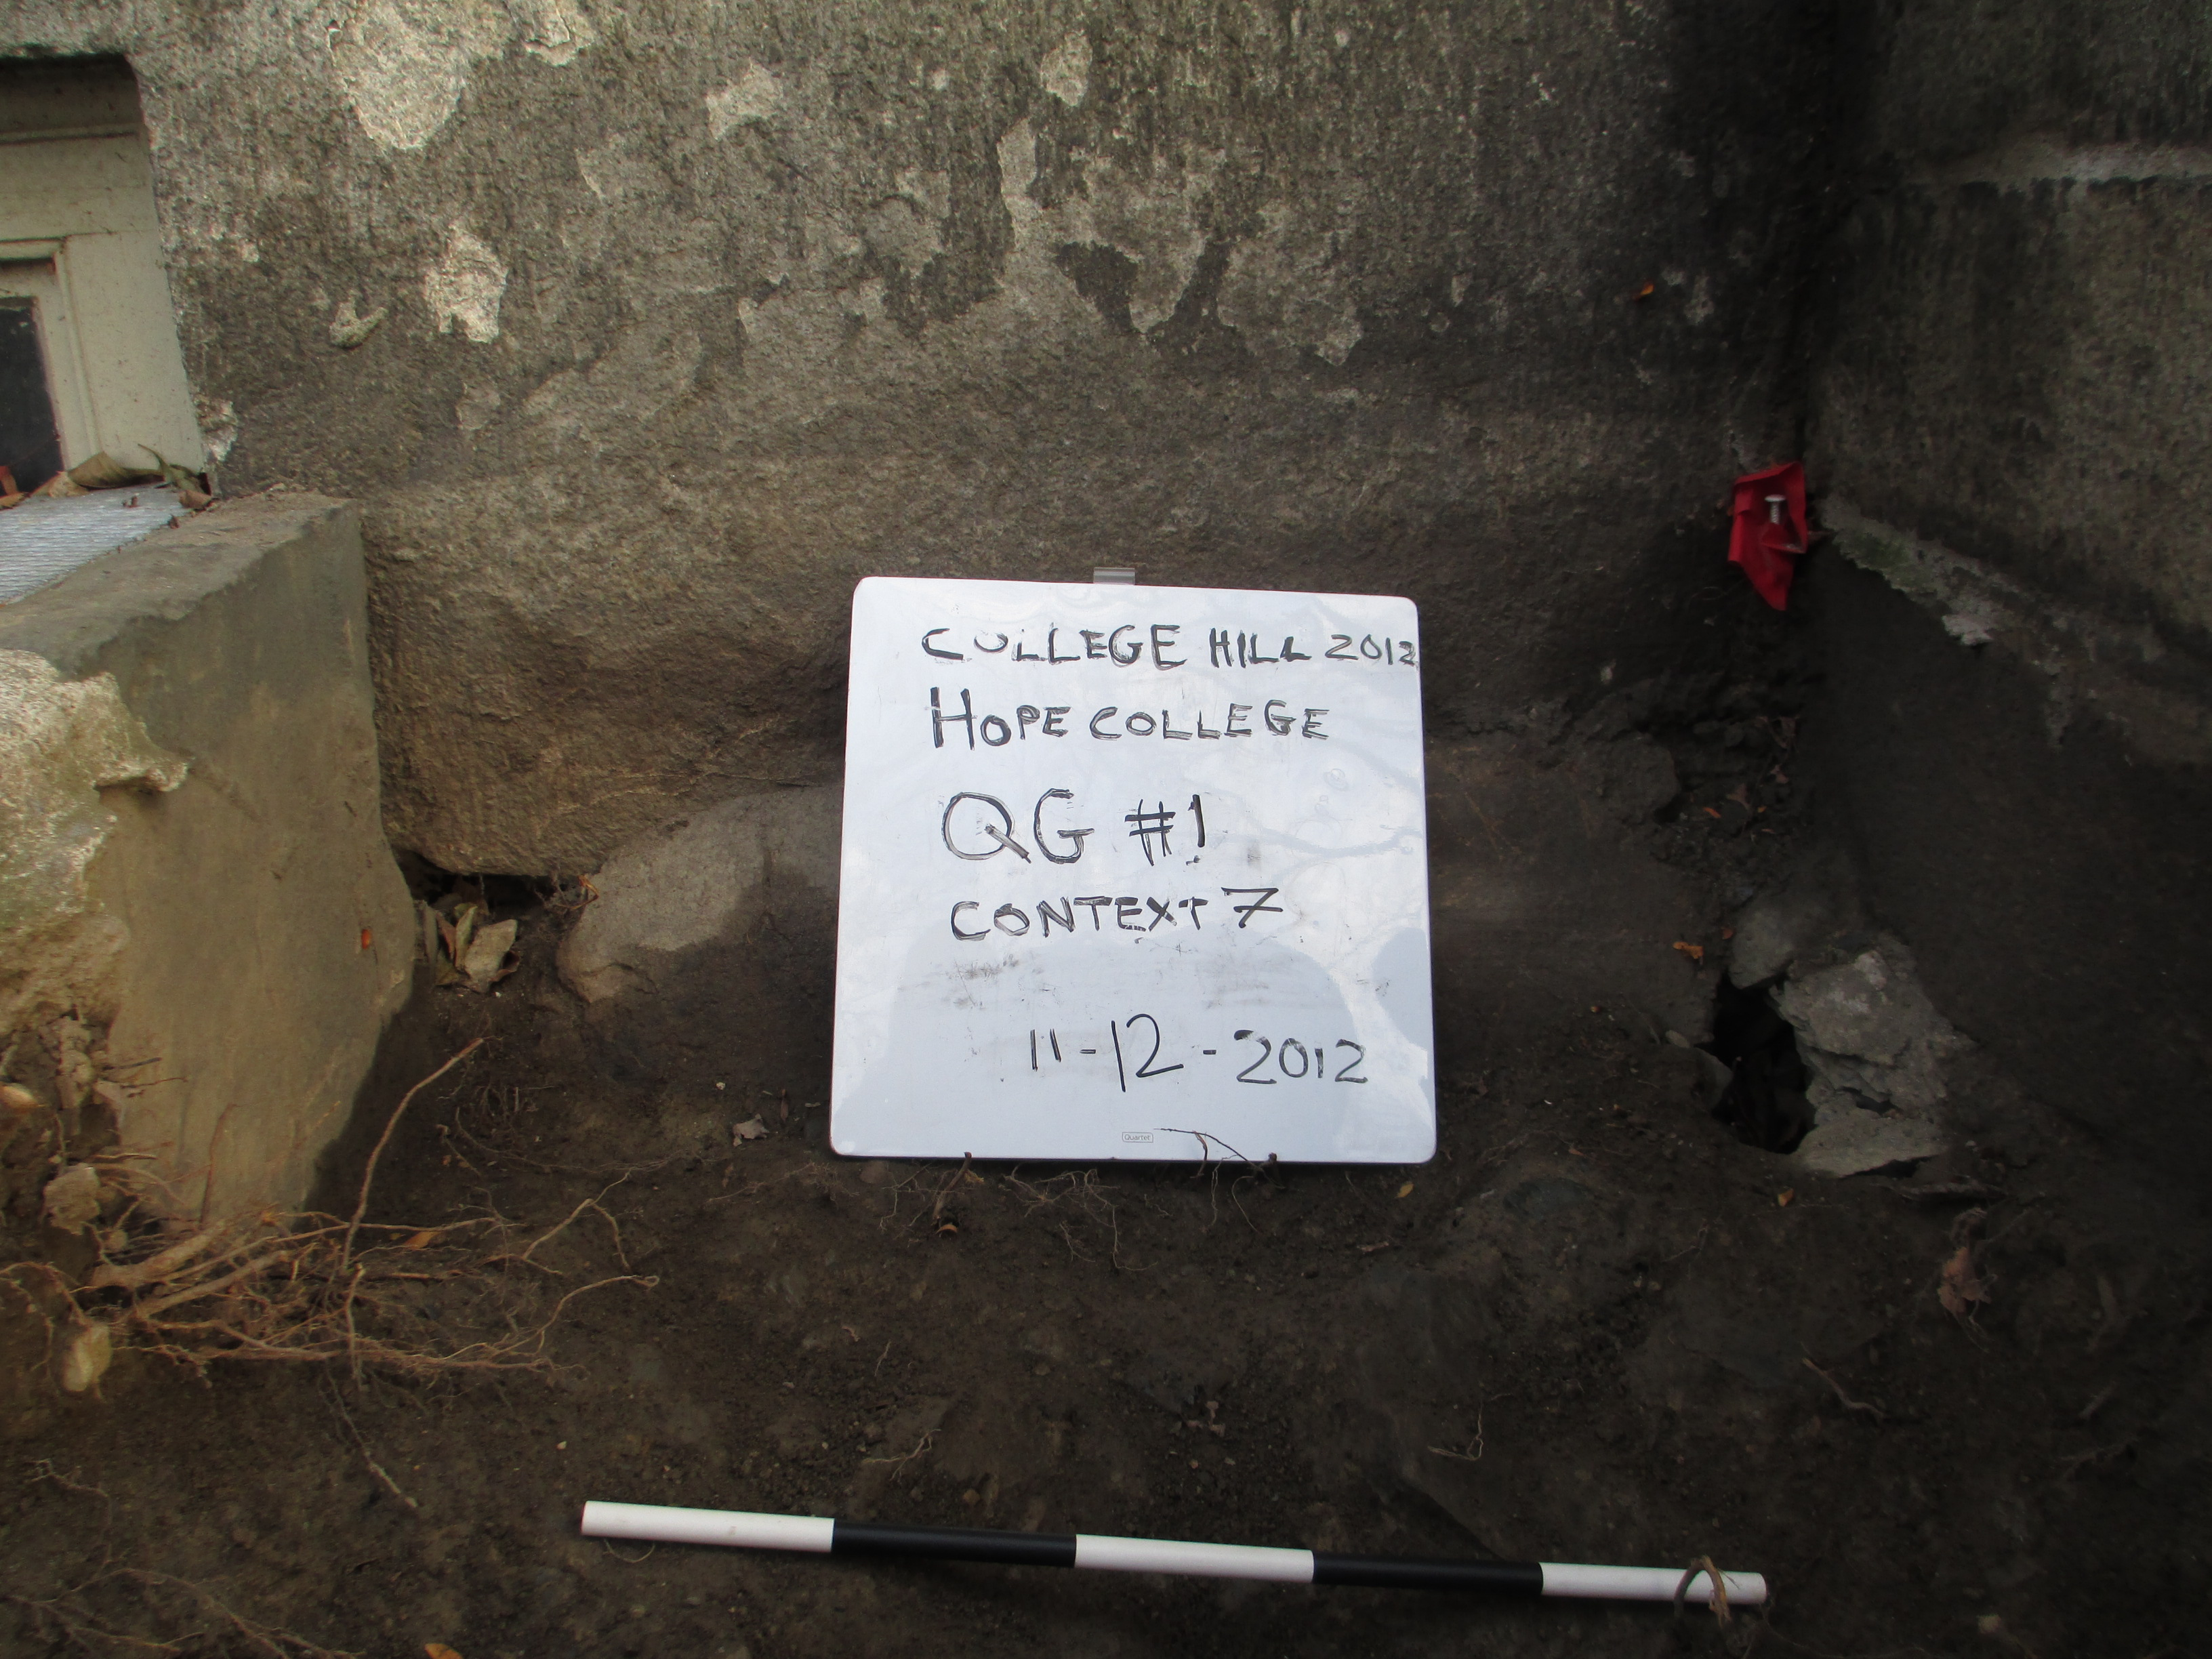

Caity Mylchreest, Joey Mallen, Eddie Cleofe, and Chris Thompson continued work on Quiet Green Trench #2 (QG #2) this week and began Context 3 after discovering a rocky sandy layer at the end of last week’s excavation. Christina DiFabio helped in the team’s progress when she was not working at the total station, and Alex Knodell oversaw the trench’s operations.
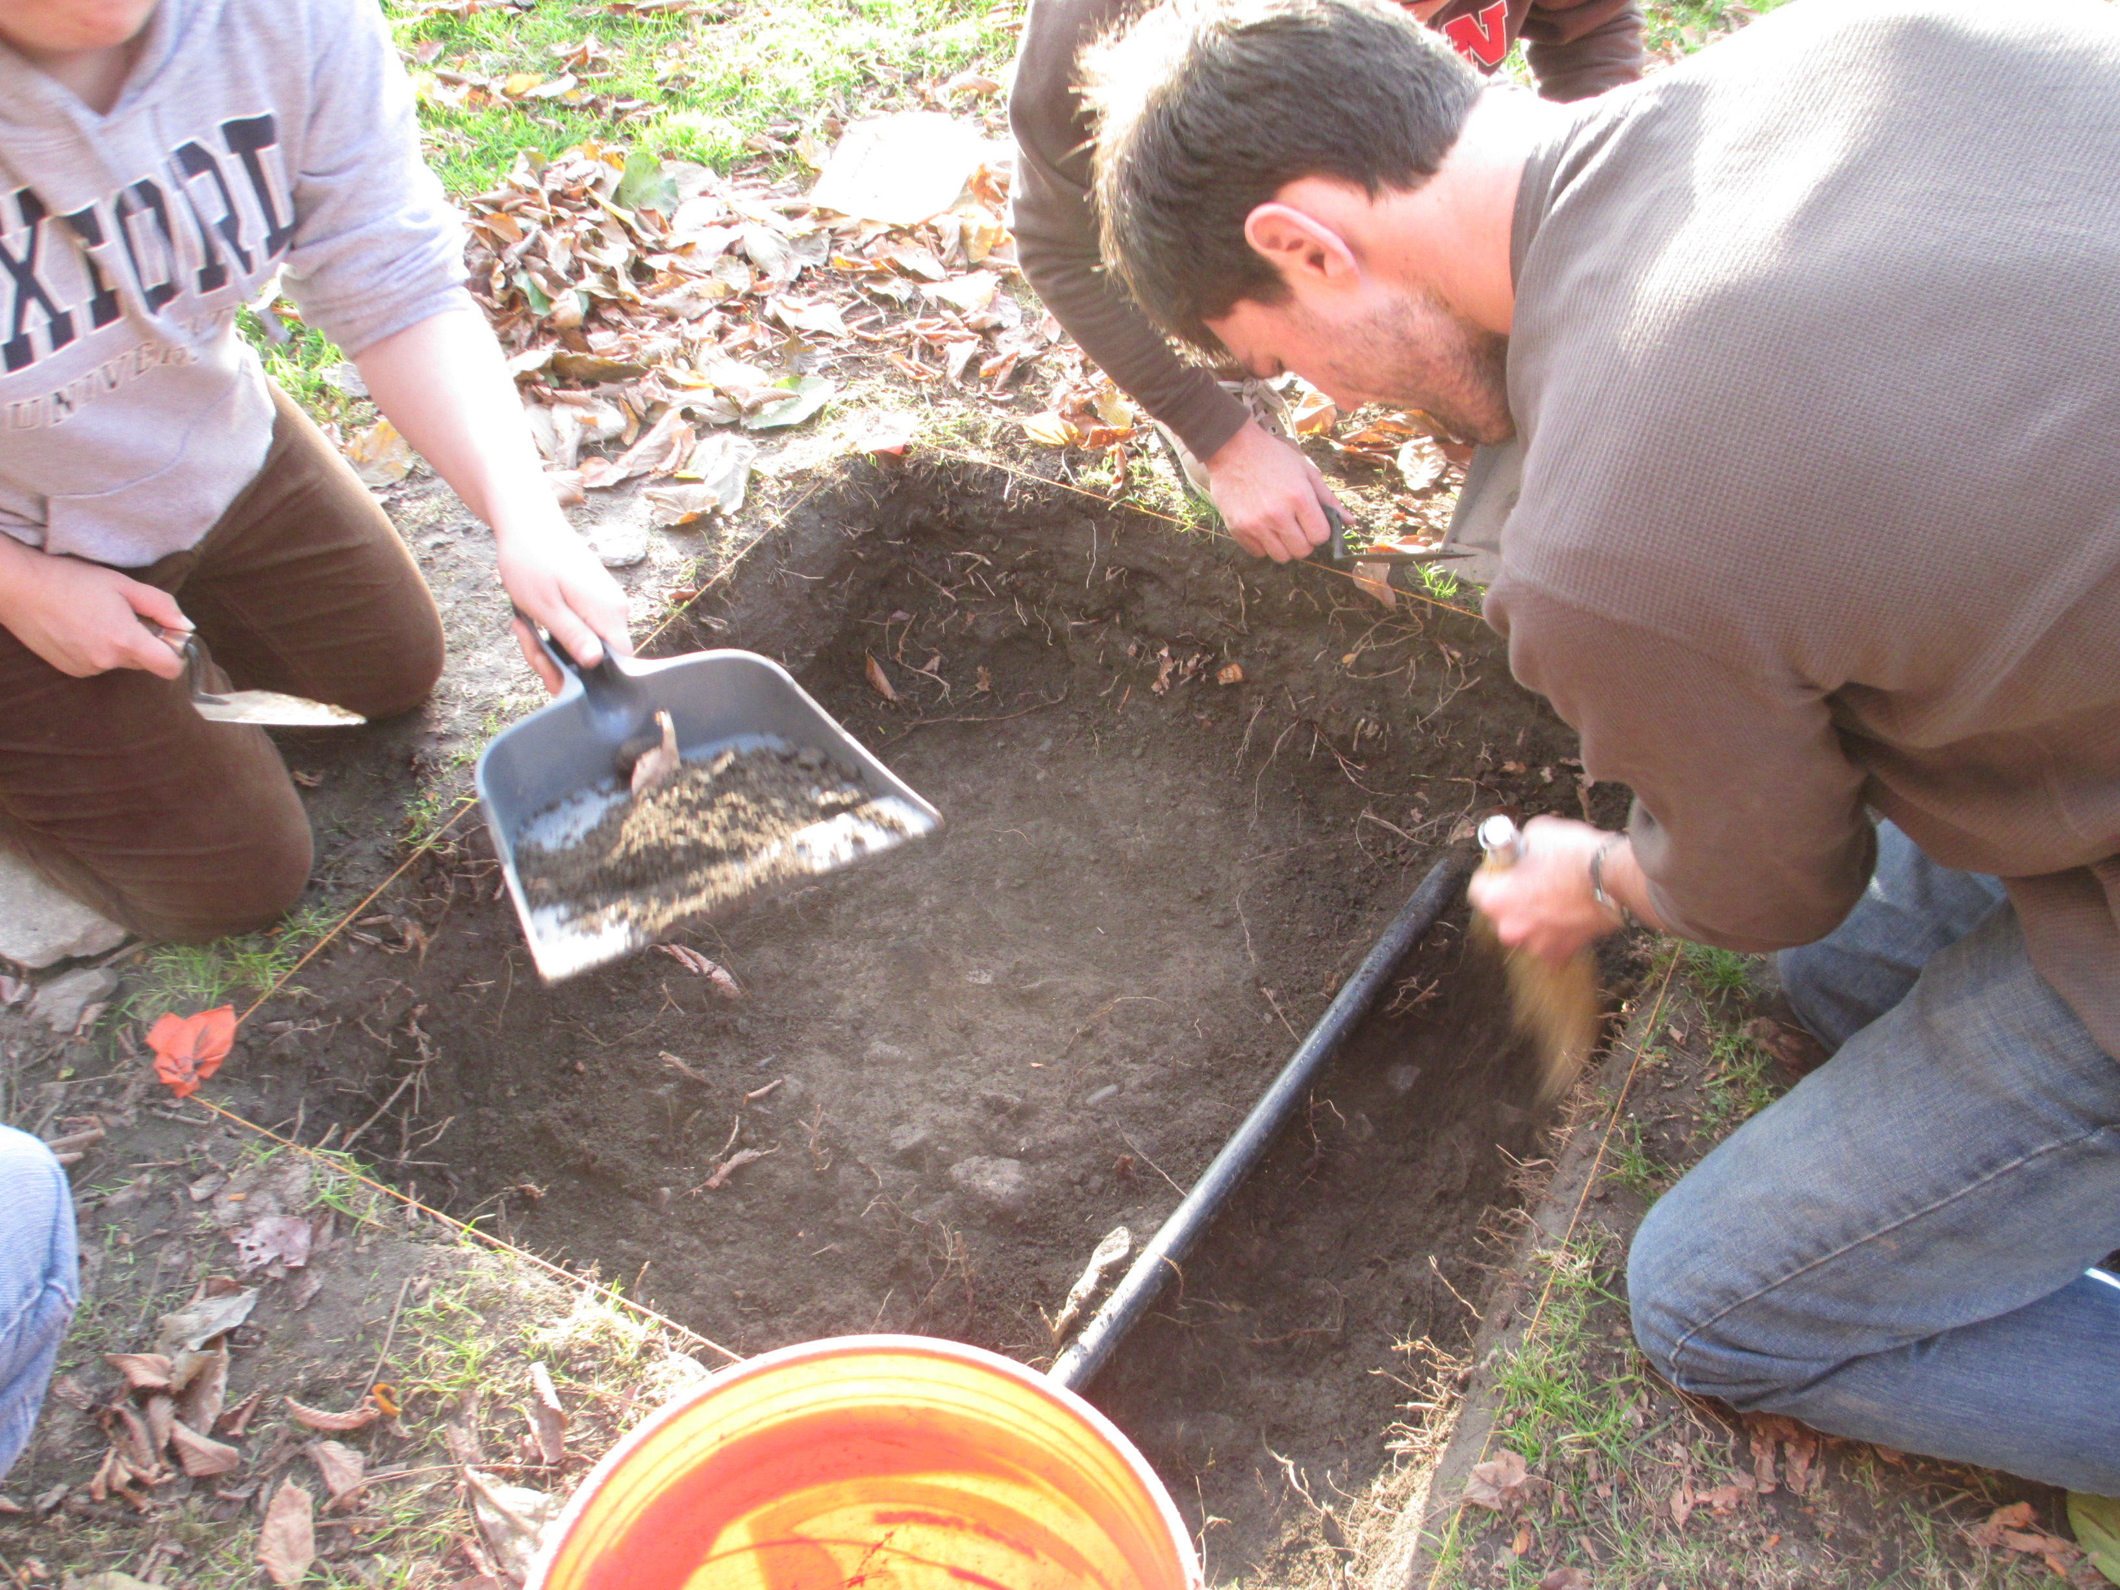
Digging in context three began on November 12 due to a change in soil quality from aerated, rooted, and uniformly dark to a lighter, rockier soil. This change in soil type can bee seen in the opening level photos, labeled Closing Context 2 (photos 1367-1369). The digging method continued to rely primarily on troweling, however more shoveling was used than past weeks due to a requirement to close up the trench more quickly, since this is the last week of official, class-time excavation. Time needed to be made up from the missed class due to Hurricane Sandy.

Artifact discoveries remained similar to past weeks in type and definitely diminished in quantity due to a lower level and the out of the way location of the trench with respect to the Hope College Entrance. This confirmed prior hypotheses that more debris would be found at lower depths in QG#1 than QG#2 due to the disposal of debris and trash near a key door of the building. Only a few pieces of ceramics and glass were found through sifting in QG#2, a noticeable decrease from last week’s excavation, and these pieces seemed to diminish in size as they now remained scattered in this context level instead of grouped with similar artifact types, such as a collection of similarly colored glass in varying sizes, in the previous two contexts. However, the team of QG#2 did find lots of gravel and brick chips, which spurred questions as to possible construction backfill from the many renovation projects that occur on the landscape of the Quiet Green. Also, a few chunks of asphalt were found and confirmed by a burnt smell. Most of these pieces were discovered off center in roughly the southwest corner of the trench. Also, as the team began to clear away the loose rocky layer, a possible layer of slate was discovered in the southeast corner.
Context 3 was closed at the end of excavation today due to the discovery of a flatter, smoother rock layer, as opposed to the collection of loose pebbles and sand found throughout context 3. Excavation had to stop sooner today due to it getting darker earlier, and it became difficult to distinguish between change in soil types and the appearance of artifacts. It is possible that Context 4 will be opened on an optional Saturday excavation. This would certainly help to conclude activities in QG#2 effectively and provide interesting points of comparison with the introduction of this new, seemingly solid rock layer. Also, this would help the excavation team to make more educated hypotheses about the existence of a prior marked path on the Quiet Green that now remains buried in QG#2 at a lower level. This might help to explain the increase in rock layers as the context numbers increase.
Class time will now be reserved for analysis of artifacts found in the past month of excavation to complete object reports for final projects. If the teamwork that has defined the project so far continues, all research for final reports is sure to be a cooperative, smooth effort.

