Rhode Island’s State House
Politics and architecture, among other offerings, are two great contributions of the Ancient Greeks to our modern society. Ancient Greece has greatly influenced our very own world, as we have copied and sometimes modified (other times, not) different aspects of their culture to improve or embellish our own. Politics and architecture demonstrate two facets of Ancient Greek civilization, the enlightening and theoretical abstract expression as well as the elegant and majestic physical manifestation. Structures created for the purpose of housing any sort of political entity or organized group are a combination of both the abstract expression and the physical manifestation of the Ancient Greeks. Here, in our own Providence, there are examples of these buildings. Because I have a personal interest in our government, I decided it was best to turn my focus to the top of Smith Hill, which, from a distance, has several Greco-Roman features. It is my desire that by the end of this micro-project, I will have a greater appreciation of the architectural genius of the Ancient Greeks by analyzing one of the most prominent buildings in the Providence skyline: the Rhode Island State House.

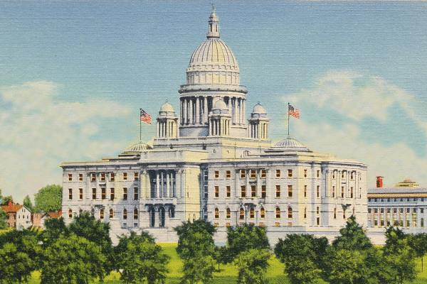

(Early 20th century postcard courtesy of Chris Miller)

As the capital of Rhode Island, Providence is the location of the Rhode Island State House. This current state house is the state’s seventh overall and the second located in Providence. It houses the Rhode Island General Assembly, the offices of the Governor, the Lieutenant-Governor, the Secretary of State, and the General Treasurer. The architectural firm of McKim, Mead, and White designed the current structure and it was constructed from 1895 to 1904 in the neoclassical style. It is important to note that it was indeed built in the neoclassical style since it focuses on the “purity” of the arts of Rome and the “ideal” of Ancient Greece; as such, it must therefore have numerous characteristics of both periods, particularly Greek.

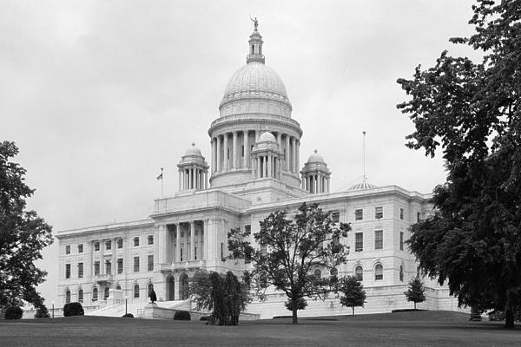

(Photograph taken from the Southeast between 1982 and 1983 by William Edmund Barrett for the Library of Congress)

One of the first parts that one notices when one catches a glimpse of the Rhode Island State House coming from I-95 is the great dome. It is the fourth-largest self-supporting dome in the world, behind St. Peter’s Basilica, the Minneapolis State Capitol, and the Taj Mahal. In addition, it is the second-largest self-supporting marble dome in the world, only after St. Peter’s Basilica. The dome is distinctively classical as it was used throughout the Greco-Roman world for various edifices, many of which were for buildings of importance to religion and politics. An example is the Roman Pantheon, where homage was paid to the gods and politics were discussed at the same time.

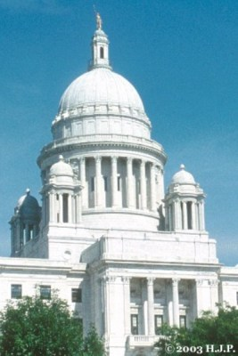
(Photograph by Howard J. Partridge in 1994)

Surveying the Rhode Island Capitol a little better, one comes to realize that there are a number of cupolas that surround the main dome. From the Greek “kupellon,” it consists of a dome-shaped or quadrilateral-shaped ornamental structure located on top of a larger dome or roof. These architectural marvels are ubiquitous, particularly in the old churches and temples. The cupolas demonstrate that the structure was built in the model of the Italian Renaissance Revival style.

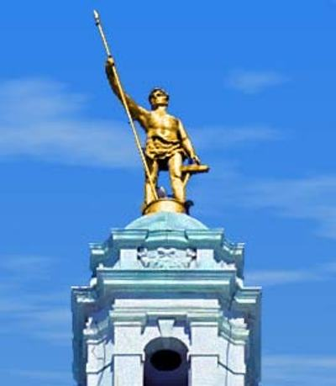
(from Michael Heintz’s webpage dedicated to William Brewster’s descendants)

As one comes closer to the State House, one begins to observe other smaller yet significant components. At the very top of the Capitol stands a gold-covered bronze statue of what was formerly known as “Hope” but has since been renamed “Independent Man,” for Roger Williams who courageously settled and established Providence and Rhode Island after being banished from Massachusetts. The 11-foot tall, 500-pound statue alludes to Roger Williams’ independent spirit. Like the statues found in Greece and Italy, this effigy is a model for the ideal, in this case, of independence in terms of the state’s founder. It can be compared to statues of heroes and other notable individuals such as gods and goddesses, in ancient times that have been captured for posterity to remember. Like Athena wearing her military equipment and an owl present close by representing Athens, Independent Man also has an anchor at his feet (Rhode Island’s symbol) and a spear in his left hand, representing the Ocean State.

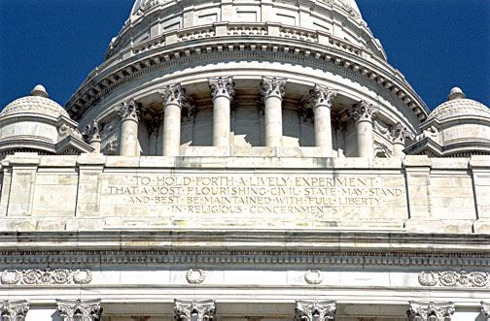
(South Entrance Inscription)

Studying the outside even closer, one comes to distinguish that the columns throughout the structure are Corinthian columns and that there are wreaths and other similar designs throughout the building. The Corinthian columns of course are Greek while the wreaths and other smaller designs are distinctly Roman. There are even two inscriptions on both entrances of the Rhode Island Capitol, which are written in a very formal style, reminiscent of the Ancient Greek or sometimes Latin that is found on the temples in the ancient world.

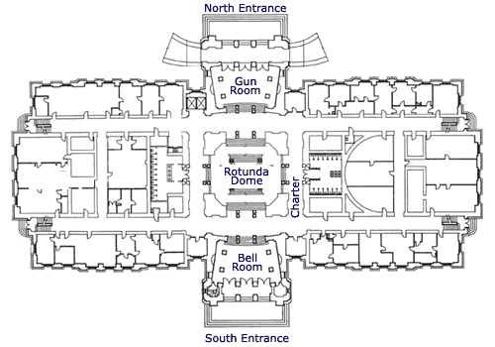

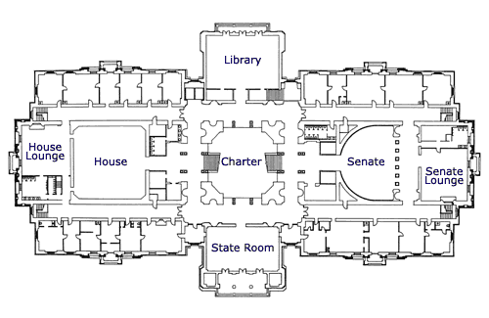

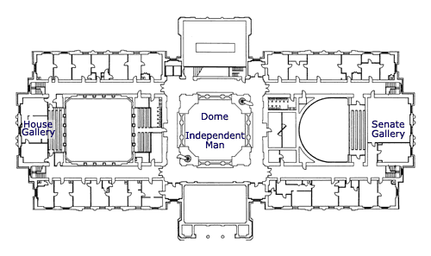
(Floor plans of the RI State House)

After examining the exterior, one should visit the interior of the Capitol. Unlike the ancient temples, we know exactly the general purpose of each smaller room. In the same spirit of functionality, each room represents an office for an elected representative. The larger rooms, as one would assume, are for large gatherings of these important individuals. While the temples and other structures in ancient times had only one floor, the Rhode Island State House has three levels. Nevertheless, it is interesting to examine the layout of the different rooms in the floor plans. Clearly certain objects, such as the dome, are in central areas, as are the seals of the state.

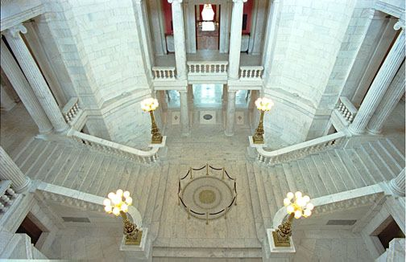
(Rotunda State Seal)

When entering the Rotunda, one immediately encounters the state seal proudly displayed in the very center of the room. The marble truly emphasizes the solid bronze seal and its importance to the room, particularly due to its central location at the bottom of both stairwells. The columns in the room, however, unlike the Corinthian ones outside, are now Doric inside.

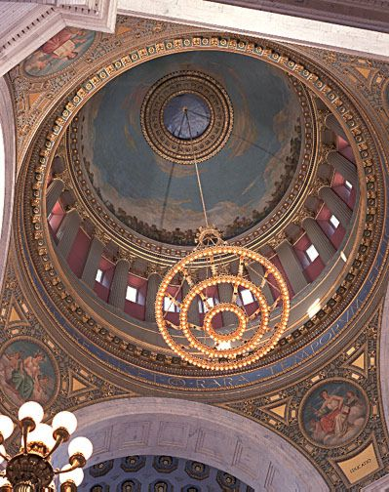
(The Rotunda)

Located in the first and second floors of the State House is the Rotunda itself, the central area of the entire structure. The most intriguing aspects of this room are the four paintings in the ceiling that are very reminiscent of the Greek muses. They represent four pillars of Rhode Island: Commerce, Education, Literature, and of course, Justice.

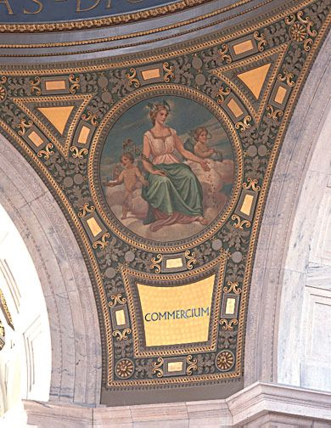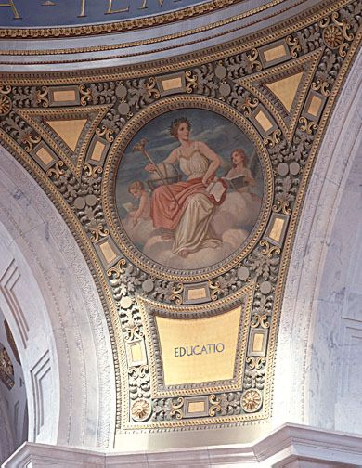

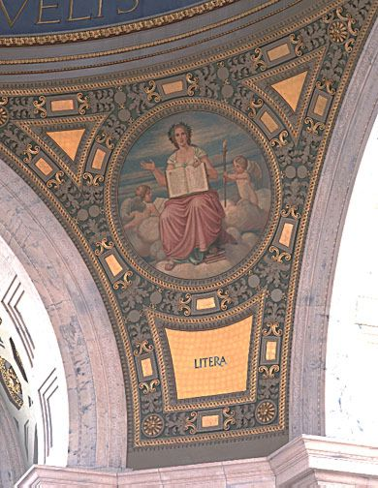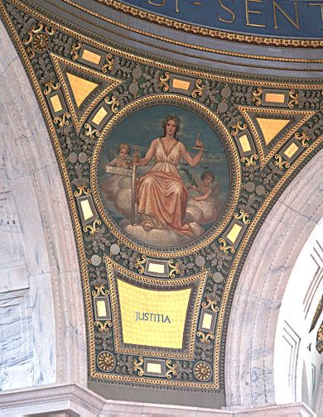

Not only do they have Latin names, but they are decorated with similar Greco-Roman designs such as the gold-leaf pieces. Above these paintings which from a distance look like frescoes, there is actual Latin around the dome (RARA TEMPORUM FELICITAS UBI SENTIRE QUAE VELIS ET QUAE SENTIAS DICERE LICET or “Rare felicity of the times when it is permitted to think as you like and say what you think”) from the first-century Roman historian Tacitus. Above these, there are the four major murals created by James A. King in the 1940’s. Known as the “Four Freedoms,” they are titled “The Land Grant,” “Religious Tolerance,” “Origins of Construction,” and finally “Beginnings of Industry,” all relating to Rhode Island’s history. One could almost compare these murals to the reliefs of the Twelve Labors of Herakles on certain temples throughout Greece, since Herakes is also part of the historical tradition. The decorations also are adorned with gold-leaf and have a distinct classical feel to their design. The most outer design from a distance appears to be like that of the Greek meander.

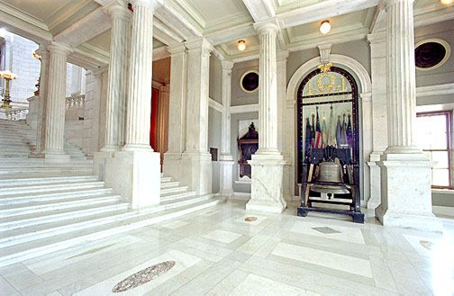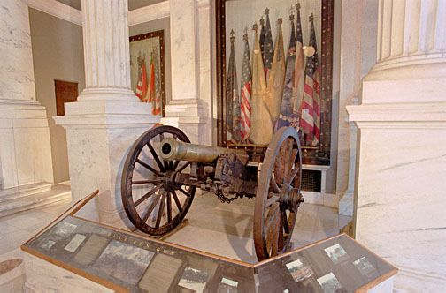
(Liberty Bell and the Civil War Cannon and Flags)

In both the North portico as well as the South portico, there are two symbols of American independence, the replica of the Liberty Bell that was given to each of the fifty states in commemoration of each state’s contribution to the war effort in World War II, and an actual cannon and flags utilized during the Civil War. Both of these are similar to the prizes that were left in the treasuries, for example, at Delphi where war booty was displayed for all to see. Very similarly, these two artifacts recall a time of war and are displayed proudly for visitors to observe and marvel, although they are not booty per se.

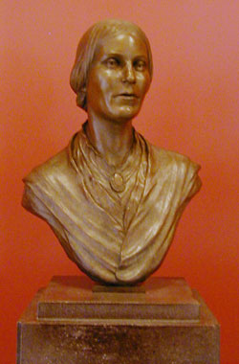
(Bust of Elizabeth Buffum Chace)

There is even a bust of a certain woman, Elizabeth Buffum Chace, who lived from 1806 to 1899. She was pivotal in the Underground Railroad movement that saved many slaves and brought them to freedom in the North. This bust is important because busts were created depicting major figures of society back in ancient times, particularly of the Roman emperors and patriarchs. Aristocratic women were also objects of these busts during that time, and this is true even today, with this bust of Elizabeth Buffum Chace in the 19th century. Although she may not have been an aristocratic woman, she worked for an extraordinary cause risking her own safety and well-being.

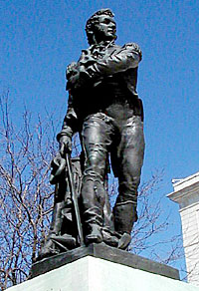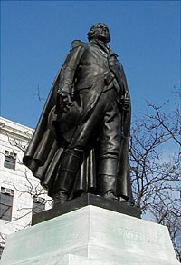
(Statues of two of America’s greatest heroes)

As one exist the State House, one comes across the statues of Commodore Oliver Hazard Perry (left) and General Nathanael Greene (right). They are considered two of our nation’s greatest heroes. Commodore Oliver Hazard Perry defeated the invading British troops in 1813 while General Nathanael Greene is regarded as one of the best generals during the Revolutionary War, probably second only to George Washington. As true heroes, they have been immortalized by these two bronze statues. Like Kleobis and Biton who were also made into statues, these two military men will also be remembered for their deeds. These statues represent the present evolution of statues, although many ancient aspects remain, including having one foot ahead of the other as well as the use of bronze itself to create these works of art.

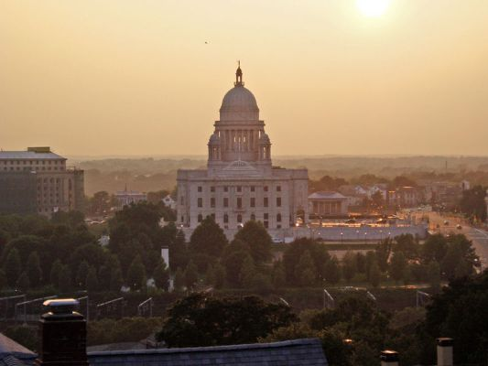
(Rhode Island Capitol in the late afternoon)

The ancients truly influenced much of our present world, providing us with both physical and abstract legacies. There is so much wealth in the architectural treasures that have been utilized in the formation of such a majestic government building. Simply studying over the Rhode Island State House, one comes to recognize the distinct roles of seemingly unimportant creations such as the arch which not only serves to adorn the edifice but also aids in its structure. It is possible for books to be filled with all of the architectural and artistic developments that have been borrowed and introduced into our own present designs. The Rhode Island Capitol has definitely taught me that the Greco-Roman legacy is very much present in our world today and that we owe much to the ancients not only for their concepts of functionality but also aesthetics in creating our beautiful and stately buildings.

http://brown.theleadershipalliance.org/matriarch/MultiPiecePage.asp_Q_PageID_E_25_A_PageName_E_AboutProvidence
http://www.fodors.com/world/north%20america/usa/rhode%20island/providence/entity_96125.html
http://brown.theleadershipalliance.org/matriarch/MultiPiecePage.asp_Q_PageID_E_25_A_PageName_E_AboutProvidence
http://www.cupola.com/html/bldgstru/statecap/cap09.htm
http://brown.theleadershipalliance.org/matriarch/MultiPiecePage.asp_Q_PageID_E_25_A_PageName_E_AboutProvidence
http://www.fodors.com/world/north%20america/usa/rhode%20island/providence/entity_96125.html
http://www.quahog.org/attractions/index.php?id=62
http://www.quahog.org/attractions/index.php?id=62

