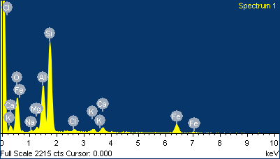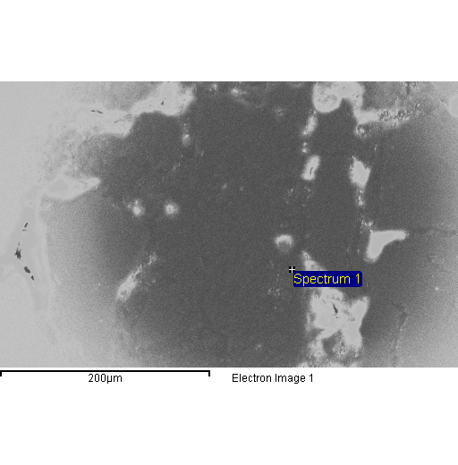

Spectrum processing :

Peak possibly omitted : 4.500 keV

Processing option : All elements analyzed (Normalised)

Number of iterations = 4

Standard :

O SiO2 1-Jun-1999 12:00 AM

Na Albite 1-Jun-1999 12:00 AM

Mg MgO 1-Jun-1999 12:00 AM

Al Al2O3 1-Jun-1999 12:00 AM

Si SiO2 1-Jun-1999 12:00 AM

Cl KCl 1-Jun-1999 12:00 AM

K MAD-10 Feldspar 1-Jun-1999 12:00 AM

Ca Wollastonite 1-Jun-1999 12:00 AM

Fe Fe 1-Jun-1999 12:00 AM

|  |  |  |  |
| --- | --- | --- | --- |
| Element | Weight% | Atomic% |  |
|  |  |  |  |
| O K | 40.87 | 56.81 |  |
| Na K | 1.01 | 0.97 |  |
| Mg K | 1.42 | 1.30 |  |
| Al K | 13.38 | 11.03 |  |
| Si K | 30.14 | 23.87 |  |
| Cl K | 1.11 | 0.70 |  |
| K K | 1.23 | 0.70 |  |
| Ca K | 1.91 | 1.06 |  |
| Fe K | 8.93 | 3.56 |  |
|  |  |  |  |
| Totals | 100.00 |  |  |

Comment:

3/26/2010 12:50:39 PM

Project 1

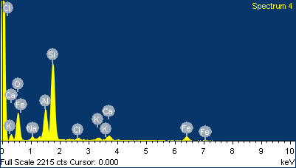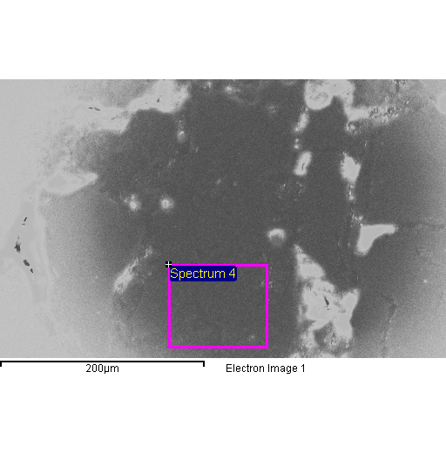

Spectrum processing :

No peaks omitted

Processing option : All elements analyzed (Normalised)

Number of iterations = 4

Standard :

O SiO2 1-Jun-1999 12:00 AM

Na Albite 1-Jun-1999 12:00 AM

Al Al2O3 1-Jun-1999 12:00 AM

Si SiO2 1-Jun-1999 12:00 AM

Cl KCl 1-Jun-1999 12:00 AM

K MAD-10 Feldspar 1-Jun-1999 12:00 AM

Ca Wollastonite 1-Jun-1999 12:00 AM

Fe Fe 1-Jun-1999 12:00 AM

|  |  |  |  |
| --- | --- | --- | --- |
| Element | Weight% | Atomic% |  |
|  |  |  |  |
| O K | 43.37 | 58.77 |  |
| Na K | 2.06 | 1.94 |  |
| Al K | 11.25 | 9.04 |  |
| Si K | 32.81 | 25.33 |  |
| Cl K | 1.16 | 0.71 |  |
| K K | 1.00 | 0.55 |  |
| Ca K | 2.69 | 1.45 |  |
| Fe K | 5.67 | 2.20 |  |
|  |  |  |  |
| Totals | 100.00 |  |  |

Comment:

3/26/2010 12:53:10 PM

Project 2

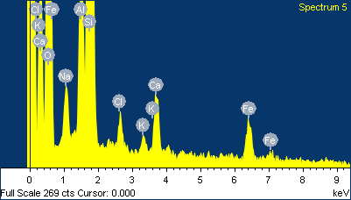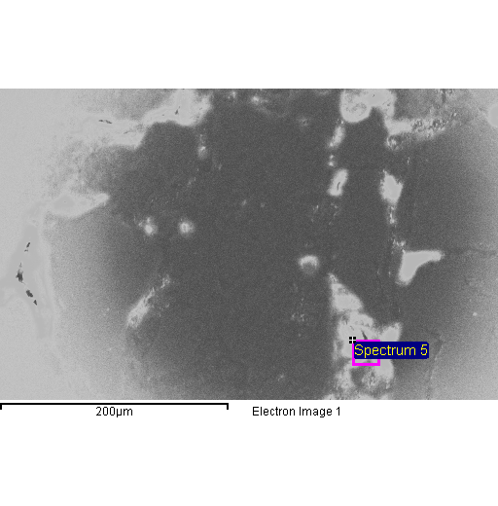

Spectrum processing :

No peaks omitted

Processing option : All elements analyzed (Normalised)

Number of iterations = 4

Standard :

O SiO2 1-Jun-1999 12:00 AM

Na Albite 1-Jun-1999 12:00 AM

Al Al2O3 1-Jun-1999 12:00 AM

Si SiO2 1-Jun-1999 12:00 AM

Cl KCl 1-Jun-1999 12:00 AM

K MAD-10 Feldspar 1-Jun-1999 12:00 AM

Ca Wollastonite 1-Jun-1999 12:00 AM

Fe Fe 1-Jun-1999 12:00 AM

|  |  |  |  |
| --- | --- | --- | --- |
| Element | Weight% | Atomic% |  |
|  |  |  |  |
| O K | 53.31 | 67.61 |  |
| Na K | 2.47 | 2.18 |  |
| Al K | 5.20 | 3.91 |  |
| Si K | 32.03 | 23.14 |  |
| Cl K | 1.04 | 0.60 |  |
| K K | 0.58 | 0.30 |  |
| Ca K | 2.17 | 1.10 |  |
| Fe K | 3.20 | 1.16 |  |
|  |  |  |  |
| Totals | 100.00 |  |  |

Comment:

3/26/2010 12:56:41 PM

Project 3

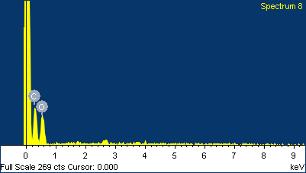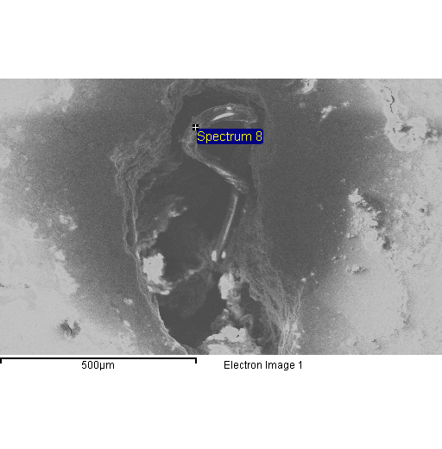

Spectrum processing :

Peaks possibly omitted : 1.740, 2.650 keV

Processing option : All elements analyzed (Normalised)

Number of iterations = 4

Standard :

C CaCO3 1-Jun-1999 12:00 AM

O SiO2 1-Jun-1999 12:00 AM

|  |  |  |  |
| --- | --- | --- | --- |
| Element | Weight% | Atomic% |  |
|  |  |  |  |
| C K | 44.12 | 51.26 |  |
| O K | 55.88 | 48.74 |  |
|  |  |  |  |
| Totals | 100.00 |  |  |

Comment:

3/26/2010 1:02:46 PM

Project 4

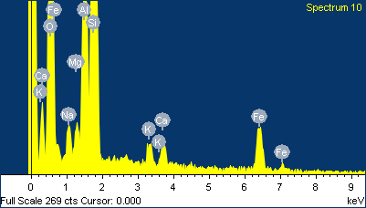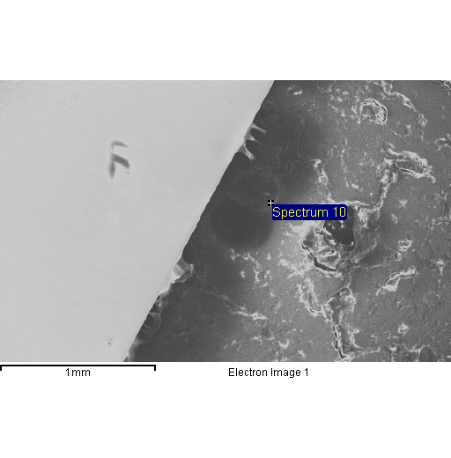

Spectrum processing :

No peaks omitted

Processing option : All elements analyzed (Normalised)

Number of iterations = 4

Standard :

O SiO2 1-Jun-1999 12:00 AM

Na Albite 1-Jun-1999 12:00 AM

Mg MgO 1-Jun-1999 12:00 AM

Al Al2O3 1-Jun-1999 12:00 AM

Si SiO2 1-Jun-1999 12:00 AM

K MAD-10 Feldspar 1-Jun-1999 12:00 AM

Ca Wollastonite 1-Jun-1999 12:00 AM

Fe Fe 1-Jun-1999 12:00 AM

|  |  |  |  |
| --- | --- | --- | --- |
| Element | Weight% | Atomic% |  |
|  |  |  |  |
| O K | 53.14 | 67.59 |  |
| Na K | 2.12 | 1.88 |  |
| Mg K | 1.28 | 1.07 |  |
| Al K | 9.55 | 7.20 |  |
| Si K | 26.58 | 19.26 |  |
| K K | 0.99 | 0.51 |  |
| Ca K | 1.17 | 0.59 |  |
| Fe K | 5.18 | 1.89 |  |
|  |  |  |  |
| Totals | 100.00 |  |  |

Comment:

3/26/2010 1:06:43 PM

Project 5

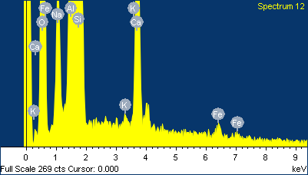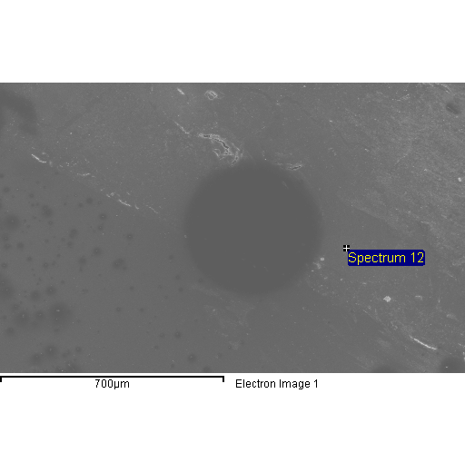

Spectrum processing :

No peaks omitted

Processing option : All elements analyzed (Normalised)

Number of iterations = 4

Standard :

O SiO2 1-Jun-1999 12:00 AM

Na Albite 1-Jun-1999 12:00 AM

Al Al2O3 1-Jun-1999 12:00 AM

Si SiO2 1-Jun-1999 12:00 AM

K MAD-10 Feldspar 1-Jun-1999 12:00 AM

Ca Wollastonite 1-Jun-1999 12:00 AM

Fe Fe 1-Jun-1999 12:00 AM

|  |  |  |  |
| --- | --- | --- | --- |
| Element | Weight% | Atomic% |  |
|  |  |  |  |
| O K | 45.88 | 60.17 |  |
| Na K | 3.69 | 3.37 |  |
| Al K | 11.72 | 9.12 |  |
| Si K | 32.18 | 24.04 |  |
| K K | 0.24 | 0.13 |  |
| Ca K | 5.48 | 2.87 |  |
| Fe K | 0.80 | 0.30 |  |
|  |  |  |  |
| Totals | 100.00 |  |  |

Comment:

3/26/2010 1:14:32 PM

Project 6

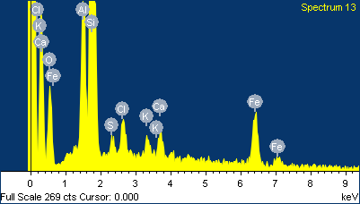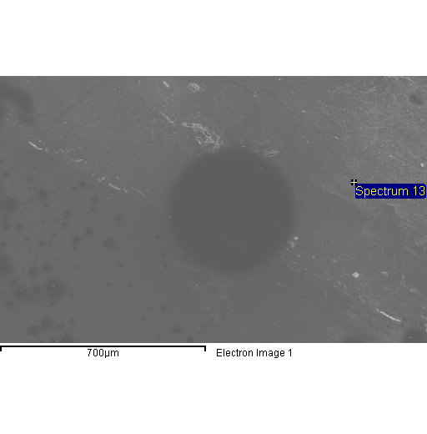

Spectrum processing :

No peaks omitted

Processing option : All elements analyzed (Normalised)

Number of iterations = 3

Standard :

O SiO2 1-Jun-1999 12:00 AM

Al Al2O3 1-Jun-1999 12:00 AM

Si SiO2 1-Jun-1999 12:00 AM

S FeS2 1-Jun-1999 12:00 AM

Cl KCl 1-Jun-1999 12:00 AM

K MAD-10 Feldspar 1-Jun-1999 12:00 AM

Ca Wollastonite 1-Jun-1999 12:00 AM

Fe Fe 1-Jun-1999 12:00 AM

|  |  |  |  |
| --- | --- | --- | --- |
| Element | Weight% | Atomic% |  |
|  |  |  |  |
| O K | 27.55 | 42.79 |  |
| Al K | 10.18 | 9.38 |  |
| Si K | 40.36 | 35.72 |  |
| S K | 1.80 | 1.40 |  |
| Cl K | 3.73 | 2.62 |  |
| K K | 1.70 | 1.08 |  |
| Ca K | 2.75 | 1.70 |  |
| Fe K | 11.93 | 5.31 |  |
|  |  |  |  |
| Totals | 100.00 |  |  |

Comment:

3/26/2010 1:16:26 PM

Project 7

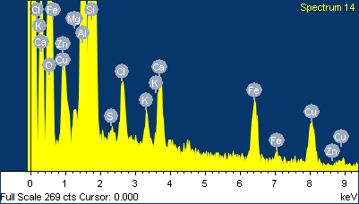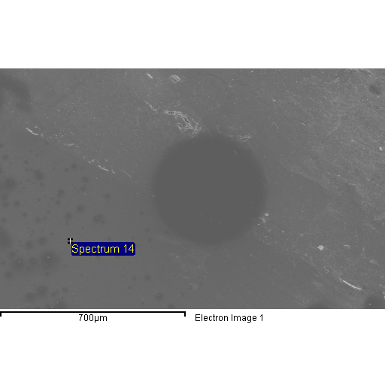

Spectrum processing :

No peaks omitted

Processing option : All elements analyzed (Normalised)

Number of iterations = 3

Standard :

O SiO2 1-Jun-1999 12:00 AM

Mg MgO 1-Jun-1999 12:00 AM

Al Al2O3 1-Jun-1999 12:00 AM

Si SiO2 1-Jun-1999 12:00 AM

S FeS2 1-Jun-1999 12:00 AM

Cl KCl 1-Jun-1999 12:00 AM

K MAD-10 Feldspar 1-Jun-1999 12:00 AM

Ca Wollastonite 1-Jun-1999 12:00 AM

Fe Fe 1-Jun-1999 12:00 AM

Cu Cu 1-Jun-1999 12:00 AM

Zn Zn 1-Jun-1999 12:00 AM

|  |  |  |  |
| --- | --- | --- | --- |
| Element | Weight% | Atomic% |  |
|  |  |  |  |
| O K | 41.85 | 59.17 |  |
| Mg K | 0.88 | 0.82 |  |
| Al K | 9.39 | 7.87 |  |
| Si K | 29.57 | 23.81 |  |
| S K | 0.42 | 0.30 |  |
| Cl K | 2.21 | 1.41 |  |
| K K | 1.04 | 0.60 |  |
| Ca K | 2.64 | 1.49 |  |
| Fe K | 5.09 | 2.06 |  |
| Cu K | 7.00 | 2.49 |  |
| Zn K | -0.08 | -0.03 |  |
|  |  |  |  |
| Totals | 100.00 |  |  |

Comment:

3/26/2010 1:19:44 PM

Project 8

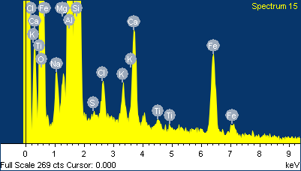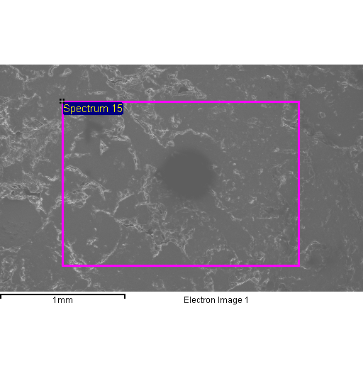

Spectrum processing :

No peaks omitted

Processing option : All elements analyzed (Normalised)

Number of iterations = 4

Standard :

O SiO2 1-Jun-1999 12:00 AM

Na Albite 1-Jun-1999 12:00 AM

Mg MgO 1-Jun-1999 12:00 AM

Al Al2O3 1-Jun-1999 12:00 AM

Si SiO2 1-Jun-1999 12:00 AM

S FeS2 1-Jun-1999 12:00 AM

Cl KCl 1-Jun-1999 12:00 AM

K MAD-10 Feldspar 1-Jun-1999 12:00 AM

Ca Wollastonite 1-Jun-1999 12:00 AM

Ti Ti 1-Jun-1999 12:00 AM

Fe Fe 1-Jun-1999 12:00 AM

|  |  |  |  |
| --- | --- | --- | --- |
| Element | Weight% | Atomic% |  |
|  |  |  |  |
| O K | 44.68 | 60.39 |  |
| Na K | 2.03 | 1.91 |  |
| Mg K | 1.11 | 0.99 |  |
| Al K | 9.57 | 7.67 |  |
| Si K | 30.17 | 23.23 |  |
| S K | 0.20 | 0.13 |  |
| Cl K | 1.20 | 0.73 |  |
| K K | 1.05 | 0.58 |  |
| Ca K | 3.11 | 1.68 |  |
| Ti K | 0.37 | 0.17 |  |
| Fe K | 6.50 | 2.52 |  |
|  |  |  |  |
| Totals | 100.00 |  |  |

Comment:

3/26/2010 1:23:11 PM

Project 9

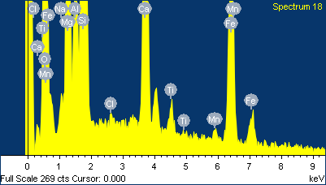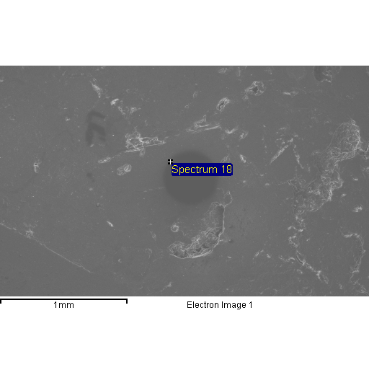

Spectrum processing :

No peaks omitted

Processing option : All elements analyzed (Normalised)

Number of iterations = 4

Standard :

O SiO2 1-Jun-1999 12:00 AM

Na Albite 1-Jun-1999 12:00 AM

Mg MgO 1-Jun-1999 12:00 AM

Al Al2O3 1-Jun-1999 12:00 AM

Si SiO2 1-Jun-1999 12:00 AM

Cl KCl 1-Jun-1999 12:00 AM

Ca Wollastonite 1-Jun-1999 12:00 AM

Ti Ti 1-Jun-1999 12:00 AM

Mn Mn 1-Jun-1999 12:00 AM

Fe Fe 1-Jun-1999 12:00 AM

|  |  |  |  |
| --- | --- | --- | --- |
| Element | Weight% | Atomic% |  |
|  |  |  |  |
| O K | 41.18 | 58.56 |  |
| Na K | 1.06 | 1.05 |  |
| Mg K | 8.14 | 7.61 |  |
| Al K | 3.72 | 3.14 |  |
| Si K | 23.60 | 19.11 |  |
| Cl K | 0.25 | 0.16 |  |
| Ca K | 8.24 | 4.68 |  |
| Ti K | 0.90 | 0.43 |  |
| Mn K | 0.48 | 0.20 |  |
| Fe K | 12.45 | 5.07 |  |
|  |  |  |  |
| Totals | 100.00 |  |  |

Comment:

3/26/2010 1:27:31 PM

Project 10