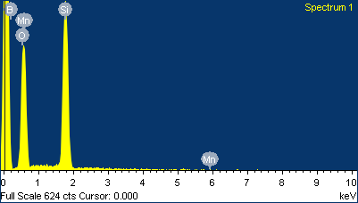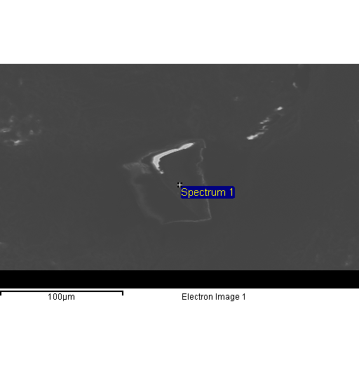

Spectrum processing :

No peaks omitted

Processing option : All elements analyzed (Normalised)

Number of iterations = 5

Standard :

B B 20-Jul-1999 12:00 AM

O SiO2 1-Jun-1999 12:00 AM

Si SiO2 1-Jun-1999 12:00 AM

Mn Mn 1-Jun-1999 12:00 AM

|  |  |  |  |
| --- | --- | --- | --- |
| Element | Weight% | Atomic% |  |
|  |  |  |  |
| B K | 33.44 | 46.39 |  |
| O K | 44.77 | 41.97 |  |
| Si K | 21.79 | 11.64 |  |
| Mn K | 0.00 | 0.00 |  |
|  |  |  |  |
| Totals | 100.00 |  |  |

Comment:

4/16/2010 2:49:26 PM

Pale 1

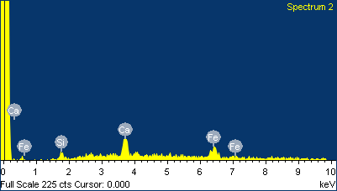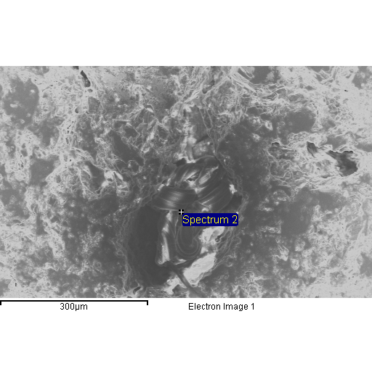

Spectrum processing :

No peaks omitted

Processing option : All elements analyzed (Normalised)

Number of iterations = 2

Standard :

Si SiO2 1-Jun-1999 12:00 AM

Ca Wollastonite 1-Jun-1999 12:00 AM

Fe Fe 1-Jun-1999 12:00 AM

|  |  |  |  |
| --- | --- | --- | --- |
| Element | Weight% | Atomic% |  |
|  |  |  |  |
| Si K | 6.66 | 11.08 |  |
| Ca K | 33.05 | 38.51 |  |
| Fe K | 60.28 | 50.41 |  |
|  |  |  |  |
| Totals | 100.00 |  |  |

Comment:

4/16/2010 2:53:30 PM

Pale 2

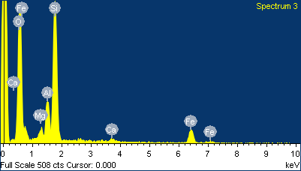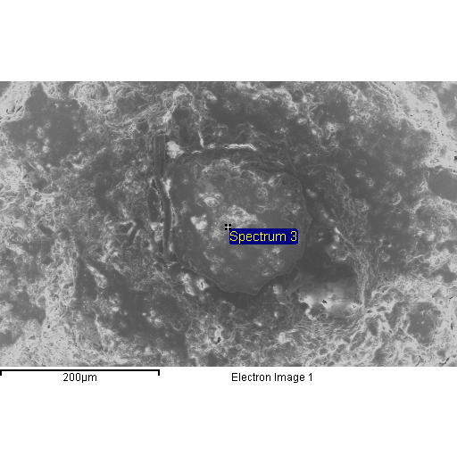

Spectrum processing :

No peaks omitted

Processing option : All elements analyzed (Normalised)

Number of iterations = 3

Standard :

O SiO2 1-Jun-1999 12:00 AM

Mg MgO 1-Jun-1999 12:00 AM

Al Al2O3 1-Jun-1999 12:00 AM

Si SiO2 1-Jun-1999 12:00 AM

Ca Wollastonite 1-Jun-1999 12:00 AM

Fe Fe 1-Jun-1999 12:00 AM

|  |  |  |  |
| --- | --- | --- | --- |
| Element | Weight% | Atomic% |  |
|  |  |  |  |
| O K | 49.82 | 66.85 |  |
| Mg K | 1.82 | 1.61 |  |
| Al K | 6.78 | 5.40 |  |
| Si K | 26.38 | 20.16 |  |
| Ca K | 0.98 | 0.52 |  |
| Fe K | 14.22 | 5.47 |  |
|  |  |  |  |
| Totals | 100.00 |  |  |

Comment:

4/16/2010 2:55:47 PM

Pale 3

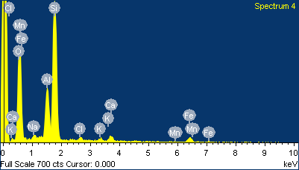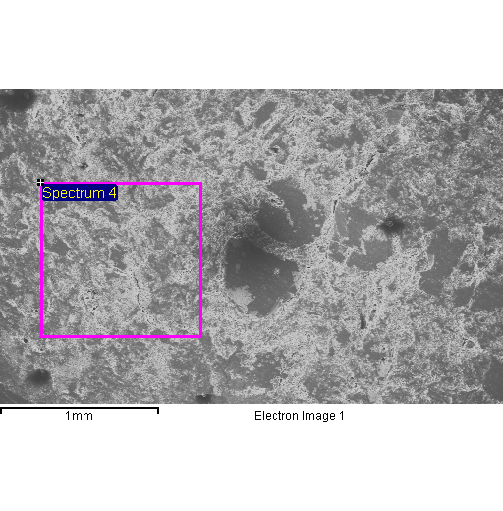

Spectrum processing :

No peaks omitted

Processing option : All elements analyzed (Normalised)

Number of iterations = 3

Standard :

O SiO2 1-Jun-1999 12:00 AM

Na Albite 1-Jun-1999 12:00 AM

Al Al2O3 1-Jun-1999 12:00 AM

Si SiO2 1-Jun-1999 12:00 AM

Cl KCl 1-Jun-1999 12:00 AM

K MAD-10 Feldspar 1-Jun-1999 12:00 AM

Ca Wollastonite 1-Jun-1999 12:00 AM

Mn Mn 1-Jun-1999 12:00 AM

Fe Fe 1-Jun-1999 12:00 AM

|  |  |  |  |
| --- | --- | --- | --- |
| Element | Weight% | Atomic% |  |
|  |  |  |  |
| O K | 49.26 | 64.44 |  |
| Na K | 1.33 | 1.21 |  |
| Al K | 9.79 | 7.60 |  |
| Si K | 30.60 | 22.80 |  |
| Cl K | 0.87 | 0.51 |  |
| K K | 0.80 | 0.43 |  |
| Ca K | 1.76 | 0.92 |  |
| Mn K | 0.11 | 0.04 |  |
| Fe K | 5.48 | 2.05 |  |
|  |  |  |  |
| Totals | 100.00 |  |  |

Comment:

4/16/2010 2:58:51 PM

Pale 4

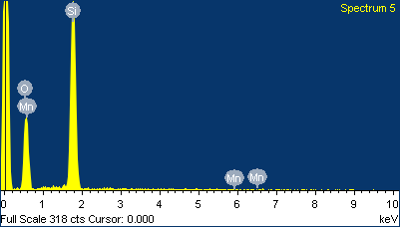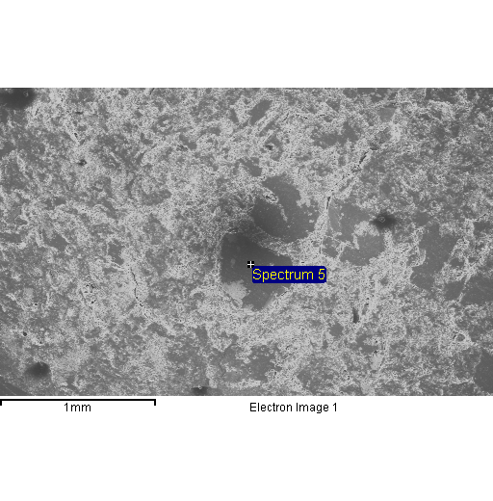

Spectrum processing :

No peaks omitted

Processing option : All elements analyzed (Normalised)

Number of iterations = 3

Standard :

O SiO2 1-Jun-1999 12:00 AM

Si SiO2 1-Jun-1999 12:00 AM

Mn Mn 1-Jun-1999 12:00 AM

|  |  |  |  |
| --- | --- | --- | --- |
| Element | Weight% | Atomic% |  |
|  |  |  |  |
| O K | 50.34 | 64.09 |  |
| Si K | 49.35 | 35.79 |  |
| Mn K | 0.30 | 0.11 |  |
|  |  |  |  |
| Totals | 100.00 |  |  |

Comment:

4/16/2010 2:59:40 PM

Pale 5

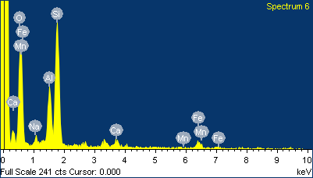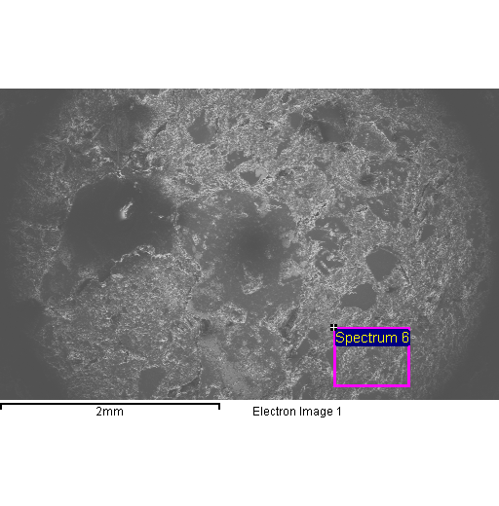

Spectrum processing :

No peaks omitted

Processing option : All elements analyzed (Normalised)

Number of iterations = 3

Standard :

O SiO2 1-Jun-1999 12:00 AM

Na Albite 1-Jun-1999 12:00 AM

Al Al2O3 1-Jun-1999 12:00 AM

Si SiO2 1-Jun-1999 12:00 AM

Ca Wollastonite 1-Jun-1999 12:00 AM

Mn Mn 1-Jun-1999 12:00 AM

Fe Fe 1-Jun-1999 12:00 AM

|  |  |  |  |
| --- | --- | --- | --- |
| Element | Weight% | Atomic% |  |
|  |  |  |  |
| O K | 50.25 | 65.64 |  |
| Na K | 1.99 | 1.81 |  |
| Al K | 10.44 | 8.08 |  |
| Si K | 27.43 | 20.41 |  |
| Ca K | 2.44 | 1.27 |  |
| Mn K | 0.02 | 0.01 |  |
| Fe K | 7.42 | 2.78 |  |
|  |  |  |  |
| Totals | 100.00 |  |  |

Comment:

4/16/2010 3:06:32 PM

Sandy 2

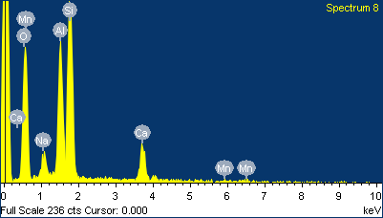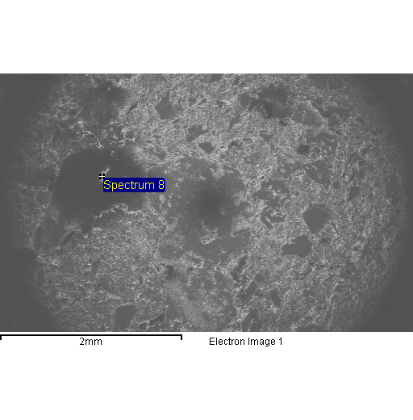

Spectrum processing :

No peaks omitted

Processing option : All elements analyzed (Normalised)

Number of iterations = 4

Standard :

O SiO2 1-Jun-1999 12:00 AM

Na Albite 1-Jun-1999 12:00 AM

Al Al2O3 1-Jun-1999 12:00 AM

Si SiO2 1-Jun-1999 12:00 AM

Ca Wollastonite 1-Jun-1999 12:00 AM

Mn Mn 1-Jun-1999 12:00 AM

|  |  |  |  |
| --- | --- | --- | --- |
| Element | Weight% | Atomic% |  |
|  |  |  |  |
| O K | 47.88 | 62.23 |  |
| Na K | 3.62 | 3.27 |  |
| Al K | 14.94 | 11.52 |  |
| Si K | 25.24 | 18.69 |  |
| Ca K | 8.13 | 4.22 |  |
| Mn K | 0.20 | 0.07 |  |
|  |  |  |  |
| Totals | 100.00 |  |  |

Comment:

4/16/2010 3:07:42 PM

Sandy 3

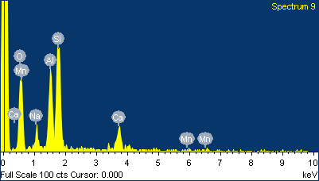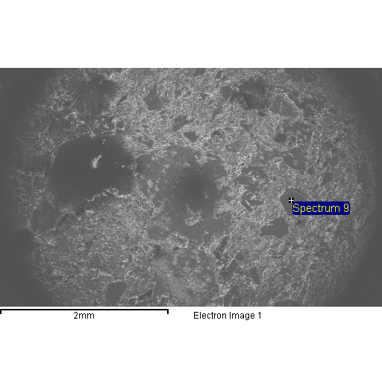

Spectrum processing :

No peaks omitted

Processing option : All elements analyzed (Normalised)

Number of iterations = 4

Standard :

O SiO2 1-Jun-1999 12:00 AM

Na Albite 1-Jun-1999 12:00 AM

Al Al2O3 1-Jun-1999 12:00 AM

Si SiO2 1-Jun-1999 12:00 AM

Ca Wollastonite 1-Jun-1999 12:00 AM

Mn Mn 1-Jun-1999 12:00 AM

|  |  |  |  |
| --- | --- | --- | --- |
| Element | Weight% | Atomic% |  |
|  |  |  |  |
| O K | 48.36 | 62.84 |  |
| Na K | 3.76 | 3.40 |  |
| Al K | 13.74 | 10.58 |  |
| Si K | 25.13 | 18.60 |  |
| Ca K | 8.26 | 4.28 |  |
| Mn K | 0.74 | 0.28 |  |
|  |  |  |  |
| Totals | 100.00 |  |  |

Comment:

4/16/2010 3:08:23 PM

Sandy 4

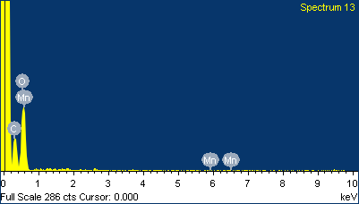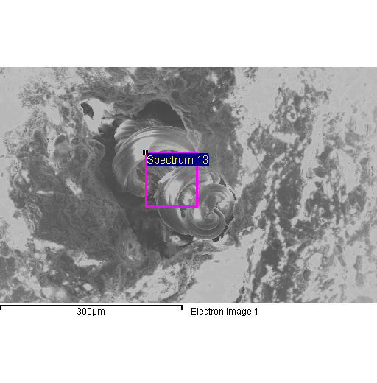

Spectrum processing :

No peaks omitted

Processing option : All elements analyzed (Normalised)

Number of iterations = 4

Standard :

C CaCO3 1-Jun-1999 12:00 AM

O SiO2 1-Jun-1999 12:00 AM

Mn Mn 1-Jun-1999 12:00 AM

|  |  |  |  |
| --- | --- | --- | --- |
| Element | Weight% | Atomic% |  |
|  |  |  |  |
| C K | 28.78 | 35.02 |  |
| O K | 71.08 | 64.94 |  |
| Mn K | 0.14 | 0.04 |  |
|  |  |  |  |
| Totals | 100.00 |  |  |

Comment:

4/16/2010 3:15:49 PM

Sandy 5