Katey Lesneski
5/16/10
ARCH0330
Final Project
Consequences of the Laki Fissure Eruption

June 8th 1783 marked the first day of the most voluminous lava flow in recorded history. The Laki fissure eruption in Iceland continued through February 1784, and in just eight short months a total of 2.9 cubic miles of basaltic lava covered over 218 square miles on this volcanic island located on the Mid-Atlantic Ridge [Topinka]. Along with this massive outpouring of effusive volcanic materials came extensive acid pollution from sulfur dioxide emissions, making this particular eruption profoundly consequential for many Europeans. Although volcanology was not a developed science during the 18th century, various written records from this time period demonstrate the full range of the effects from this eruption and give the scientific community an understanding of future implications of such an event.
Two spreading events occurring 150 and then 90 million years ago set the foundation for Iceland. The mid Atlantic Ridge is a spreading center that marks the divergence of two tectonic plates, the Eurasian plate and the North American Plate, and runs down the entire Atlantic Ocean. This ridge is visible in Iceland, which was created directly by the outpouring and gradual accumulation of basaltic lava, in conjunction with a mantle plume [Iceland on the Web]. There are over 100 volcanoes on Iceland, and at least 35 have erupted in the past 10,000 years [Iceland on the Web]. With eruptions of various intensities occurring every 5 years on average, Iceland is one of the most geologically active areas in the world. Upwelling of hot, buoyant material from a mantle plume (hot spot) can cause fractures in previously erupted and solidified material, and these areas, designated as rift zones, are common regions of magma surfacing. The Laki eruption flowed from a 25-kilometer fissure [SDSU Geology] in the south-central part of Iceland, but had many more far reaching effects.
When the Laki fissure first began to spew lava from its extensive fracture system, neither Icelandic residents nor any other Europeans could have possibly fathomed the level to which this situation would escalate in such a short time. Although many people may consider lava to be the most obvious threat of volcanic eruptions, in the case of the Laki eruption the overwhelming emission of sulfur dioxide proved to be the largest concern. Estimates for total output average to 122 megatons of sulfur dioxide [Grattan 2005], which is a very large mass in comparison to an eruption such as Mt. Pinatubo, which ejected 20 million metric tons into the atmosphere in 1991 [USGS Geology]. With at least 60% if the total volume of gases being discharged within the first 48 days of the eruption in combination with the fact that fissure eruptions are usually not energetic enough to penetrate the stratosphere with aerosol ejections [Thordarson], many European countries were at high risk for the occurrence of dry sulfuric fogs. The particular meteorological settings during the summer months directed gases and tephra towards Eastern Europe. Much of the material was confined to 5 kilometers above sea level, and the movement of winds associated with stable high pressure air cells played a key role in the transport of ejecta towards mainland countries [Grattan 1994]. Surface level winds moving westward from Europe converged over Iceland, and this air rose, carrying tephra and gases, and was subsequently blown toward the east by high altitude winds, where they then converged with another high pressure cell, and finally descended [Grattan 1998]. Calm surface conditions allowed for the descending volcanic material to become highly concentrated [Grattan 1998].
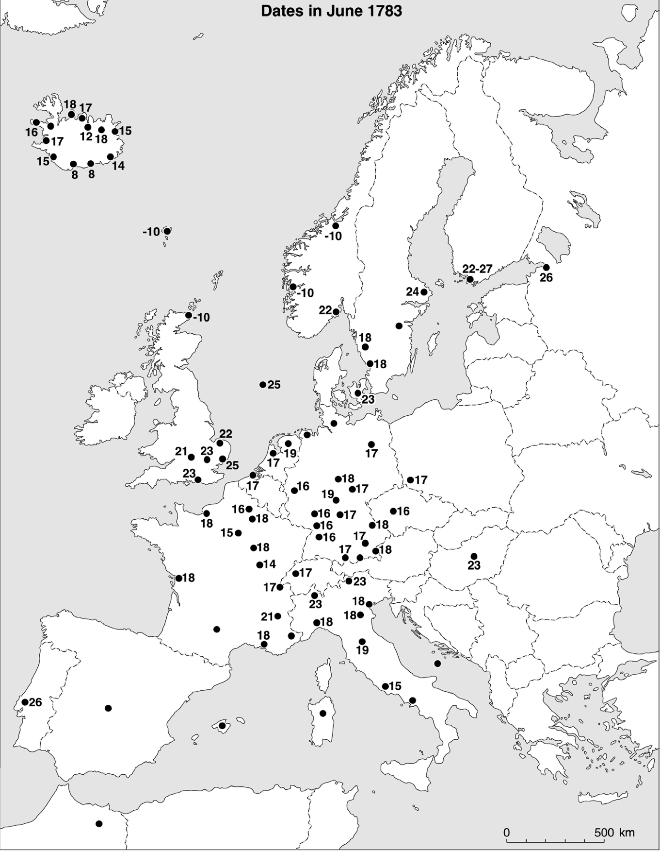
The resulting dry fog was reported in many European countries, including Scotland, Spain, France, Italy, England, Germany, Norway, Sweden, Belgium, Denmark, the Netherlands, Switzerland, and the Czech Republic [Grattan 2005].
Newspaper articles, journals, and letters of correspondence all record similar descriptions of this phenomenon. Many of these reports come several weeks after the start of the eruption. A British newspaper reported, "the state of the atmosphere for this week past has been more remarkable close and thick when was ever observed at this season. Such a haziness has prevailed, that the hills, at two or three miles distance, have not been discernible, and the appearance of the sun has been like that of a faint fire ball, without a ray darting from it" [Grattan 1998/Bristol Journal 19th July 1783]. In France, another newspaper described how "the fog sometimes emits a strong odour and it is so dry, it does not tarnish a looking glass and instead of liquefying salts, it dries them" [Grattan 1998/Aberdeen Journal, 18 August 1783]. Many other sources describe the sun as having a dull red appearance more common of winter fogs. Benjamin Franklin even noted in one of his historical observations that the fog that plagued Europe (and eventually part of North America) "was of a permanent nature" [Franklin].
Dry fog appearances in June 1783, Grattan 2005
Apart from remarks about the general ambiance, many sources note the beginnings of environmental impacts. In a letter, Horace Walpole proclaims that he has grown tired of the recent weather, as "it parches the leaves [and] makes the turf crisp" [Cunningham]. In Suffolk, Sir John Cullum wrote a detailed account of crops in his garden, noting that barley became "brown and weathered," the "rye had the appearance of being mildewed," and that trees of all types shed leaves well before autumn [Cullum]. He also noted that "vegetables appeared exactly as if a fire had been lighted near them, that had shrivelled and discoloured their leaves" [Cullum]. Reports from other regions of spotted, dried, and yellowed leaves on crops, shrubs, and trees were very common in the summer of 1783. All of these descriptions are very characteristic of sulfuric acid aerosol damage when the pH of absorbed water falls below 3.5 [Grattan 1998]. Apart from crop damage, several weeks after the start of the eruption many animals were affected, with dead fish observed near Edinburgh [Grattan 1998] and by the end of the eruption, 50% of cattle and 79% of horses in northern and western Britain perished [Grattan 1994].
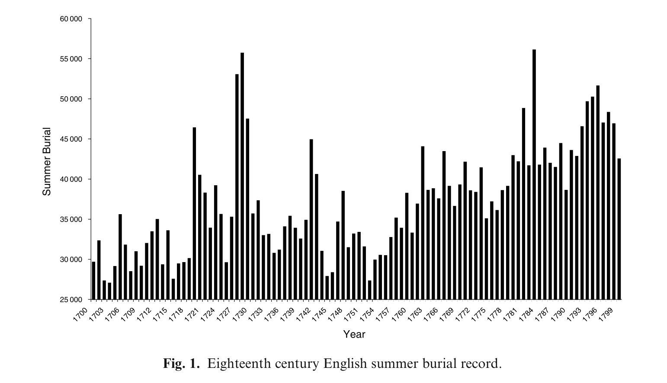
Along with the strange atmospheric phenomenon, crop damage, and animal death, the human health effects from the fallout from this eruption were exceptionally significant. The most common symptoms from exposure to this dry fog were headaches, eye irritation, decreased lung function, and asthma [Grattan 2003]. Other people reported to experience tingling sensations in their throats (possibly caused by induced bronchitis) and loss of appetite. During the day surface temperatures were considerably higher than other summers, as the high concentration of aerosols in the lower layers of the atmosphere can absorb and retain thermal energy [Grattan 2003]. The symptoms associated with these aerosols were exacerbated by the sometimes-intolerable heat and were especially critical in people with pre-existing asthma or other cardiovascular conditions [Grattan 2003]. Another population at risk during this summer was farmers, as working outside for many hours during the day at an increased physical activity rate (and thus ventilation rate) increased the strength and duration of the exposure to aerosols [Grattan 2005]. Many exposed individuals with predispositions for respiratory or cardiovascular conditions could not handle the extra physiological stress brought on by the fallout from the eruption, and death rates spiked between 1783 and 1784. During the first few months, some likened these deaths to a resurgence of the 1720's plague, and as a result "many ignorant doctors treated it by bleeding and applying emetics" [Grattan 2003]. In Iceland, 25% of the population died from a number of factors besides illness, including environmental stress and famine [Grattan 2003]. Many historical European data sets show that in the 18th century deaths in local areas peaked during March and April and that summer months showed a decline in mortality rates, as the weather was more favorable to health and food was more plentiful [Grattan 2003]. In England specifically, the summer of 1783 saw the highest burial rate recorded in the 18th century, and the national death rate for 1783 to 1784 was 16.7% higher than the projected trend for this time period [Grattan 2003]. Burial records from local parishes throughout England and in other countries all show increased numbers for the time immediately during and after the Laki eruption, and the mortality was actually higher at the time than during the typhoid and smallpox epidemics in the 1720's [Grattan 2003]. Elevated burial rates continued into the winter months in 1784 in numerous parishes, most likely because many people were left weakened in the colder months by health and environmental stresses associated with the eruption.
Grattan/Durand/Taylor 2003
In less than a year, the Laki fissure eruption left thousands of surviving Europeans struggling to recover from illness, environmental degradation, and likely in many cases shock from the extensive effects of this volcano. Although these events took place more than 200 years ago, the aftermath is a prime example of how concentrated sub-stratospheric air pollution can affect a large population in a short period of time. The symptoms described in many historical records are typical of modern severe air pollution events [Grattan 2005], such as those related to types of smog associated with sulfur dioxide emissions. With many urban areas already facing difficulty with air pollution from various sources including power plants and cars, any additional emissions from a volcanic eruption similar to the one in the 18th century would intensify health and environmental issues connected with these atmospheric conditions. The populations near active volcanic centers in many parts of the world today are dense, and the consequences of a similar event will be complex and far-reaching. The current Eyjafjallajokull eruption has drawn worldwide attention due to the huge ash plume which disrupted air travel, but some scientists predict that this particular eruption won't have climate effects to the same degree as some other recent eruptions such at Mt. Pinatubo [RedOrbit]. The average amount of sulfur dioxide released in conjunction with the relatively low altitudes that the plume has reached in comparison to other eruptions will mostly likely cause regional effects on European climate, but only if the eruption continues for many more months [RedOrbit]. Considering Iceland's active and regular eruptive history, the European community must prepare for an inevitable repeat of a massive fissure eruption analogous to Laki.

References
Cullum, J. 1783. Of a remarkable frost on the 23rd of June, 1783. Philosophical Transactions of the Royal Society of London. Abridged Volume 15, 1781-1785, 604.

Cunningham, P. 1938. The letters of HORACE WALPOLE. Volume VIII. Richard Bentley, London.

Franklin, B. 1784. Meterorological imaginations and conjectures. Mem. Lit. Philos. Soc. Manchester 2, 373-377

"Geology of Iceland." Iceland on the Web. Web. 16 May 2010. <http://iceland.vefur.is/iceland_nature/geology_of_iceland/index.htm>.

Grattan, John (1998) ‘The distal impact of Icelandic volcanic gases and aerosols in Europe: a review of the 1783 Lake Fissure eruption an d environmental vulnerability in the late 20th century,’ Geological Society, London, Engineering Geology Special Publications 15, 97-103

Grattan, JP, Durand, M and Taylor, S (2003) ‘Illness and elevated human mortality coincident with volcanic eruptions’, Volcanic Degassing, Geological Society Special Publication 213, 401–14

Grattan, JP and Pyatt, FB (1994) ‘Acid damage in Europe caused by the Laki Fissure eruption – an historical review’, The Science of the Total Environment 151, 241–47

Grattan, John, Roland Rabartin, Self Stephen, and Thorvaldur Thordarson, (2005), ‘Volcanic air pollution and mortality in France 1783-1784,’ C. R. Geoscience, 337, 641-651.

"How Volcanos Work: Fissure Eruptions." SDSU Geology.Web. 16 May 2010. <http://www.redorbit.com/news/science/1851356/iceland_eruption_too_small_to_cool_the_planet/index.html>.

"Iceland Eruption Too Small to Cool the Planet." RedOrbit. 17 Apr 2010. Web. 16 May 2010. <http://www.redorbit.com/news/science/1851356/iceland_eruption_too_small_to_cool_the_planet/index.html>.

Thordarson, Th. and Self, S., (1993) ‘The Laki and Grimsvotn eruptions in 1783-85’, Bulletin Volcanologique, v.55, p.233-263

Topinka, Lyn. "Description: Iceland Volcanoes and Volcanics." USGS Geology. 27 Mar 2006. Web. 16 May 2010. <http://vulcan.wr.usgs.gov/Volcanoes/Iceland/description_iceland_volcanics.html>

"Volcanic Gases and Their Effects." USGS. 30 Apr 2010. Web. 16 May 2010. <http://volcanoes.usgs.gov/hazards/gas/index.php>.

